import java.util.Scanner;

public class Triangle

{

public static void main( String [] args )

{

// create three variables to store the length of edges

int a;

int b;

int c;

// create Scanner object

Scanner input = new Scanner(System.in);

// read inputs from keyboard and assign them to each edge.

System.out.print( "Please enter the length of the first edge: ");

a = input.nextInt();

System.out.print( "Please enter the length of the second edge: ");

b = input.nextInt();

System.out.print( "Please enter the length of the third edge: ");

c = input.nextInt();

// test if the inputs are valid

if( ( a + b ) > c && ( a + c > b ) && ( b + c > a ) )

{

int perimeter = a + b + c;

System.out.println( "The inputs are valid as sum of any two edges is" +

" greater than the third edge, and the perimeter of this triangle is " +

perimeter );

}

else

System.out.println( "The inputs are invalid as sum of two edges is less than or equal to the third edge." );

// end if

}

}

|  |  |  |  |  |
| --- | --- | --- | --- | --- |
| **Test Case #** | **Inputs**  **(a, b and c are edges of triangle** | **Expected Output** | **Actual Output** | **Test Passed? (Yes/No)** |
| 1 | a = 2, b = 1, c = 2 | ***The inputs are valid as sum of any two edges is greater than the third edge and the perimeter of this triangle is 5.*** | ***The inputs are valid as sum of any two edges is greater than the third edge and the perimeter of this triangle is 5.*** | Y |
| 2 | a = 1, b = 2, c = 1 | ***The inputs are invalid as sum of two edges is less than or equal to the third edge.*** | ***The inputs are invalid as sum of two edges is less than or equal to the third edge.*** | Y |
| 3 | a = 3, b = 1, c = 2 | ***The inputs are invalid as sum of two edges is less than or equal to the third edge.*** | ***The inputs are invalid as sum of two edges is less than or equal to the third edge.*** | Y |
| 4 | a = 5, b = 6, c = 7 | ***The inputs are valid as sum of any two edges is greater than the third edge, and the perimeter of this triangle is 18*** | The inputs are valid as sum of any two edges is greater than the third edge, and the perimeter of this triangle is 18 | Y |
| 5 | a = 4, b = 10, c = 7 | ***The inputs are valid as sum of any two edges is greater than the third edge, and the perimeter of this triangle is 21*** | The inputs are valid as sum of any two edges is greater than the third edge, and the perimeter of this triangle is 21 | Y |

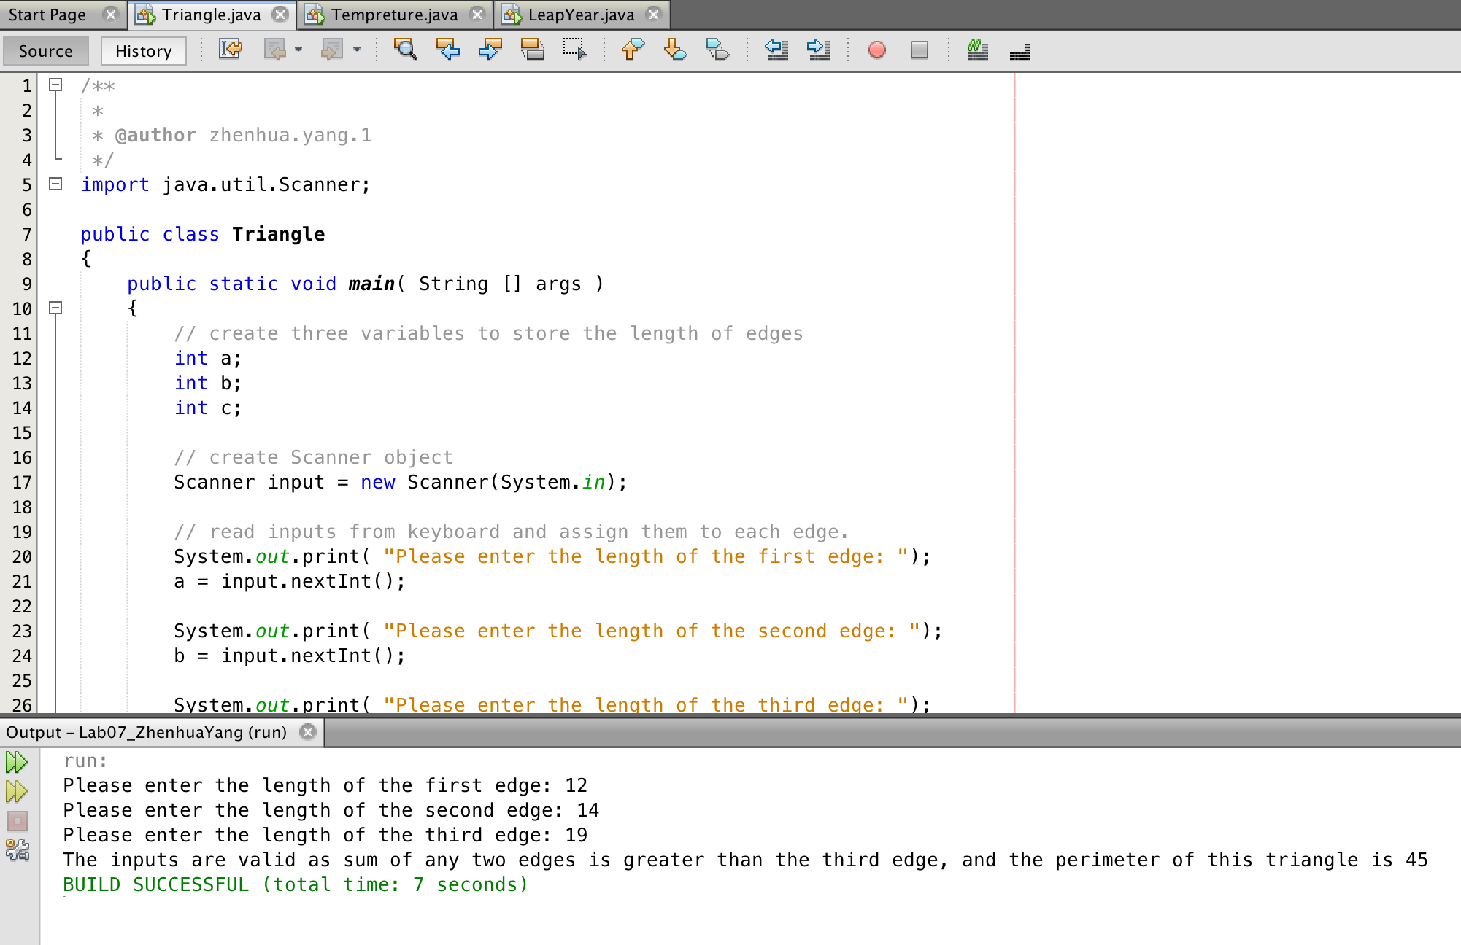

import java.util.Scanner;

public class Tempreture

{

public static void main( String[] args )

{

// create a variable t

int t;

// create a Scanner object

Scanner input = new Scanner( System.in );

// read a data from keyboard and assign it to the variable t.

System.out.print("Please enter a tempreture> ");

t = input.nextInt();

// check the statements:

if( t >= 90 && t <= 110 )

System.out.println( "It is probably summer." );

else if( t >= 70 && t < 90 )

System.out.println( "It is probably spring." );

else if( t >= 50 && t < 70 )

System.out.println( "it is probably fall." );

else if( t < 50 )

System.out.println( "It is probably winter." );

else if( t > 110 || t < -5 )

System.out.println( "Outside the valid range.." );

}

}

|  |  |  |  |  |
| --- | --- | --- | --- | --- |
| **Test Case #** | **Inputs**  **Temperature** | **Expected Output** | **Actual Output** | **Test Passed? (Yes/No)** |
| **1** | **111** | **Outside the valid range** | **Outside the valid range..** | **Y** |
| **2** | **110** | **Outside the valid range** | **It is probably summer.** | **N** |
| **3** | **109** | **It is probably summer** | **It is probably summer.** | **Y** |

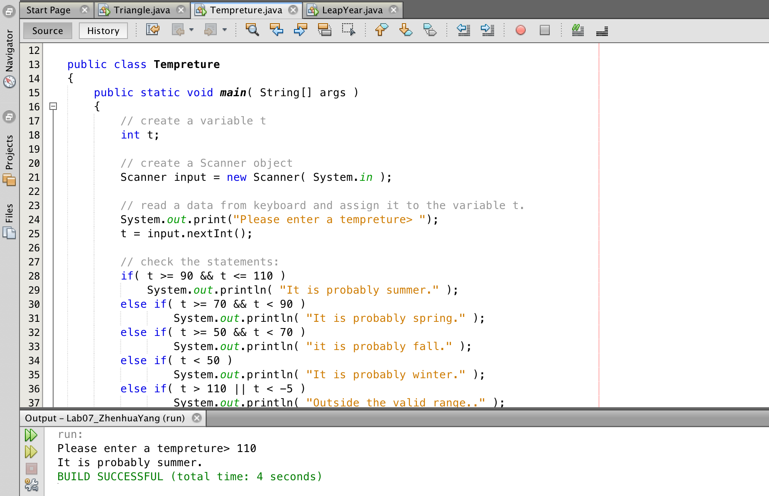

import java.util.Scanner;

public class LeapYear

{

public static void main( String[] args )

{

// create a variable to store user's inupt.

int year;

// create a Scanner object;

Scanner input = new Scanner( System.in );

// read the year from keyboard and assign it to "year"

System.out.print( "Please enter a year> " );

year = input.nextInt();

if( year % 4 == 0 || year % 400 == 0 ) //If the year is divisible by 4 and not divisible by 100,

//or if the year is divisible by 400

{

System.out.println( year + " is a leap year. " );

} else if( year < 1528 ) // if the year is less than 1528

{

System.out.println( "the year the Gregorian calendar was adopted.");

} else

System.out.println( year + " is not a leap year. ");

} // end if

}

