/\*\*

\*

\* @author zhenhua.yang.1

\*/

import java.util.Random;

import java.util.Scanner;

public class Guessing

{

public static void main( String[] args )

{

// create variables and assign initial value of 1 to count

int num;

int count = 1;

int guessNum;

Random rand = new Random(); // instantiate Random object

num = rand.nextInt(100) + 1; // assign a random number from 1-100 to num

Scanner input = new Scanner( System.in ); // instantiate Scanner object

System.out.print("Please guess a number, or enter -1 to exit> ");

guessNum = input.nextInt(); // save user input from keyboard

while( guessNum != num )

{

// if the user enters -1, the loop would stop and this count would be ignored.

if( guessNum == -1 )

{

count--;

break;

}

// guess does not equal to num, user inputs another ingeter,

// and count increments for 1.

System.out.print( "Not that number, try another number, or enter -1 to exit> " );

guessNum = input.nextInt();

count ++;

} // end while statement.

if ( guessNum == num )

System.out.println( "\nAwesome! You found the right number with " + count + " tries!" );

else{

System.out.println( "\nThe number is " + num );

System.out.println( "You tried " + count + " times. " );

}

}

}

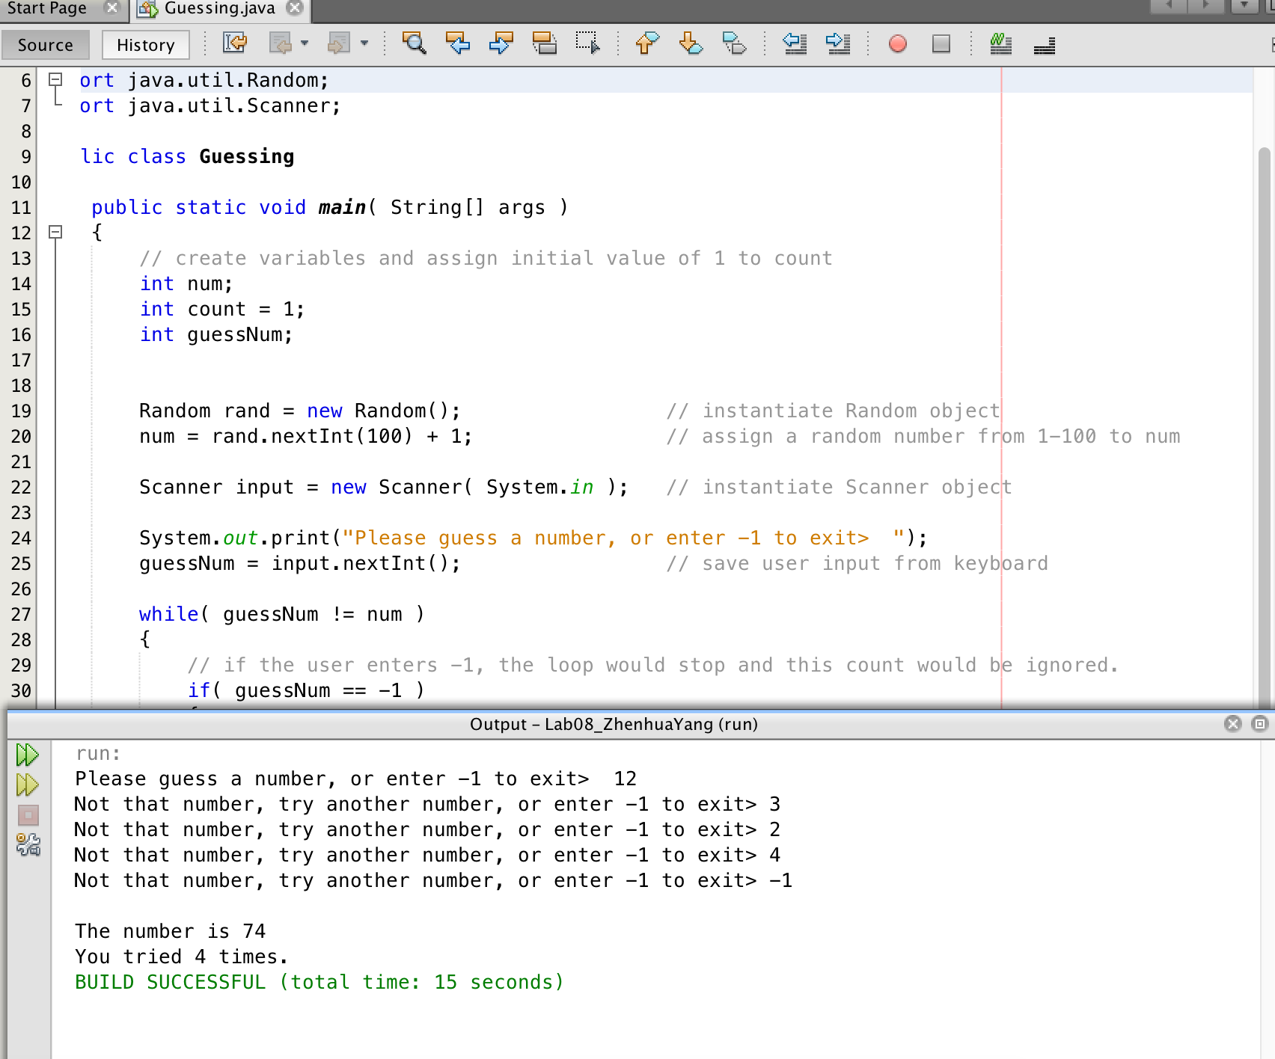

import java.io.File;

import java.io.FileNotFoundException;

import java.util.Scanner;

public class Grades

{

public static void main( String[] args ) throws FileNotFoundException

{

// create variables

int count = 0;

int grade;

int total = 0;

int average;

int max = 0;

int min = 100;

// create and initiate variables for each grade scale

int countP = 0, countA = 0, countB = 0, countC = 0, countD = 0, countF = 0;

File inputFile = new File("grades.txt"); // Initiate File object and link to grades.txt file

Scanner file = new Scanner( inputFile ); // Initiate Scanner object and read inputFile

// start while loop

while ( file.hasNext() )

{

grade = file.nextInt(); // read a data from the file and assign it to grade

total += grade; // calculate the sum of all grades

count ++; // increment count

if( max < grade ) // find the highest grade

max = grade;

if( min > grade ) // find the lowest grade

min = grade;

if( grade >= 60 ) // find the number of students who passed( grade >=60 )

countP ++;

if( grade >= 90 ) // find the number of students who got "A" ( grade >=90 )

countA ++;

if( grade >= 80 && grade <= 90 ) // find the number of students who got "B" ( 80 - 90)

countB ++;

if( grade >= 70 && grade <= 80 ) // find the number of students who got "C" ( 70 - 80 )

countC ++;

if( grade >= 60 && grade <= 70 ) // find the number of students who got "D" ( 60 - 70)

countD++;

if( grade < 60 ) // find the number of students who got "F" ( < 60 )

countF++;

} // end while statement

average = total / count; // calculate the average of all grades

// print the result

System.out.println( "\nCount of Students: " + count +

"\nAverage grade: " + average +

"\nHighest Grade: " + max +

"\nLowest Grade: " + min +

"\n\nNumber of students who passed (grade >=60): " + countP +

"\nNumber of students who got “A” grade ( >= 90): " + countA +

"\nNumber of students who got “B” grade (>=80 - <90): " + countB +

"\nNumber of students who got “C” grade ((>=70 - <80): " + countC +

"\nNumber of students who got “D” grade (>= 60 - <70): " + countD +

"\nNumber of students who got “F” grade (<60): " + countF );

}

}

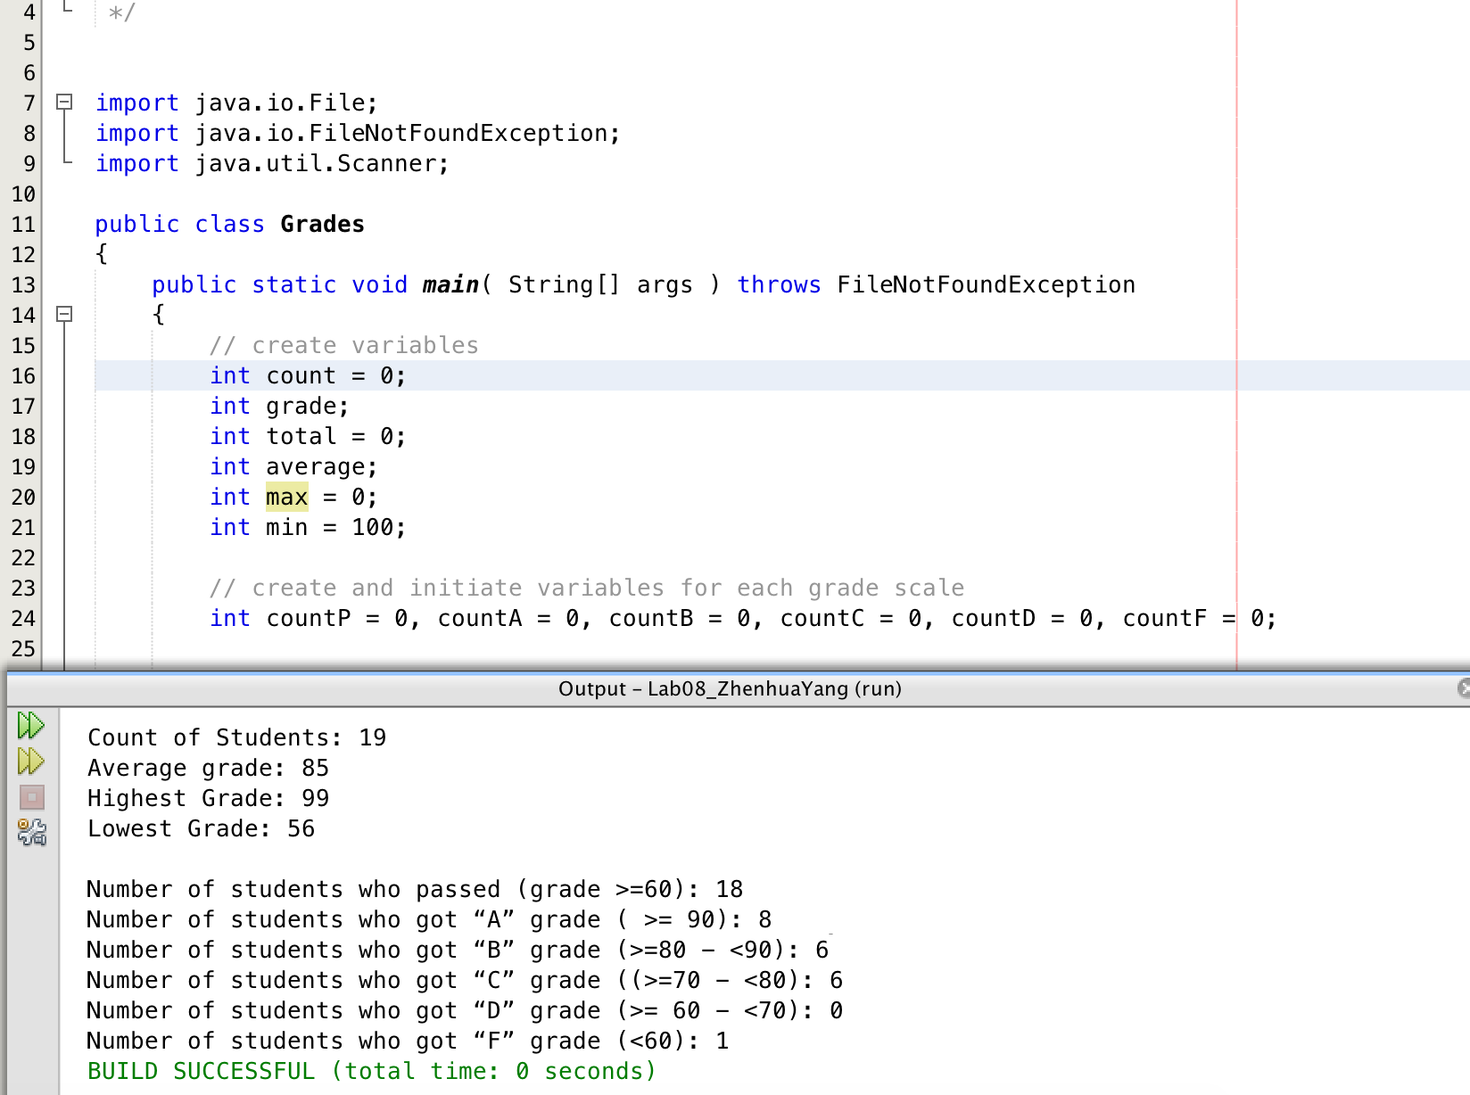

import java.util.Scanner;

import java.util.Random;

public class RockPaperScissors

{

public static void main( String [] args )

{

// create variables

int userOption;

int computerOption;

Random rand = new Random(); // instantiate Random object

Scanner input = new Scanner( System.in ); // instantiate Scanner object

System.out.println( "1 = Rock \n2 = Paper \n3 = Scissors" ); // print options for the user

System.out.print( "Please enter your option, or enter 0 to exit > ");

// while loop

while( true )

{

userOption = input.nextInt(); // save user input from keyboard

computerOption = rand.nextInt(3) + 1; // assign a random number from 1-100 to computerOption

while( userOption > 3 || userOption < 0)

{

System.out.print( "Please select from 0, 1, 2, and 3 > "); // if the user enters a number other then 0 - 3

userOption = input.nextInt();

}

if ( (computerOption == 1 && userOption == 2)

|| (computerOption == 2 && userOption == 3)

|| (computerOption == 3 && userOption == 1) ) // the condition that Computer wins

System.out.print( "Computer wins. \nPlease enter your option, or enter 0 to exit > " );

if( computerOption == userOption ) // the considition that ties

System.out.print( "Ties. \nPlease enter your option, or enter 0 to exit > " );

if( (userOption == 1 && computerOption == 2)

|| (userOption == 2 && computerOption == 3)

|| (userOption == 3 && computerOption == 1) ) // the conditions that the user wins

System.out.print( "You win. \nPlease enter your option, or enter 0 to exit > " );

if ( userOption == 0 ) // the condition that the user stoped game

{

System.out.println( "\nGoodbey!" );

break; // terminate the while loop

}

}

}

}

