/\*\*

\*

\* @author zhenhua.yang.1

\*/

import java.util.Scanner;

public class XorSimulation

{

public static void main( String[] args )

{

// Create variables

char result;

char input2;

String input;

// Create a Scanner class object

Scanner scan = new Scanner( System.in );

// Prompt and read the input from keyboard

System.out.print("Please enter your value> ");

input = scan.next();

// Initiate result, set defalt value the first digit of input.

result = input.charAt(0);

// for loop to perform XOR operation

for( int i = 1; i < input.length(); i++ )

{

input2 = input.charAt(i);

if ( result == input2 )

{

result = '0';

}

else

{

result = '1';

}

}

// print the result

System.out.println( "The result is " + result );

}

}

run:

Please enter your value> 1011010010

The result is 1

Please enter your value> 1101010011010

The result is 1

Please enter your value> 11010111010101111

The result is 0

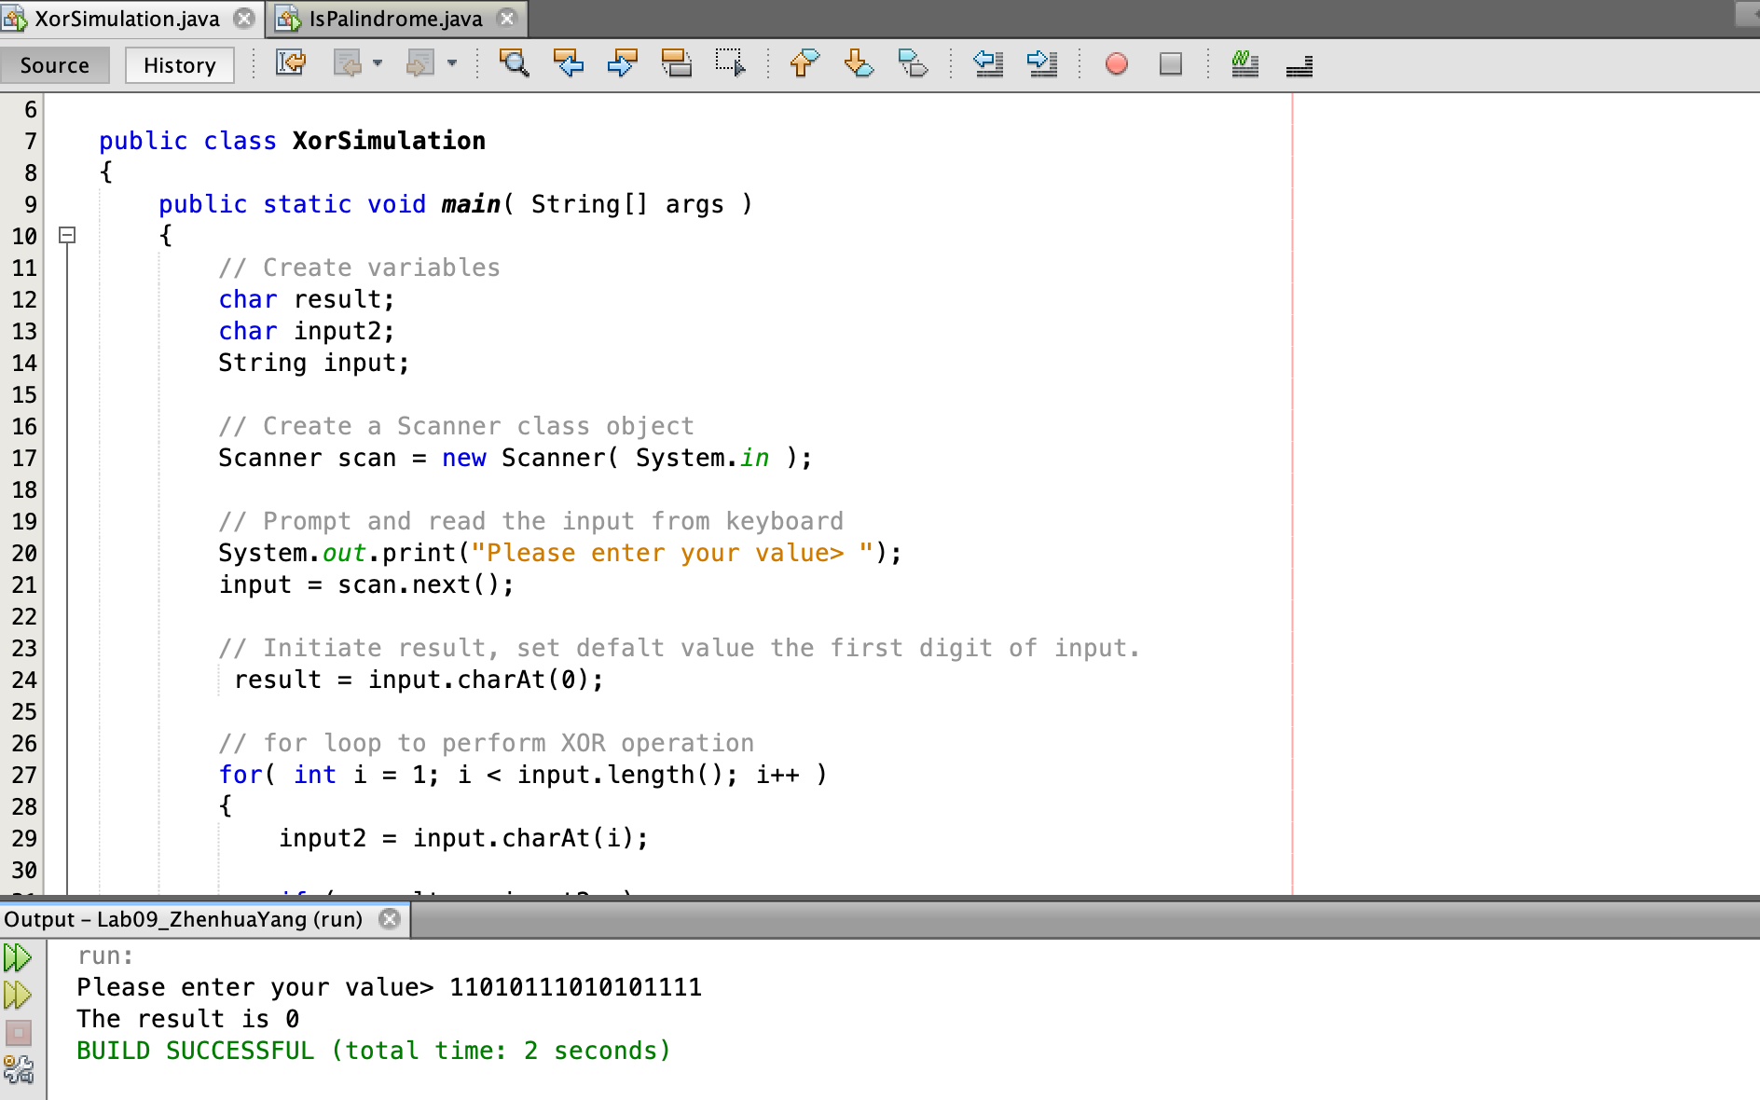

import java.util.Scanner;

public class IsPalindrome

{

public static void main( String [] args )

{

String word = ""; // the variable that will save the user input

String result = ""; // the variable that save the result

// instantiate the Scanner object

Scanner input = new Scanner( System.in );

// do...while loop to perform the operation

do {

System.out.print( "Please enter your word, or enter 0 to exit> " );

word = input.next();

if( word.equals("0"))

break;

// check each character in the input word

for( int i = 0; i < word.length() / 2; i++ )

{

if( word.charAt(i) != word.charAt(word.length() - 1 - i))

result = "not a palindrome";

else

result = "a palindrome";

}

// print out the result

System.out.println("It is " + result + "\n" );

}while ( word.length() != 0 );

// end the do...while loop

}

}

run:

Please enter your word, or enter 0 to exit> racecar

It is a palindrome

Please enter your word, or enter 0 to exit> madam

It is a palindrome

Please enter your word, or enter 0 to exit> noon

It is a palindrome

Please enter your word, or enter 0 to exit> 0

BUILD SUCCESSFUL (total time: 18 seconds)

