Figure 1: Flowchart of participant selection from the UK Biobank cohort

502413 adults who are recruited in
the UK biobank

Excluded:
Low quality data: n = 1,405
Missing physical activity questionnaire:n=117131
Total excluded: n = 118,536

Participants with high quality
accelerometer data n = 383598

Cardiovascular disease diagnosis in HES
Prior to accelerometer wear n = 15491

Participants with usable data and without
prevalent cardiovascular disease n = 368107

Missing data for biomarkers n = 75603

Participants included in the main
analysis n = 292504

Table 1. Baseline characteristics of the study population
Characteristics | Overall  (N=292504) | Q1  (≤824  MET-min/week) | Q2  (824–1791 MET-min/week) | Q3  (1791–3546 MET-min/week) | Q4  (>3546  MET-min/week) | P value
Age, mean (SD) | 55.9 (8.1) | 55.6 (7.9) | 55.8 (8.1) | 55.9 (8.3) | 56.5 (8.2) | <0.001
Sex, n (%) |  |  |  |  |  | <0.001
Female | 153056 (52.3) | 38521 (52.6) | 39371 (53.9) | 38815 (52.9) | 36349 (49.8)
Male | 139448 (47.7) | 34649 (47.4) | 33719 (46.1) | 34493 (47.1) | 36587 (50.2)
Ethnicity, n (%) |  |  |  |  |  | <0.001
White | 279573 (95.6) | 69444 (94.9) | 69831 (95.5) | 70203 (95.8) | 70095 (96.1)
Nonwhite | 12931 (4.4) | 3726 (5.1) | 3259 (4.5) | 3105 (4.2) | 2841 (3.9)
University education, n (%) | 107688 (36.8) | 27685 (37.8) | 30481 (41.7) | 28768 (39.2) | 20754 (28.8) | <0.001
Smoking status, n (%) |  |  |  |  |  | <0.001
Never | 162934 (55.7) | 40490 (55.3) | 41630 (57) | 41320 (56.4) | 39494 (54.1)
Previous | 100950 (34.5) | 24507 (33.5) | 24906 (34.1) | 25664 (35) | 25873 (35.5)
Current | 28620 (9.8) | 8173 (11.2) | 6554 (9) | 6324 (8.6) | 7569 (10.4)
Alcohol drinking, n (%) |  |  |  |  |  | <0.001
Never | 10420 (3.6) | 2987 (4.1) | 2464 (3.4) | 2324 (3.2) | 2648 (3.6)
Previous | 9348 (3.2) | 2605 (3.6) | 2092 (2.9) | 2124 (2.9) | 2527 (3.5)
Current | 272736 (93.2) | 67581 (92.4) | 68534 (93.8) | 68860 (93.9) | 67761 (92.9)
Red and processed meat frequency, mean (SD) | 1.9 (1.1) | 1.9 (1.1) | 1.9 (1.0) | 1.8 (1.1) | 1.8 (1.1) | <0.001
Fresh fruit portions, mean (SD) | 2.2 (1.6) | 2.0 (1.5) | 2.2 (1.5) | 2.3 (1.6) | 2.4 (1.7) | <0.001
Cooked vegetable intake, mean (SD) | 2.7 (1.9) | 2.5 (1.8) | 2.6 (1.8) | 2.8 (1.9) | 3.0 (2.1) | <0.001
Townsend deprivation index, mean (SD) | -1.5 (3.0) | -1.5 (3.0) | -1.5 (3.0) | -1.6 (2.9) | -1.4 (3.0) | <0.001
BMI (kg/m²), mean (SD) | 27.2 (4.7) | 28.2 (5.2) | 27.1 (4.6) | 26.7 (4.3) | 26.7 (4.3) | <0.001
Summed minutes activity  (min/week) | 127（98） | 36 (23) | 82 (31) | 133 (42) | 256 (88) | <0.001
Diabetes mellitus, n (%) | 2603（0.9） | 913（1.2） | 608（0.8） | 557（0.8） | 525（0.7） | <0.001
Hypertension, n (%) | 53151（18.2） | 15180（20.7） | 13221（18.1） | 12424（16.9） | 12326（16.9） | <0.001
Dyslipidemia, n (%) | 42442（14.5） | 12254（16.7） | 10445（14.3） | 9943（13.6） | 9800（13.4） | <0.001
Totalcholesterol (mmol/L), mean  (SD) | 5.6 (1.0) | 5.6 (1.0) | 5.6 (1.0) | 5.6 (1.0) | 5.7 (1.0) | <0.001
HDL cholesterol (mmol/L), mean (SD) | 1.5 (0.4) | 1.4 (0.4) | 1.4 (0.4) | 1.5 (0.4) | 1.5 (0.4) | <0.001
LDL cholesterol (mmol/L), mean (SD) | 3.5 (0.8) | 3.5 (0.8) | 3.5 (0.8) | 3.5 (0.7) | 3.5 (0.8) | 0.021
Triglycerides (mmol/L), mean (SD) | 1.7 (1.0) | 1.8 (1.1) | 1.7 (1.0) | 1.6 (0.9) | 1.6 (1.0) | <0.001
Calcium (mmol/L), mean (SD) | 2.378 (0.093) | 2.376 (0.094) | 2.378 (0.092) | 2.379 (0.093) | 2.378 (0.092) | <0.001
Alkaline phosphatase (U/L), mean (SD) | 82.15 (25.04) | 83.82 (26.14) | 81.60 (24.69) | 81.12 (24.65) | 82.06 (24.58) | <0.001
IGF-1 (nmol/L), mean (SD) | 21.63 (5.64) | 21.44 (5.77) | 21.83 (5.65) | 21.81 (5.62) | 21.45 (5.50) | <0.001
Vitamin D (nmol/L), mean (SD) | 49.14 (21.07) | 44.61 (20.29) | 48.17 (20.50) | 50.88 (21.00) | 52.9 (21.56) | <0.001

Table 2: Association of questionnaire-based total physical activity（MET-min/week）with incident CVD
Physical activity quartiles | No.of participants/cases | Model 1 HR (95% CI) | Model 2 HR (95% CI) | Model 3 HR (95% CI)
Q1 (Lowest, < 825MET-min/week) [Ref] | 73170/7923 | 1.00 (Reference) | 1.00 (Reference) | 1.00 (Reference)
Q2 (825 - 1794 MET-min/week) | 73090/7056 | 0.89(0.86,0.91)*** | 0.93(0.90,0.96)*** | 0.92(0.89,0.95)***
Q3 (1795 - 3558 MET-min/week) | 73308/6984 | 0.87(0.85,0.90)*** | 0.91(0.88,0.94)*** | 0.90(0.87,0.93)***
Q4 (Highest, > 3558 MET-min/week)) | 72936/7738 | 0.98(0.95,1.01） | 0.94(0.91,0.97)*** | 0.94(0.91,0.97)***
P for trend(Q1-Q4) | - | 0.14 | 0.016 | 0.96
Numbers are presented as total participants / incident cases
Model 1: unadjusted
Model 2: Adjusted for age, sex, ethnicity, education,Townsend deprivation index, smoking status, alcohol consumption frequency and BMI
Model 3: Adjusted for Model 2 + red and processed meat intake, vegetable intake, fresh fruit intake, hypertension, Diabetes mellitus, and dyslipidemia
P for trend was calculated by modeling quartile as an ordinal variable
*P<0.05, **P<0.01, ***P<0.001
Values without asterisk indicate no statistically significant difference (P≥0.05)

Table3：Associations between questionnaire-based physical activity and incident ischaemic heart disease and cerebrovascular disease
Physical activity quartiles | No.of participants/cases | Model 1 HR (95% CI) | Model 2 HR (95% CI) | Model 3 HR (95% CI)
Ischaemic Heart Disease
Q1 (Lowest, < 825MET-min/week) [Ref] | 73170/5788 | 1.00 (Reference) | 1.00 (Reference) | 1.00 (Reference)
Q2 (825 - 1794 MET-min/week) | 73090/5032 | 0.86(0.83,0.90)*** | 0.93(0.89,0.96)*** | 0.91(0.88,0.94)***
Q3 (1795 - 3558 MET-min/week) | 73308/5036 | 0.86(0.83,0.90)*** | 0.92(0.88,0.95)*** | 0.90(0.86,0.93)***
Q4 (Highest, > 3558 MET-min/week)) | 72936/5539 | 0.96(0.93,1.00)* | 0.94(0.91,0.98)** | 0.93(0.90,0.97)***
Cerebrovascular Disease
Q1 (Lowest, < 825MET-min/week) [Ref] | 73170/2848 | 1.00 (Reference) | 1.00 (Reference) | 1.00 (Reference)
Q2 (825 - 1794 MET-min/week) | 73090/2526 | 0.88(0.84,0.93)*** | 0.90(0.85,0.95)*** | 0.90(0.86,0.95)***
Q3 (1795 - 3558 MET-min/week) | 73308/2508 | 0.87(0.83,0.92)*** | 0.87(0.83,0.92)*** | 0.88(0.83,0.93)***
Q4 (Highest, > 3558 MET-min/week)) | 72936/2848 | 1.00(0.95,1.06） | 0.93(0.88,0.98)** | 0.94(0.89,0.99)*
Numbers are presented as total participants / incident cases
Model 1: unadjusted
Model 2: Adjusted for age, sex, ethnicity, education,Townsend deprivation index, smoking status, alcohol consumption frequency and BMI
Model 3: Adjusted for Model 2 + red and processed meat intake, vegetable intake, fresh fruit intake, hypertension, Diabetes mellitus, and dyslipidemia
*P<0.05, **P<0.01, ***P<0.001
Values without asterisk indicate no statistically significant difference (P≥0.05)

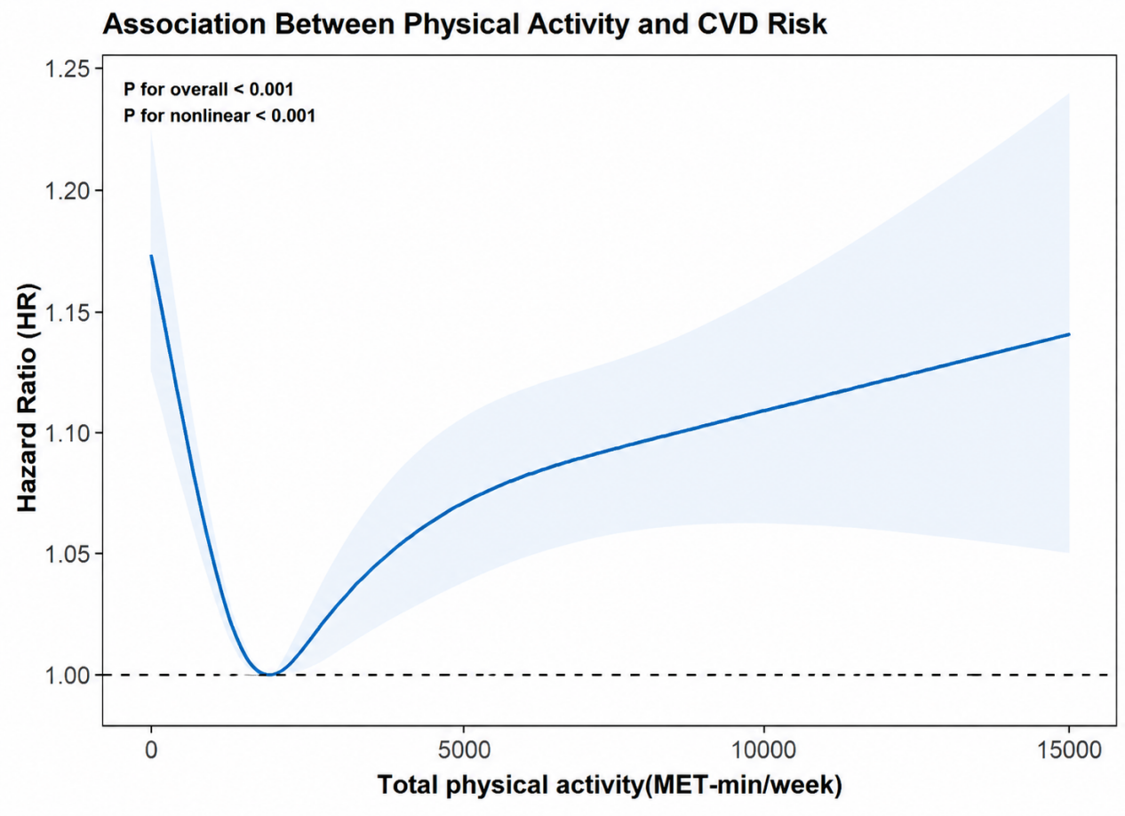

Table4: Association Between Physical Activity（MET-min/week）and Incident CVD by RCS Cutpoint
Exposure  (Physical Activity) | Model 1 HR  (95% CI) | Model 2 HR  (95% CI) | Model 3 HR  (95% CI) | P Value
MET-min/week≤1803.98 | 0.66  (0.61,0.72) | 0.76  (0.70,0.83) | 0.74  (0.69,0.80) | <0.001
MET-min/week＞1803.98 | 1.06  (1.05,1.08) | 1.02  (1.01,1.04) | 1.03  (1.01,1.05) | <0.001

Cutpoint 1803.98 MET-min/week corresponds to the lowest HR in restricted cubic spline analysis.
Model 1: unadjusted
Model 2: Adjusted for age, sex, ethnicity, education,Townsend deprivation index, smoking status, alcohol consumption frequency and BMI
Model 3: Adjusted for Model 2 + red and processed meat intake, vegetable intake, fresh fruit intake, hypertension, Diabetes mellitus, and dyslipidemia

Table5. Mediation analysis of bone metabolism markers in the association between physical activity and incident cardiovascular disease
Mediator | Total effect  HR (95% CI)a | Direct effect  HR (95% CI) | Indirect effect  HR (95% CI) | Proportion  Mediated(%)
MET-min/week≤1803.98
Vitamin D | 0.928（0.898-0.960）*** | 0.931（0.900-0.963）*** | 0.997（0.995，0.999）** | 4.1*
ALP | 0.930（0.905-0.955）*** | 0.932（0.907-0.958）*** | 0.998（0.997，0.998）*** | 3.3***
IGF-1 | 0.929（0.905-0.954）*** | 0.930（0.906-0.955）*** | 0.999（0.998，0.9997）** | 1.3**
Ca | 0.929（0.905-0.954）*** | 0.929（0.905-0.954）*** | 1.000（0.9996，1.0001） | -
MET-min/week＞1803.98
Vitamin D | 0.991（0.988-0.995）*** | 0.992（0.988-0.995）*** | 0.9997（0.9995-1.0002） | -
ALP | 0.991（0.988-0.994）*** | 0.992（0.988-0.995）*** | 0.9997（0.9995-0.9999）** | 3.2*
IGF-1 | 0.991（0.988-0.994）*** | 0.991（0.988-0.995）*** | 1.0000（0.9997-1.0000） | -
Ca | 0.991（0.988-0.995）*** | 0.991（0.988-0.995）*** | 1.0000（0.9996，1.0001） | -
HR = Hazard Ratio; CI = Confidence Interval.
Adjusted for full covariates in Model 3.
*P<0.05, **P<0.01, ***P<0.001.
Values without asterisk indicate no statistically significant difference (P≥0.05)

Supplementary Table S1: Association of accelerometer-measured physical activity with incident CVD （N=91077）
Exposure (Physical Activity) | No.of participants/cases | Model 1 HR (95% CI) | Model 2 HR (95% CI) | Model 3 HR (95% CI) | P Value
Continuous (Per 1-SD increase) | 91077/5444 | 0.69(0.67,0.71) | 0.87(0.85,0.90) | 0.89(0.86,0.92) | <0.001
Quartile
Q1 (Lowest, < 22.65mg) [Ref] | 22700/2023 | 1.00 (Reference) | 1.00 (Reference) | 1.00 (Reference) | -
Q2 (22.65 - 27.27 mg) | 22848/1378 | 0.67(0.62,0.71) | 0.84(0.78,0.90) | 0.86(0.80,0.92) | <0.001
Q3 (27.27 - 32.69 mg) | 22798/1162 | 0.56(0.52,0.60) | 0.81(0.75,0.87) | 0.84(0.78,0.91) | <0.001
Q4 (Highest, > 32.69 mg) | 22731/881 | 0.42(0.39.0.46） | 0.73(0.67,0.80) | 0.77(0.70,0.83) | <0.001
P for trend(Q1-Q4) | - | <0.001 | <0.001 | <0.001 | -
Numbers are presented as total participants / incident cases
Model 1: unadjusted
Model 2: Adjusted for age, sex, ethnicity, education,Townsend deprivation index, smoking status, alcohol consumption frequency and BMI
Model 3: Adjusted for Model 2 + red and processed meat intake, vegetable intake, fresh fruit intake, hypertension, Diabetes mellitus, and dyslipidemia

Supplementary Table S2: Sensitivity analysis after excluding cardiovascular disease events occurring within the first 2 years of follow-up
Physical activity quartiles | No.of participants/cases | Model 1 HR (95% CI) | Model 2 HR (95% CI) | Model 3 HR (95% CI)
Q1 (Lowest, < 825MET-min/week) [Ref] | 73170/7252 | 1.00 (Reference) | 1.00 (Reference) | 1.00 (Reference)
Q2 (825 - 1794 MET-min/week) | 73090/6506 | 0.89(0.86,0.92)*** | 0.94(0.91,0.97)*** | 0.93(0.89,0.96)***
Q3 (1795 - 3558 MET-min/week) | 73308/6425 | 0.88(0.85,0.91)*** | 0.91(0.88,0.94)*** | 0.90(0.87,0.93)***
Q4 (Highest, > 3558 MET-min/week)) | 72936/7164 | 0.99(0.96,1.02） | 0.95(0.92,0.99)** | 0.95(0.92,0.98)**
P for trend(Q1-Q4) | - | 0.44 | 0.002 | 0.37
Numbers are presented as total participants / incident cases
Model 1: unadjusted
Model 2: Adjusted for age, sex, ethnicity, education,Townsend deprivation index, smoking status, alcohol consumption frequency and BMI
Model 3: Adjusted for Model 2 + red and processed meat intake, vegetable intake, fresh fruit intake, hypertension, Diabetes mellitus, and dyslipidemia
P for trend was calculated by modeling quartile as an ordinal variable
*P<0.05, **P<0.01, ***P<0.001
Values without asterisk indicate no statistically significant difference (P≥0.05)

