An Auditable Reliability-Regret Profile for Retrospective ADMET QSAR Model Selection: A Fixed-Benchmark Study Across 22 Endpoints
Huajian Jiang (First and Corresponding Author)
College of Computing and Data Science, Nanyang Technological University, Singapore
Correspondence: jian0157@e.ntu.edu.sg
ORCID: 0009-0001-3992-2286
Candidate declaration version for author confirmation; do not submit until the author list and all statements are approved.

Abstract
ADMET model selection is often based on one validation metric, although predictive ranking, probability calibration, selective risk, residual coverage and chemical support can disagree. We define an auditable reliability-regret profile (RRP) that compares a family selected by a designated validation metric with a retrospective, non-deployable candidate-pool reference on prespecified reliability dimensions. The audit covers 22 TDC ADMET endpoints, five model families and five seeds (550 fits), with cleaning sensitivity, support-conditioned diagnostics and descriptive source-transport analyses. Mean regret was 0.0325 for expected calibration error, 0.0092 for Brier score, 0.0179 for coverage error, 0.0793 for relative excess area under the risk-coverage curve and 0.1195 for applicability alignment. Validation and reliability winners agreed in 4/13, 8/13, 2/9, 2/22 and 4/22 comparisons, respectively. Isotonic calibration reduced expected calibration error on 13/13 classification endpoints, but Brier improvements were uncertain. The planned confirmatory external matrix was stopped by an outcome-blind power gate; the focused CYP2D6 analysis is retrospective and exploratory because test-role outcomes were examined before protocol freeze. The study supports multi-dimensional QSAR reliability auditing within this fixed benchmark; it does not establish independent external or temporal validity, deployment benefit, clinical utility or acceptance.
Keywords: ADMET prediction; model selection; uncertainty quantification; calibration; applicability domain

1. Introduction
Computational QSAR prediction of absorption, distribution, metabolism, excretion, and toxicity (ADMET) properties is used to prioritize compounds and support decisions during drug discovery. Public benchmark collections make it possible to compare models across endpoints, but the resulting score depends on the endpoint, data version, split, and evaluation metric. The Therapeutics Data Commons (TDC) was developed to organize therapeutic machine-learning datasets, tasks, data splits, and evaluation resources; its ADMET Group provides a common setting for multi-endpoint assessment [1].
Because these are structure-property relationships, QSAR reliability also depends on chemical support, assay heterogeneity, and endpoint-specific calibration. A high predictive score alone therefore does not establish safe extrapolation to compounds outside the observed chemical domain.
Many benchmark comparisons rank candidate models by a task-specific predictive metric. Such a metric is useful for comparing predictive ranking or error magnitude, but it does not by itself describe every property relevant to using predictions. For classification, ranking performance and probability calibration answer different questions: a model can order compounds well while its predicted probabilities remain poorly aligned with observed frequencies [2]. In compound triage, performance under selective review and the relation between structural support and prediction error may also matter. These considerations motivate evaluating a validation-selected model across multiple reliability dimensions rather than treating its validation score as a complete account of test behaviour.
We use these observations to define an auditable reliability-regret profile (RRP). For each endpoint, the RRP records the loss incurred by the family selected on validation for each prespecified reliability dimension, relative to the most favorable member of the locked candidate pool on the same held-out test partition. The reference is deliberately descriptive: it exposes the dimensions that a single validation score leaves unresolved without turning a test-set oracle into a deployable selector. The profile combines a computationally simple estimator with explicit identity, split, seed, and provenance checks that can be rerun when the candidate pool or data snapshot changes.
Recent work has already established several neighboring reliability questions. Hosni et al. used a structural applicability-domain method with Venn-Abers or conformal uncertainty estimates to distinguish molecules for which uncertainty estimates were more versus less reliable under temporal, cluster, and industrial splits [6]. Parrondo-Pizarro et al. benchmarked chemical-distance, ensemble-variance, and error-model uncertainty metrics for ADME properties under temporal and controlled distribution shifts using separate training, calibration, and test roles [7]. Koleiev et al. audited the top-ranked models across all 22 TDC ADMET leaderboards for reproducibility, leakage, and overfitting [8]. Castellanos et al. analysed the prospective temporal-blind OpenADMET-ExpansionRx challenge and reported applicability-domain and error-tracking results; that work is a preprint and is cited here only as a complementary challenge report [9]. These studies delimit the present contribution: we do not introduce a new uncertainty estimator, calibration method, applicability-domain method, error model, temporal split, or reproducibility audit. The present contribution is the narrower reliability-regret selection audit and its evidence contract, which compares a validation-selected family with a retrospective candidate-pool reference across prespecified reliability dimensions.
Earlier benchmarking also examined data scarcity, structural distribution shift, representation choice, data cleaning, cross-source transfer, and structural-frontier controls in ADMET evaluation [3-5].
Here, we conduct a retrospective audit of model selection and held-out reliability across 22 TDC ADMET endpoints. For each endpoint, we select one model family using the designated validation metric and compare that choice with the candidate family that has the most favorable value on each test-set reliability dimension. This test-set reference is a descriptive, candidate-pool counterfactual; it is not an implementable selection rule. The study therefore asks a bounded question: within this fixed benchmark and candidate pool, how closely does selection by the designated validation metric align with reliability measured on the corresponding fixed test set? The dataset roles are separated in the training code, but this analysis is not an independent external confirmation: the same benchmark test endpoints have been examined during prior development, and the primary TDC analysis used no independent calibration cohort. A separate descriptive transport diagnostic is reported in Section 2.8 and does not change this limitation.

2. Materials and Methods

2.1. Study design and benchmark tasks
This retrospective benchmark audit covered 22 ADMET tasks in five categories: absorption, distribution, metabolism, excretion, and toxicity. Thirteen tasks were binary classification and nine were regression. Endpoint metadata defined each task's designated metric. The locked matrix comprised five model families and five random seeds (1-5) for each endpoint, corresponding to 550 endpoint-model-seed fits. This primary TDC analysis evaluates model-family selection and test-set reliability; it is not a prospective or clinical evaluation. A separate source-specific external transport diagnostic is described below and kept outside the primary TDC matrix.
The formal runs described in this draft used a PyTDC 1.1.15 data snapshot staged on the remote compute system and audited as a distinct data version. The earlier full_003 snapshot was unavailable during this run and was not merged with the newer snapshot. Accordingly, the data version in this manuscript must be reported as the audited PyTDC 1.1.15 snapshot, not as an exact reproduction of the unavailable historical run. Raw TDC records are not redistributed in the public project package; data access remains subject to the source dataset terms.

2.2. Data identity and split protocol
For each endpoint, the analysis loaded the cached train_val.csv and test.csv files. For each seed, only the train_val partition was randomly divided into training and validation subsets using scikit-learn train_test_split with test_size=0.125, shuffling enabled, and random_state equal to the task seed. Classification labels were used for stratification; regression labels were not. This produced a nominal 7:1 training-to-validation split within the cached non-test rows. The cached test membership and row order were retained and were not repartitioned. The same task-seed split identities were used across all five model families.
The split name locked_cache denotes this explicit portable protocol. It does not assert that the validation subset reproduces a version-specific PyTDC default split or that validation is scaffold-disjoint. The manuscript also does not label the cached test set as scaffold-disjoint until the source-level provenance of that exact snapshot has been verified. The test set was excluded from model fitting, checkpoint selection, and calibration fitting. It was used for final model evaluation and for constructing the descriptive candidate-pool reliability reference. Because the same test endpoints had been inspected during prior project development, the analysis is retrospective and not a blinded confirmatory evaluation.
Two legacy pyridine N-oxide SMILES in the Solubility_AqSolDB source file required parser-compatibility translations under the current RDKit runtime. The original source strings, labels, row indices, split assignments, and prediction identities were retained. Only the private strings passed to model parsers were translated under a finite, audited mapping; no additional row was dropped, duplicated, relabelled, or reassigned under this policy.

2.3. Candidate model families and training
The candidate pool comprised a random forest (RF), XGBoost, LightGBM, a graph isomorphism network (GIN), and Chemprop's directed message-passing neural network (D-MPNN) [6-11]. The historical custom node-message-passing implementation was excluded from the formal candidate pool and was not treated as Chemprop D-MPNN.
RF, XGBoost, and LightGBM used binary Morgan fingerprints generated with radius 2 and 2,048 bits [6]. RF used 500 trees, maximum depth 20, minimum split size 5, and minimum leaf size 2; classification runs used balanced-sub-sample class weights. XGBoost and LightGBM used 1,000 boosting iterations, maximum depth 6, learning rate 0.01, and configuration values of 0.8 for row and feature subsampling. In the locked LightGBM implementation, subsample_freq=0 disables row bagging despite the subsample=0.8 field, while feature subsampling remains configured. No broad hyperparameter search was conducted for this matrix; model configurations were fixed in the project code and configuration files.
GIN operated on molecular graphs with 117-dimensional atom features encoding atomic number, degree, formal charge, and hybridization. The model used five trainable-epsilon GIN layers, hidden dimension 256, sum pooling, and dropout 0.2. It was trained for up to 100 epochs with Adam (learning rate 0.001; weight decay 0.00001), unweighted binary cross-entropy for classification, and unscaled mean squared error for regression. Early stopping was applied after 20 validation checks without improvement [7].
Chemprop D-MPNN runs used Chemprop 2.2.1 with directed bond messages, message hidden dimension 300, depth 3, zero dropout, normalized aggregation with normalization constant 100, and a one-layer feed-forward network with hidden dimension 300. Training was limited to 100 epochs with patience 20, two warm-up epochs, and batch size 64. The per-run configuration records the selected validation metric and runtime environment [8]. These Chemprop settings refer to the formal Chemprop implementation; parameters from the legacy custom message-passing runner are not used to describe this model.

2.4. Checkpointing and validation-based family selection
Each endpoint-model-seed fit used its seed-specific training and validation rows. The traditional estimators were fit once using their locked configurations. For GIN and Chemprop, the checkpoint within a run was selected using the task's configured validation metric and the corresponding direction of optimisation. For these neural models, classification checkpoint selection used AUROC or AUPRC; regression checkpoint selection used MAE or Spearman correlation, except as noted for Chemprop. Chemprop 2.2.1 did not track Spearman for checkpoint selection, so its checkpoints on Spearman-designated tasks were selected using validation MAE; final validation and test reporting for those runs used the designated Spearman metric. This implementation-specific difference is retained as a limitation of the candidate comparison.
For family selection, the designated metric was recomputed from each seed's validation predictions, oriented so that larger values represented better performance, and averaged arithmetically over the five seeds. The family with the highest mean validation score was selected for that endpoint. Validation rows were not pooled by row index across seeds because each seed produced a different validation partition. Near-tie membership and seed-bootstrap selection stability were recorded separately from the winning-family rule.

2.5. Test predictions and reliability measures
After family selection, the five seed-specific test predictions for each eligible family were aligned by source sample identity. The per-compound ensemble prediction was the arithmetic mean across seeds; ensemble uncertainty was the sample standard deviation of those predictions. The test labels were not used to select the validation winner. Test-set reliability measures were calculated for every candidate family before the selected-family value was compared with the most favorable candidate value for the corresponding endpoint and reliability dimension.
Classification reliability included the Brier score, log loss, and expected calibration error (ECE). ECE used ten equal-width probability bins over [0, 1]. Regression reliability included empirical coverage error for a nominal 90% absolute-residual interval: a finite-sample-corrected upper quantile of validation absolute residuals (alpha=0.1) was estimated and applied to test predictions. Because validation data were also used for checkpointing and family selection, this interval is reported as a validation-residual coverage diagnostic and not as an independent calibration result or an unconditional conformal-coverage guarantee.
Selective-prediction behaviour was summarized with risk-coverage curves that ordered compounds from lower to higher ensemble uncertainty. Per-sample loss was Brier score and log loss for classification and absolute error for regression. The area under the risk-coverage curve (AURC) was compared with a loss-ordered oracle curve; excess AURC was divided by the mean sample loss to obtain relative excess AURC. Ties in uncertainty were handled by their expected within-tie ordering, independent of input row order. The loss-ordered oracle is used only to define a descriptive reference.
Applicability support was measured as each test compound's maximum Tanimoto similarity to the endpoint's training compounds using radius-2, 2,048-bit Morgan fingerprints. Applicability alignment was the Spearman correlation between this maximum similarity and negative absolute prediction error; higher values indicate that more-supported test compounds tended to have lower errors in this benchmark.
Reliability-regret profile. Let e index endpoints, m index the locked candidate families, and d index reliability dimensions. Let V(e,m) be the mean validation score over the five seeds after orienting the metric so that larger is better, and let L(e,m,d) be the corresponding test loss after reorienting higher-is-better reliability measures as losses. The validation-selected family is:
$$m̂ₑ = arg maxₘ Vₑ,ₘ$$
where the frozen family order resolves exact ties. The dimension-specific regret is:
$$Rₑ,𝒹 = Lₑ,m̂ₑ,𝒹 − minₘ Lₑ,ₘ,𝒹$$
The range-normalized profile is:
$$R̃ₑ,𝒹 = Rₑ,𝒹 / (maxₘ Lₑ,ₘ,𝒹 − minₘ Lₑ,ₘ,𝒹 + ε)$$
The output is the vector of dimension-specific regrets for each endpoint, together with candidate availability, sample-identity audits, seed-level values, and endpoint-level uncertainty. This estimator is a diagnostic of selection completeness: it does not estimate a population effect, and the minimizing family is never used as a future-data selection rule. Support-conditioned and selective-risk analyses are attached to the same endpoint-level profile rather than pooled across compounds.
For each endpoint and reliability dimension, the reliability regret was the non-negative difference between the validation-selected family's reliability loss and the lowest reliability loss observed among the eligible candidate families on the test set. Higher-is-better dimensions were reoriented as losses before this comparison. The test-set oracle is an after-the-fact candidate-pool reference and cannot be used to select a model for future compounds. Raw and range-normalized regret, tie-aware summaries, and regret relative to uniform random selection were retained in the analysis outputs. Dimension-specific practical tolerances and the combined evidence gate are code-defined analysis criteria, not prospectively registered hypotheses.

2.6. Statistical summaries
The endpoint was the aggregation unit for cross-task summaries. For the support-conditional analyses, model-task contrasts were first averaged within endpoint; endpoint means were then used for the reported means, percentile 95% bootstrap intervals, sign-flip diagnostics, and endpoint-positive counts. The n_pairs field in the source table counts eligible model-task contrasts before this endpoint aggregation. Percentile 95% intervals for mean regret summaries were obtained by 5,000 bootstrap resamples of endpoint-level values; validation-family selection stability used 1,000 resamples of the five seeds. Monte Carlo sign-flip p-values used 20,000 repetitions with Holm adjustment across reliability dimensions. Since regret is non-negative by construction relative to a test-set oracle, these p-values are retained as descriptive diagnostics and are not used by the evidence gate. TDC endpoints may share compounds or source lineage, so endpoint-bootstrap intervals are descriptive summaries of this fixed task set and should not be interpreted as population-level inference over independent assays.

2.7. Reproducibility and data access
The formal analysis uses explicit split identifiers, seed-specific prediction files, and task/model run manifests. Prediction audits check sample identity, row order, and label alignment, while per-run records preserve model identifiers, seeds, and artifact hashes. GIN and Chemprop formal fits used NVIDIA A40 GPUs; the Chemprop manifests record Python 3.12.10, Chemprop 2.2.1, PyTorch 2.7.1+cu128, RDKit 2026.09.1, NumPy 2.5.4, and CUDA 12.8. The formal five-model ledger was executed in the tracked remote research environment. The local Mac was used for document preparation, figure rendering, an independent replay audit of the 330 traditional-model artifacts, and the descriptive external diagnostics, including the 120-fit traditional lane and the B3DB inference lanes; the Mac replay is a verification lane and is not substituted for the primary ledger. The Mac replay environment was macOS 26.6 arm64 with Python 3.11.15, scikit-learn 1.9.1, RDKit 2026.09.1, XGBoost 3.2.0, and LightGBM 4.7.0. The retained local manifests do not contain a complete package-version inventory for the formal remote traditional CPU lane, so those versions are not inferred or claimed; the full inventory is recorded in docs/CPU_ENVIRONMENT_INVENTORY_20261021.md. The source package does not contain raw TDC records or model checkpoints, so released prediction views and hashes alone cannot independently reproduce label-dependent metrics; exact replay requires an authorized matching TDC snapshot and the documented split protocol.

2.8. Descriptive external transport diagnostic
The first diagnostic covered eight cohort-source combinations aligned to four TDC classification tasks. For each cohort, RF, XGBoost, and LightGBM were trained only on the corresponding locked TDC development rows (train + valid), with five task seeds. External records were divided into a calibration role and a sealed test role using the frozen identity assignment; Platt and isotonic transforms were fit on the calibration role, and the sealed test role was used only for evaluation. We report source-by-model metrics as five-seed means and standard deviations, without pooling cohorts or treating seeds as independent external replicates.
An independent B3DB diagnostic was kept in a separate ledger. After exclusion of identities overlapping the locked TDC snapshot and the frozen v3 external cohorts, the candidate contained 1,078 connectivity-deduplicated identities, with 390 records assigned to calibration and 688 to sealed test. The B3DB ledger comprised RF, XGBoost, and LightGBM fits for five seeds (15 files) and locked GIN and Chemprop inference for five seeds each (10 files). B3DB labels were not used for model fitting or checkpoint selection.
The planned confirmatory external analysis required a separate 150-fit matrix and a prespecified outcome-blind power gate. That gate did not pass, and the B3DB candidate's outcome-blind log-loss power screen also failed (power 0.118 for a +0.010 log-loss effect under the prespecified simulation), so neither descriptive diagnostic is a substitute for the unrun broad confirmatory analysis.

2.9. Validation-only ExpansionRx replication
To assess whether validation-stage family selection was sensitive to a source-specific replication, we ran a post-hoc analysis on eight regression endpoints from the public ExpansionRx replication package. The analysis included five candidate families (RF, XGBoost, LightGBM, GIN, and Chemprop D-MPNN), five seeds per family, and therefore 200 model slots. Models were trained and scored only on the replication package's development and validation roles. The validation-reliability selector (VRRS) combined equal within-endpoint rank scores for validation MAE and the Spearman association between maximum Morgan similarity to the seed-specific training set and negative absolute validation error. Exact ties were resolved alphabetically.
The selector protocol was written after the replication execution and is therefore explicitly post-hoc rather than preregistered. The selection table and its leave-one-seed stability analysis were written before any test-target directory was opened. No ExpansionRx test targets were available to this analysis, so this replication cannot estimate unseen-test performance or validate the selector as a deployable rule.

2.10. Exploratory CYP2D6 diagnostic
A focused CYP2D6 diagnostic was run for CYP2D6_Veith, using XGBoost selected from the locked TDC validation table, five seeds, and two source cohorts (EPA Tox21 and NCATS/NCGC). Each model was fit only on the locked TDC train-plus-validation rows. However, the same source-specific test-role metrics had already been reported before the focused protocol was frozen, and all ten later rerun prediction files were byte-identical to the earlier candidate files. The test roles therefore were not untouched for confirmatory inference.
For audit traceability, the diagnostic estimand was uncalibrated test log loss minus Platt-calibrated test log loss, summarized as the equal-weight mean of the two source-level means across seeds. Input, hash, and arithmetic checks pass but do not repair prior test-role exposure. The result is exploratory only and supports no confirmatory CYP2D6 calibration or transport claim.

2.11. AI-assisted preparation and accountability
Generative AI assisted with study-code development and review, literature and evidence organisation, document preparation, and language editing. Before submission, the author will identify each tool and version and specify its actual role in accordance with the journal policy. AI systems were not treated as authors or scientific authorities. The human author will independently verify the code, analyses, references, and manuscript and retains responsibility for the accuracy, integrity, and interpretation of the submitted work.

3. Results

3.1. Analysis coverage and artifact completion
The final matrix covered all 22 endpoints, all five candidate families, and five seeds per family, corresponding to 550 fit slots. The reliability-regret manifest reported exact task, model, seed, and sample-identity coverage, with 79 applicable endpoint-dimension cells and 31 task-type-inapplicable cells out of 110 grid cells. The final figure suite included the five-model matrix for the conditional-reliability and calibration analyses. A separate paired cleaning sensitivity analysis contained 120 runs across eight endpoints and three traditional model families; its source, run, and prediction audits passed, and the summary gate was SENSITIVITY_STABLE.

3.2. Reliability regret after validation-based selection
Validation-selected models showed non-zero reliability regret across multiple dimensions. Mean ECE regret was 0.0325 (95% CI, 0.0148-0.0539) across 13 classification endpoints, with a practically meaningful regret on 9/13 endpoints. Mean Brier regret was 0.0092 (95% CI, 0.0034-0.0169), with meaningful regret on 6/13 endpoints. For the nine regression endpoints with coverage diagnostics, mean coverage-error regret was 0.0179 (95% CI, 0.0099-0.0258), with meaningful regret on 6/9 endpoints. Across all 22 endpoints, mean relative excess-AURC regret was 0.0793 (95% CI, 0.0401-0.1251) and mean applicability-alignment regret was 0.1195 (95% CI, 0.0739-0.1770); both dimensions had meaningful regret on 15/22 endpoints, and the tie-robust counts were 12/22 for each dimension.

3.3. Agreement between validation selection and reliability winners
The validation-selected family and the test-set reliability winner often differed. Exact winner agreement was 4/13 endpoints for uncalibrated ECE, 8/13 for uncalibrated Brier score, 2/9 for coverage error, 2/22 for selective-prediction gain, and 4/22 for applicability alignment. The corresponding mismatch fractions were 69.2%, 38.5%, 77.8%, 90.9%, and 81.8%, respectively. These values are candidate-pool comparisons made after observing the fixed test set; they do not define a deployable test-set selection rule.

3.4. Reliability conditional on chemical support
At the primary maximum-similarity threshold of 0.5, the outside-to-inside log-error ratio was positive for 20/21 eligible endpoints, with a mean of 0.2654 (95% CI, 0.1960-0.3390). The source table contains 105 eligible model-task contrasts for this measure; estimates and intervals are based on endpoint means after averaging available model-task contrasts within each endpoint. The uncertainty-correlation advantage for supported compounds was positive for 14/21 endpoints, with a mean of 0.0850 (95% CI, 0.0420-0.1314). The selective-gain contrast was heterogeneous and centered below zero (mean -0.0407; 95% CI, -0.0939 to 0.0005). For the 12 classification endpoints with the calibration contrast, the Brier gap was positive for 11/12 endpoints (mean 0.0398; 95% CI, 0.0241-0.0567), whereas the ECE gap was near zero (mean -0.0009; 95% CI, -0.0147 to 0.0118).

3.5. Calibration and cleaning sensitivity
Isotonic calibration reduced ECE on all 13 classification endpoints, with a mean ECE reduction of 0.0221 (95% CI, 0.0155-0.0294; exploratory Holm-adjusted sign-flip p=0.0010). The corresponding Brier reduction was small and uncertain (mean 0.0010; 95% CI, -0.0015 to 0.0037). Platt scaling showed no similarly consistent endpoint-level ECE or Brier improvement in these summaries. In the cleaning sensitivity analysis, the selected traditional-model winner changed for BBB_Martins and PPBR_AZ, but no task met the gate's material-effect criterion; the overall status was SENSITIVITY_STABLE and the prediction audit status was GO.

3.6. Descriptive external transport diagnostic
The first transport diagnostic completed 120 traditional-model fits across eight cohort-source combinations, three model families, and five seeds. Locked-checkpoint inference added 20 GIN prediction files and 10 Chemprop prediction files on selected source-endpoint cohorts. Models were fit only on TDC development rows; external calibration and test roles were kept separate, and calibration transforms were fit on the calibration role alone. A separate B3DB diagnostic completed 15 traditional-model fits and 10 locked neural prediction files on 1,078 connectivity-deduplicated identities, with 390 calibration and 688 sealed-test records. The supplementary source-by-model tables report metrics as means and standard deviations across the five seeds, without pooling cohorts or treating seeds as independent external replicates. The outcome-blind power screen for the planned confirmatory external analysis did not pass, and the B3DB candidate power screen was also below the prespecified threshold; the 150-fit broad confirmatory matrix therefore remained at 0/150 POWER_FAIL_HOLD. The focused CYP2D6 diagnostic is reported separately in Section 3.8 because its test-role outcomes were examined before protocol freeze; it is excluded from confirmatory external evidence.

3.7. Validation-only ExpansionRx replication
The ExpansionRx replication completed all 200 planned model slots across eight regression endpoints, five model families, and five seeds. VRRS selected Chemprop D-MPNN for caco2_efflux, caco2_papp, and logd; RF for hlm_clint and mlm_clint; GIN for ksol; and LightGBM for mbpb and mppb. The VRRS choice differed from the validation-MAE-only choice on 6/8 endpoints. The leave-one-seed stability diagnostic agreed with the full VRRS choice in 33/40 comparisons (82.5%). Because the test-target directory was not provided, no post-freeze external test comparison was performed. The result supports only validation-stage selector stability within this source-specific replication.

3.8. Exploratory CYP2D6 diagnostic
The CYP2D6 diagnostic completed 10/10 XGBoost seed packages across EPA Tox21 and NCATS/NCGC. Its exploratory equal-weight source-level paired log-loss improvement was 0.1630 (95% source-stratified bootstrap CI, 0.1521-0.1739; 12,545 test rows), with pooled row-weighted summary 0.1585. These metrics are retained only for diagnostic traceability: they were examined before protocol freeze, and the later prediction files were byte-identical to earlier candidate outputs. They are not confirmatory external evidence.

3.9. Figures and source files
Figure 1 summarizes validation-selected reliability regret across the five reliability dimensions; the colour scale is normalized regret and the markers encode the locked practical and tie-robust thresholds. Figure 2 shows conditional reliability contrasts by maximum training-set similarity at the primary threshold of 0.5. Figure 3 reports endpoint-level calibration gains and failures for isotonic and Platt scaling. Editable SVG, publication PDF, PNG, and source-data files are retained in the corresponding results/figures/ directories, with hashes recorded in the figure manifests.

4. Discussion
This audit shows that a validation metric can identify a reasonable predictive family without identifying the family that is best on every reliability dimension of the fixed held-out set. The largest and most recurrent mismatches involved selective prediction and applicability alignment, while Brier-score agreement was higher than agreement for those dimensions. The result is therefore a warning against treating one validation score as a complete proxy for how uncertainty, calibration, and chemical support behave across an endpoint.
The conditional analysis gives a more specific interpretation. Lower-support compounds generally had larger errors and weaker support-error relationships, but the selective-prediction contrast was not uniformly favorable. Calibration was also dimension-specific: isotonic scaling improved ECE consistently in this benchmark, while Brier improvements were not stable. These patterns argue for reporting several reliability dimensions together and for distinguishing a descriptive benchmark audit from an operationally validated model-selection procedure.
The methodological contribution is the reliability-regret profile and its reproducible audit contract: validation selection, dimension-specific test losses, support-conditioned diagnostics, seed aggregation, and artifact lineage are reported as one separable object. This is a computational evaluation framework rather than a new molecular architecture, chemical split, or claim of superiority over the closest recent ADMET reliability studies. The full-text comparison in docs/NEAR_NEIGHBOR_COMPARISON_20261020.md and the 2026 full-text audit record the narrower estimand and the split/model differences that limit direct comparison. In particular, the present RRP is complementary to applicability-domain and uncertainty-under-shift studies, ADME uncertainty benchmarks, TDC reproducibility audits, and the prospective OpenADMET-ExpansionRx challenge; it does not supersede or reproduce those studies.
The validation-only ExpansionRx replication adds a source-specific stability check for the selection procedure, but it does not change the estimand of the primary audit. Its post-hoc VRRS rule and the absence of test targets mean that the result is best treated as an implementation and sensitivity diagnostic, not as a new model-selection algorithm or an external generalization result.

5. Limitations
First, the main analysis uses a fixed public benchmark and an internally held-out test partition. The focused CYP2D6 rerun passed input, artifact-hash, and numeric checks but is exploratory because test-role metrics were examined before protocol freeze. The broader confirmatory external matrix was held after its outcome-blind power screen failed, and the B3DB candidate also failed its log-loss power gate; no temporal cohort or confirmatory external analysis is available to establish general transportability or deployment validity. The ExpansionRx replication is limited to validation rows, was analyzed with a post-hoc selector, and has no test-target comparison. Second, endpoints and external sources may share compounds or source lineage; endpoint-level bootstrap intervals and seed summaries are descriptive and do not represent independent assay-level sampling. Third, the test-set reliability oracle is an after-the-fact candidate-pool reference and is not an implementable model-selection rule. Fourth, several practical thresholds and the combined gate were defined in code during analysis development rather than registered prospectively. Fifth, Chemprop used a validation-MAE checkpoint proxy on Spearman-designated tasks because the implementation did not track Spearman for checkpointing. Finally, the public package does not redistribute the raw TDC rows or checkpoints, exact remote traditional-CPU package versions were not retained in the local manifests, and exact replay requires an authorized matching snapshot and environment.

6. Conclusions
Across 22 fixed TDC ADMET endpoints, validation-based family selection and held-out reliability were frequently misaligned, particularly for selective prediction and applicability alignment. The results support a multi-dimensional reliability audit as a complement to conventional validation scores. The validation-only ExpansionRx replication shows that a multi-dimensional selector can remain stable across held-out seeds in a source-specific development package, but it does not establish external performance. No confirmatory external calibration/transport result is established: the CYP2D6 diagnostic is exploratory because of prior test-role exposure, and the broader outcome-blind power gate failed. New, untouched, adequately powered external cohorts are required before stronger transportability claims.

Figures
The following figures are the audited submission graphics. Source-data files and hashes are retained in the corresponding results directories.
Figure 1. Validation-selected reliability regret across the five audited dimensions and 22 ADMET endpoints.
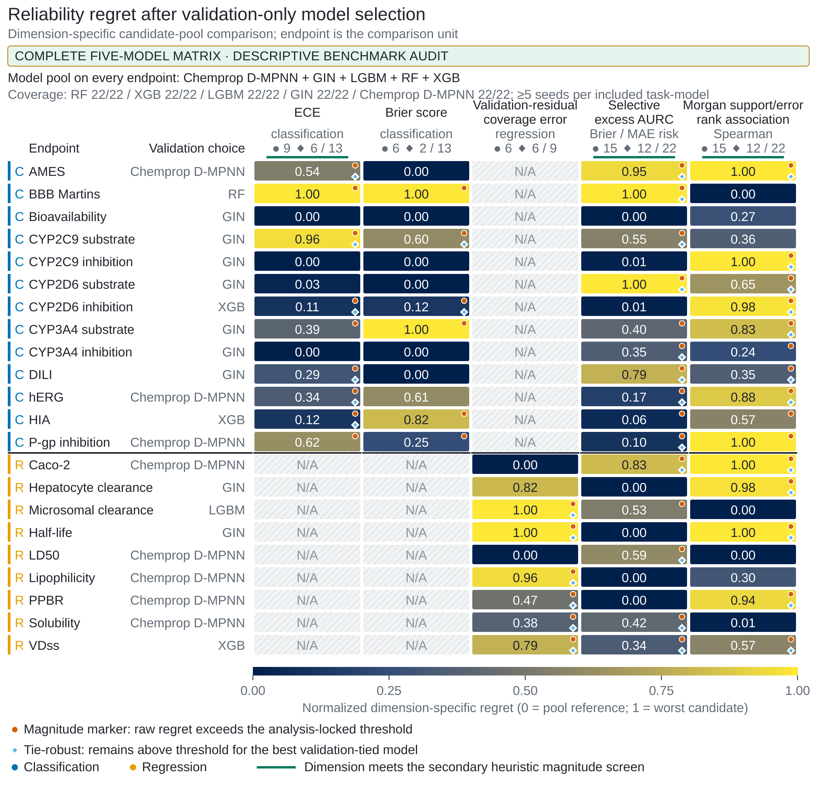
Figure 2. Conditional reliability contrasts by maximum training-set similarity at the primary threshold of 0.5.
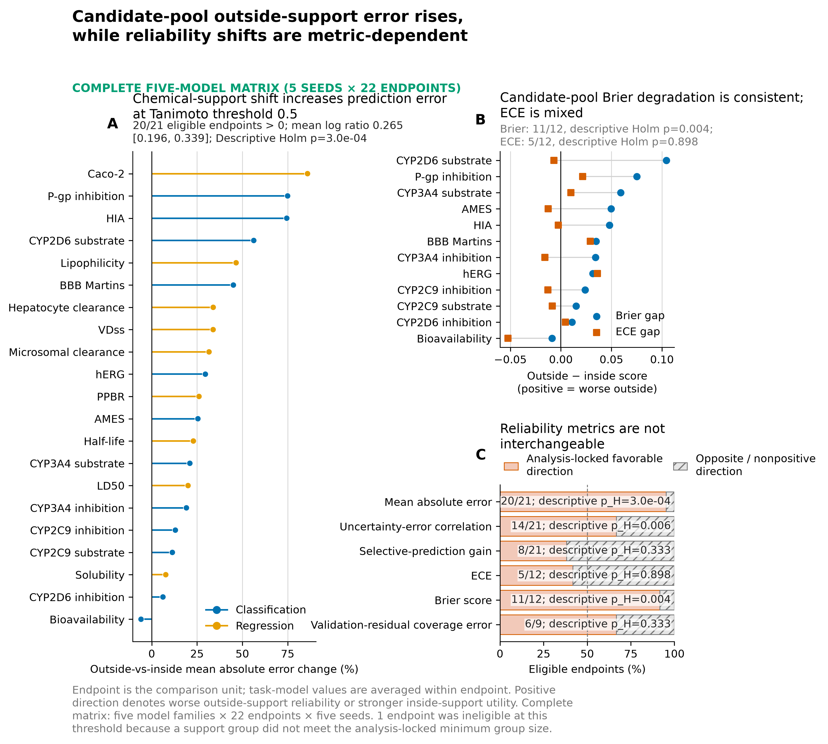
Figure 3. Endpoint-level calibration gains and failures for isotonic and Platt scaling.
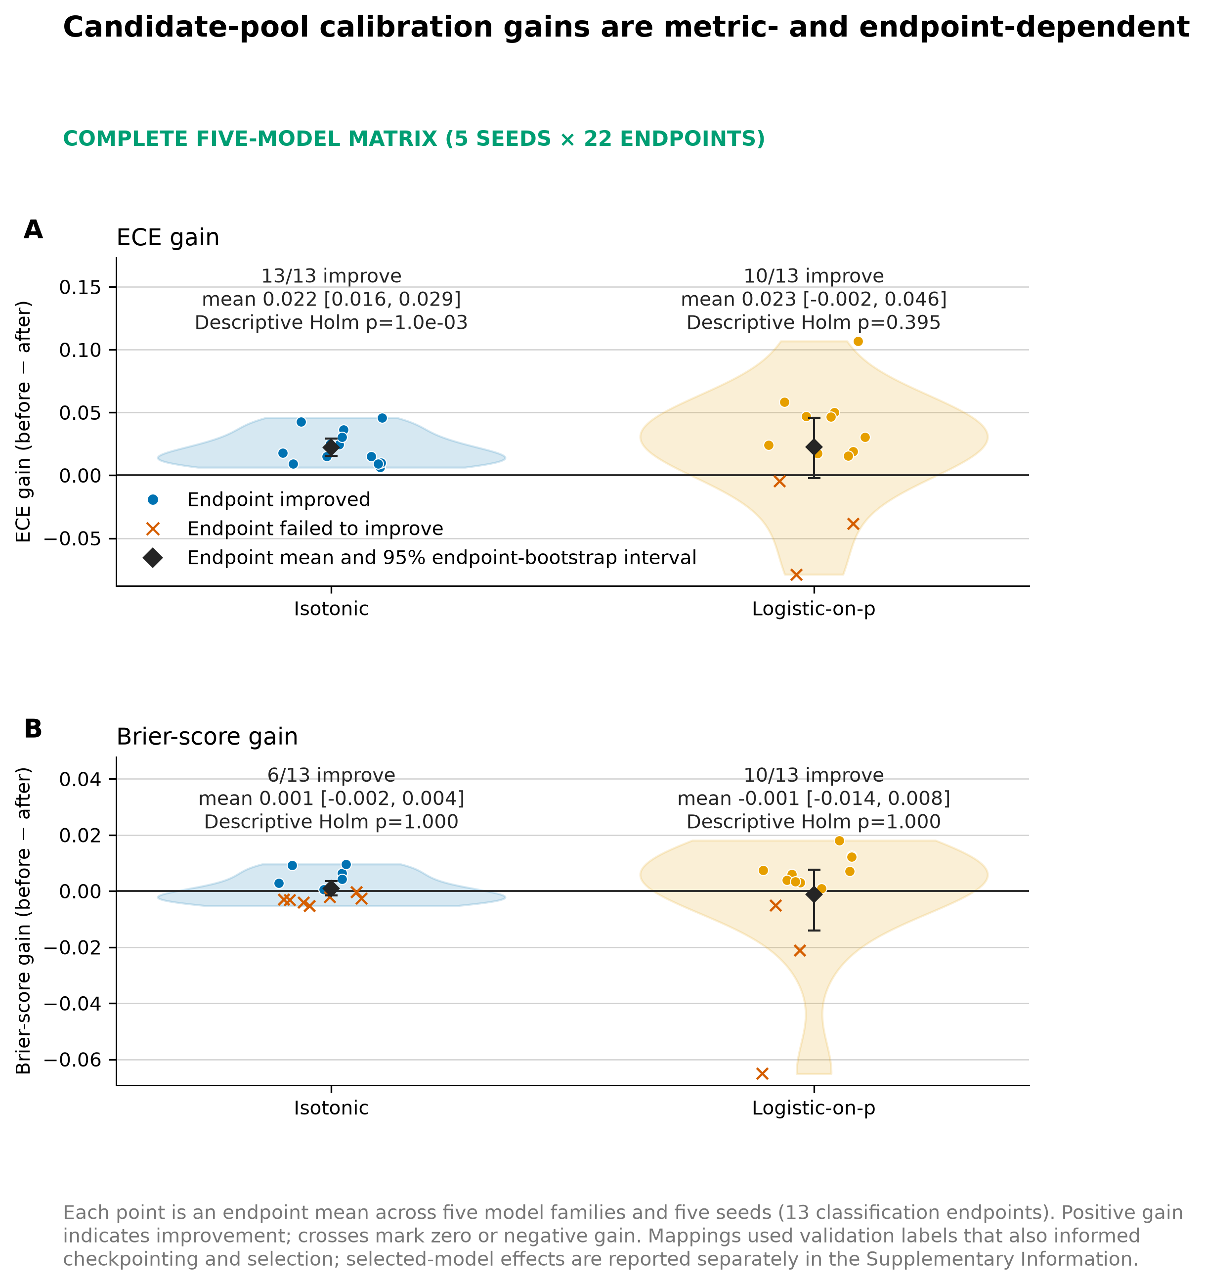

Statements and Declarations
Author information: Huajian Jiang (sole, first and corresponding author), College of Computing and Data Science, Nanyang Technological University, Singapore. Correspondence: jian0157@e.ntu.edu.sg. ORCID: 0009-0001-3992-2286.
Author contributions: Huajian Jiang: Conceptualization; Data curation; Formal analysis; Investigation; Methodology; Software; Validation; Visualization; Writing -- original draft; Writing -- review and editing. Confirm or revise before submission.
Funding: No funding was received for conducting this study or preparing this manuscript.
Competing interests: The author declares no relevant financial or non-financial competing interests.
Ethics approval and consent to participate: Ethics approval and informed consent were not applicable because this retrospective computational study used public chemical and assay data and involved no human participants, identifiable personal data, or human materials.
Data and code availability: The Zenodo v1.0.0 record (DOI 10.5281/zenodo.21374237) provides code, sanitized configurations, de-identified prediction views, and audit outputs for the original 22-endpoint TDC core study. It excludes raw TDC data, source structures and labels, and model checkpoints; it also does not include the later broad external-transport, B3DB, or focused CYP2D6 diagnostic packages described in this manuscript. The manuscript reports selected summary results from those diagnostics, but their run-level code and artifacts are not covered by this DOI. Confirm the final public archive/supplementary route, licensing, and exact contents before submission. Exact replay of the core study requires an authorized matching TDC snapshot and the documented split protocol.
AI-use disclosure: Generative AI assisted with study-code development and review, literature and evidence organization, document preparation, and language editing. Before submission, list each tool and version, confirm the actual tasks performed, and verify the disclosure against the selected journal policy. The human author must independently verify the code, analyses, references, and manuscript and retains responsibility for the submitted work. Confirm or revise; no final approval is inferred.
Acknowledgements: None.

