- npm install yo –g
- npm install generator-react-webpack
- 进入文件夹，新建项目 yo react-webpack gallery-by-react
- 跑项目 npm run serve
- 打包项目 npm run dist
- git commit –A git commit git push
- git subtree push –prefix=dist origin gh-pages
- 图片排布
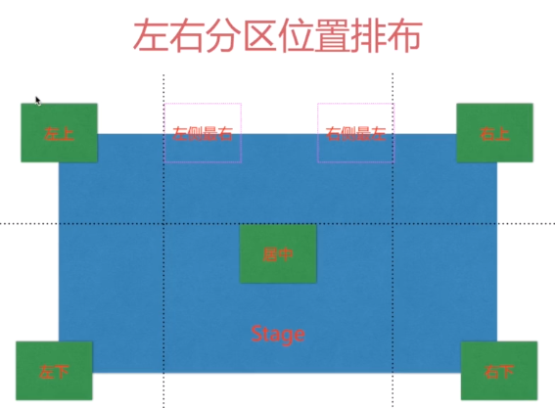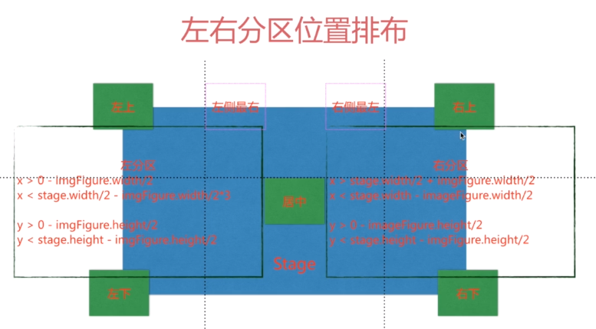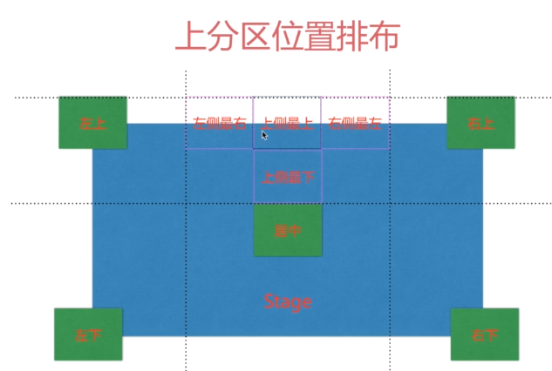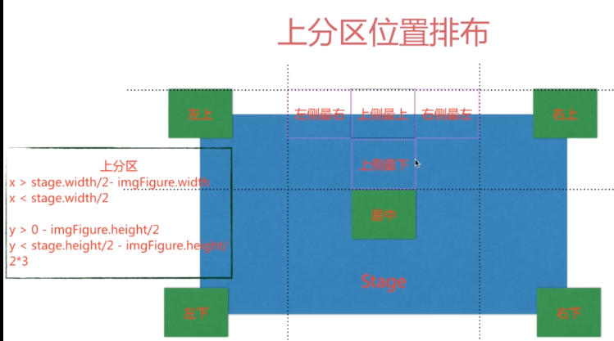

- 首先按快捷键windows+R，在运行框里输入cmd，如图所示，进入黑色界面后，输入netstat -ano，查看端口。
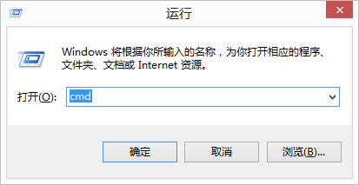
- 找到8080端口，查看正在运行程序的pid，如图所示。
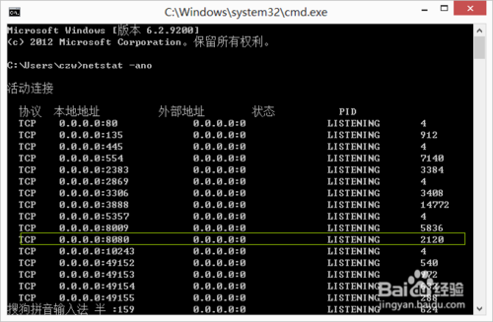
- 回到桌面，从控制面板进入任务管理器，如图所示会显示正在运行的程序。
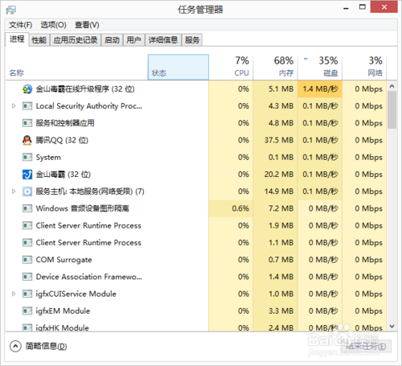
- 从进程里看程序是看不到PID的，只有点右侧的详细信息，才可以看到PID，如图所示。
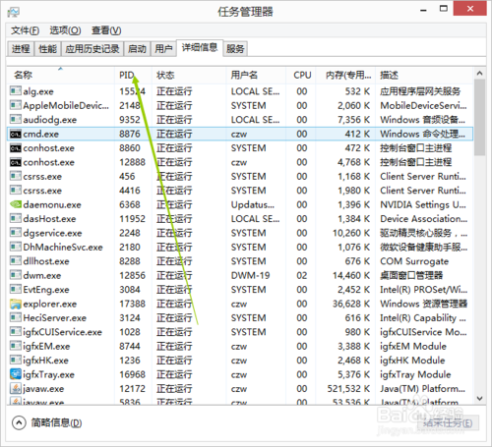
- 5
找到相同的PID进程，点结束进程就可以了，这样8080端口就不会再被占用了。

Setting up projects
# Create a new directory, and `cd` into it:
mkdir my-new-project && cd my-new-project

# Run the generator
yo react-webpack
Please make sure to edit your newly generated package.json file to set description, author information and the like.

Generating new components
# After setup of course :)
# cd my-new-project
yo react-webpack:component my/namespaced/components/name
The above command will create a new component, as well as its stylesheet and a basic testcase.

Generating new stateless functional components
yo react-webpack:component my/namespaced/components/name --stateless
Stateless functional components where introduced in React v0.14. They have a much shorter syntax than regular ones and no state or lifecycle methods at all. Please read the React 0.14 release notes to get more information about those components.
Note: You will still be able to set properties for stateless components!

Adding PostCSS plugins
If you have enabled PostCSS at generation time, install your PostCSS plugins via npm and require it in postcss function incfg/base.js.
Example for autoprefixer:
cd my-new-project
npm install autoprefixer
Require in cfg/base.js
...
postcss: function () {
return [
require('autoprefixer')({
browsers: ['last 2 versions', 'ie >= 8']
})
];
}
...

Usage
The following commands are available in your project:
# Start for development
npm start # or
npm run serve

# Start the dev-server with the dist version
npm run serve:dist

# Just build the dist version and copy static files
npm run dist

# Run unit tests
npm test

# Auto-run unit tests on file changes
npm run test:watch

# Lint all files in src (also automatically done AFTER tests are run)
npm run lint

# Clean up the dist directory
npm run clean

# Just copy the static assets
npm run copy

Naming Components
We have opted to follow @floydophone convention of uppercase for component file naming e.g. Component.js. I am open to suggestions if there is a general objection to this decision.

Modules
Each component is a module and can be required using the Webpack module system. Webpack uses Loaders which means you can also require CSS and a host of other file types. Read the Webpack documentation to find out more.

Props
Thanks to Edd Hannay for his Webpack optimisations, my local merge and testing meant his additions lost his signature (my fault, sorry). So, big thanks Edd.

Contribute
Contributions are welcomed. When submitting a bugfix, write a test that exposes the bug and fails before applying your fix. Submit the test alongside the fix.

Running Tests
npm test or node node_modules/.bin/mocha

