**React16+React-Router4 从零打造企业级电商后台管理系统**

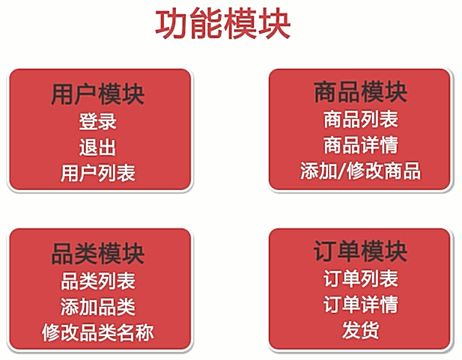



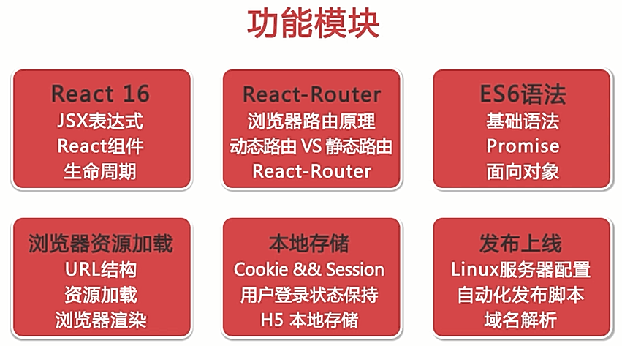

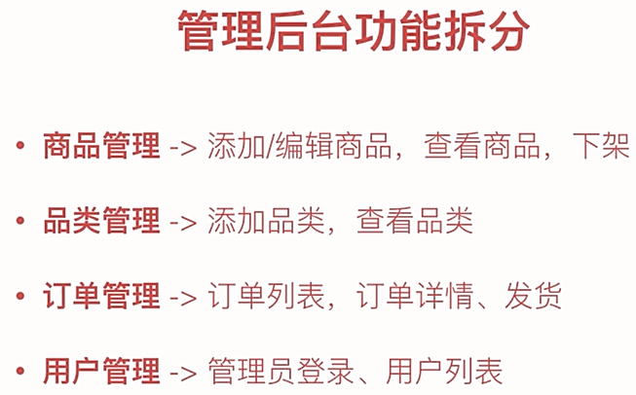

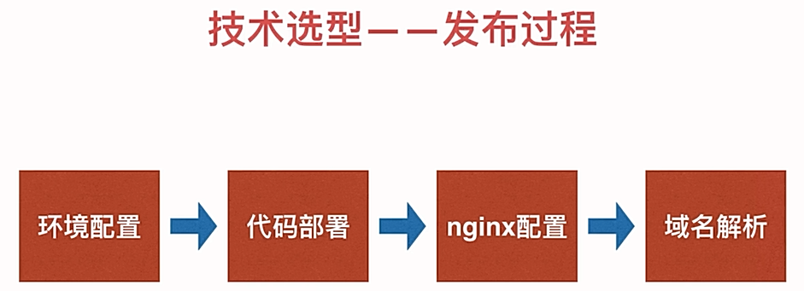

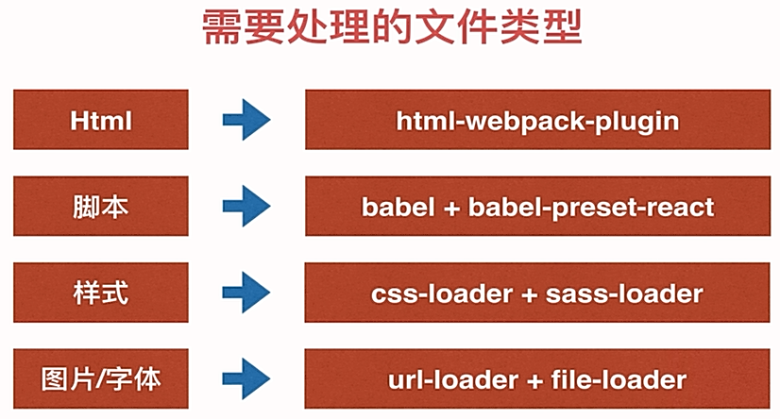

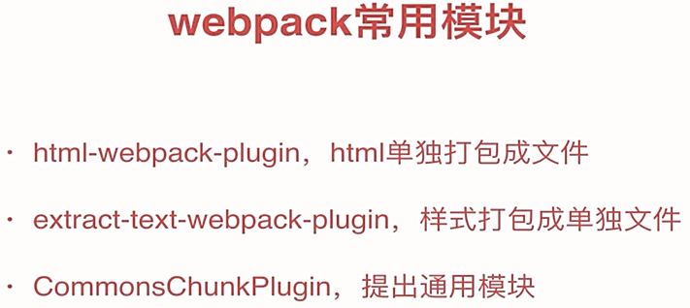

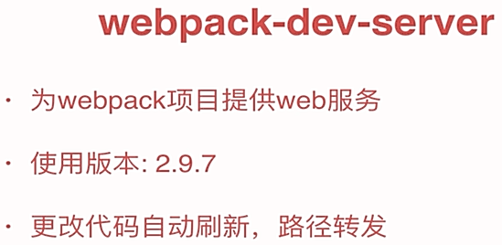

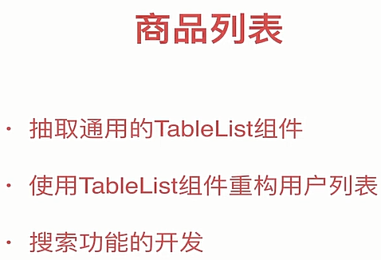

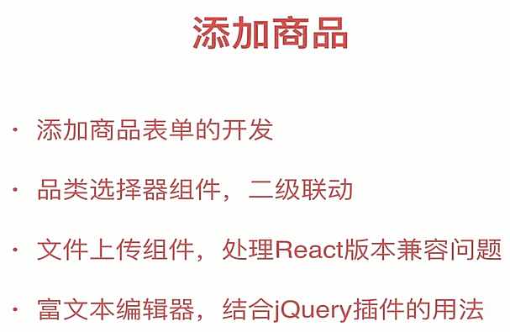

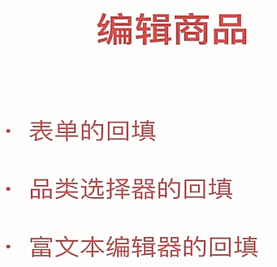

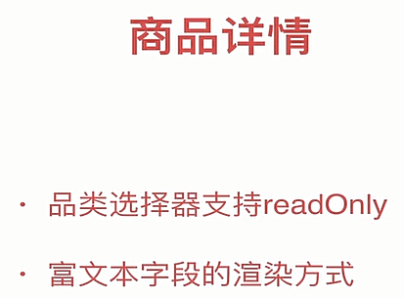

npm init

npm install webpack webpack-cli –-save-dev

npm install html-webpack-plugin –save-dev

npm install babel-loader babel-core babel-preset-env –save-dev

npm install babel-preset-react –save-dev

npm install react react-dom –save-dev

npm install style-loader css-loader –save-dev

npm install extract-text-webpack-plugin@next --save-dev

npm install sass-loader node-sass --save-dev

npm install file-loader url-loader --save-dev

npm install font-awesome --save-dev

npm install webpack-dev-server --save-dev

npm install react-router-dom --save-dev

npm install rc-pagination --save-dev

npm install prop-types –-save-dev

npm install simditor --save-dev 富文本编辑器

后台接口地址：https://gitee.com/imooccode/happymmallwiki/wikis/Home