AIV-200 Integration Test

2021-12-07 | Establish this document | YY

Date | Test Attendees | Test Environment
2021-12-07  2021-12-10 | Silicon Valley: Yusuke Yakuwa, Zhenyu Wang | TX2  iPad  SITE-B

Date | Name | Confirmation
2021-12-10 | Yusuke Yakuwa
2021-12-10 | Zhenyu Wang

Table 1. Test system configuration
No. | Description | Note
1. Server Software | 1.1 Jetpack  1.2 L4T version R32.5.1 (Ubuntu18.04)  1.2 Login with nvidia/nvidia  1.3 OS Time zone is PST  1.4 OS Time is correct  1.5 Python version 3.6.9  1.6 OpenCV version 4.  1.7 Tensorflow version 2.3.1  1.8 CUDA version 10  1.9 ngrok; provides HTTP access on public network, the Internet | (2021-12-7 YY)  1.4 Browser access and Mobile app can not set TX2 time clock and zone
2. Server Hardware | 2.1 TX2 model xxxxxxxx
3. Mobile App Software | 3.1 iOS 15.0
4. Test mobile device | 4.1 iPad (8th generation) model MYLD2LL/A
5. Program | 5.1 Python programs are cythonized

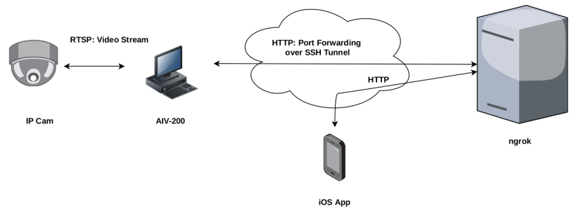
Figure1: Integrate Test Environment

Table 2. Test cases.
No. | Test Case | Date | Results | Note
1. Home | (1) Home page is shown
2. Cat 3: Intrusion Detection | (1) Intrusion Detection is working  (2) Concatenating video stream  (3) Drawing ROI (rectangle) is available  (4) Sending SMS is available  (5) Event is recorded in DB
3. Live View | (1) Live View is working  (2) Concatenating video stream
4a. Summary | (1) Show the list, Event, Event Start Time  (2) Navigate to detail page
4b.  Summary  Detail | (1) Show Event, Camera Name, Location, Face ID(Facial Recognition), First name(Facial Recognition), Last Name(Facial Recognition), Event Start Time, Event End Time, SMS Receivers, SMS Receivers NG  (2) CSV downloading contains Event, Camera Name, Location, Face ID(Facial Recognition), First name(Facial Recognition), Last Name(Facial Recognition), Event Start Time, Event End Time, SMS Receivers, SMS Receivers NG  (3) Downloading JPG photo  (4) Downloading AVI video
5. Settings | (1) Show the settings list; SMS Record, Camera Information, Alert Receiver, SMS Settings, Server Settings  (2) Navigate to SMS Record  (3) Navigate to Camera Information  (4) Navigate to Alert Recever  (5) Navigate to SMS Settings  (6) Navigate to Server Settings
6a. SMS Record | (1) Clicking “Search” button shows the result  (2) Navigate to SMS Record Detail
6b. SMS Record | (1) Show Date, Camera Name, Send Result, Receiver Name, Phone Number, Message, SID
7a. Camera Settings  List | (1) Show the camera list  (2) Navigate to “Create Camera Information” page  (3) Navigate to “Edit Camera Information”
7b. Create Camera Information | (1) Create new camera information;  Name, Short Name, URL, Location, (PTZ) IP Address, (PTZ) TCP Port, (PTZ) User Name, (PTZ) Password, Enabled Switch
7c. Edit  Camera Settings | (1) Update camera information;  Name, Short Name, URL, Location, (PTZ) IP Address, (PTZ) TCP Port, (PTZ) User Name, (PTZ) Password, Enabled Switch  (2) Delete the camera information  (3) If the Enable switch is off, the camera button or check box will not be shown in AI features or Live View  (4) “Camera PTZ” button navigates to “Camera PTZ”
7d. Camera PTZ | (1) Live View video streaming  (2) Up-Left button is working  (3) Up button is working  (4) Up-Right button is working  (5) Left button is working  (6) Right button is working  (7) Down-Left button is working  (8) Down button is working  (9) Down-Right button is working  (10) Zoom In button is working  (11) Zoom out button is working
8a. Alert  SMS Receiver  List | (1) Show the alert receiver list  (2) Navigate to “Create Alert SMS Receiver“  (3) Navigate to “Alert SMS Receiver Detail”
8b. Create Alert  SMS Receiver | (1) Create new receiver information;  Name, Phone Number, Sending Switch
8c. Edit Alert  SMS Receiver | (1) Update receiver information;  Name, Phone Number, Sending Switch  (2) Delete receiver information  (3) If the “Send” switch is off, the Alert SMS will not be sent to the receiver
9. SMS Settings | (1) Twilio Account information can be saved;  Twilio Account SID, Auth Token, Phone Number, AIV-200 URL

(END)

