

|  |  |  |  |
| --- | --- | --- | --- |
| Date | Description | Version | Created By |
| 10/29/19 | This document consists of the connections of the non -contact temperature sensor with the RJ45 connector and also the images to show the mounting of the sensor on prototype PCB Board. | 1.0 | Deepak Shivani |

Figure 1: Top view of the prototype board

|  |  |  |
| --- | --- | --- |
| S.NO | RJ45 | AMG88 |
| 1. | Pin 1 | VIN |
| 2. | Pin 3 | GND |
| 3. | Pin 5 | SDA |
| 4. | Pin 7 | SCL |
| 5. | Pin 6 | INT |

Table 1. Pin Connections

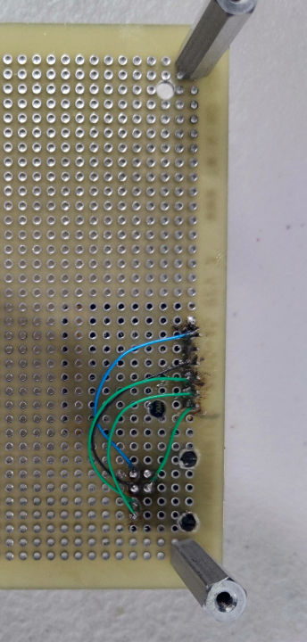

Figure 2. Back view of the Prototype Board

1. Description:

1.1 Start by choosing a stable work environment since drilling will be involved.

1.2 Mark the points on the prototype board based on the set points of the RJ45 connector.

1.3 Use drilling machine to make the holes on the marked set points. Remember to gradually increase the drill bit size while drilling in order to avoid damage. Start with slickest drill bit and move just a maximum of 3 or 4 points up.

1.4 Once the holes are made, bend the unwanted pins on the RJ45 connector.

1.5 Place the components (RJ45 connector and AMG88) on the prototype board as per the space available.

1.6 Use soldering iron to solder the equipment on the prototype board based on the connections shown in table 1.

END