AIV100 Product Pricing
CTI Plus Corporation
3679 Enochs Street
Santa Clara, CA 95051
email: harry.li@ctione.com
2019-7-15 | Establish this document | HL
2019-7-17 | Check the naming convention | HL
2019-10-23 | Update the Server Line | HL, GS

Table 1. The Intelligent Security and Surveillance Solutions
Product ID | Name | Description | Unit price ($)
CTI-AIV100- GPUSVR | AI GPU GPUSVR  Server | High Performance GPU-AI-Vision Server:  (1) GPU engine;  (2) capable to provide all AIV100 functions;  (3) 7 category functions (total up to 27 features). The combination of the any features can be mixed per need and resources has to be calculated based on the feature.  (4) Including 8 IP cameras (Ethernet based); | $39800
CTI-AIV100- GPUSVR |  | Including 8 IP cameras; | Free
CTI-AIV100- GPUSVR | AIV100 AI GPU Server Software | Pres-installed for standard AI functions | Free
CTI-AIV100- GPUSVR | AIV100 AI Server Pack1 | Optional for supervising AIV100 AI GPU Server; generates alarms to the management if the AI GPU GPUSVR Server program is down. | Free
CTI-AIV100- NVDSVR | AI Edge GPUNVD server | Embedded small form factor AI-Vision Server with 128 GPU processors and 4 RISC CPU, for AIV100 category 4 and 5 functions. | (till Q2 2020)
CTI-AIV100- CAMSVR | Smart IP Camera with AI functions | 1280x720 @ 30 FPS, rtsp streaming IP camera integrated with (1) intrusion detection, (2) displacement; (3) fire lane obstruction detection (no pedestrian) | $2599
CTI-AIV100-EMDNOD | Embedded controller | Embedded access control unit:  (1) Light and sound alarm interface;  (2) Up to 8 channel Access control signals;  (3) Interface to gate/door access lock (from 8 channel access control signals);  (4) Interface to lighting control switches (from 8 channel access control signals); | $11000
Harry to do:
1. Wifi
1.1 Wifi system configuration, see figure below from document
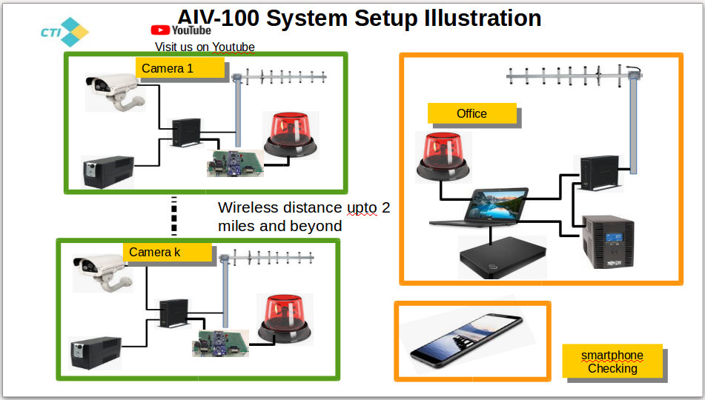

Figure 1.1. WIFI solution.

1.2 Pricing

2. mobile network solutions
(not now, phase 2)

3. additional features increamental cost???
Additional feature cost can be calculated incrementally, the guideline is (1) for the total features to be supported by GPUSVR, percentage formula is given for each features, if the existing GPUSVR with additional resources, then the added new feature will be charged $450 each; (2) if the existing GPUSVR without additional resources, then additional GPU engine blade (model 1060) will have to be added to the server box, in this case the cost will be $449; in case, simply adding the additional GPU engine blade (model 1060) can not support the needed features, then additional GPUSVR will have to be added.

II. The General Capabilities

Category | Features | Note
CAT 1 face recognition based attendance management | 1.1. Employee attendance based on facial detection  1.2. Contractor attendance based on facial detection  1.3. Workers attendance based on facial detection  1.4. Customers service attendance, check in based on facial detection  1.5. Visitors facial registration;  1.6. Visitors gender detection, and age detection  1.7. Access control with snap shot of face photos and to establish face ID database with facial detection and tagging.  1.8. Alarm and messaging for matching up blacklisted persons based on facial detection | Record facial ID, snap shot of the face photo in a data base, and time of the day
Summary:
8 features; supports up to 4 streams (4 IP CAMs); 25% per feature
CAT 2 Access control and movement tracking | 2.1. First time visitor facial photo capture and tagging, facial detection and gender detection;  2.2. Entry and departure recording based on facial detection;  2.3. Statistical data for any and all of the feature detection functions based on facial ID;  2.5. People movement counting, their numbers, locations, time;  2.6. Counting number of visitors, groups, and time, location; | 2.1 ( Capture facial image of stranger, tig it with an ID, identify age, gender, place time stamp, and location information based on IP location.
Summary:
6 features;
supports up to 2 streams (2 IP CAMs) Check for update
CAT 3 Displacement and intrusion detection, theft prevention | 3.1. Intrusion detection for theft prevention;  3.2. Receptionist area object displacement detection and warning;  3.3. Object displacement detection and classification for warehouse, offices, court yard, parking space; | 3.1 Draw a region of interest around the object, name each region.  3.2 An alarm will be triggered if the object is moved;  3.3 The timer for triggering an alarm is reset when the object is moved back;  3.4 Classify the event category, camera ID, name of the region of interest, time, snapshot, and video clips will be recorded.
Summary:
3 features;
supports up to 8 streams (8 IP CAMs) Check for update
CAT 4 Cellphone use and sleeping detection | 4.1. Employee absence detection for either standing post or sitting post;  4.2. Cellphone use detection and alarm;  4.3. Sleeping detection; | 4.1 Return the event category, employee ID, event time, Camera ID, snapshot and short video.  4.2 User define timer for triggering alarm for employee absence detection.
Summary:
3 features;
For 4.1 supports up to 4 streams (4 IP CAMs)
for 4.2 and 4.3 Check for update
CAT 5  Employee Attendance management | 5.1. Employee absence detection in front desk at customer service center. | 5.1 Return event category, employee ID, event time, camera ID, snapshot.  5.2 User defined timer for triggering alarm for employee absence.
Summary:
1 features;
supports up to 4 streams (4 IP CAMs)
CAT 6  High risk behavior detection, trash detection | 6.1. Noncompliance detection, including not standing up detection;  6.2. Detection of high risk behavior, including holding a knife, stick, etc;  6.3. Trash detection, send message to staff for action, set automated alarm when trash detected. | 6.1 Return event category, employee ID, event time, camera ID, snapshot, video
Summary:
3 features;
For 6.3 Level 1 supports up to about 6 streams (6 IP CAMs) check???; Level 2 supports up to about 4 streams (4 IP CAMs)
For 6.1 supports up to about 4 streams (4 IP CAMs)
For 6.2 supports up to about 1-2 streams (1-2 IP CAMs) check???
CAT 7  Flame detection | 7.1. Flame detection, once detected then will set an alarm, send message, record snapshot and short video;  7.2 Fire lane obstruction detection;  7.3 Garbage detection;
Summary:
3 feature;
for 7.1 feature, supports up to 4 streams (4 IP CAMs)
for 7.2 and 7.3 features, supports up to 2 streams (2 IP CAMs), check???
 | Total: 27 features for all CATs.

Appendix A.

- AIV100 Quotation on GPUSVR and NVDSVR

1.1 One IP Camera Streaming-One Function on GPUSVR and NVDSVR
note: most of the data was older version data in August 2019, new updated features is given in document 101. Internal use only.

# | Functions | GPUSVR | NVDSVR | CAMSVR
1 | CV100_FACREC  (Facial Detection) | $2550 per function | $350 per function | $110 per function
2 | CV100_BHRDET  (Behaviour  Detection) | $2550 per function | $350 per function | N/A
3 | CV100_GENDET  (Gender Detection) | $2550 per function | $350 per function | N/A
4 | CV100_INTDET  (Illegal Intrusion) | $2550 per function | $350 per function | $110 per function
5 | CV100_LIPDET  (License Plate Detection) | $2550 per function | $350 per function | N/A

1.2 One IP Camera Streaming - Multiple functions on GPUSVR and NVDSVR
note: most of the data was older version data in August 2019, new updated features is given in document 101. Internal use only.
Run with 2 functions:

# | Functions | GPUSVR | NVDSVR | CAMSVR
1 | CV100_FACREC  (Facial Detection) | $1785 per function | $245 per function | N/A
2 | CV100_BHRDET  (Behaviour  Detection) | $1530 per function | $210 per function | N/A
3 | CV100_GENDET  (Gender Detection) | $1275 per function | $175 per function | N/A
4 | CV100_INTDET  (Illegal Intrusion) | $1530 per function | $210 per function | N/A
5 | CV100_LIPDET  (License Plate Detection) | $1530 per function | $210 per function | N/A

1.3 Multiple IP Camera Streaming - One function on GPUSVR and NVDSVR

1.3.1 GPUSVR
# | Functions | GPUSVR
# | Functions | 1 Stream | 2 Streams | 3 Streams | 4 Streams | 5 Streams
1 | CV100_FACREC  (Facial Detection) | $2550 per stream | $1275 per stream | $850 per stream | $637.5 per stream | $510 per stream

1.3.4 NVDSVR
# | Functions | NVDSVR
# | Functions | 1 Stream | 2 Streams
1 | CV100_INTDET  (Illegal Intrusion) | $350 per stream | $175 per stream

Note: CAMSVR cannot run multiple IP Cameras Streaming.

- CV100 Profiling on NVDSVR

Profiling by | Date | Test Leader | Stage
Minh Duc Ong | 7/23/2019 | Dr. Harry Li | 2.0

2.1.1 Profiling with 1 stream

Observation: 1 function for each stream.
No pedestrian detection due to software support.

# | Functions | CPU Utilization | GPU Utilization | Bandwidth | Streaming | FPS IP Cam | FPS Regular Cam
1 | CV100_FACREC  (Facial Detection) | 56.25% | 3.6/3.9 =92%  Swap: 1.6/6 | 890KB/s Max | 1 | 1 | 4.5
2 | CV100_BHRDET  (Behaviour  Detection) | 46.25% | 3.2/3.9 = 82%  Swap: 0/6 | 1500KB/s Max | 1 | 3 | 4
3 | CV100_GENDET  (Gender Detection) | 86.25% | 3/3.9=77%  Swap: 0/6 | 200KB/s Max | 1 | 3 | 4.5
4 | CV100_INTDET  (Illegal Intrusion) | 86.25% | 1.2/3.9=30.76%  Swap: 0/6 | 2100KB/s Max | 1 | 0ROI: 30  1ROI: 22  2ROI: 18  3ROI: 12 | 0ROI: 120  1ROI: 90  2ROI: 60  3ROI: 35
5 | CV100_LIPDET  (License Plate Detection) | 53.75% | 1.5/3.9=38.46%  Swap: 0/6 | 551KB/s Max | 1 | 1 | 5

2.1.2 Profiling with 2 IP Camera streams

Observation: Other functions are frozen when the number of streaming is more than 2

# | Functions | CPU Utilization | GPU Utilization | Bandwidth | Streaming | FPS IP Cam
1 | CV100_INTDET  (Illegal Intrusion) | 100% | 1..6/3.9 =40%  Swap: 1.6/6 | 890KB/s Max | 2-3 | 0ROI 2streams: 23fps  0ROI 3streams: 12fps  1ROI 2streams: 10fps  1ROI 3streams: 6fps

2.1.3 Profiling with multi-function - 1 IP Camera stream

Observation:
- Facial cannot run with other AI program except intrusion detection, because of GPU memory not enough.
- Intrusion detection can run with any AI program.

# | Functions | CPU Utilization | GPU Utilization | Bandwidth | Functions | FPS IP Cam
1 | CV100_FACREC  (Facial Detection)  CV100_GENDET  (Gender Detection) | N/A | Resource Exhausted | N/A | N/A | N/A
2 | CV100_FACREC  (Facial Detection)  CV100_INTDET  (Illegal Intrusion) | 99% | 3.4/3.9= 87%  Swap: 2/6 | 2885KB/s Max | 2 | FACREC: 1fps  INT_DET: 18fps
3 | CV100_GENDET  (Gender Detection)  And  CV100_BHRDET  (Behaviour  Detection) | 98% | 3.6/3.9=92%  Swap:1.8/6 | 890KB/s Max | 2 | GENDET: 2 fps  BHRDET: 3 fps
4 | CV100_BHRDET  (Behaviour  Detection)  And  CV100_LIPDET  (License Plate Detection) | 90% | 3.3/3.9= 84%  Swap: 0.53/6 | 1368KB/s Max | 2 | BHRDET: 3 fps  LIPDET: 1 fps
5 | CV100_GENDET  (Gender Detection)  And  CV100_BHRDET  (Behaviour  Detection)  CV100_INTDET  (Illegal Intrusion) | 98% | 3.6/3.9=92%  Swap:2.1/6 | 2230/s Max | 3 | GENDET: 1 fps  BHRDET: 2 fps  INTDET: 7 fps

- CV100 Profiling on GPUSVR:

Profiling by | Date | Test Leader | Stage
Prashanth Rajasekar | 7/12/2019 | Dr. Harry Li | 2.0

3.1 Profiling with 1 Stream:
GPU Utilization Cmd : nvidia-smi
Bandwidth Utilization Cmd : slurm -z -i eth0

Functions | CPU Utilization | GPU Utilization | Bandwidth
CV100_FACREC | 27% | 5.957/6.078 = 98% | 190KB/s Max
CV100_BHRDET | 32.5% | 5.909/6.078 = 97% | 220KB/s Max
CV100_GENDET | 15.8% | 6.007/6.078=98% | 200KB/s Max
CV100_INTDET | 20% | 0.578/6.078=9.5% | 120KB/s Max
CV100_PEDDET | 22% | 1.030/6.078=16.9% | 191.02KB/s Max
CV100_FACREC
CV100_PEDDET
CV100_INTDET

3.2 Facial Recognition profiling with 5 IP Camera Streams

3.2.1 Profiling Result

TotalCams | IPCAM_address | CPU | GPU
1 | 192.168.1.61 | 25% | 96%
2 | 192.168.1.61  192.168.1.62 | 26% | 96%
3 | 192.168.1.61  192.168.1.62  192.168.1.63 | 27% | 96%
4 | 192.168.1.61  192.168.1.62  192.168.1.63  192.168.1.64 | 27% | 97%
5 | 192.168.1.61  192.168.1.62  192.168.1.63  192.168.1.64  192.168.1.65 | 28% | 97%

(END)

