6 DoF Robot Unity
How to train your Robot Arm?. Training a 6 axis robot arm using Unity… | by Raju K | XRPractices | Medium
rkandas/RobotArmMLAgentUnity: Training 6 axis robot arm Inverse kinematics using Unity ML Agents (github.com)

- Actions: An array of actions – each action in the array represents the degree of rotation.
We have 5 types of actions in total: 1 Rotate and 4 Bends.

  - Axis 1: is the bottom-most axis and can rotate 0 to 360 degrees [ Rotate ]

armAxes[0].transform.localRotation =
Quaternion.AngleAxis(angles[0] * 180f, armAxes[0].GetComponent<Axis>().rotationAxis);

  - Axis 2: is the first bend axis and the range is -90 to 90 degrees [Bend]
armAxes[1].transform.localRotation =
Quaternion.AngleAxis(angles[1] * 90f, armAxes[1].GetComponent<Axis>().rotationAxis);

  - Axis 3: second bend axis and the range is -120 to 120 degrees [Bend]
armAxes[2].transform.localRotation =
Quaternion.AngleAxis(angles[2] * 180f, armAxes[2].GetComponent<Axis>().rotationAxis);

  - Axis 4: third bend axis and the range is -90 to 90 degrees [Bend]
armAxes[3].transform.localRotation =
Quaternion.AngleAxis(angles[3] * 90f, armAxes[3].GetComponent<Axis>().rotationAxis);

  - Axis 5: fourth bend axis and the range is -90 to 90 degrees [Bend]
armAxes[4].transform.localRotation =
Quaternion.AngleAxis(angles[4] * 90f, armAxes[4].GetComponent<Axis>().rotationAxis)

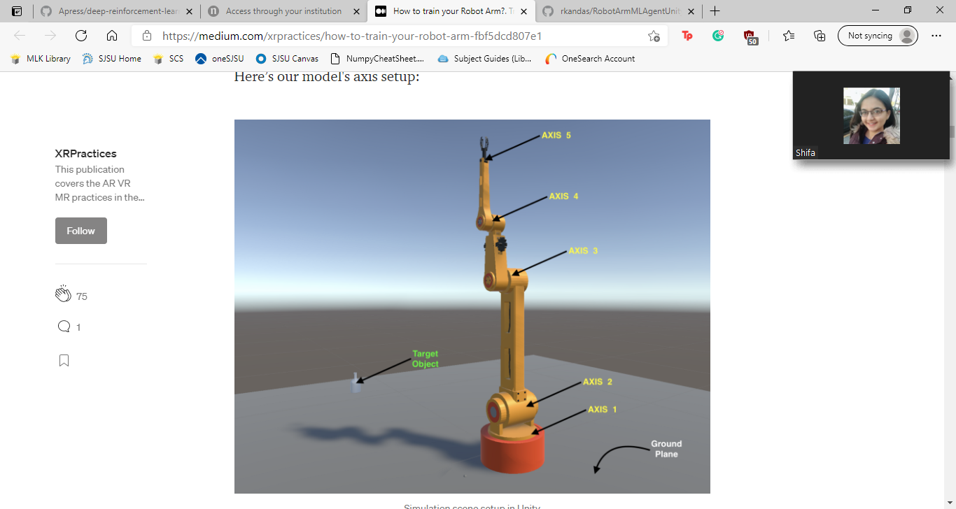

2. States: 7 types of states

- sensor.AddObservation(angles);

- sensor.AddObservation(transform.position.normalized);

- sensor.AddObservation(nearestComponent.transform.position.normalized);

- sensor.AddObservation(endEffector.transform.TransformPoint(Vector3.zero).normalized);

- sensor.AddObservation(toComponent.normalized);

- sensor.AddObservation(Vector3.Distance(nearestComponent.transform.position,endEffector.transform.TransformPoint(Vector3.zero)));

- sensor.AddObservation(StepCount / 5000);

3. Reward
- When the arm hits the ground — Hefty Penalty (-1) and end episode
- When the arm reaches the target — Hefty Reward (+1) and end episode
- When the arm reaches closer to the target — Marginal reward (the difference in distance as reward)
- When the arm moves far from the target — Marginal Penalty (how far is it from the target as penalty)

