PYTHON API for CAMSVR2
CTI One Corporation

2020-4-16 | Add API Section | HL

Location of the document
/media/harry/easystore/backup-2020-2-15/CTI0/3proejcts/3-8-smart-tech/3-8-4-huaYuan/3-8-4-6-products/CAMSVR-3-8-4-6-1/manufacturing-camsvr3-8-4-6-1/camsvr-pack/$
https://github.com/hualili/robotics-open_abb/tree/master/ai-embedded

TABLE OF CONTENTS
I. BACKGROUND
II. THE SERIAL COMMUNICATION PROTOCOL
2.1. The space time diagram description of the communication
2.2. The communication protocol
2.3. The communication protocol feature list 通讯协议明细

III. API FUNTIONS

I. BACKGROUND

The purpose of this document is:

1. To allow CAMSVR2 in Figure 1 communicate with a RS232 host which can be embedded systems, single board computer, PC, laptop for example, as long as the RS232 host is equipped with the RS232 interface. The illustration of the CAMSVR2 and RS232 host is given below in Figure 2.

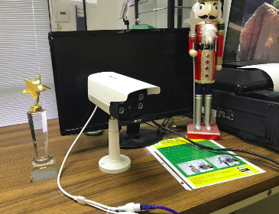

Figure 1.1. CAMSVR.

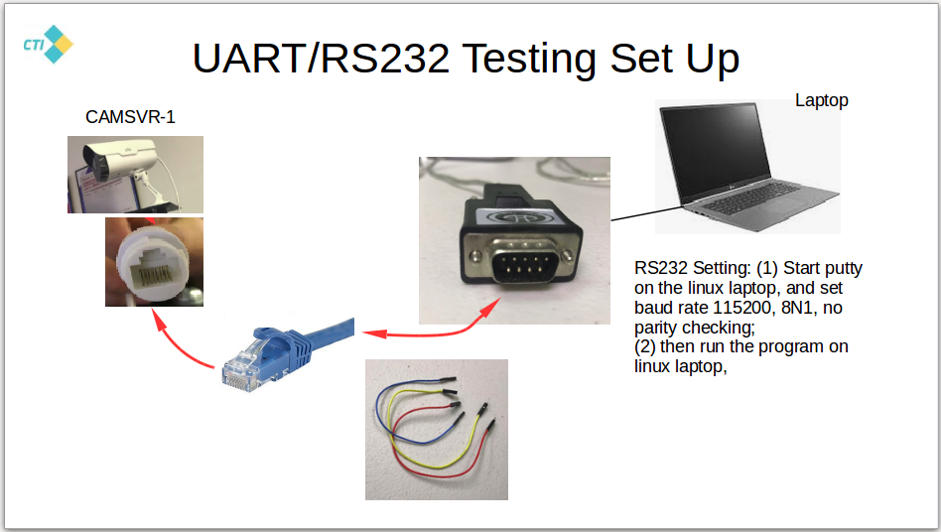

Figure 1.2a. The illustration of CAMSVR2 and a RS232 host communication. Reference: 105-1-camsvr2-testing-v2-hl-2020-3-3.odp

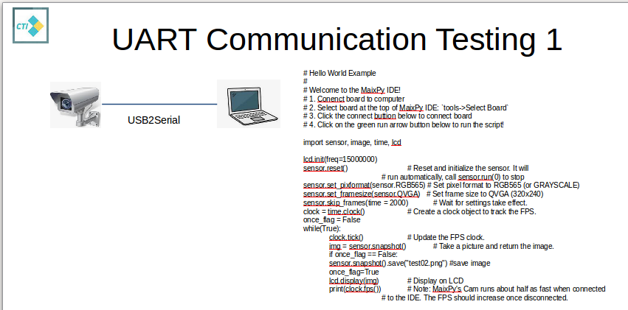

Figure 1.2b. The 2nd illustration of CAMSVR2 and a RS232 host communication. Reference: 112-0-serial-communication-MaixPy-v01.1-MO_2020-2-25.odp. Note the testing program listed in the above figure can be made available up request to our company's management.

II. THE SERIAL COMMUNICATION PROTOCOL

2.1. The space time diagram description of the communication

CAMSVR2 and a RS232 host are defined as follows:
1. CAMSVR2 is referred to as a RS232 client;
2. Laptop which is connected to CAMSVR2 and receives images from the CAMSVR is referred to as RS232 host.
3. The client and host is depicted in the following space-time diagram in Figure 2.1.
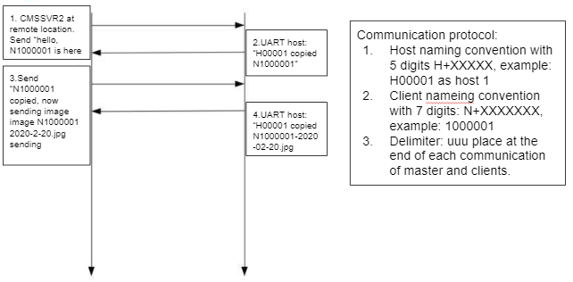
Figure 2.1 1. CAMSVR2 is referred to as a RS232 client, and a Laptop which is connected to CAMSVR2 and receives images from the CAMSVR is referred to as RS232 host. The client is on the left of this figure and the host is on the right, in the space-time diagram. Change: (HL: 2020-3-21) per meeting request on March 19 with Mr. He Jianhong from our customer, we change Host to HXXXXX to 5 digits, so the maximum number is H99999; and CAMSVR Client (Node) to NXXXXXXX, so the maximum number is N9999999.

2.2. The communication protocol

CAMSVR2 and a RS232 host communication protocol is defined based on the following condition:
1. The RS232 communication with baud rate of 115200, 8N1.
2. The communication between the client and the server is given in the following table, Table 2.1.

Table 2.1. CAMSVR2 and a RS232 host communication protocol.
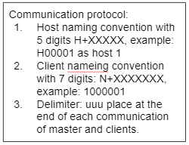
Change 1: (HL: 2020-3-21) (Note this change has been implemented throughout the entire document and the entire implemented source code as well). per meeting request on March 19 with Mr. He Jianhong from our customer, we change Host to HXXXXX to 5 digits, so the maximum number is H99999; and CAMSVR Client (Node) to NXXXXXXX, so the maximum number is N9999999.

Change 2: (HL: 2020-4-11) (Note this change has been implemented throughout the entire document and the entire implemented source code as well). Per technical leadership circle meeting on April 11 based on the system integration test and from the debugging need, we change the 32 bytes communication protocol between CAMSVR2 and the RS232 Host to the following:
(1) establish data frame with a header of 3 bytes with each byte bing a symbol '*', delimiter field of 3 bytes with each byte being a symbol '@', and padding symbol being 'u' for each byte. As illustrated in the following table.

Table Change2-(1) 32 bytes serial-communication protocol
Field | Description | Note
Start (3 byte) | ***
Payload (26 byte) | Padding uuu...u if needed | Maximum 26 bytes at time
End (3 byte) | @@@

Example: CAMSVR2 sends “Hello, this is N1000001”(23byte) with the serial-communication protocol defined above, we have

***(3)Hello, this is N1000001(23)uuu(3)@@@(3)

so the total number of bytes = 3 + 23 + 3 + 3 = 32.

2.3. The communication protocol feature list 通讯协议明细

Note: 1. The data is in ASCII format, each letter or digit takes 8 bits.

Table 2.2 The Communication protocol feature list 通讯协议明细

No. 编号 | Description 功能描述 | Note 备注
1. Heart beat signal (HRTSID) | Heart beat features:  (1) The CAMSVR2 sends the self identification signal (SID) at specified time interval (TIMSID), by default the TIMSID is 1 second, the user can set TIMSID from 1 second to 1000 seconds if prefers at the initialization process.  (2) The format of the self identification signal (SID) is given as follows, the length of SID: 23 bytes. HRTSID = DID + STI + TMS  DID + STI + TMS; e.g., detailed as follows:  DID (device ID, total 8 bytes ) +  STI( device status ID, 3 bytes) +  TMS (TimeStamp in the format of YYMMDDHHMMSS with 12 bytes)  For STI (HL 2020-3-21) STI = ACT, no error, system is alive; and  STI = ITR, intrusion is detected.  Example:  for CAMSVR2 number 1000001, STI(ACT, no error, active status), 2020 year, 03 month, 15 day, 23 hour, 56 minute, 21 second. so we have:  N1000001 (DID) +  ACT(STI) + 20 (year 2020) + 03 (month) + 15 (day) + 23 (hour) + 56 (minute) + 21 (second).  The HRTSID to be transmitted then is:  N1000001ACT200315235621  举例:  对于CAMSVR2 第1000001号机,  Device Status: ACT (Active)  时间戳年: 2020 (年)  时间戳月: 03 (月)  时间戳日: 15 (号)  时间戳时: 23 (时)  时间戳分: 56 (分)  时间戳秒: 21 (秒)  所以从一体机CAMSVR2传输的信号是：  N1000001ACT200315235621  Note: the final message will be in item 2. Intrusion detection triggered  (ITRACT)
2. Intrusion detection triggered  (ITRACT) | Intrusion detection features:  (1) The CAMSVR2 sends 2 frames of images if any intrusion is detected.  (2) The naming convention of these images is as follows:  HRT.jpg  (3) Every minutes the CAMSVR-2 send Intrusion status message:  000+HRTSID( No Intrusion)  YYY+HRTSID(Intrusion-Happenned)  The HearBeat signal sent from CAMSVR-2 to Host, will be:  000N1000001ACT200315235621 (26 bytes)  or  YYYN1000001ACT200315235621 (26 bytes)  As mentioned in Table Change2-(1) 32 bytes serial-communication protocol, to add 3 Start Bytes and 3 Delimiter bytes, the HeartBeat Signal will be:  ***000N1000001ACT200315235621@@@ (32 bytes)  or  ***YYYN1000001ACT200315235621@@@ (32 bytes) | 32 byte for exchange information, follow the format in  Table Change2-(1) 32 bytes serial-communication protocol
3. Real Time Clock Synchronization (RTCSYN) | HL 2020-3-21: find and use NTP time,  HL 2020-4-11: use time.set_time( ) in python, and the time value is provided by the host/server.
4. Video Recoding | Video Names: VQA-CameraID-YYYYMMDD-hhmmss.avi  Example:  video_name = 'VQA-N1000001-20200411-090645.avi '  1.VQA: Video+Qvga+Avi  2.N1000001 : Camera ID  3.20200411-090645 : date time : 2020 April 11th 9h 6m 45s
5. Machine reset | 5.1 To prevent CAMSVR2 locked down from Unforeseeable crash, add machine reset function, to reboot the machine every few hours, using the following command: machine.reset( )  5.2 In the event the camsvr2 reset occurs, the roi information is stored in the memory on the webserver, when the machine restarts then the roi information can be retrieved and send to camsvr2, so the roi information will not be lost. | April 4, 20
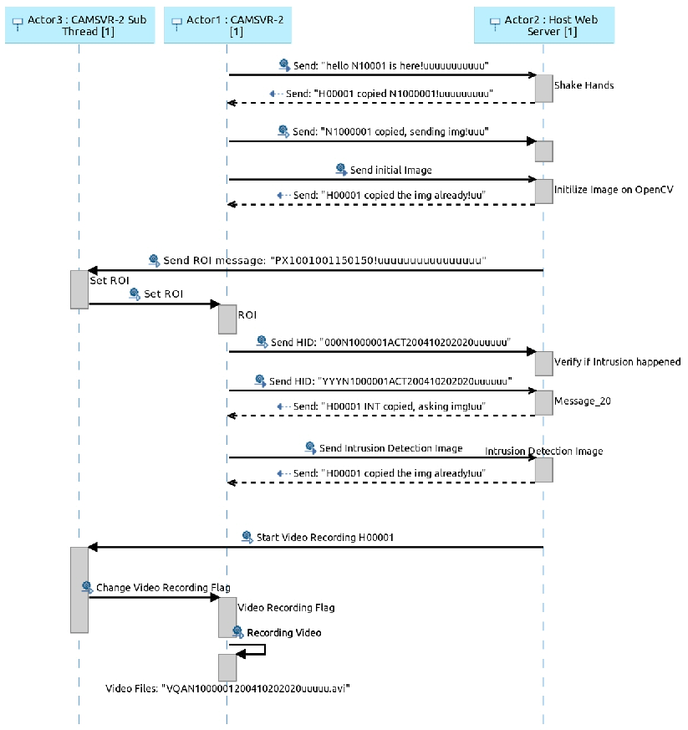
Figure 2.3 Serial Communication Protocol Sequence Diagram

III. API FUNCTIONS FOR PYTHON

Table 3.1. Group A and Group B Definitions
 | Description
Group A Settings | CAMSVR2 connected to RS232 Host via Serial to USB cable, see Figure 2.4.2.1 Group A, lab setting environment.
Group B Settings | CAMSVR2 connected to webservere and the web browser via DTU from the CAMSVR2.

Table 3.2. API for Group A
 | Description
A1: Hello, the world | (1) camsvr2.a1_handshaking(buffer1,var1,var2,camsvr2.CAMHND_UART)  where  buffer1: type???, size???, for sending/receiving data between camsvr2 and rs232 host;  var1: type???, size???, for???  var2: type???, size???, for???  camsvr2.CAMHND_UART: for urt handshaking  Note: for Group B, use camsvr2.CAMHND_DTU)  camsvr2.b1_handshaking  camsvr2.CAMHND_DTU: for DTU IP handshaking  (2) camsvr2.a1_periodic_reset(buffer1,var1,var2,camsvr2.CAMHND_UART)  where  buffer1: type???, size???, for sending/receiving data between camsvr2 and rs232 host;  var1: type???, size???, for???  var2: type???, size???, for???  camsvr2.CAMHND_UART: for urt handshaking
A2: ROI plus Intrusion Detection | camsvr2.a2_roi_intrusion_detection(buffer1,var1,var2,camsvr2.CAMHND_UART)  where  buffer1: type???, size???, for ??? between camsvr2 and rs232 host;  var1: type???, size???, for???  var2: type???, size???, for???  camsvr2.ITRDET: for intrusion detection algorithm 1.
A3: Heart Beat | (1)  camsvr2.a2_heart_beat(buffer1,var1,var2,amsvr2.BETHRT)  where  buffer1: type???, size???, for sending/receiving data between camsvr2 and rs232 host;  var1: type???, size???, for???  var2: type???, size???, for???  amsvr2.BETHRT: for heart beat implementation format 1.  (2)  camsvr2.a2_heart_beat_get(buffer1,var1,var2,amsvr2.BETHRT)  where  buffer1: type???, size???, for sending/receiving data between camsvr2 and rs232 host;  var1: type???, size???, for???  var2: type???, size???, for???  amsvr2.BETHRT: for heart beat implementation format 1.
A4: RTC | (1) No read ???  camsvr2.a2_rtc_read(buffer1,var1,var2,camsvr2.CAMHND_UART)  where  buffer1: type???, size???, for sending/receiving data between camsvr2 and rs232 host;  var1: type???, size???, for???  var2: type???, size???, for???  amsvr2.RTCSYN: for RTC Synchronization implementation format 1.  (2)  camsvr2.a2_rtc_write(buffer1,var1,var2,camsvr2.CAMHND_UART)  where  buffer1: type???, size???, for sending/receiving data between camsvr2 and rs232 host;  var1: type???, size???, for???  var2: type???, size???, for???  amsvr2.RTCSYN: for RTC Synchronization implementation format 1.
A5: Video Recording and Retrieving | (1)  camsvr2.a2_video_recording(buffer1,var1,var2,camsvr2.CAMHND_UART)  where  buffer1: type???, size???, for sending/receiving data between camsvr2 and rs232 host;  var1: type???, size???, for???  var2: type???, size???, for???  amsvr2.RECVID: for video recording implementation format 1.  (2)  camsvr2.a2_video_get(buffer1,var1,var2,camsvr2.CAMHND_UART)  where  buffer1: type???, size???, for sending/receiving data between camsvr2 and rs232 host;  var1: type???, size???, for???  var2: type???, size???, for???  amsvr2.GETVID: for video recording implementation format 1.  (3)  camsvr2.a2_video_list(buffer1,var1,var2,camsvr2.CAMHND_UART)  where  buffer1: type???, size???, for sending/receiving data between camsvr2 and rs232 host;  var1: type???, size???, for???  var2: type???, size???, for???  amsvr2.DELVID: for video recording implementation format 1.  (4)  camsvr2.a2_video_delet(buffer1,var1,var2,camsvr2.CAMHND_UART)  where  buffer1: type???, size???, for sending/receiving data between camsvr2 and rs232 host;  var1: type???, size???, for???  var2: type???, size???, for???  amsvr2.DELVID: for video recording implementation format 1.

Table 3.3. API for Group B

(END)

