CTI Plus Corporation, 3679 Enochs Street, Santa Clara, CA 95051

Title: README ML-Agents
Document Number: nnn-nnn
CTI One Corporation
Table 1a. Document History
2022-03-20 | Establish this document, document archive: /media/harry/easystore/backup-2020-2-15/CTI0/3proejcts/3-8-smart-tech/3-8-4-CTI/3-8-4-6-products/AIV200/103-app/103-1e-streamVideoLAN-hls | YY  (Please add the company’s master archive location)

Table 1b. Testing and Release Approval Form
2022-03-?? | Tested by ??? and approved for release by ??? | Pending for testing and approval

Table 2. References
Number | Name and URL | Note
1. | Unity ML-Agents Toolkit  https://github.com/Unity-Technologies/ml-agents
2. | Getting Started with Unity  https://learn.unity.com/course/getting-started-with-unity
3. | Karting Mod: Smart Karts Training Guide  https://learn.unity.com/tutorial/karting-mod-smart-karts-training-guide
4. | PyPi.org ML-Agents  https://pypi.org/project/mlagents/

Table 3. Prerequisite
Software Prerequisite No. | Description and Version | Note
1. | Ubuntu 18.04
2. | Python version 3.7
3. | Anaconda version 4.7.12
4. | Unity 2020.3.26
5. | ML-Agents Unity package version 1.0.8
6. | ML-Agents Python package version 0.16.1
7. | Barracuda Unity Package version 1.0.4
8. | Karting Microgame version 3.1.0
Hardware Prerequisite No. | Description and Version
1.

1. Setup a Python environment
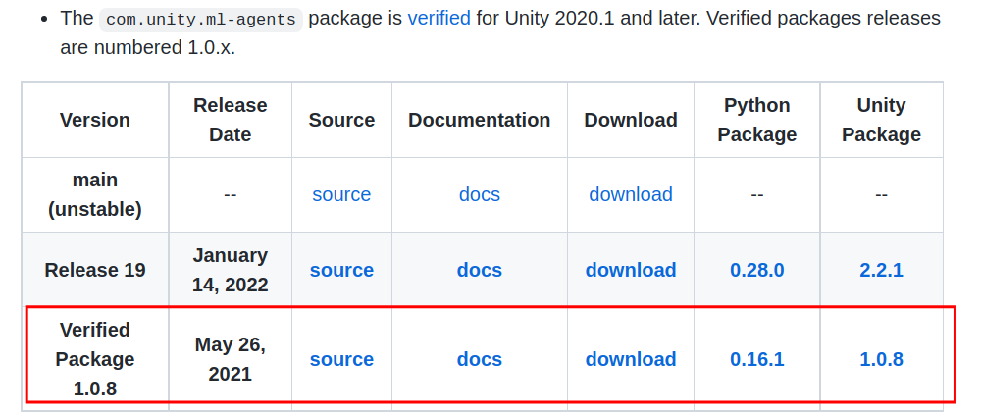
Figure 1: ML-Agents Unity and Python Packages
1.1. Create a Python environment
conda create --name unity-mlagents python=3.7
1.2. Activate the Python environment
conda activate unity-mlagents
1.3. Install Python ML-Agents package
pip3 install mlagents==0.16.1
https://pypi.org/project/mlagents/

2. Create a Kating Microgame on Unity
2.1. Create a Kating Microgame on Unity Hub
Project Name: Karting-Microgame-2022-3-19
Select “Kating Microgame” template
Push “CREATE” button
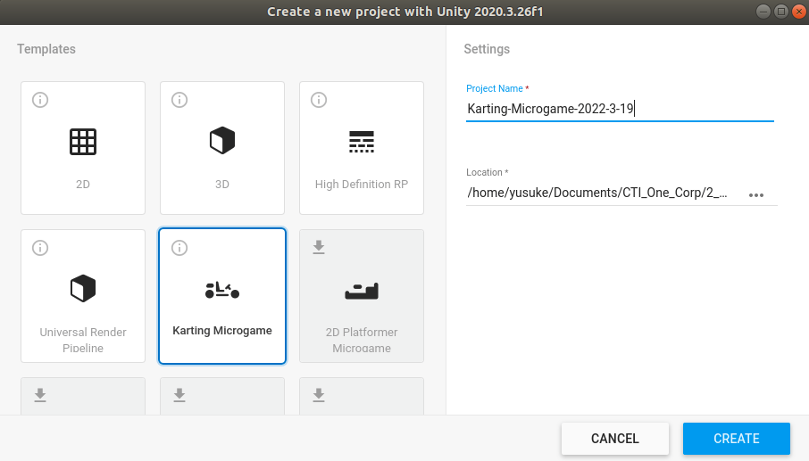
Figure 2: Creating Karting Microgame
2.2. Change Layout to default
At top right of window, select the “Default” on the list
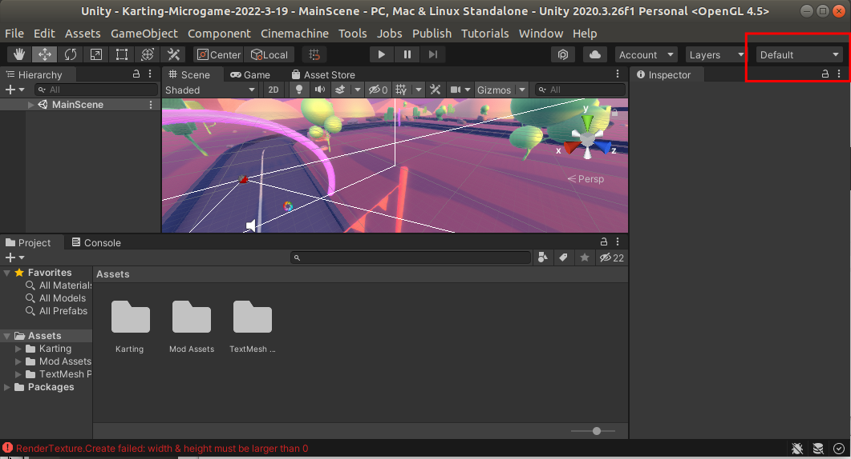
Figure 3: Chage Layout

3. Kart Classic Training
3.1. Open “Kart Classic Training”
Assets > Karting > Scenes > MLTraining > KartClassic_Training
3.2. Push play button. Push play button again to stop
3.3. Change the “Mode” from “Inferencing” to “Training”
3.3.1. Choose “KartClassic_MLAgent” object in Hierarchy window
3.3.2. Change the “Mode” to “Training” in Inspector window
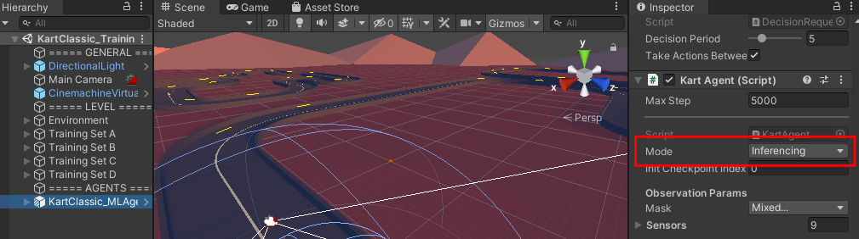
Figure 4: Kart Mode
3.4. Run the ML-Agents Python program
3.4.1. Open a terminal in the Unity Karing Microgame folder
3.4.2. Activate the ML-Agents Anaconda environment
conda activate unity-mlagents
3.4.3. Run the ML-Agents Python program
mlagents-learn Assets/Karting/Prefabs/AI/kart_mg_trainer_config.yaml --train --run-id=kart-1
3.5. Push “Play” button to start training
Figure 5: Python AL-Agents outputs

3.6. Push “Play” button to stop training
Model file will be exported.
Figure 6: Python AL-Agents result
3.7. Copy “ArcadeDriver.nn” to Unity folder: Assets → Karting → Prefabs → AI
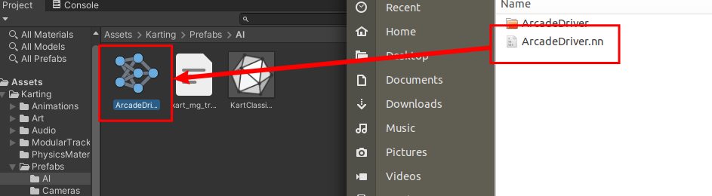
Figure 7: Copy NN model file to the Unity environment
3.8. Set new NN model and play
3.8.1. Choose “KartClassic_MLAgent” object in Hierarchy window
3.8.2. Change the “Mode” from “Training” to “Inferencing” in Inspector window
3.8.3. Drag “ArcadeDriver” in Assets window and drop to “Model” in Insepector window
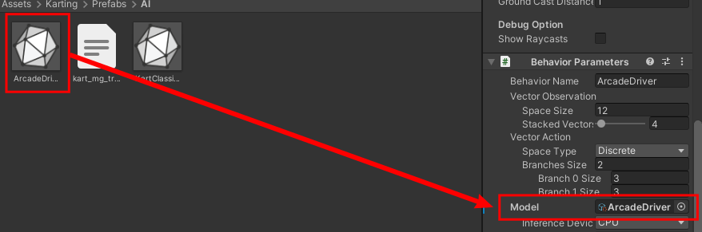
Figure 8: Set NN model to the Kart object
3.9. Push “Play” button to start inferencing

4. Import CAPP Track 1 Unity Scene
4.1. Import CAPP Track 1 Scene
(Menu) Assets → Import Package → Custom Package…
Select CAPP_Track_1.unitypackage
4.2. Open CAPP_Track_1 Scene
In Project windows, Assets → Karting → Scenes → MLTraining

Note: Increasing the number of KartClassic_MLAgent makes the training speed faster

(END)
CTI Plus Corporation

