Readme for Robot Arm ML Agent Unity
CTI One Corporation
2021-3-14 | Created this document | Chee Vang
2021-3-26 | Tested and verified with update | HL and Yusuke Yakuwa
2021-4-9 | Updated with more details | Chee Vang

https://github.com/rkandas/RobotArmMLAgentUnity
https://medium.com/xrpractices/how-to-train-your-robot-arm-fbf5dcd807e1

This project requires ML-Agent 1.0.3 and Python 3.7.

1) Create a conda environment with Python 3.7

conda create --name unityenv python=3.7
conda activate unityenv

2) Clone the github

cd ~/<where you want to save the project>/
git clone https://github.com/rkandas/RobotArmMLAgentUnity.git

3) Install ML-Agents (Use pip3 instead if pip does not work)

pip install mlagents

4) Open Unity Hub. Add a new project and select the folder RobotArmMLAgentUnity that was just downloaded.

5) There might be a warning symbol on the project about the Unity version. You can ignore the warning and select a version, or install Unity 2019.3.12f1.

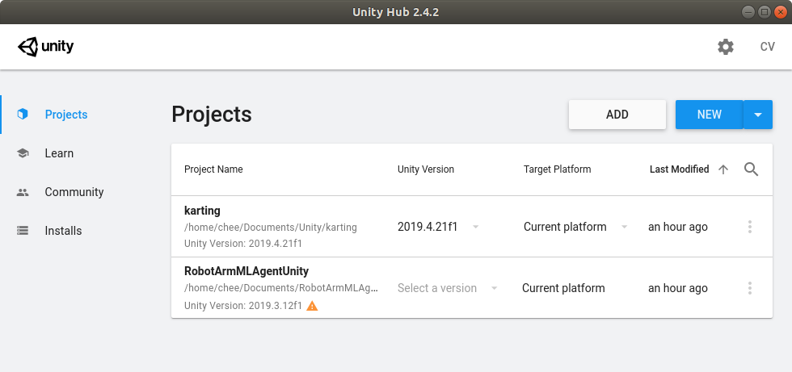
6) When the project is first opened, there will be a few errors. Just import ML Agents by going to Window >> Package Manager and on ML Agents click on See all version to import/install version 1.0.3.

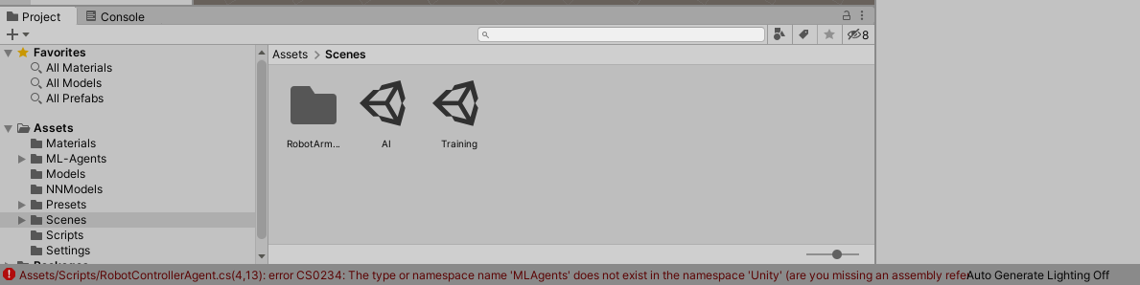
Will go away after installing ML Agents Unity Package

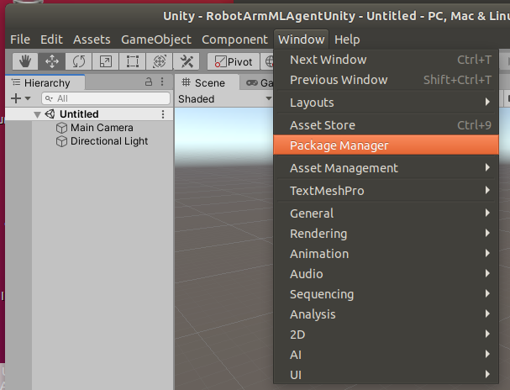

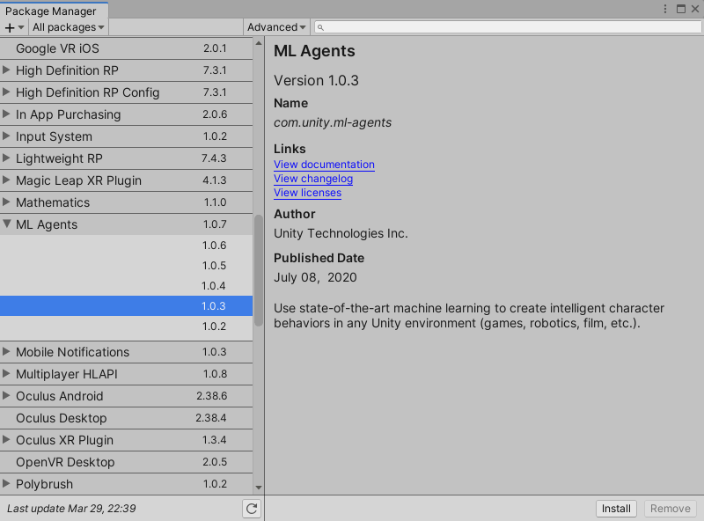

7) In the Project window, go to Assets >> Scenes and open the Training scene with 12 robot arms.

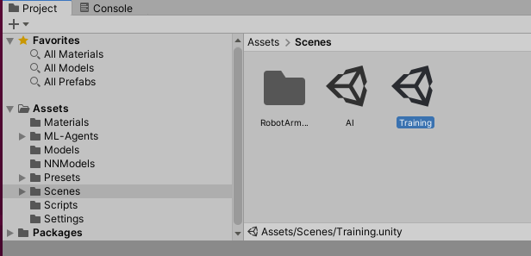

8) An issue will appear where the prefabs are pink like the figure below. If not, go to the step (9). Otherwise, continue.

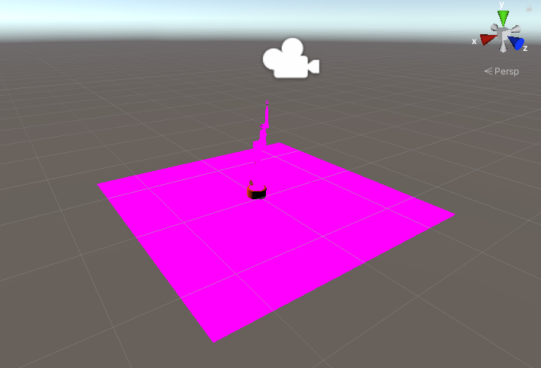

8.1 In the Project window, go to Assets >> Models.
8.2 Double click on RobotWithColliders.prefab in the Project Window (shown below)
8.3 Click on the robot arm, it will be highlighted. On the right side, is the Inspector panel.
8.4 In Inspector >> Robot Material, change Shader to Standard.
8.5 Do the same for other pink items: bottle and grabber.
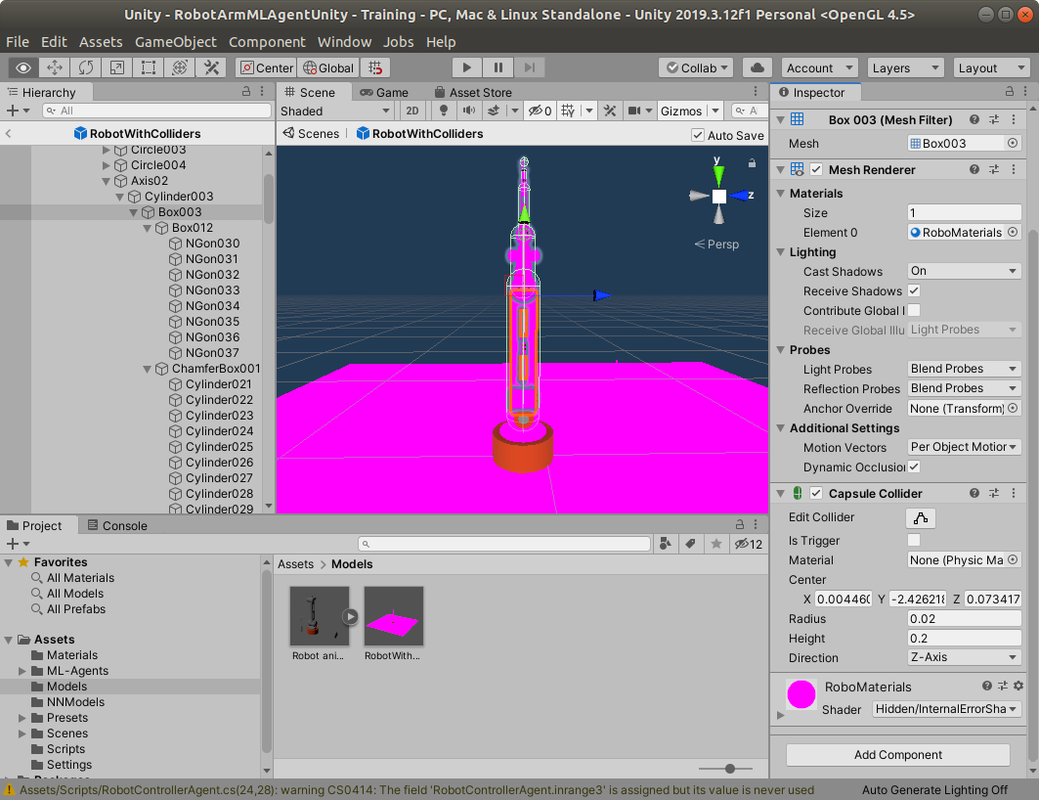
8.6 To change the ground: select the ground and change the material in Inspector >> Mesh Renderer >> Materials >> Element 0 to another material

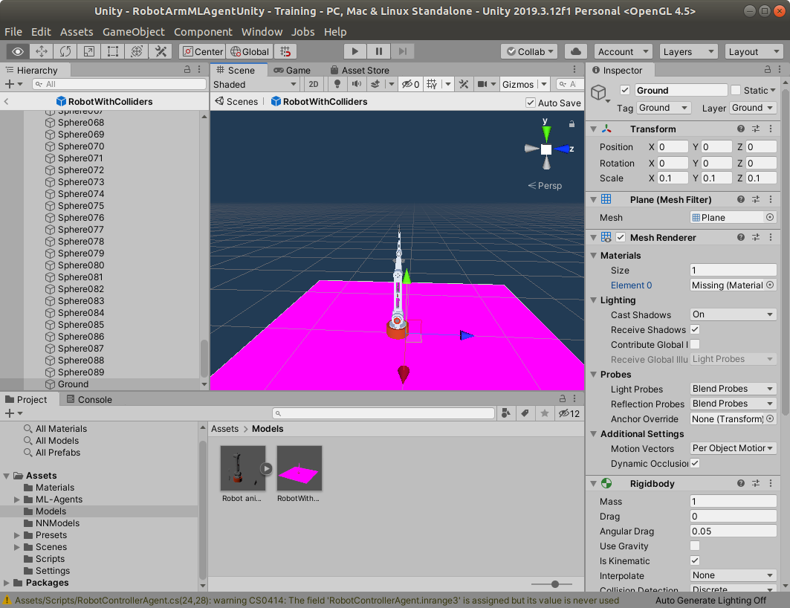
Select the ground

After changing the materials/shader, this should also affect the prefabs in the scenes we will use. Go back to Project >> Assets >> Scenes >> Training and the robot arm should be the selected color.

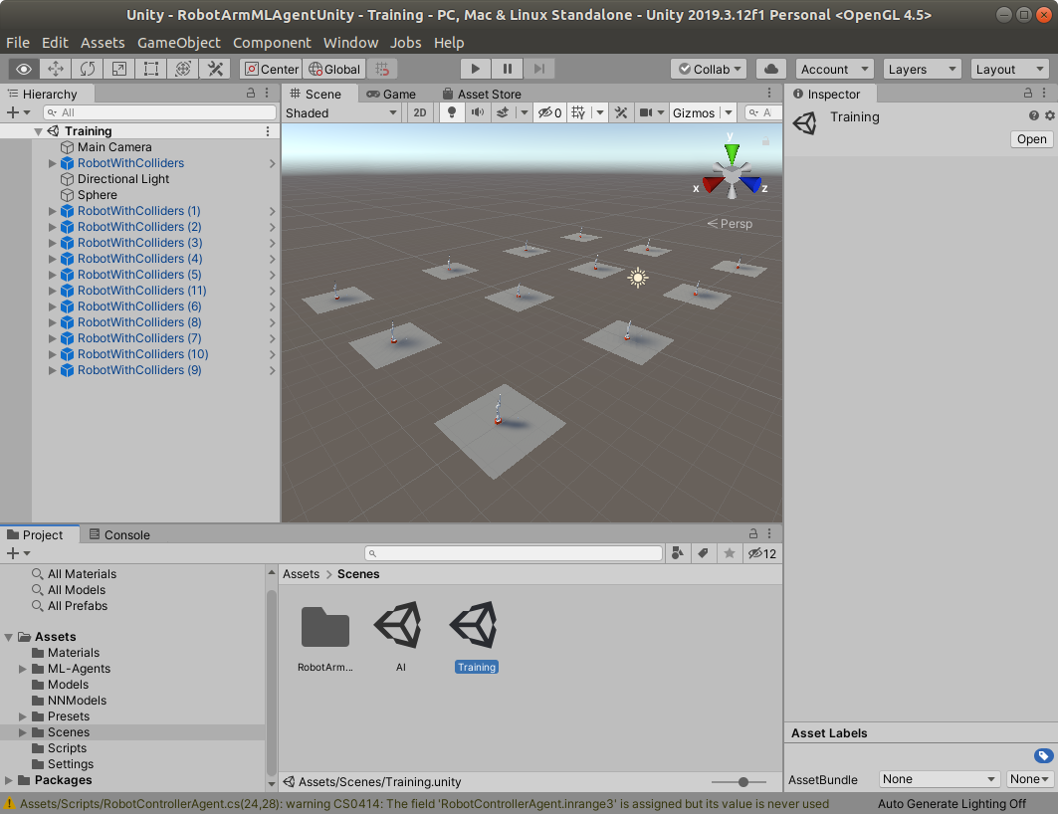
Go back to Training scene

9) Select all the RobotWithColliders in the Hierarchy and change the model to None in Inspector >> Behavior >> Model. (Hold the [Shift] key to select more than one item in the Hierarchy. Use [Ctrl] key to select/deselect one item at a time.)
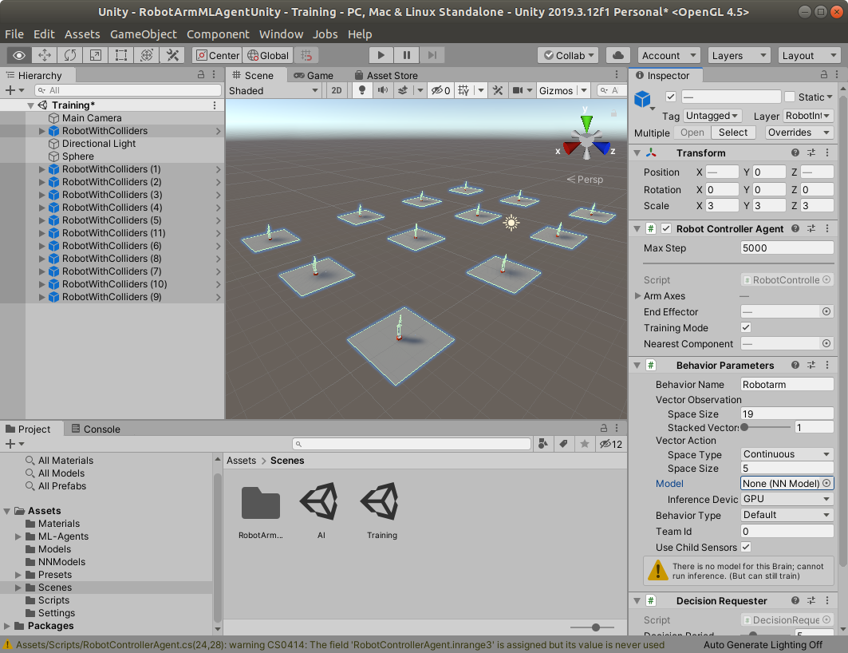

10) The trainer_config.yaml file (found in the project folder RobotArmMLAgentUnity) can be modified to change some of the configurations for Robotarm:

Note: Changing any of these parameters will change the result, accuracy and model
- batch_size :
- hidden_units : number of nodes per layer in NN
- num_layers : number of layers
- max_steps : number of training steps (Mine was changed to 1.0e6)

11) On the terminal, start the training process with the command:

mlagents-learn ./trainer_config.yaml --run-id ra_01

Note:
- rund-id is changeable
- add --force to overwrite training model with name specified by run-id
- add --resume to continue training from previously paused/stopped model with name specified by run-id

11) Go back to Unity and press the Play button to start the training. It will take several minutes.

12) Once it completes, the terminal should have the following:

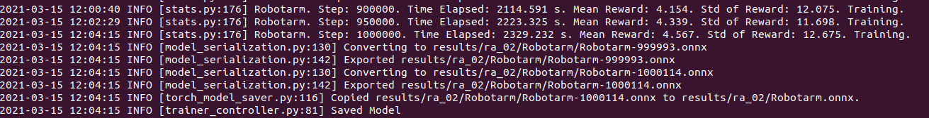

Note (HL 2021-3-27) checking the printed message in the console, you will see
(1) this following line of message shows the result converted to the results folder and sub-folders in a file with file extension “.onnx”;

2021-03-26 18:17:07 INFO [model_serialization.py:183] Converting to results/ra_01/Robotarm/Robotarm-1060.onnx

(2) the 2nd line of message shows the result is exported as follows:

2021-03-26 18:17:07 INFO [model_serialization.py:195] Exported results/ra_01/Robotarm/Robotarm-1060.onnx

(3) the 3rd line of the message shows the copied result.

2021-03-26 18:17:07 INFO [torch_model_saver.py:116] Copied results/ra_01/Robotarm/Robotarm-1060.onnx to results/ra_01/Robotarm.onnx.

(4) finally, the message for the saved model.

2021-03-26 18:17:07 INFO [trainer_controller.py:81] Saved Model

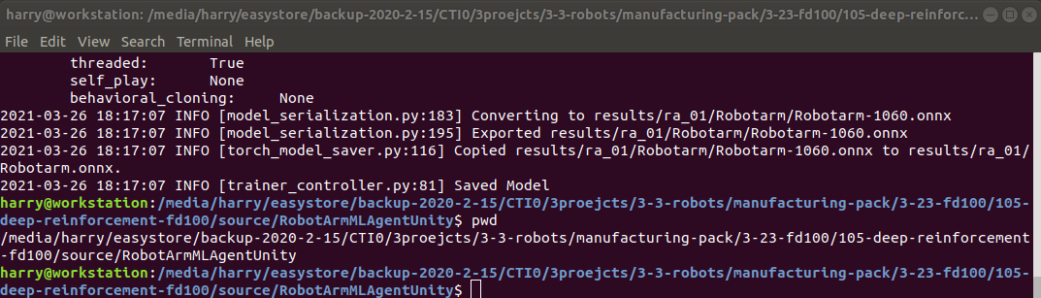

13) To play the trained model for visualization purposes, drag and drop the trained model in RobotArmMLAgentUnity/results/ra_01/Robotarm.onnx to Unity in Project > Assets > NNModels

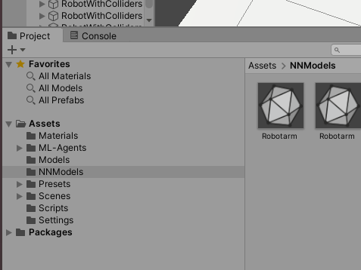

Drag and drop Robotarm.onnx into Unity in Project > Assets > NNModels

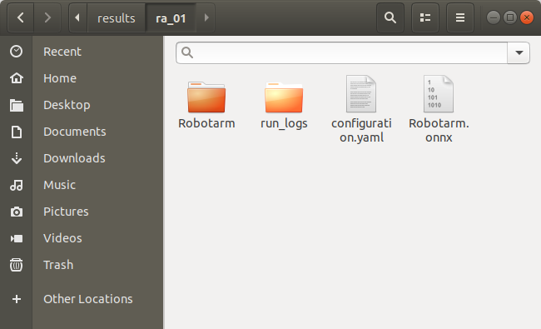

14) Select all the RobotWithColliders. Drag and drop the new Robotarm.onnx into Model in Inspector >> Behavior Parameters >> Model

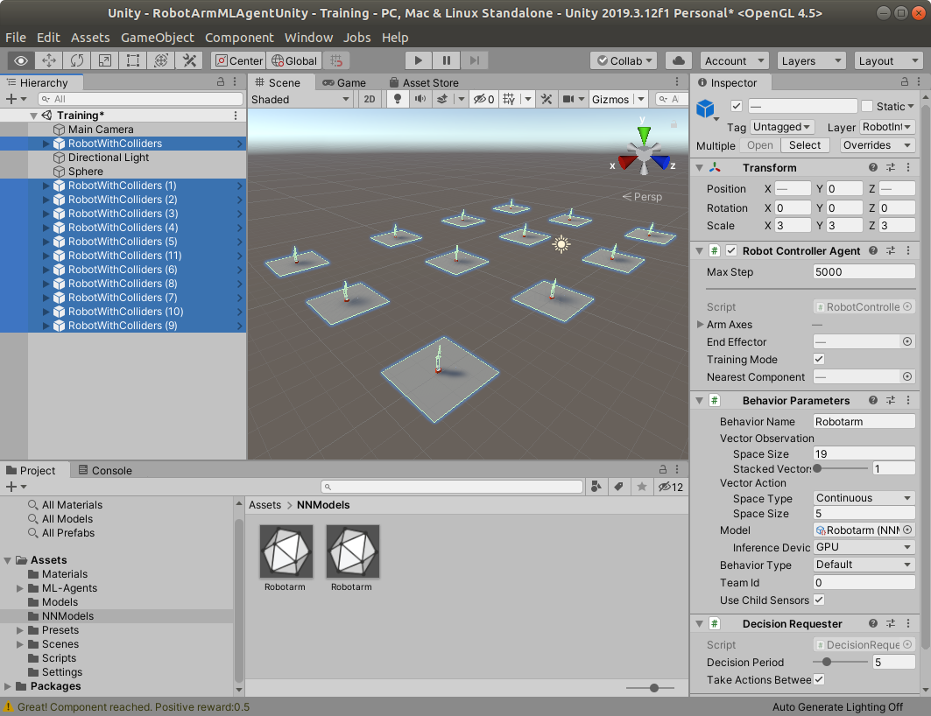

Note: if you just select the one you want, then the Unity will only play with that selected robot

15) Press Play button to watch the animation of the trained result.

(END)

