CAMSVR2 Serial Communication Protocol

2020-3-17 | Establish this document | HL

/media/harry/easystore/backup-2020-2-15/CTI0/3proejcts/3-8-smart-tech/3-8-4-huaYuan/3-8-4-6-products/CAMSVR-3-8-4-6-1/manufacturing-camsvr3-8-4-6-1/camsvr-pack/$

https://github.com/hualili/robotics-open_abb/tree/master/ai-embedded

I. Background

The purpose of this document is:

1. To allow CAMSVR2 in Figure 1 communicate with a RS232 host which can be embedded systems, single board computer, PC, laptop for example, as long as the RS232 host is equipped with the RS232 interface. The illustration of the CAMSVR2 and RS232 host is given below in Figure 2.

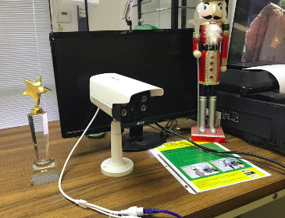

Figure 1.1. CAMSVR.

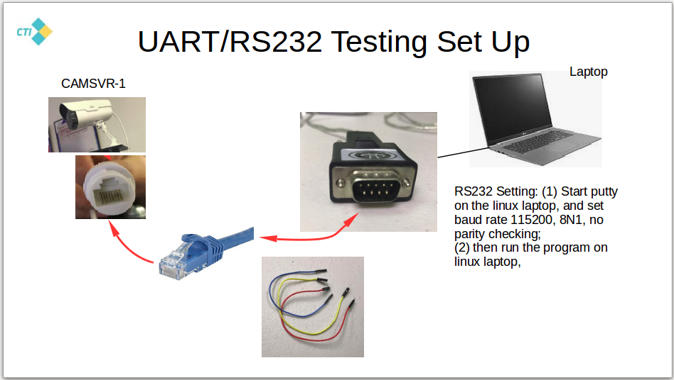

Figure 1.2a. The illustration of CAMSVR2 and a RS232 host communication. Reference: 105-1-camsvr2-testing-v2-hl-2020-3-3.odp

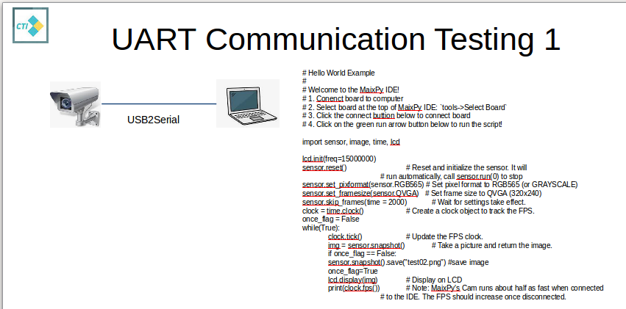

Figure 1.2b. The 2nd illustration of CAMSVR2 and a RS232 host communication. Reference: 112-0-serial-communication-MaixPy-v01.1-MO_2020-2-25.odp. Note the testing program listed in the above figure can be made available up request to our company's management.

II. The Serial Communication Protocol

2.1. The space time diagram description of the communication

CAMSVR2 and a RS232 host are defined as follows:
1. CAMSVR2 is referred to as a RS232 client;
2. Laptop which is connected to CAMSVR2 and receives images from the CAMSVR is referred to as RS232 host.
3. The client and host is depicted in the following space-time diagram in Figure 2.1.

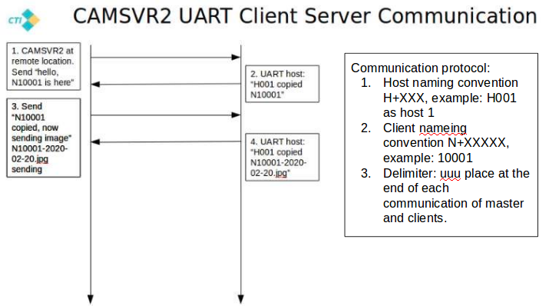

Figure 2.1 1. CAMSVR2 is referred to as a RS232 client, and a Laptop which is connected to CAMSVR2 and receives images from the CAMSVR is referred to as RS232 host. The client is on the left of this figure and the host is on the right, in the space-time diagram.

2.1. The communication protocol

CAMSVR2 and a RS232 host communication protocol is defined based on the following condition:
1. The RS232 communication with baud rate of 115200, 8N1.
2. The communication between the client and the server is given in the following table, Table 1.

Table 1. CAMSVR2 and a RS232 host communication protocol.

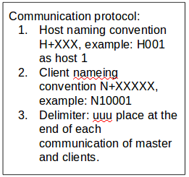

III. References
This document is for CAMSVR2 serial communication protocol design, the following references and document may be useful as a background information. However you don't need to read any other references rather than this document to be able to get all the information for the CAMSVR2 serial communication.
The reference list is given below:
1. 105-1-camsvr2-testing-v2-hl-2020-3-3.odp

(END)

