Readme for Robot Arm ML Agent Unity
CTI One Corporation
2021-3-14 | Created this document | Chee Vang
2021-3-26 | Tested and verified with update | HL and Yusuke Yakuwa

https://github.com/rkandas/RobotArmMLAgentUnity
https://medium.com/xrpractices/how-to-train-your-robot-arm-fbf5dcd807e1

This project requires ML-Agent 1.0.3 and Python 3.7.

1) Create a conda environment with Python 3.7

conda create --name unityenv python=3.7
conda activate unityenv

2) Clone the github

cd ~/<where you want to save the project>/
git clone https://github.com/rkandas/RobotArmMLAgentUnity.git

3) Install ML-Agents

pip install mlagents #HL 2021-3-25: failed, so change to pip3

4) Open Unity Hub. Add a new project and select the folder RobotArmMLAgentUnity that was just downloaded.

5) There might be a warning symbol on the project about the Unity version. You can ignore the warning, or install Unity 2019.3.12f1.

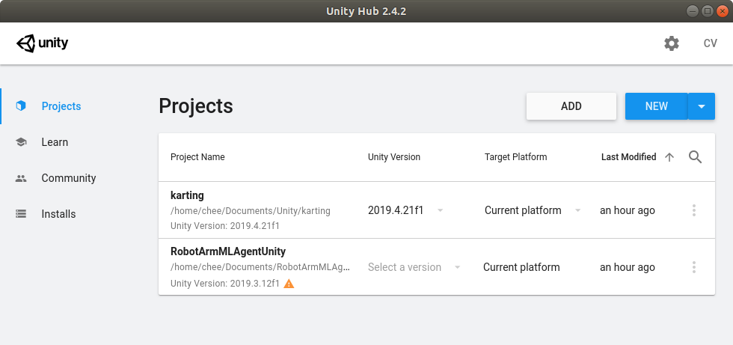
6) When the project is first opened, there will be a few errors. Just import ML Agents by going to Window >> Package Manager and on ML Agents click on See all version to import version 1.0.3.

7) In the Project window, go to Assets >> Scenes and open the Training scene with 12 robot arms.

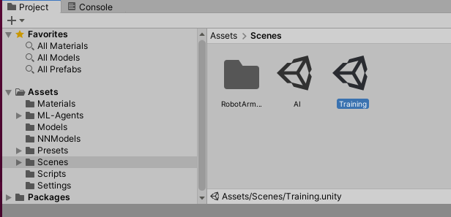

8) An issue will appear where the prefabs are pink like the figure below. If not, go to the step (9). Otherwise, continue.

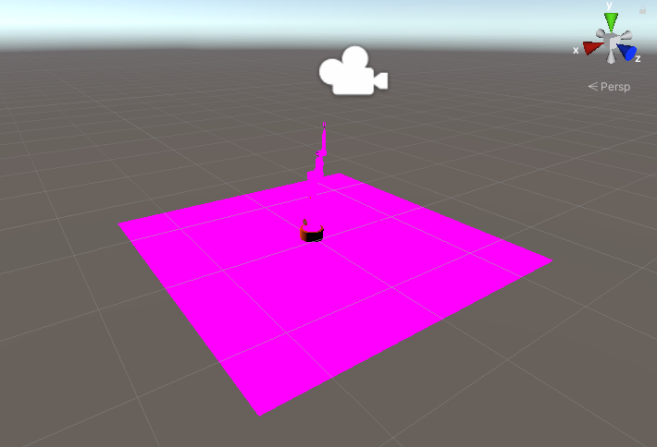

8.1 In the Project window, go to Assets >> Models.
8.2 Double click on RobotWithColliders.prefab (shown below) (Note: HL, go to the middle section panel, single click on the tab of “scene”, and you will see the robot with 3D coordinate system, and you can move around with your mouse.)
8.3 Click on the robot arm, it will be highlighted, then on the right side, Inspector panel will show up.
8.4 In the Inspector >> Robot Material, change Shader to a shade you prefer.
8.5 Do the same for other pink items: bottle and grabber.(Note, (1) the Shader is at the very bottom of the panel, (2) choose “standard” for the shader model, (3) click on the roller, which is the middle button of the mouse, you can roll it to scale up or down of the scene, and you can click right button and hold it while moving to change the perspective of the view).
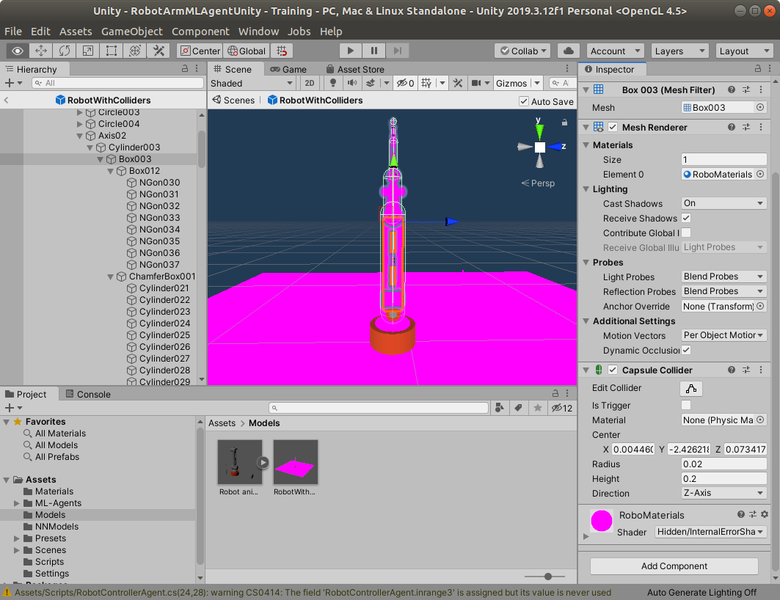
8.6 To change the ground: select the ground and change the material in Inspector >> Mesh Renderer >> Materials >> Element 0 to another material

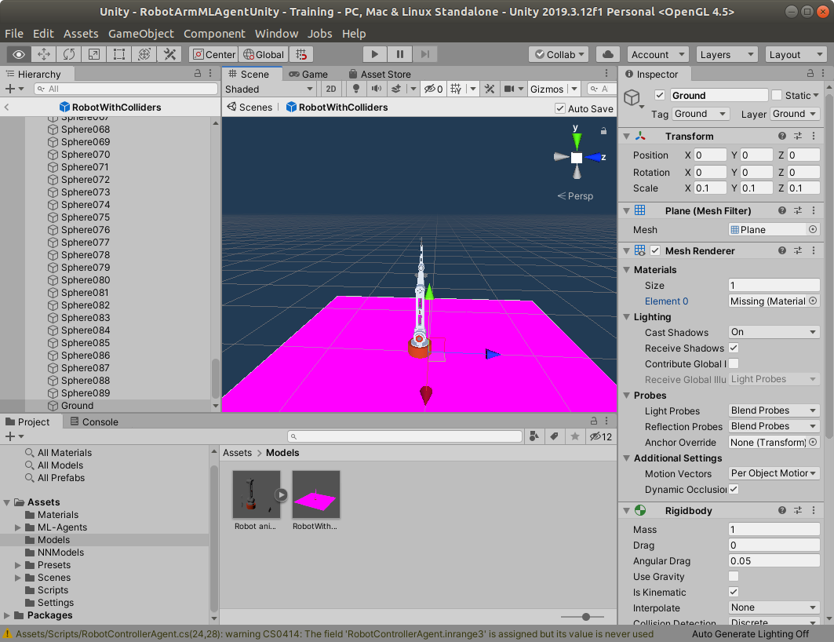

After changing the materials/shader, this should also affect the prefabs in the scenes we will use. Go back to Project >> Assets >> Scenes >> Training and the robot arm should be the selected color.

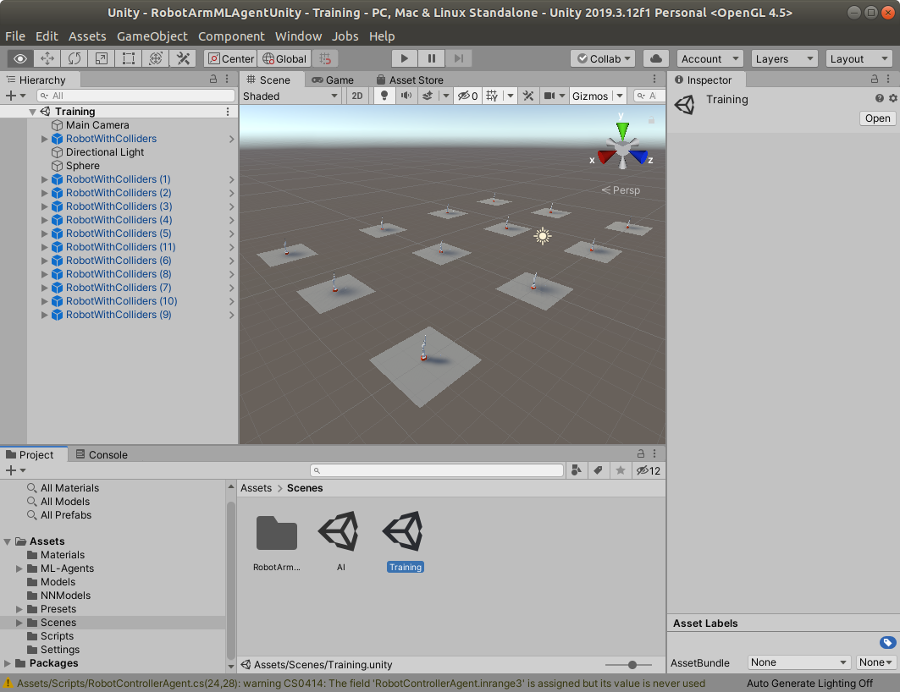

9) Select all the RobotWithColliders in the Hierarchy and change the model to None in Inspector >> Behavior >> Model
(hold down “shift” key to select more than one item, once it is clicked it select start item and the 2nd click it select the end item; control key on the other hand, allows the user to do one selection or deselection at time).
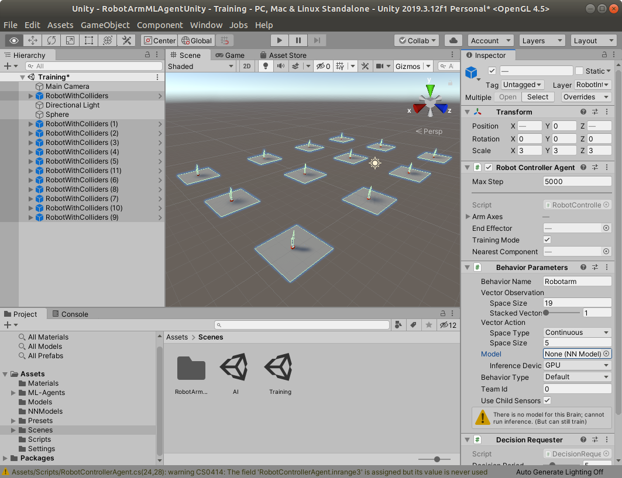

10) (HL-2021-3-26: outside unity at the folder where your ML robot arm software is installed, for example, RobotArmMLAgentUnity) The trainer_config.yaml file can be modified to change some of the configurations for Robotarm:

batch_size, hidden_units : number of nodes per layer in NN
num_layers : number of layers
max_steps : number of training steps (Mine was changed to 1.0e6)

11) On the terminal, start the training process with the command:

mlagents-learn ./trainer_config.yaml --run-id ra_01

11) Go back to Unity and press the Play button to start the training. It will take several minutes.

12) Once it completes, the terminal should have the following:

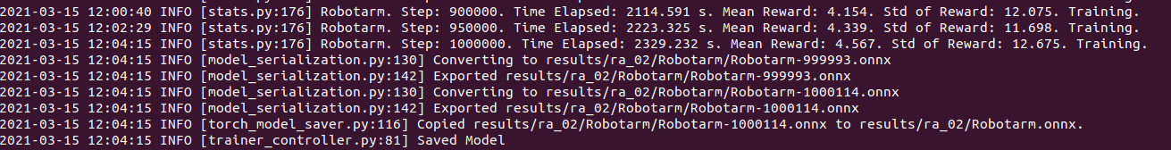

Note (HL 2021-3-27) checking the printed message in the console, you will see
(1) this following line of message shows the result converted to the results folder and sub-folders in a file with file extension “.onnx”;

2021-03-26 18:17:07 INFO [model_serialization.py:183] Converting to results/ra_01/Robotarm/Robotarm-1060.onnx

(2) the 2nd line of message shows the result is exported as follows:

2021-03-26 18:17:07 INFO [model_serialization.py:195] Exported results/ra_01/Robotarm/Robotarm-1060.onnx

(3) the 3rd line of the message shows the copied result.

2021-03-26 18:17:07 INFO [torch_model_saver.py:116] Copied results/ra_01/Robotarm/Robotarm-1060.onnx to results/ra_01/Robotarm.onnx.

(4) finally, the message for the saved model.

2021-03-26 18:17:07 INFO [trainer_controller.py:81] Saved Model

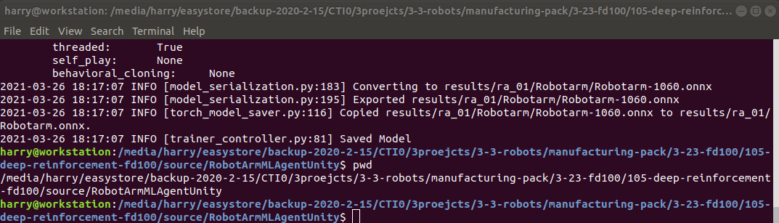

13) (Note: now you can copy the trained result into the Unity platform, then to play it for visualization purpose. In order to do so, you will have to copy the trained result, e.g., Robotarm.onnx, to the Unity platform. This is really easy)
Drag and drop the trained model in RobotArmMLAgentUnity/results/ra_01/Robotarm.onnx to NNModels

(You can find NNModels from Project panel located at lower left side of the UI display, e.g., Project > Assets > NNModels then right to the project panel is a window at the lower center of the UI with caption Assets > NNModels, can drag and drop “Robotarm.onnx” file here.)

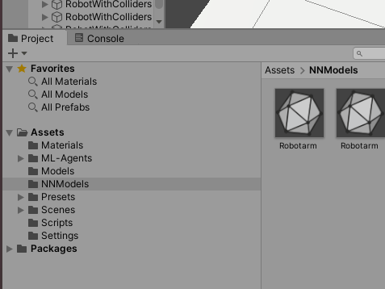

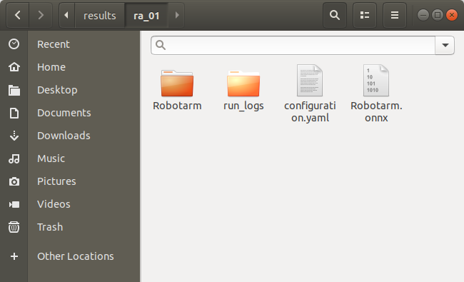

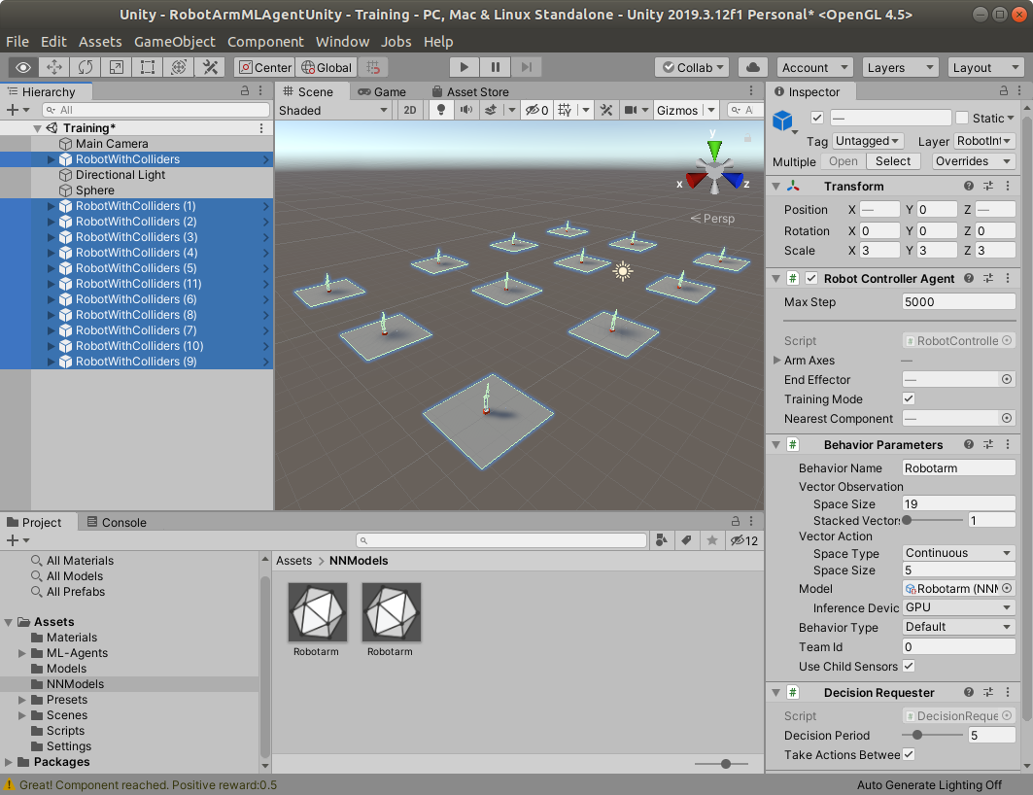

14) Select all the RobotWithColliders. Drag and drop the new Robotarm.onnx into Model in Inspector >> Behavior Parameters >> Model

(Note: if you just select the one you want, then the Unity will only play with that selected robot)

15) Press Play button to watch the animation of the trained result.

(END)

