

AIV-100 System
User Manual
Version 0.1 – Alpha
(For Customer Use)

CTI Plus Corporation
3679 Enochs St
Santa Clara, CA, 95051
www.ctione.com

Oct 2019
COPYRIGHT © 2019 CTI Plus Corporation. All right reserved.
All Intellectual property, as defined below, owned by or which is otherwise the property of CTI Plus Corporation or its respective suppliers relating to the CTI Plus Corporation, is proprietary to CTI Plus Corporation and protected under International treaty, Federal Laws, and State Laws. Furthermore, you should not modify, prepare derivative works of, decompile, disassemble, reverse engineer, or otherwise attempt to create source code from software. No title to or ownership in the Intellectual Property is transferred to you. All applicable rights of the Intellectual Property shall remain with CTI Plus Corporation and its suppliers.

About this Manual
This manual is applicable to AIV-100 System.
The manual includes instructions for using and managing the product. Pictures, charts, images and all other information hereinafter are for description and explanation only. The information contained in the Manual is subject to change, without notice, due to the firmware updates or other reasons. Please find the latest version of this manual on the www.ctione.com
Legal Information
Important legal information can be accessed in writing on the
www.ctione.comPLEASE READ THIS INFORMATION BEFORE USING THE AIV-100 System.
Disclaimer of Warranties
EXCEPT AS SET FORTH IN THE WARRANTY AGREED UPON OR EXPRESS WARRANTY CONTAINED IN THE WARRANTY PAGE ENCLOSED WITH THE PRODUCT, THE PURCHASER TAKES THE PRODUCT "AS IS", AND CTI Plus Corporation MAKES NO EXPRESS OR IMPLIED WARRANTY OF ANY KIND WHATSOEVER WITH RESPECT TO THE PRODUCT, INCLUDING BUT NOT LIMITED TO THE MERCHANTABILITY OF THE PRODUCT OR ITS FITNESS FOR ANY PARTICULAR PURPOSE OR USE.
REGARDING THE PRODUCT WITH INTERNET ACCESS, THE USE OF THE PRODUCT SHALL BE WHOLLY AT YOUR OWN RISK. CTI Plus Corporation SHALL NOT TAKE ANY RESPONSIBILITIES FOR ABNORMAL OPERATION, PRIVACY LEAKAGE OR OTHER DAMAGES RESULTING FROM CYBER ATTACK, HACKER ATTACK, VIRUS INSPECTION, OR OTHER INTERNET SECURITY RISKS.
SURVEILLANCE LAWS VARY BY JURISDICTION. PLEASE CHECK ALL RELEVANT LAWS IN YOUR JURISDICTION BEFORE USING THIS PRODUCT IN ORDER TO ENSURE THAT YOUR USE CONFORMS TO THE APPLICABLE LAWS. CTI Plus Corporation SHALL NOT BE LIABLE IN THE EVENT THAT THIS PRODUCT IS USED WITH ILLEGITIMATE PURPOSES.
Regulatory Information
FCC Information
Please take notice that any changes or modifications not expressly approved by CTI Plus Corporation could void your authority to operate the device. This equipment has been tested and found to comply with the limits for a Class B digital device, pursuant to part 15 of the FCC Rules. Operation is subject to the following two conditions:
- This device may not cause harmful interference, and
- This device must accept any interference received, including interference that may cause undesired operation.
These limits are designed to provide reasonable protection against harmful interference in a residential installation. This equipment generates, uses and can radiate radio frequency energy and, if not installed and used in accordance with the instructions, may cause harmful interference to radio communications.
However, there is no guarantee that interference will not occur in a particular installation. If this equipment does cause harmful interference to radio or television reception, which can be determined by turning the equipment off and on, the user is encouraged to try to correct the interference by one or more of the following measures:
• Reorient or relocate the receiving antenna.
• Increase the separation between the equipment and receiver.
• Connect the equipment into an outlet on a circuit different from that to which the receiver is connected.
• Consult the dealer or an experienced radio/TV technician for help.

Safety Instruction
These instructions are meant to ensure that the user can use the product correctly to avoid danger or property loss.
The precaution measure is divided into “Warnings” and “Cautions”
Warnings: Serious injury or death may occur if any of the warnings are neglected.
Cautions: Injury or equipment damage may occur if any of the cautions are neglected.
 | 
Warnings: Follow these safeguards to prevent serious injury or death. | Cautions: Follow these precautions to prevent potential injury or material damage.

Warnings
- In the use of AIV-100 System, you must be in strict compliance with the electrical safety regulations of the nation and region. Please refer to technical specification for detailed information.
- Do not connect several devices to one adapter as adapter overload may cause over-heating or fire hazard.
- Please make sure that the plug is firmly connected to the power socket. When the product is mounted on wall or ceiling, the device shall be firmly fixed.
- If smoke, odor, or noise rise from the device, turn off the power at once and unplug the power cable, then please contact the service center.
- Proper configuration of all password and other security settings is the responsibility of the installer and/or end-user.
Cautions
- Make sure the power supply voltage is correct before using the AIV-100 System.
- Do not drop the AIV-100 System or subject it to physical shock.
- Do not place the AIV-100 System in extremely hot, cold (The operating temperature shall be 10°C to 60°C), dusty or damp condition.
- To avoid heat accumulation, good ventilation is required for operating environment.
- Keep the AIV-100 System away from liquid while in use.
- While in delivery, the AIV-100 System shall be packed in its original packing or similar.
- Regular part replacement: a few parts of the equipment shall be replaced regularly according to their average enduring time. Therefore, regular checking is recommended for all users. Please contact with CTI Plus Corporation for further details.
- If the product does not work properly, please contact the CTI Plus Corporation for support. Never attempt to disassemble the AIV-100 System yourself.

Table of Contents
About this Manual 2
Safety Instruction 5
Table of Contents 7
1.AIV-100 System APPEARANCE 9
1.1 Type 1 9
1.2 Type 2 10
2. TYPES AND FUNCTION SUPPORT LIST - TODO 11
3.SYSTEM PREREQUISITES 12
3.1 Hardware Requirements 12
3.2 Software Requirement 13
4.INSTALLATION 14
4.1 Client / Laptop Access – TODO 14
4.1.1 Type 1 14
4.1.2 Type 2 14
5.HOME GUI (GRAPHICAL USER INTERFACE) – TODO 15
5.1 Home Page 15
5.1.1Top Bar Menu 15
5.1.2Side Bar Menu 16
6.FUNCTIONS SUPPORTED BY AIV-100 System 17
6.1 Employee Absence - TODO 17
6.2 Employee Attendance - TODO 18
6.3 Employee Stand Guard - TODO 19
6.4 Guard Facial Recognition - TODO 20
6.5 Not Standing Up for Service - TODO 21
6.6 Reception Area Object Displacement – TODO 22
7.UPLOAD CONFIGURATION - TODO 23
7.1Upload Animal Attributes - TODO 23
7.2 Upload People Attributes – TODO 23
8.Search Function - TODO 25
9.Summary - TODO 26
Appendix A Trouble Shooting 28
Appendix B How To Get Help 29
Appendix C Technician installation 0
Check the specification of the product for the installation environment. 0
9.1 Router Installation - TODO 0
9.2 Camera Installation – TODO 0
9.3 GPUSVR Installation – TODO 1

Introduction - TODO

AIV-100 System APPEARANCE
AIV-100 System has two separate types. The Type 1 is a Stand-alone configuration where it could run independently without any network or internet connection. The Type 2 supports all functions developed by CTI Plus Corporation, but it requires stronger computer. The list for the Types will be as follows:

Type 1
Following is the Type 1 System Configuration diagram:
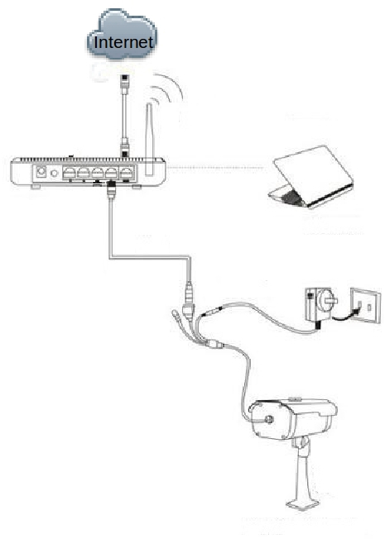
Figure 1.1 Type 1 System Configuration
In this system configuration, the module runs independently on a single laptop. All the process for functions were run on the laptop. Then, the results will be displayed in the modern browser (such as Mozilla Firefox or Google Chrome browser).

Type 2
Following is the Type 2 System Configuration diagram:
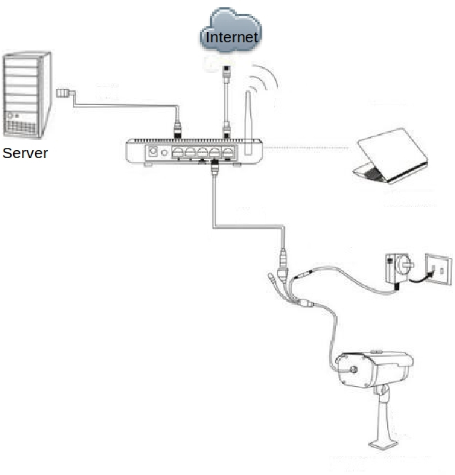
Figure 1.2 Type 2 System Configuration
In this system configuration, it consists of a laptop / computer with the internet connection as a client and the process of the program will be done on the computer as the server. Notice that in this architecture, the client will be quite lightweight. The server will process the modules separately on the remote location. It requires more power and a GPU. The hardware specifications are shown in Table 3.2.

TYPES AND FUNCTION SUPPORT LIST - TODO
The AIV-100 System has six functions that are readily available for use right now. However, a minimum computation power necessary to meet the demands of the functions. Therefore, not all functions supported in Type 1. Following is the list of all function and which platform it supports (To see how this function works, see page 17):
Type 1 | Type 2
- A  - B | - Employee Absence  - Employee Attendance  - Employee Stand Guard  - Guard Facial Recognition  - Not Standing Up for Service  - Reception Area Object Displacement
Table 2.1 Architecture with the type of module run on it.

SYSTEM PREREQUISITES

Hardware Requirements
Following is the hardware requirements for each Types:
 | Type 1 | Type 2
 | For the Laptop / Computer: | For the Client:
Operating System | Ubuntu 14.04 LTS | Ubuntu 14.04 LTS or later
Computer and Processor | Intel core i5-6200U @ 2.30GHz or faster | Intel core i5-6200U @ 2.30GHz or faster
Memory | 8GB of RAM or bigger is recommended | 8GB of RAM or bigger is recommended
GPU Requirement | Minimum Nvidia GeForce 940M or faster | -
Disk Space | At least 100 Gb of free disk | At least 20 Gb of free disk
Network | Cisco Lynksys EA9200 | Cisco Lynksys EA9200
Display | 1024x768 resolution or higher | 1024x768 resolution or higher
 |  | For the Server:
Operating System |  | Ubuntu 14.04 LTS
Computer and Processor |  | Intel core i7-8700 @ 3.20GHz (12 core) or faster is recommended
Memory |  | 16GB of RAM or bigger is recommended
GPU Requirement |  | Nvidia GeForce GTX 1060 with 6GB Video memory or bigger
Disk Space |  | At least 280 GB of free disk
Network |  | Fast enough network to upload video
Table 3.2 Hardware requirements for each architecture

Software Requirement
Following is the software requirement for each device used in the architecture:
Stand-alone Architecture | GPUSRV Architecture
For the Laptop / Computer: | For the Client:
- Python  - Tensorflow  - OpenCV | - Any modern browser that’s capable of streaming online videos (Example: Google Chrome or Mozilla Firefox)
- Python  - Tensorflow  - OpenCV | For the Server:
- Python  - Tensorflow  - OpenCV | - Python  - Tensorflow  - OpenCV
Table 3.3 Software requirements for each architecture

INSTALLATION
Before you start:
- Make sure the device is in good condition and turned on.

Client / Laptop Access – TODO
The AIV-100 System can be accessed using modern browser (like Mozilla Firefox or Google Chrome). Each Type needs to be accessed a bit differently.

Type 1
Follow these steps to access the AIV-100 System user interface:
- Connect your computer using wifi to the
- Use the Username: xxxx
- Password: xxxx
- Wait until it connects.
[insert photo]
- Open the web browser.
- Browse to 127.0.0.1:8080/home
[insert photo]

- And the home page will be shown as follows:
[insert photo]

Type 2
Follow these steps to access the AIV-100 System user interface:
- Connect your computer using wifi to the
- Use the Username: xxxx
- Password: xxxx
- Wait until it connects.
[insert photo]
- Open the web browser.
- Browse to 192.168.1.99:8080/home
[insert photo]

- And the home page will be shown as follows:
[insert photo]

HOME GUI (GRAPHICAL USER INTERFACE) – TODO

Home Page
From home page, there is some statistics for each function. And user can click the menu on the left to access the feature of AIV-100 System. And it contains all function link, user can directly see the whole structure about our system.
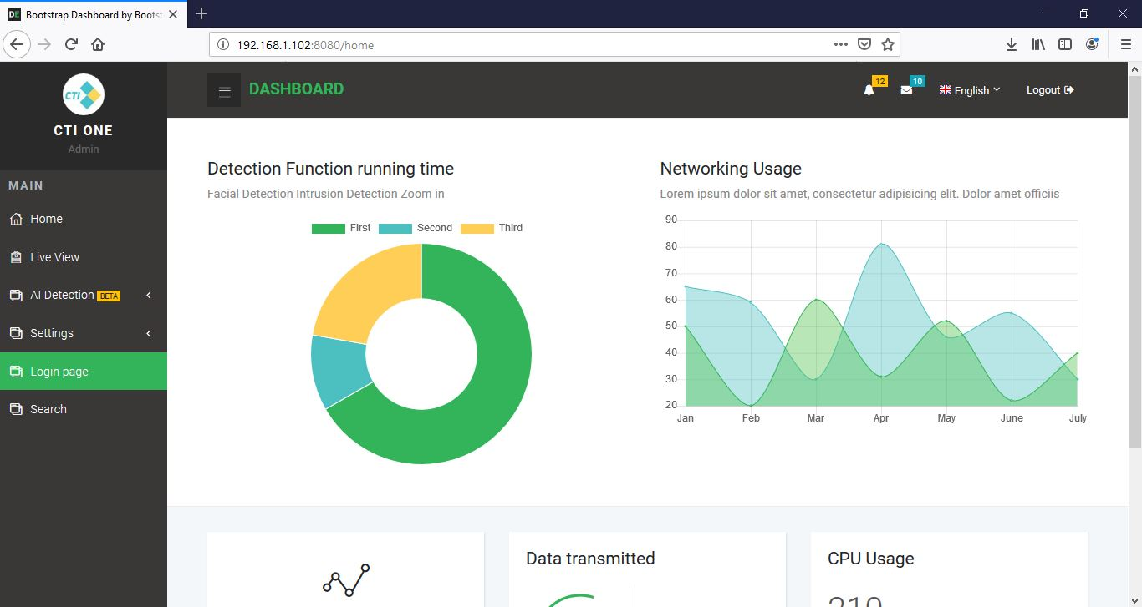
Figure 5.3 AIV-100 System Home Page

Top Bar Menu
This menu is where the logout and language can be set.
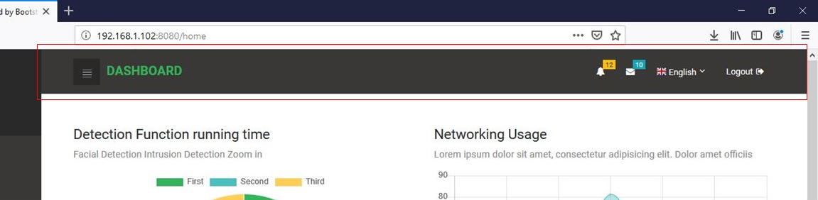
Figure 5.4 AIV-100 System Top Bar Menu

Side Bar Menu
This menu contains the function which will be shown in the browser.

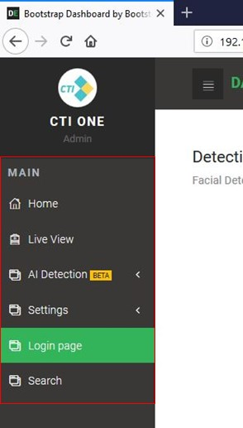
Figure 5.5 AIV-100 System Side Bar Menu

FUNCTIONS SUPPORTED BY AIV-100 System
Following is the sample display of the functions supported by AIV-100 System:

Employee Absence - TODO
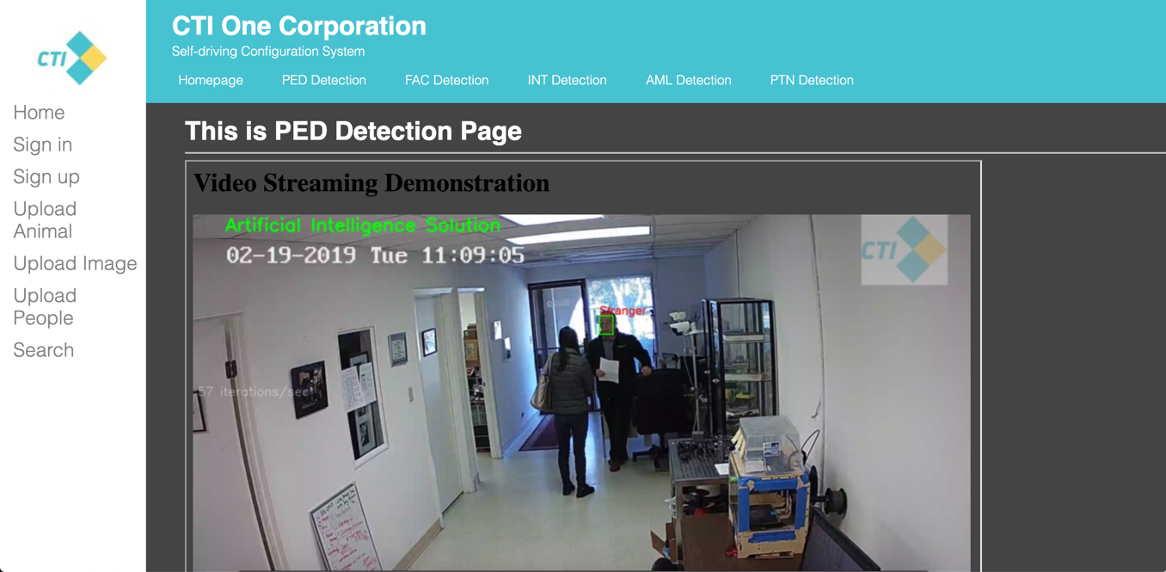
Figure 7.1 Pedestrian Detection Result.
After install pedestrian detection function, there is frames on each pedestrian on live
streaming. In Figure 7.1, we can see the result on output streaming.

Employee Attendance - TODO
Figure 8.1 Facial Detection Result.
After install facial detection function, there are two types of frames on different people. If
Database contains people’s information; it will show green frame with their name. If
Database doesn’t contain information; it will show red frame with “stranger” title. When
It detects one person, it will save the frame as image and upload it to database.
In Figure 8.1, we can see the result on output streaming.

Employee Stand Guard - TODO
Figure 9.1 Intrusion Detection Result.
After install intrusion detection function, user can use mouse to se a frame on video
Streaming to record a short video when some things were moved. The video will be saved
In local server.
In Figure 9.1, we can see the result on output streaming.

Guard Facial Recognition - TODO
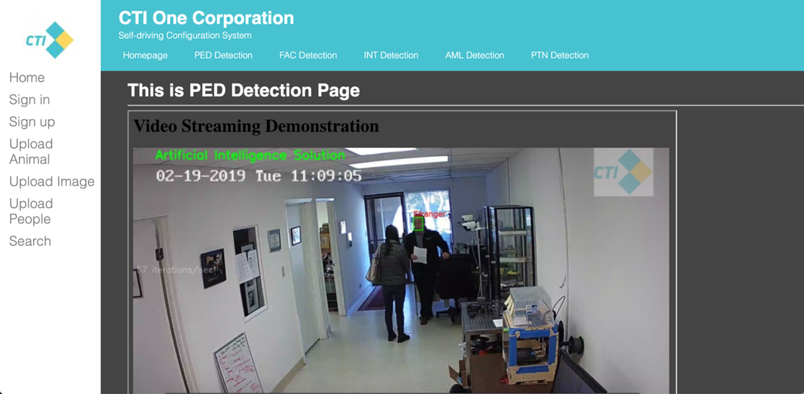
Figure 10.1 Animal Detection Result.
After install animal detection function, live video streaming will distinguish the type of
animal. User can see the animal information which was saved in database.
In Figure 10.1, we can see the result on output streaming.

Not Standing Up for Service - TODO
Figure 11.1 Plate Number Detection Result.
After install plate number detection function, for different types of plates, it will show
their plate numbers.
In Figure 11.2, we can see the result on output streaming.

Reception Area Object Displacement – TODO

UPLOAD CONFIGURATION - TODO

Upload Animal Attributes - TODO
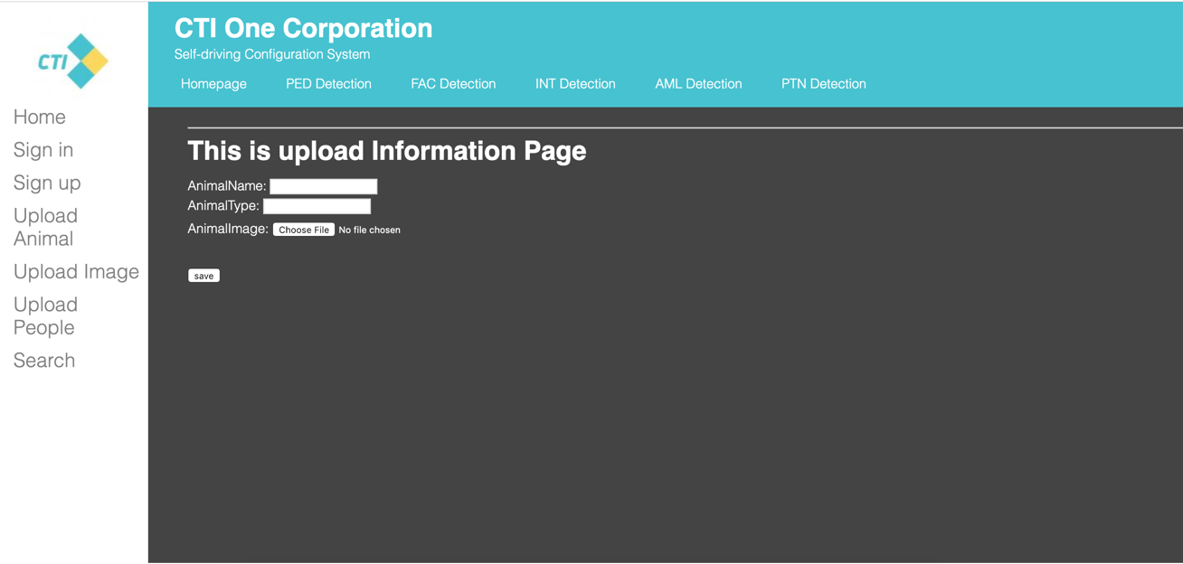
Figure 12.1 “Upload Animal” Function.
User need to upload animal information with three attributes:
1. Animal name
2. Animal Type: Big/Medium/Small
3. Animal Image
Using “submit” button, animal information will upload to “animal infos” table.
In Figure 12.1, we can see these attributes.

Upload People Attributes – TODO

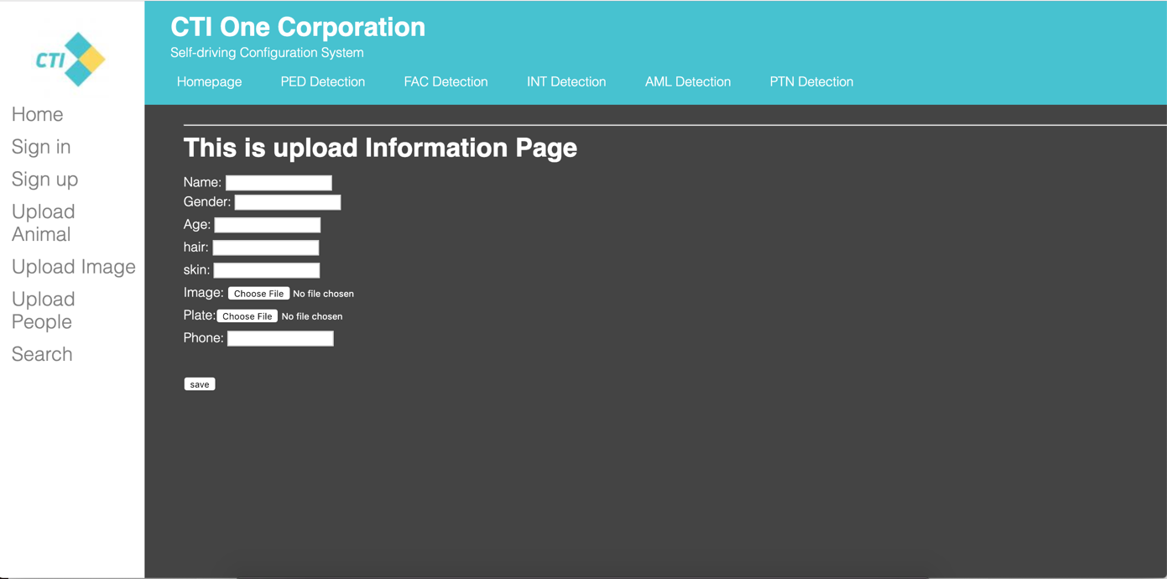
Figure 13.1 “Upload People” Function.
User need to upload people information with eight attributes:
User need to upload people information with eight attributes:
1. Name
2. Gender: male/female
3. Age
4. Hair color
5. Skin color
6. People Image
7. Plate Number
8. Phone Number
Using “submit” button, people information will upload to “people infos” table.
In Figure 13.1, we can see these attributes.

Search Function - TODO
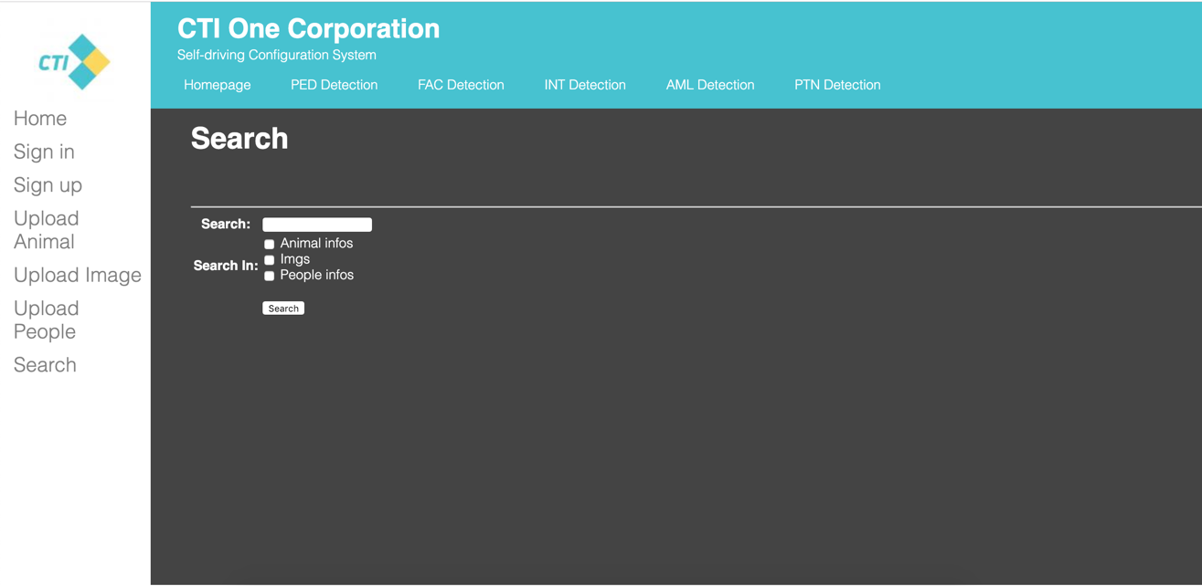
Figure 14.1 “Search” Function.
User need to choose three tables to search different information:
1. Animal infos
Include animal type, animal image and animal name
2. Imgs
Include image of facial reconginition result, time stamp, result location and the result name
3. People infos
Include image, name, gender, age, skin color, hair color, plate number, phone number
Type multi keywords like “people name+location/animal name+type/…” and choose table to do an accuracy search.
When input more keywords it will get more clearly result. The result will be shown as a list.
In Figure 14.1, we can see these choices.

Summary - TODO

AIV-100 System combine modern AI recognition technology with back-end big data statistics, use network communication protocols and database connection technology to quickly and safely and consistently present the analyzed results to users. AIV-100 System, after installation through the above steps, can be used in real-time monitoring such as hotel management, company monitoring, security systems, community entrances and exits, and crowded places in public places, timely feedback to users, real-time for unexpected situations deal with.

Appendix A Trouble Shooting

Appendix B How To Get Help

