CTI One Corporation


CAMSVR-2
User Guide

CTI One Corporation
3679 Enochs Street
Santa Clara, CA 95051

Version: 1.0

Date: Mar.18, 2020
User Guide for CAMSVR-2
CTI One Corporation
2020-03-18 | Create this document | YY

Contents
I. Hardware Description 3
Table 1. Hardware Description 3
II. Setup CAMSVR-2 4
2.1. Connect CAMSVR-2 To Host PC 4
2.2. Check USB Interface 4
2.2.1 Open a terminal window 4
2.2.2 Perform below a command to check USB Interface 4
2.3. Change USB Port Settings 4
2.3.1 Open camsvr-2/camsvr/settings.py 4
III. Operating Guide 5
3.1. Start Web Server 5
3.1.1 Move to the web server dirctory 5
3.2. Access to Web User Interface 6
3.2.1 Access to Web User Interface 6
3.3. Intrusion Detection 7
3.3.1 Intrusion Detection 7
Appendix A. Software List 9
Appendix B. Python Package List 9

I. Hardware Description

Table 1 is the hardware definition of CAMSVR-2.

Table 1. Hardware Description
Device | Description | Note
1. Camera | 1.1 Resolution 320x240;
2. Connection | 2.1 RJ-45 Interface (Cat5e Ethernet Cable)
3. Power Adapter | 3.1 Input Power: DC 12V 2A

The hardware description is illustrated in Figure 1.

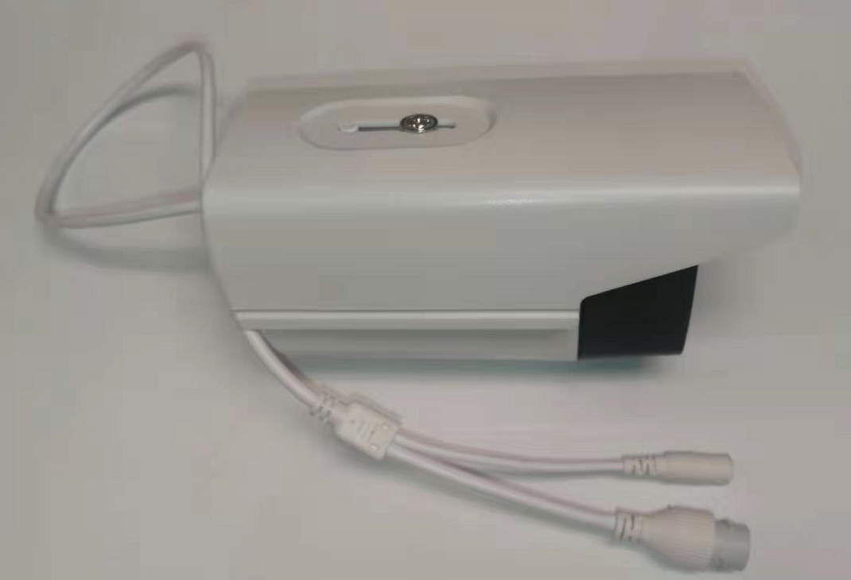

Figure 1. The hardware definition.

II. Setup CAMSVR-2

2.1. Connect CAMSVR-2 To Host PC
Connect a USB cable to a host PC; Connect Ethernet cable from CAMSVR-2 to the RJ-45 board; Connect a power supply cable to CAMSVR-2, the AI program will start on CAMSVR-2 automatically;

2.2. Check USB Interface

2.2.1 Open a terminal window

2.2.2 Perform below a command to check USB Interface
ls /dev/tty*
* Please check ttyUSB*
2.2.3 Change mode of USB interface
sudo chmod 777 /dev/ttyUSB0

2.3. Change USB Port Settings

2.3.1 Open camsvr-2/camsvr/settings.py
2.3.2 Change USB_PORT setting to same as 2.2.2
USB_PORT = '/dev/ttyUSB0'
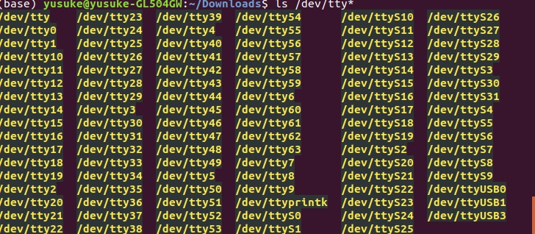

III. Operating Guide

3.1. Start Web Server

3.1.1 Move to the web server dirctory
Perform below command;
cd camsvr-2

3.2.2 Start Web Server
For running the server, perform the following command;
python3 manage.py runserver 0.0.0.0:8080

The server will start running.

3.2. Access to Web User Interface

3.2.1 Access to Web User Interface
1. Start your browser(Chromium), and enter http://127.0.0.1:8080 then hit a enter/return key, you should be directed to the starting page. See Figure 3.2.1
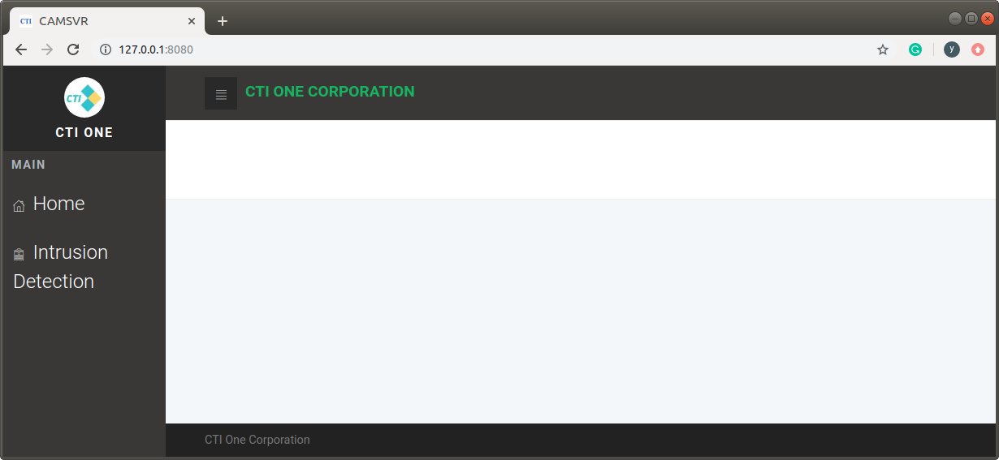

Figure 3.2.1 Web Server and UI Interface.

3.3. Intrusion Detection

3.3.1 Intrusion Detection
1. Click Intrusion Detection in the side menu, it will show the window of Intrusion Detection as Figure 3.3.1;
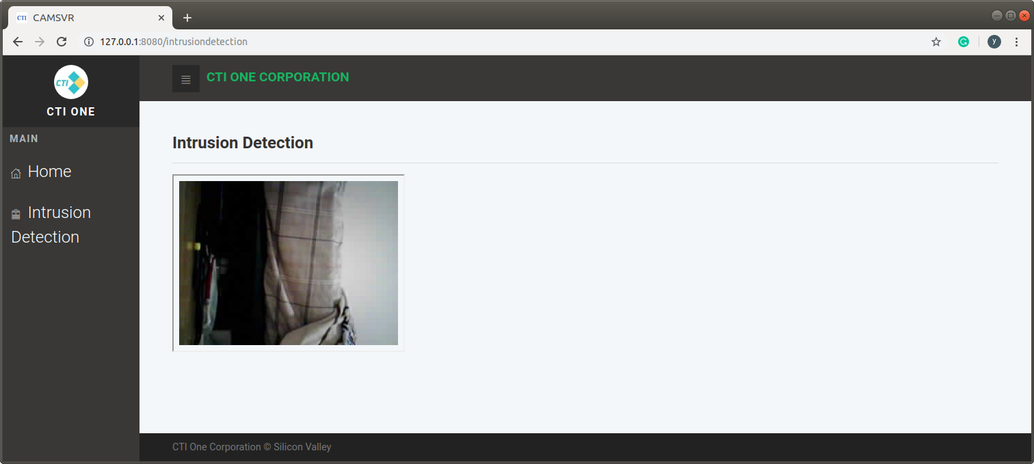

Figure 3.3.1 The window of Intrusion Detection

3.3.2 Draw a rectangle
1. In the window of Intrusion Detection, click any 2 points to draw rectangle (Not do dragging), a rectangle in green line will show as Figure 3.3.2;
(Current version Web Server does NOT show a rectangle and change picture)

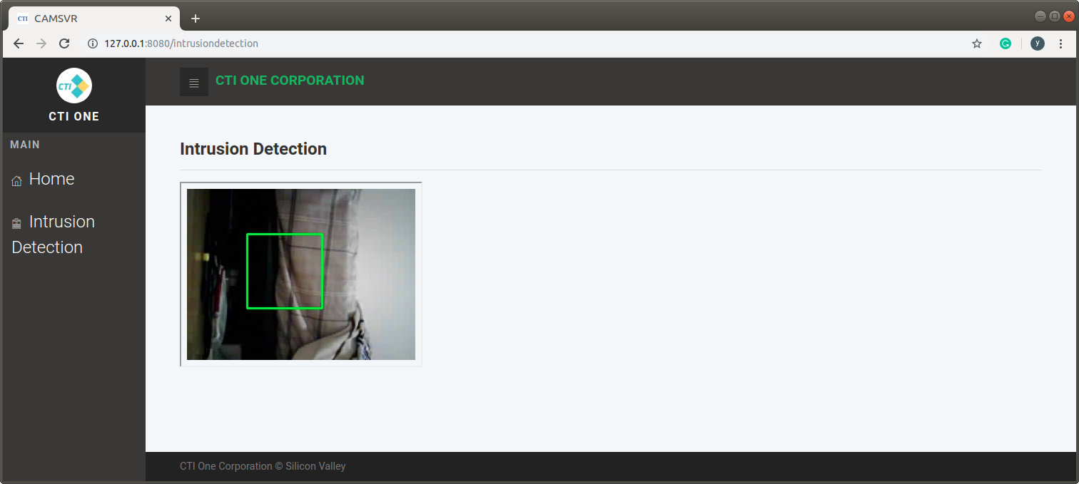

Figure 3.3.2 The rectangle in the window of Intrusion Detection

3.3.3 Detect Illegal Intrusion
1. When Illegal Intrusion is detected, The system will display a detected frame as Figure 3.3.3;
(Current version Web Server shows a previous frame that is sent by CAMSVR-2)
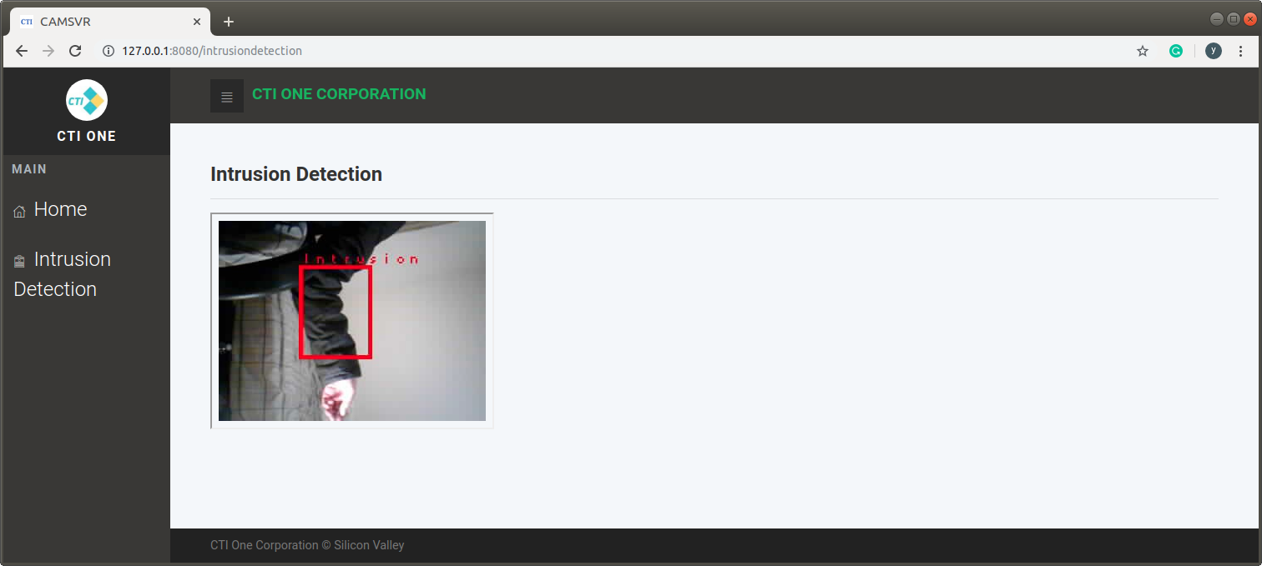

Figure 3.3.3 Detected Frame

Appendix A. Software List
Name | Version
Ubuntu | 16.04
Python | 3.5.2
Chromium | 53.0.2785.143

Appendix B. Python Package List
Name | Version | Name | Version
Django | 2.1.2 | numpy | 1.15.2
OpenCV | 3.4.2.16 | goto-statement | 1.2
pyserial | 3.4

(END)

