CAMSVR2 Bug Tracking
2020-3-17 | Establish this document | HL

Serial Number and Issue | Description | Note
3-17a CAM ribbon | a. Issue: CAM ribbon too short after installation it was broken;  b. Reported by: Minh and Shalvin;  c. Reported on, to and by: March 17, Harry by Minh on CTI chat group;  d. Analysis and by: Minh: installation by Shalvin caused the problem, Danny's prior installation had no problem back in January;  e. Correction action:  e1. keep the current design and be careful for the installation process.  e2. share this with DG manufacturing group.  f. document:
3-17b Binary Cython on host | a. Issue: ;  b. Reported by: ;  c. Reported on, to and by: ;  d. Analysis and by: ;  e. Correction action:  e1. .  e2. .  f. document:
3-17c Binary flash target board | a. Issue: ;  b. Reported by: ;  c. Reported on, to and by: ;  d. Analysis and by: ;  e. Correction action:  e1. .  e2. .  f. document:
3-17d webserver on RS232 host | a. Issue: ;  b. Reported by: ;  c. Reported on, to and by: ;  d. Analysis and by: ;  e. Correction action:  e1. .  e2. .  f. document:

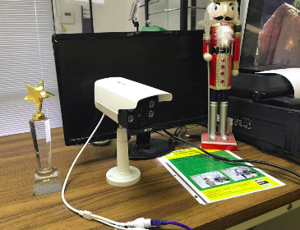

Figure 1. CAMSVR.

(END)

