CTI One Corporation, 3679 Enochs Street, Santa Clara, CA 95051

Title: README for Setup Mask RCNN
Document Number: 190l-1
CTI One Corporation
Table 1a. Document History
2022-05-2 | Establish this document, document archive: /media/harry/easystore/backup-2020-2-15/CTI/3proejcts/3-8-smart-tech/3-8-4-CTI/3-8-4-6-products/AIV200/190-robots-health/190l-mask-rcnn | YY

Table 1b. Testing and Release Approval Form
2022-05-2 | Test Status:  and  Release Status: approved for release by HL | Pending for testing and approval

Table 2. References
Number | Name and URL | Note
1. | Mask R-CNN for Object Detection and Segmentation  https://github.com/buseyaren/Installation-MaskRCNN/tree/master/Mask_RCNN  https://github.com/buseyaren/Installation-MaskRCNN | Installation
2. | Mask R-CNN for Object Detection and Segmentation  https://github.com/matterport/Mask_RCNN
3. | matterport/Mask_RCNN/releases  https://github.com/matterport/Mask_RCNN/releases
Table 3. Prerequisite
Software Prerequisite No. | Description and Version | Note
1. | Ubuntu 18.04
2. | Python version 3.6 | On Ubuntu
3. | Anaconda version 4.7.12 | On Ubuntu
Hardware Prerequisite No. | Description and Version
1. | To be added

1. Setup The Mask RCNN Environment
1.1. Create the Anaconda environment;
conda create -n maskrcnn python=3.6.12
1.2. Activate the Anaconda environment;
conda activate maskrcnn
1.3. Clone the GitHub folder;
git clone https://github.com/matterport/Mask_RCNN.git
1.4. Modify Mask_RCNN/requirements.txt
tensorflow==1.14.0
keras==2.0.5
opencv-python
h5py==2.10.0
1.5. Install the required Python package;
cd Mask_RCNN
pip install -r requirements.txt
1.6. Download the pre-trained model;
https://github.com/matterport/Mask_RCNN/releases
Download mask_rcnn_balloon.h5 from Mask_RCNN_2.1 Assets and mask_rcnn_coco.h5 from Mask_RCNN_2.0 Assets.
Copy the files to the “Mask_RCNN” folder.
1.7. Run setup.py;
python setup.py install
1.8. Loading the pycocotols module;
pip install git+https://github.com/philferriere/cocoapi.git#subdirectory=PythonAPI

2. Run Mask R-CNN
2.1. Activate the Anaconda environment;
conda activate maskrcnn
2.2. Run Jupyter Notebook
jupyter notebook
2.3. Access http://localhost:8888/tree/ by a browser
http://localhost:8888/tree/
2.4. Navigate to samples folder on the browser
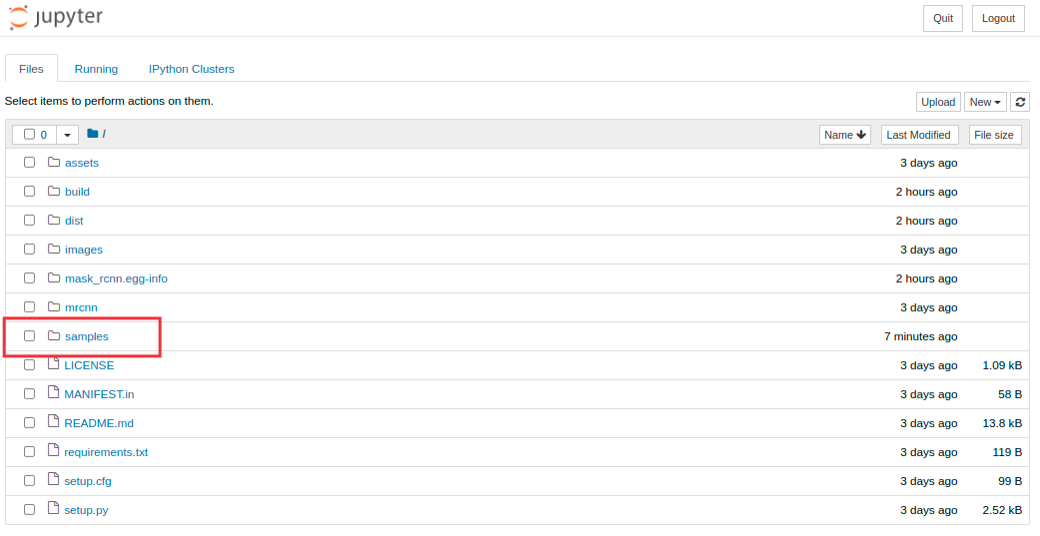
Figure 1. samples folder on Jupyter Notebook

2.5. Open demo.ipynb
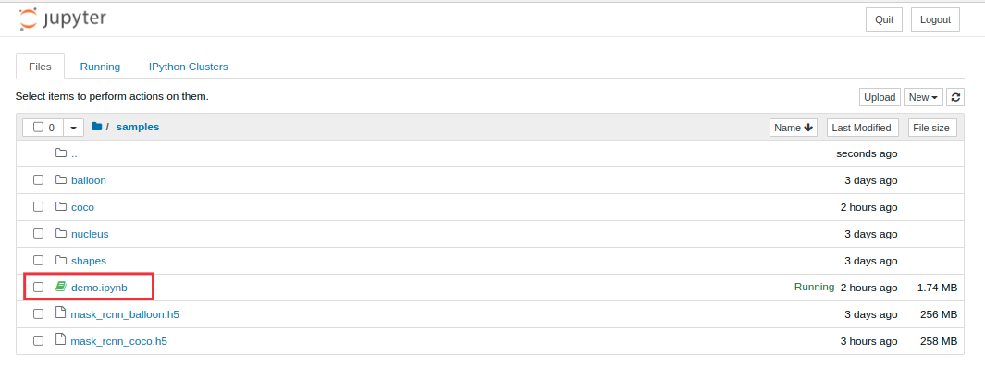
Figure 2. demo.ipynb on Jupyter Notebook

2.6. Select a code cell and push the “Run” button

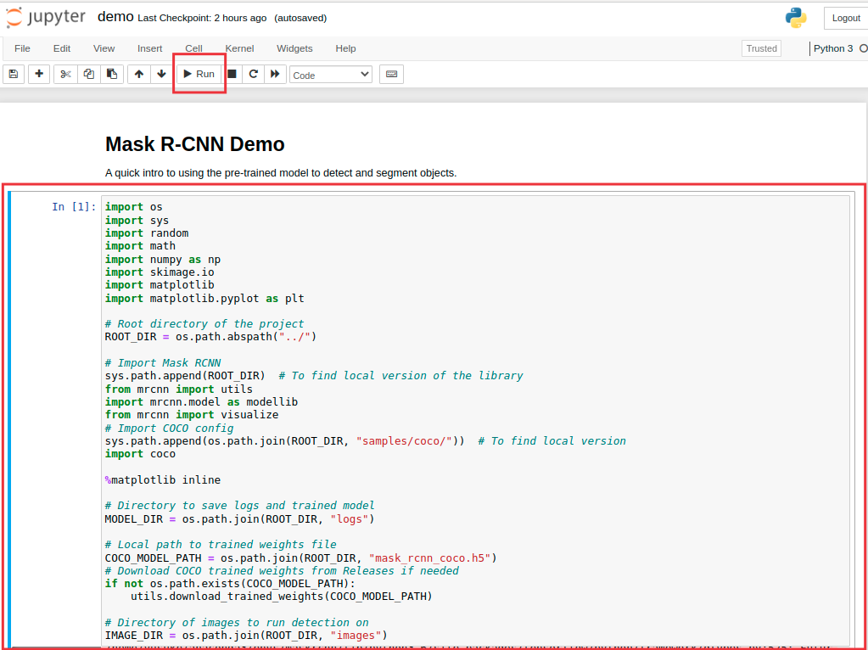
Figure 3. The first code cell on Jupyter Notebook

2.7. Run all code cells

The image is randomly chosen and the demo example is computed.

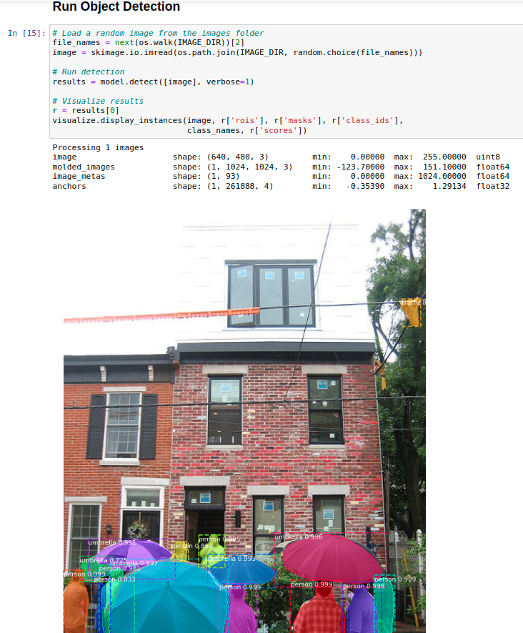
Figure 4. The result of on Jupyter Notebook
(END)

