1.

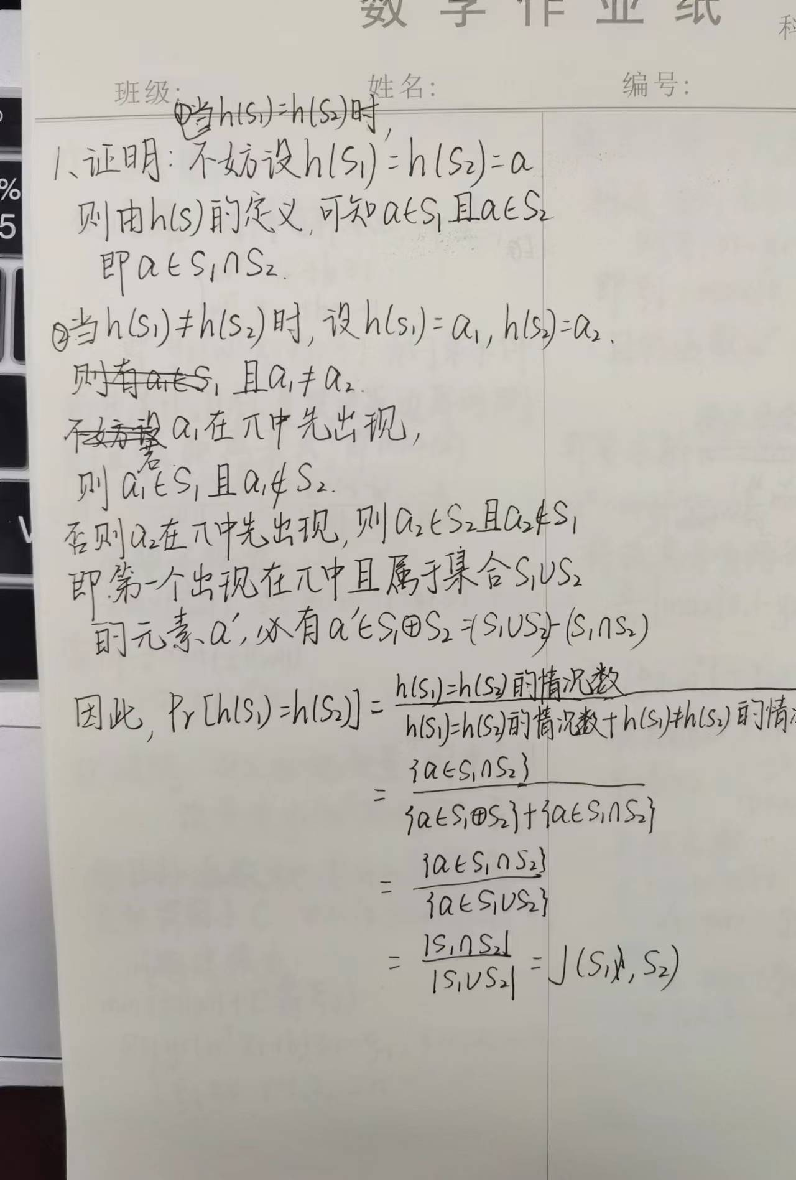

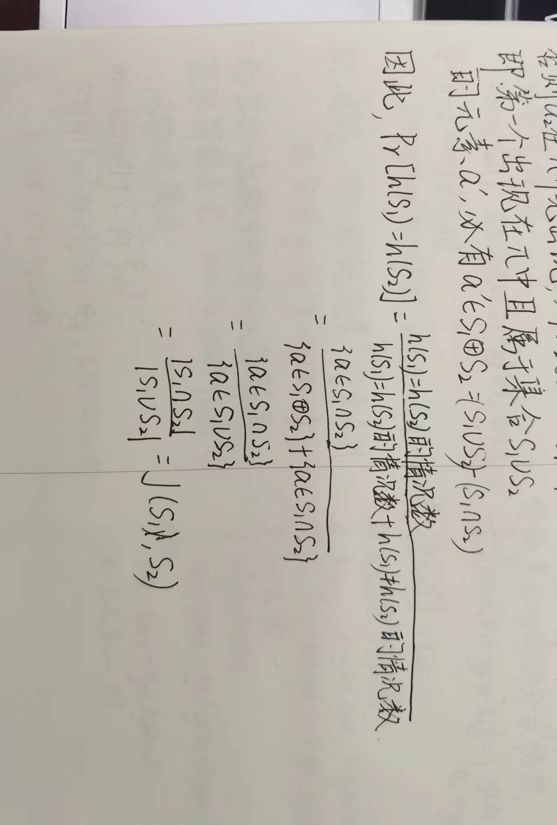

2.（a）

|  |  |  |  |  |  |  |  |
| --- | --- | --- | --- | --- | --- | --- | --- |
| element | S1 | S2 | S3 | S4 | h1 | h2 | h3 |
| 0 | 0 | 1 | 0 | 1 | 1 | 2 | 2 |
| 1 | 0 | 1 | 0 | 0 | 3 | 5 | 1 |
| 2 | 1 | 0 | 0 | 1 | 5 | 2 | 0 |
| 3 | 0 | 0 | 1 | 0 | 1 | 5 | 5 |
| 4 | 0 | 0 | 1 | 1 | 3 | 2 | 4 |
| 5 | 1 | 0 | 0 | 0 | 5 | 5 | 3 |

Signature matrix M：

|  |  |  |  |  |
| --- | --- | --- | --- | --- |
|  | S1 | S2 | S3 | S4 |
| h1 | 5 | 1 | 1 | 1 |
| h2 | 2 | 2 | 2 | 2 |
| h3 | 0 | 1 | 4 | 1 |

（b）h3，因为只有h3是全排列，未产生冲突

（c）

|  |  |  |  |  |  |  |
| --- | --- | --- | --- | --- | --- | --- |
|  | S1-S2 | S1-S3 | S1-S4 | S2-S3 | S2-S4 | S3-S4 |
| 真实 | 0 | 0 | 0.25 | 0 | 0.25 | 0.25 |
| 估计 | 0.33 | 0.33 | 0.33 | 0.67 | 1 | 0.67 |

3.

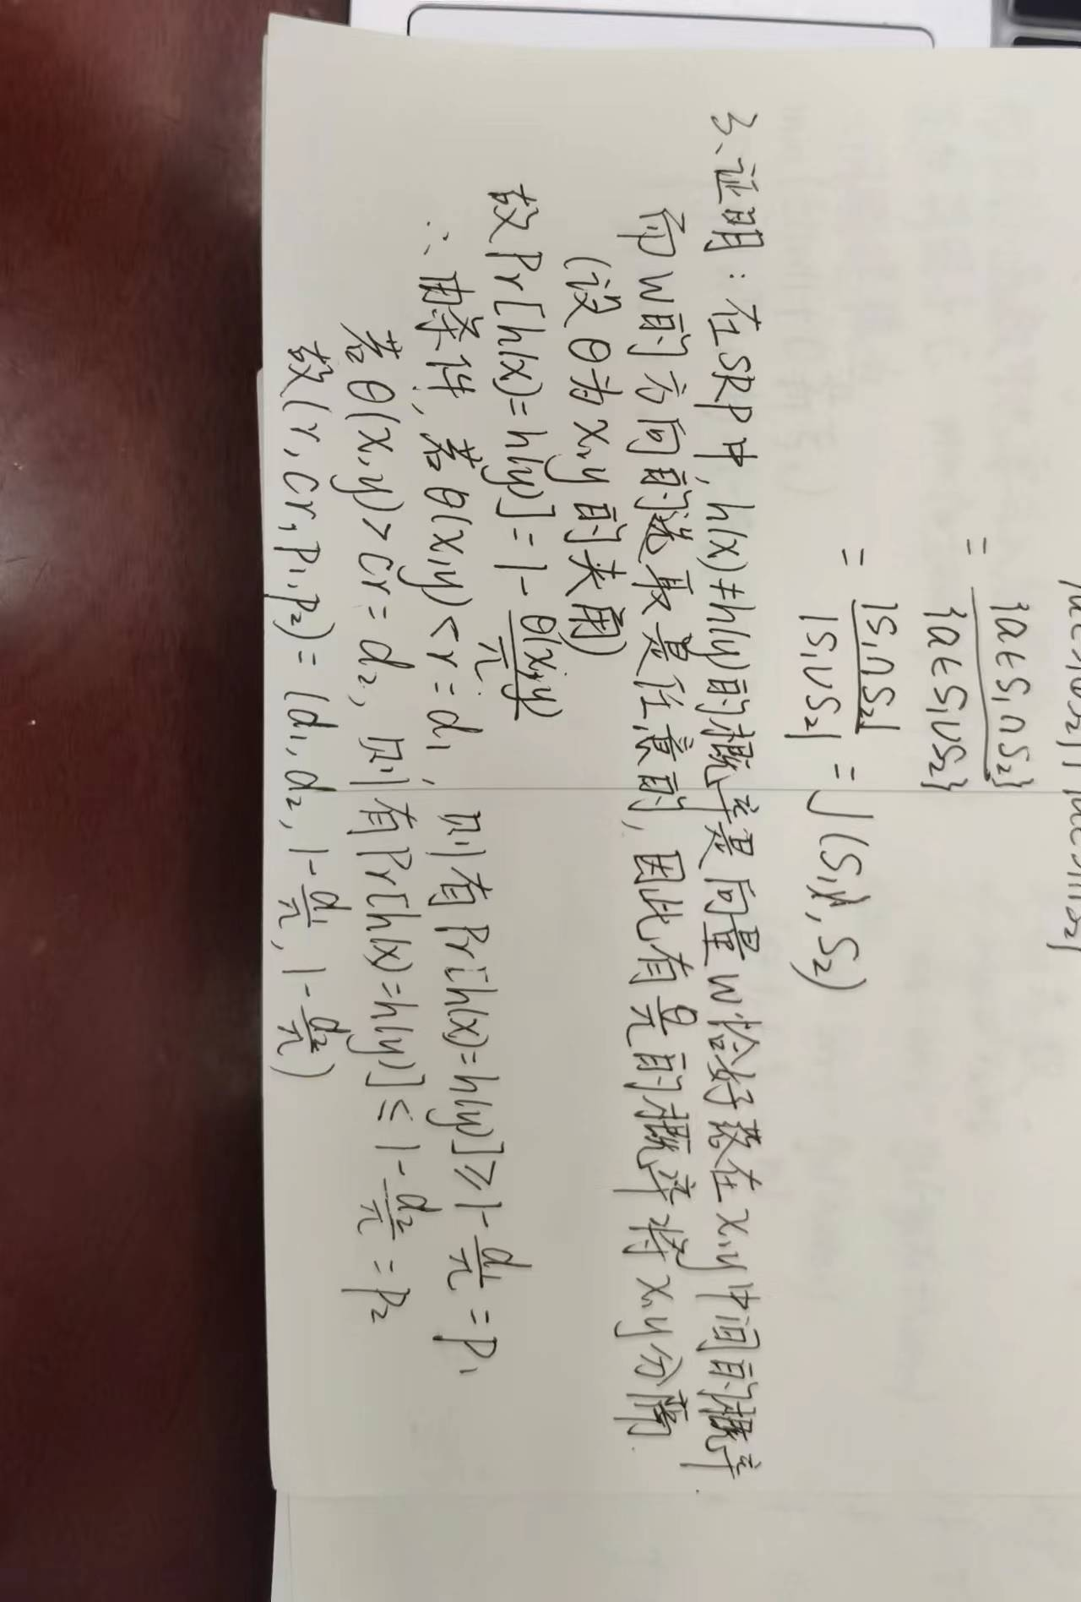

4.

