QUOTATION (报价单)

To: | From:
Attn: | From:
Tel: | Tel:
Fax.: | Fax:
E-mail: | E-mail:
Dear Valued Customer尊敬的客户
Thank you for your interest in our testing services. I am pleased to quote the following service(s) for your perusal:
您好！感谢贵司对我们测试服务的支持与关照。根据您提供的产品信息，我们做出如下建议和估价：
Product  产品名称 | Test Item  测试项目 | Conditions  测试条件 | Testing-time  测试时间 | Sample Qty’s  样品数量(pcs) | Testing fee  检测费(RMB)
Total/合计: RMB (含6%税)
Details in quotation 报价说明
1. After receiving testing samples, quotation, documents and 100% payment, then the project will be started.
自收到贵方测试样品，报价单，全部资料及100%的付款后开始。
2. Please be advised that the down payment is non-refundable, If the project is terminated due to the client and the test fee must be
charged as it occurred.
如由于客户方的原因导致项目中止，则项目开始前支付的款项不予退还，并且实际发生的费用必须结清。
3. If the real test sample varies from the documents provided in advance, the test fee will be charged as they occur.
如果提供的测试样品与原来报价时提供的资料不符，增加的测试费用将按实收取。
4.This quotation is valid for 30 days, and the quotation fee will be funds received by us.
本报价单自本日起30天内有效，所报金额为我司实收金额。
Payment accounts 付款账号
公司名称 | 鸿富锦精密工业(深圳)有限公司
人民币账号 | 757 557 937 216
开户银行名称 | 中国银行股份有限公司深圳龙华支行
Please give us the transfer documents by fax or email, after marking the remittance.
请支付款项后，将付款底单以传真或email的形式回传给我们。
We assure you of our best services at all times, Please sign and return if you accept this quotation.
我们竭诚为您提供最好的服务，若您接受此报价，请签字并回传给我们。
Foxconn China Measurement Center Confirmed and Accepted By:
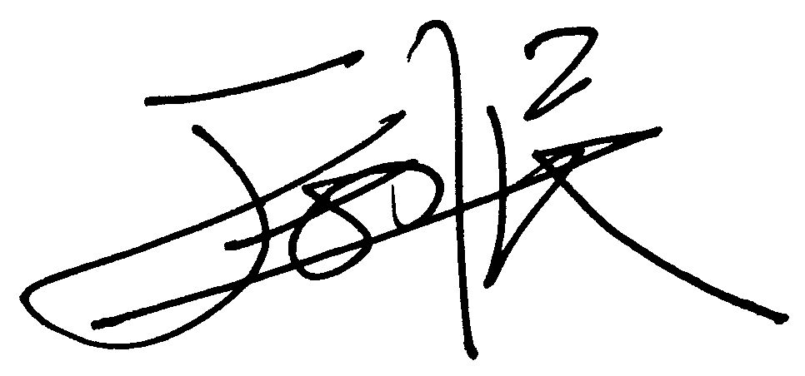
Signature with Stamp Signature with Stamp

____________________________ _____________________________
Date(日期): 2013-05-13 Date(日期):

