Algorithms
Programming Assignment #1
Sorting
Introduction:
In this PA, you are required to implement various sorters that we learnt in the class. You can download the PA1.zip file from Ceiba website. Uncompress it using linux command,
unzip PA1.zip
You can see the following directories after uncompressing it.
Name | Description
bin/ | Directory of binary file
doc/ | Directory of document
inputs/ | Directory of unsorted data
lib/ | Directory of library source code
outputs/ | Directory of sorted data
src/ | Directory of source code
utility/ | Directory of checker

Input/output Files:
In the input file (*.in), the first two lines starting with ‘#’ are just comments. Except comments, each line contains two numbers: index followed by the unsorted number. The range of unsorted number is between 0 and 1,000,000. Two numbers are separated by a space. For an example, the file 5.ac.in contains five numbers
# 5 data points
# index number
0 16
1 13
2 0
3 6
4 7
The output file(*.out) is actually the same as the input file except that the numbers are sorted in increasing order. For example 5.ac.out is like:
# 5 data points
# index number
0 0
1 6
2 7
3 13
4 16

PLOT:
You can visualize your unsorted/sorted numbers by using the gnuplot tool by the command gnuplot. After that, please key in the following

set xrange [0:5]
set yrange [0:20]
plot "5.ac.in" usi 1:2
plot "5.ac.out" usi 1:2

# if you want to save to png files
set terminal png
set output "5.ac.out.png"
replot
You need to allow X-window display to see the window if you are login remotely. For more gnuplot information, see
http://people.duke.edu/~hpgavin/gnuplot.html

There are two example "before" and "after" sort pictures with 100 numbers benchmark.
Before sort：
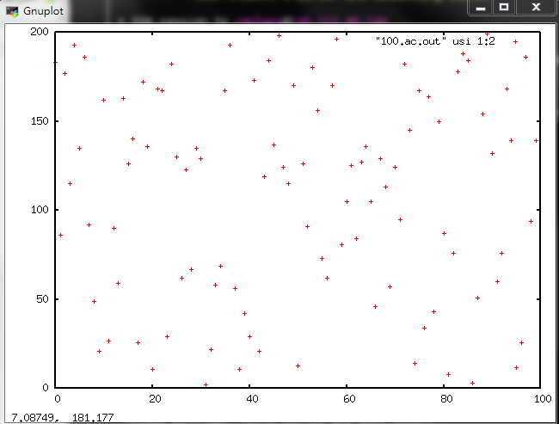
After sort：
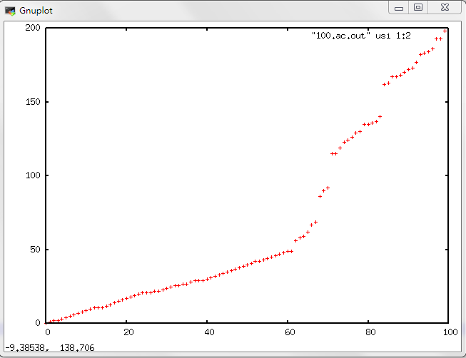

Command line parameters:
In the command line, you are required to follow this format
NTU_sort –[IS|MS|QS] <input_file_name> <output_file_name>
where IS represents insertion sort, MS is merge sort, and QS is quick sort. The square bracket with vertical bar ‘[IS|MS|QS]’ means that only one of the three versions is chosen.
The angle bracket <input_file_name> should be replaced by the name of the input file, *.[ac|bc|wc].in, where ac represents average case, bc is best case, and wc is worst case. For the best case, all the numbers are sorted in increasing order. For the worst case, all numbers are sorted in descending order. For the average case, numbers are in random order.
The output file names are *.[ac|bc|wc].out. Please note that you do NOT need to add ‘[|]’ or ‘<>’ in your command line. For example, the following command sorts 10000.ac.in to 10000.ac.out using insertion sort.
./bin/NTU_sort -IS inputs/10000.ac.in outputs/10000.ac.out
Source code files:
Notice: You are not allowed to use “sort” or “priority_queue” in STL!!

Please notice that all of the source code files have been already finished except sort_tool.cpp. You only need to complete the different sorting functions of class SortTool in sort_tool.cpp. You can still modify other source code files if you think it is necessary. The following will simply introduce the source code files.
main.cpp : main program for PA1

main.cpp
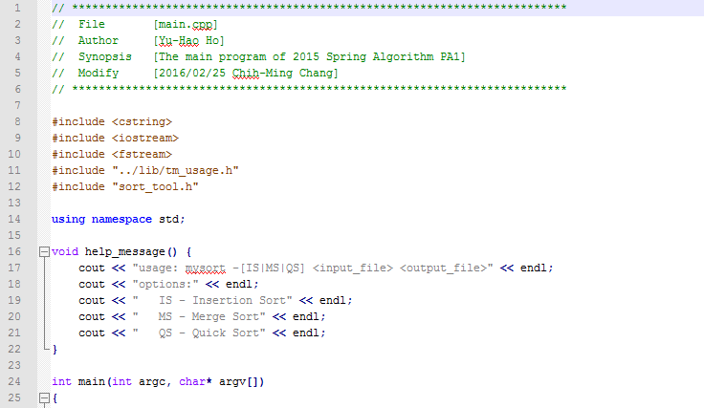
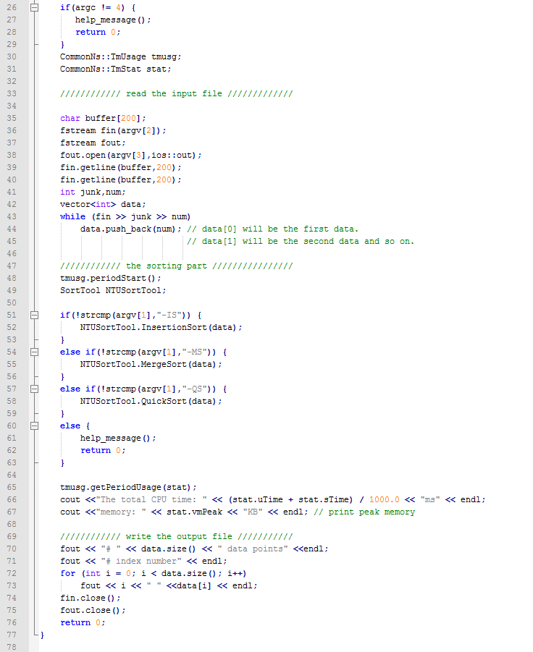
Line 34-44: parse unsorted data from input file and push them into the vector.
Line 51-63: call different function depending on given command.
Line 70-73: write the sorted data file.

sort_tool.h : the header file for the SortTool Class
sort_tool.h
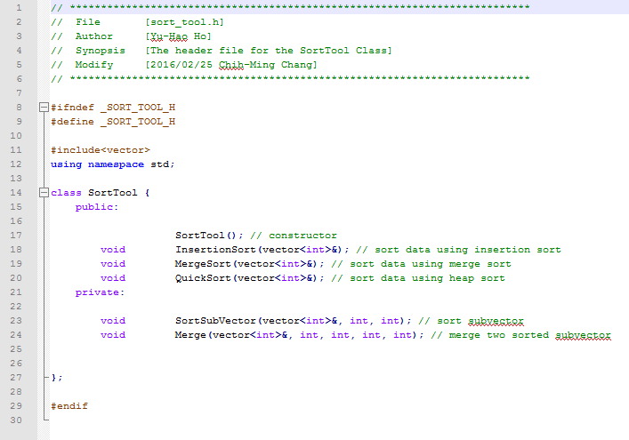
Line 18-20: sort function which will be called in main.cpp.
Line 23: This function will be used in merge sort. It will sort sub vector with given lower and upper bound. This function should be implemented to call itself for splitting and merging the sub vector.
Line 24: This function will be used in merge sort and should be implemented to merge two sorted sub vector.

sort_tool.cpp : the implementation of the SortTool Class
sort_tool.cpp
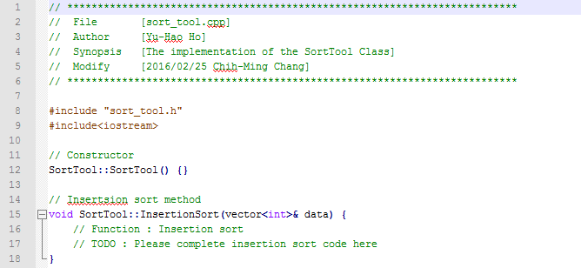
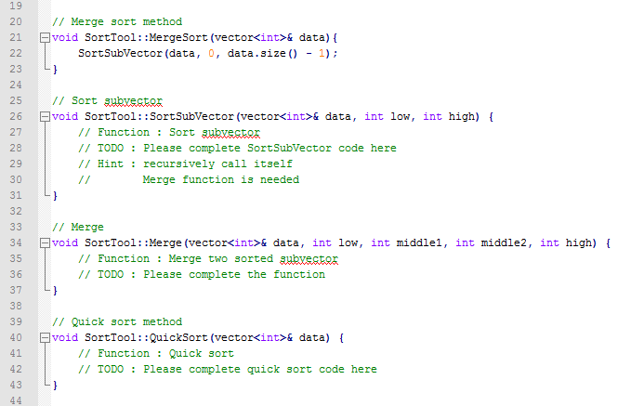
Line 15-18: please complete the function of insertion sort here.
Line 21-23: the function of merge sort will call function of Sorting sub-vector and give initial lower/upper bound.
Line 26-31: please complete the function of sorting sub-vector here.
Line 34-37: please complete the function of merging two sorted sub-vector here.
Line 40-43: please complete the function of quick sort here.

Requirements:
1. Please check the source code files under the src directory. You may need to complete the functions of class SortTool in sort_tool.cpp. You can also modify main.cpp and sort_tool.h if you think it is necessary.
2. Your source code must be written in C or C⁺⁺. The code must be executable on EDA union lab machines.
3. In your report, compare the running time of three versions of different input sizes. Please fill in the following table and also plot a figure showing the memory and running time. Please use –O2 optimization and turn off all debugging message.
Input size | IS |  | MS |  | QS
 | CPU time  (s) | Memory  (KB) | CPU time  (s) | Memory  (KB) | CPU time  (s) | Memory  (KB)
1000.bc
1000.wc
1000.ac
4000.bc
4000.wc
4000.ac
16000.bc
16000.wc
16000.ac
32000.bc
32000.wc
32000.ac
1000000.bc
1000000.wc
1000000.ac
10000000.bc
10000000.wc
10000000.ac
4. Draw figures to show the growth of running time as a function of input size. Please draw all three cases: ac, wc and bc.
5. Large case (>1000000) can be download from
https://www.dropbox.com/s/rrd4qd42bc72wip/PA1_largecase.zip?dl=0

Compile:
We expected your code can compile and run in this way.
Type the following commands under <student_id>_pa1 directory,
make
cd bin
./NTU_sort
We provide the sample makefile, please modify into yours.
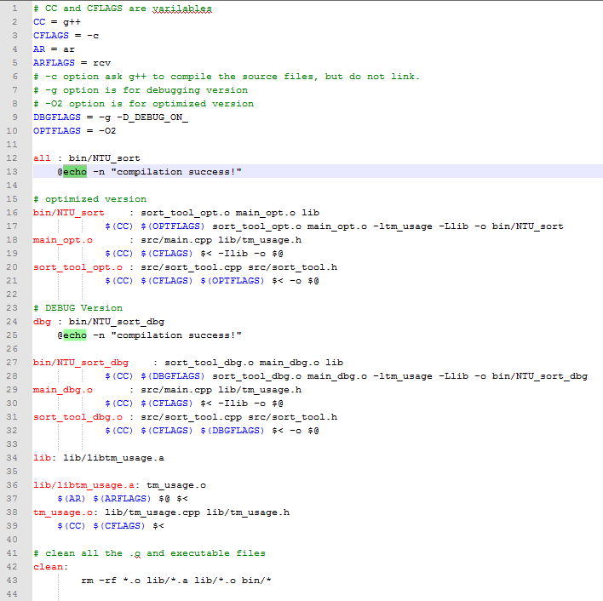
makefile
Line 38-39: compile the object file tm_usage.o from tm_usage.cpp and tm_usage.h
Line 36-37: archive tm_usage.o into a static library file libtm_usage.a. Please note that library must start with lib and ends with .a.
Line 37: this small library has only one objet file. In a big library, more than one objective files can be archived into a single lib*.a file like this
ar rcv libx.a file1.o [file2.o …]
Lines 12-21: When we type ‘make’ without any option the makefile will do the first command (line.12 in this sample). Thus, we can compile the optimization version when we type ‘make’. This version invokes options ‘-O2’ for speed improvement. Also ‘_DEBUG_ON_’ is not defined to disable the printing of arrays in sort_tool.cpp.
Lines 23-32: Compile the debug version when we type ‘make dbg’. This version invokes options ‘-g’ (for DDD debugger) and also ‘-D_DEBUG_ON_’ to enable the printing of arrays in sort_tool.cpp.
Lines 13,25: @echo –n “compilation success!” will print out the message in “compilation success!”.

Notice: $< represent the first dependency.
$@ represent the target itself.
Example: a.o : b.cpp b.h
$(CC) $(CFLAGS) $(DBGFLAGS) $< -o $@
$< = b.cpp $@ = a.o

You can find some useful information here.
http://mrbook.org/tutorials/make/

Submission:
Please submit a hardcopy of your report in class. Also, please submit a single *.tgz file to CEIBA system. Your submission must contain:
1. <student_id>_pa1 directory contains your source code in src directory. By simply typing “make” can compile.
2. a report in the doc directory. <student_id>_pa1_report.doc. Please also submit a printed report in class.
3. a README file that explains your files.
4. We will use our own test cases so do NOT include the input files.

The submission filename should be compressed in a single file <student_id>_pa1.tgz. (e.g. b90901000_pa1.tgz). If you have a modified version, please add _v2 as a postfix to the filename and resubmit it (e.g. b90901000_pa1_v2.tgz). You can use the following command to compress a whole directory:
tar -zcvf <filename>.tgz <dir>

Checker:
You must use checker which is under utility directory to check whether your result is correct or not. Please put your .tgz file in the utility directory. To use this checker, simply type
cd utility
./checkSubmitPA1.sh <filename>.tgz
For example:
./checkSubmitPA1.sh b99901000_pa1.tgz
Please notice that it will only check your data order and will not check whether the format of result file is correct or not. You have to check the format by yourself if you modify the part of writing output file in main.cpp.

We have so many students in the class so we need automatic grading. Any mistake in the submission will result in cost 20% off your score. Please be very careful in your submission.

Grading:
60% correctness (including submission correctness)
20% file format and location
20% report
Bonus :
5% bonus will be given to any extra features that you add to make your sorter faster. Please write clearly in your report.

NOTE:
TA will check your source code carefully. Copying other source code can result in zero grade for all students involved.

