Title
Abstract
Keywords: aaa, bbb, ccc

Introduction (Style: Heading 1)
Paragraph 1. (Style: Paragraphs)
Paragraph 2. (Style: New paragraphs)

Literature Review

Topic 1 (Style: Heading 2)

Topic 1.1 (Style: Heading 3)
This is an example of citing a table, a figure, and a Equation. Table 1 shows nothing meaningful. Figure 1 is just an example here. Equation (1) is a imple equation, and you need to type ‘Equation’ before the number (1).
(To insert a caption of a Table, right click the table, choose ‘Insert Caption’, and choose ‘Table’ and ‘Above Selected Item’. To insert a caption of a Figure, right click the figure, choose ‘Insert Caption’, and choose ‘Figure’ and ‘Below Selected Item’)
(Using table template: there are two templates here, namely ‘SanXianBiao’ and ‘SanXianBiao_Simple’. They are accessible in Insert -> Table -> Quick Tables)
(To cite a table/figure, please use Insert -> Cross-reference -> Choose ‘Table’ or ‘Figure’ -> Choose ‘Only label and number’ -> Choose the item that you want to cite)
(Mostly you don’t need to change the style of Table/Figure caption. In case you need to, in the top menu, choose Home -> the righ-bottom arrow of ‘Styles’ -> in the pop-up window, choose ‘Caption’ -> update the style there.)
Table 1. Table caption (Style: Caption) (Table template: SanXianBiao_Simple)
n | m | Solution time (h) | Objective value | Optimal?
25 | 3 | 0.03 | 0.1871 | Y
25 | 4 | 0.04 | 0.1397 | Y
25 | 5 | 0.24 | 0.1082 | Y
25 | 6 | 11.3 | 0.1003 | Y
25 | 7 | 15.6 | 0.0828 | Y
25 | 8 | 24 | 0.0723 | N
25 | 9 | 24 | 0.0605 | N

Table 2. Table caption (Table template: SanXianBiao)
 |  | GUROBI |  |  |  | GP-TS
n | m | Solution time (h) | Objective value | Optimal? |  | Best gap (%) | Average gap(%)
25 | 3 | 0.03 | 0.1871 | Y |  | 0.00 | 0.00
25 | 4 | 0.04 | 0.1397 | Y |  | 0.00 | 0.00
25 | 5 | 0.24 | 0.1082 | Y |  | 12.80 | 12.80
25 | 6 | 11.3 | 0.1003 | Y |  | 0.89 | 0.89
25 | 7 | 15.6 | 0.0828 | Y |  | 0.00 | 11.55
25 | 8 | 24 | 0.0723 | N |  | 0.00 | 0.99
25 | 9 | 24 | 0.0605 | N |  | 9.11 | 18.58

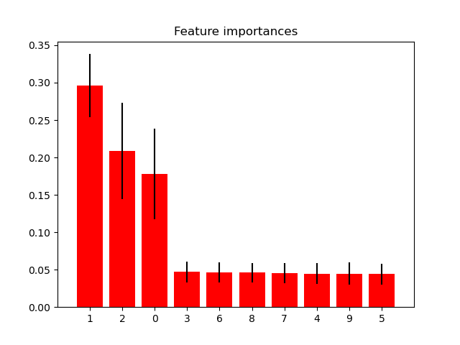
Figure 1. Figure caption (Style: Caption)

(To insert a numbered formula, please use Insert -> Table -> Quick Tables -> Table_Formula_Numbered. This will insert a column row table as below. Alternatively, you can copy and paste the table below. The number can be updated using the F9 shortcut.)
(To cite a formula, using Insert -> Cross-reference -> Equation -> Entire caption. The cited style would be (#), with # representing the equation number.)
 | $obj=α\frac{\sum_{k=1}^{m}{L_{k}}}{m}+\left(1-α\right)\frac{\sum_{k=1}^{m}{{AD}_{k}}}{m}$ | (1)

 | $obj=α\frac{\sum_{k=1}^{m}{L_{k}}}{m}+\left(1-α\right)\frac{\sum_{k=1}^{m}{{AD}_{k}}}{m}$ | (2)

Acknowledgements

References
To cite an item in the text using Mendeley, use Refereces -> Mendeley Cite-O-Matic -> Insert Citation
To add a bibliography, use Refereces -> Mendeley Cite-O-Matic -> Insert Bibliography
If you cite a paper within a group of collaborators, please choose the paper from the Mendeley group that is shared within this group of collaborators. This guarantees that all collaborators can view and revise the citations without errors.

