题目1：

源代码：

package School.HomeWork;

import java.util.ArrayList;

import java.util.Collections;

import java.util.List;

import java.util.Random;

import java.util.Scanner;

public class _3_1 {

public static void main(String[] args) {

Scanner scanner = new Scanner(System.in);

//随机点名

System.out.print("请输入学生人数（2<=N<=10）：");

int n = scanner.nextInt();

scanner.nextLine();

if (n < 2 || n > 10) {

System.out.println("输入人数不符合要求！");

return;

}

List<String> names = new ArrayList<>();

System.out.println("请输入学生姓名：");

for (int i = 0; i < n; i++) {

names.add(scanner.nextLine());

}

//随机点名

Random random = new Random();

int randomIndex = random.nextInt(n);

System.out.println("随机点名结果： " + names.get(randomIndex));

//分组

System.out.println("\n=== 拓展功能：随机分组 ===");

System.out.print("请输入每组人数（1<=M<N）：");

int m = scanner.nextInt();

scanner.nextLine();

if (m < 1 || m >= n) {

System.out.println("输入每组人数不符合要求！");

return;

}

//按字典序排序

Collections.sort(names);

List<List<String>> groups = new ArrayList<>();

//分组

for (int i = 0; i < n; i += m) {

groups.add(new ArrayList<>(names.subList(i, Math.min(i + m, n))));

}

//输出分组结果

System.out.println("分组结果：");

for (int i = 0; i < groups.size(); i++) {

System.out.println("组 " + (i + 1) + "：" + groups.get(i));

}

}

}

运行截图：

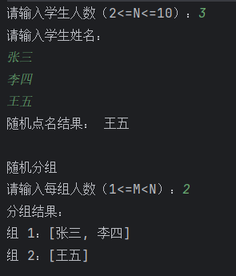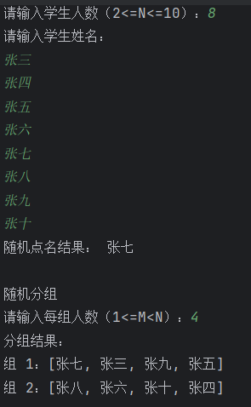

题目2：

源代码：

package School.HomeWork;

public class _3_2 {

public static void main(String[] args) {

int[] array1 = {16, 13, 15, 18};

int[] array2 = {29, 36, 100};

//调用合并方法

int[] mergedArray = arrayMerge(array1, array2);

//输出合并后的数组

System.out.print("合并后的数组: ");

for (int num : mergedArray) {

System.out.print(num + " ");

}

}

//合并两个数组的方法

public static int[] arrayMerge(int[] a, int[] b) {

int[] mergedArray = new int[a.length + b.length];

//将第一个数组的元素复制到新数组

System.arraycopy(a, 0, mergedArray, 0, a.length);

//将第二个数组的元素复制到新数组

System.arraycopy(b, 0, mergedArray, a.length, b.length);

return mergedArray;

}

}

运行截图：



题目3：

源代码：

package School.HomeWork;  
  
import java.util.Arrays;  
import java.util.Scanner;  
  
public class _3_3 {  
 public static void main(String[] args) {  
 Scanner input = new Scanner(System.*in*);  
 //输入 n  
 System.*out*.print("Enter n: ");  
 int n = input.nextInt();  
 //输入矩阵 m1  
 System.*out*.println("Enter m1 (a " + n + " by " + n + " matrix) row by row:");  
 int[][] m1 = new int[n][n];  
 for (int i = 0; i < n; i++) {  
 for (int j = 0; j < n; j++) {  
 m1[i][j] = input.nextInt();  
 }  
 }  
 //输入矩阵 m2  
 System.*out*.println("Enter m2 (a " + n + " by " + n + " matrix) row by row:");  
 int[][] m2 = new int[n][n];  
 for (int i = 0; i < n; i++) {  
 for (int j = 0; j < n; j++) {  
 m2[i][j] = input.nextInt();  
 }  
 }  
 //判断并输出结果  
 if (*equals*(m1, m2)) {  
 System.*out*.println("The two arrays are identical");  
 } else {  
 System.*out*.println("The two arrays are not identical");  
 }  
 input.close();  
 }  
 //判断两个二维数组是否相同  
 public static boolean equals(int[][] m1, int[][] m2) {  
 if (m1.length != m2.length || m1[0].length != m2[0].length) {  
 return false;  
 }  
 //逐个元素比较  
 m1 = *Sort*(m1);  
 m2 = *Sort*(m2);  
 for (int i = 0; i < m1.length; i++) {  
 for (int j = 0; j < m1[i].length; j++) {  
 if (m1[i][j] != m2[i][j]) {  
 return false;  
 }  
 }  
 }  
 return true;  
 }  
 //二维数组排序  
 public static int[][] Sort(int [][] n) {  
 //展开成一维数组  
 int[] number = new int[n.length * n[0].length];  
 int num = 0;  
 for (int[] row : n) {  
 for (int line : row) {  
 number [num++] = line;  
 }  
 }  
 //排序一维数组  
 Arrays.*sort*(number );  
 //重新构造成二维数组  
 int[][] newnumber = new int[n.length][n[0].length];  
 num = 0;  
 for (int i = 0; i < newnumber.length; i++) {  
 for (int j = 0; j < newnumber[i].length; j++) {  
 newnumber[i][j] = number [num++];  
 }  
 }  
 return newnumber;  
 }  
  
}

运行截图：

