以下是在n=100的随机图3-SAT情况下进行的

4_0 表示R=4 没有引用数据
6-4 表示R=6 有引用R=4的数据
（R=2等价于普通BP）
Method Avg Entropy Avg Error Avg Time (s) Avg Steps
Exact 59.60591440 0.00000000 0.029422 N/A
BP 59.60680298 0.03707160 0.376082 6.06
FTNBP_2_0 59.60680084 0.00062284 4.519642 7.56
FTNBP_4_0 59.60074913 0.00023502 5.027207 7.96
FTNBP_6_0 59.60655006 0.00008519 8.685078 7.84
FTNBP_8_0 59.60546349 0.00003714 23.332000 6.06
FTNBP_10_0 59.60574814 0.00000407 21.405717 4.34
FTNBP_2_2 59.60679985 0.00062276 1.016047 1.00
FTNBP_2_4 59.60771172 0.00061712 4.360071 5.30
FTNBP_2_6 59.60755280 0.00061548 1.403325 1.00
FTNBP_2_8 59.60851089 0.00060407 1.603872 1.00
FTNBP_2_10 59.60872192 0.00060597 1.785345 1.00
FTNBP_4_2 59.60075470 0.00023487 3.601191 5.52
FTNBP_4_4 59.60075935 0.00023455 3.875007 4.62
FTNBP_4_6 59.60075668 0.00023495 5.725012 5.84
FTNBP_4_8 59.60074768 0.00023504 7.134551 6.24
FTNBP_4_10 59.60075249 0.00023503 8.226932 6.30
FTNBP_6_2 59.60656441 0.00008486 6.335867 5.50
FTNBP_6_4 59.60654007 0.00008511 6.716541 5.06
FTNBP_6_6 59.60656288 0.00008509 7.427618 5.00
FTNBP_6_8 59.60657936 0.00008582 8.323446 5.06
FTNBP_6_10 59.60658043 0.00008583 9.090965 5.04
FTNBP_8_2 59.60546043 0.00003723 10.986786 2.88
FTNBP_8_4 59.60546074 0.00003720 13.090648 2.64
FTNBP_8_6 59.60546028 0.00003719 16.010704 2.64
FTNBP_8_8 59.60546097 0.00003720 18.672159 2.58
FTNBP_8_10 59.60546066 0.00003720 21.899464 2.64
FTNBP_10_2 59.60574539 0.00000405 10.238415 2.00
FTNBP_10_4 59.60574554 0.00000405 14.489793 1.96
FTNBP_10_6 59.60574570 0.00000405 18.886718 1.96
FTNBP_10_8 59.60574570 0.00000405 23.277247 1.96
FTNBP_10_10 59.60574577 0.00000406 21.196847 1.58

结果已保存到 averages.csv

以下是按照 R=2、4、6、8、10 分组，每组包含对应 R 值的所有六个变种（后缀 0,2,4,6,8,10）的表格。每个表格列出了方法名称、平均熵、平均误差、平均时间和平均步数。
---

R=2 组
Method | Avg Entropy | Avg Error | Avg Time (s) | Avg Steps
FTNBP_2_0 | 59.60680084 | 0.00062284 | 4.519642 | 7.56
FTNBP_2_2 | 59.60679985 | 0.00062276 | 1.016047 | 1.00
FTNBP_2_4 | 59.60771172 | 0.00061712 | 4.360071 | 5.30
FTNBP_2_6 | 59.60755280 | 0.00061548 | 1.403325 | 1.00
FTNBP_2_8 | 59.60851089 | 0.00060407 | 1.603872 | 1.00
FTNBP_2_10 | 59.60872192 | 0.00060597 | 1.785345 | 1.00

R=4 组
Method | Avg Entropy | Avg Error | Avg Time (s) | Avg Steps
FTNBP_4_0 | 59.60074913 | 0.00023502 | 5.027207 | 7.96
FTNBP_4_2 | 59.60075470 | 0.00023487 | 3.601191 | 5.52
FTNBP_4_4 | 59.60075935 | 0.00023455 | 3.875007 | 4.62
FTNBP_4_6 | 59.60075668 | 0.00023495 | 5.725012 | 5.84
FTNBP_4_8 | 59.60074768 | 0.00023504 | 7.134551 | 6.24
FTNBP_4_10 | 59.60075249 | 0.00023503 | 8.226932 | 6.30

R=6 组
Method | Avg Entropy | Avg Error | Avg Time (s) | Avg Steps
FTNBP_6_0 | 59.60655006 | 0.00008519 | 8.685078 | 7.84
FTNBP_6_2 | 59.60656441 | 0.00008486 | 6.335867 | 5.50
FTNBP_6_4 | 59.60654007 | 0.00008511 | 6.716541 | 5.06
FTNBP_6_6 | 59.60656288 | 0.00008509 | 7.427618 | 5.00
FTNBP_6_8 | 59.60657936 | 0.00008582 | 8.323446 | 5.06
FTNBP_6_10 | 59.60658043 | 0.00008583 | 9.090965 | 5.04

R=8 组
Method | Avg Entropy | Avg Error | Avg Time (s) | Avg Steps
FTNBP_8_0 | 59.60546349 | 0.00003714 | 23.332000 | 6.06
FTNBP_8_2 | 59.60546043 | 0.00003723 | 10.986786 | 2.88
FTNBP_8_4 | 59.60546074 | 0.00003720 | 13.090648 | 2.64
FTNBP_8_6 | 59.60546028 | 0.00003719 | 16.010704 | 2.64
FTNBP_8_8 | 59.60546097 | 0.00003720 | 18.672159 | 2.58
FTNBP_8_10 | 59.60546066 | 0.00003720 | 21.899464 | 2.64

R=10 组
Method | Avg Entropy | Avg Error | Avg Time (s) | Avg Steps
FTNBP_10_0 | 59.60574814 | 0.00000407 | 21.405717 | 4.34
FTNBP_10_2 | 59.60574539 | 0.00000405 | 10.238415 | 2.00
FTNBP_10_4 | 59.60574554 | 0.00000405 | 14.489793 | 1.96
FTNBP_10_6 | 59.60574570 | 0.00000405 | 18.886718 | 1.96
FTNBP_10_8 | 59.60574570 | 0.00000405 | 23.277247 | 1.96
FTNBP_10_10 | 59.60574577 | 0.00000406 | 21.196847 | 1.58

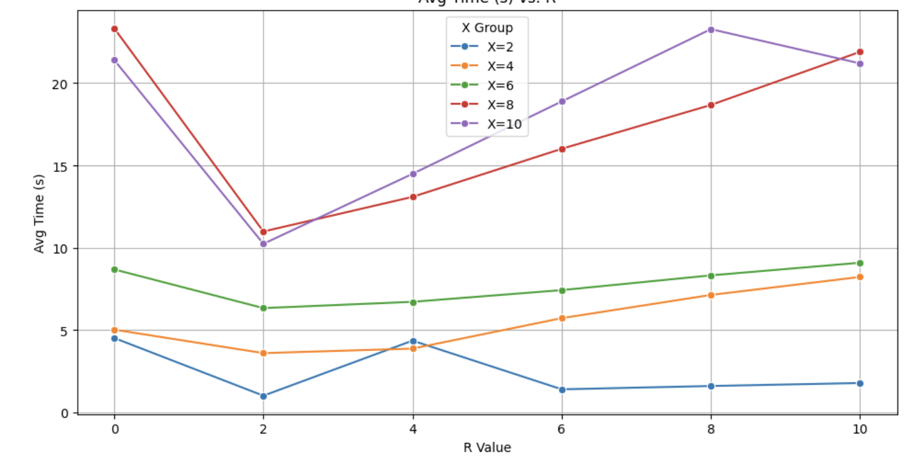
X是实验所用的R，而R value是指引用的R的数据，RValue=0表示无引用，RValue=2表示引用普通BP的数据，从图中可知引用BP可以减少最多的时间。
猜测是引用BP减少时间是先把FTNMP到一个距离终点附近的地方，所以可以减少迭代次数和时间

