实验二

**function g = sigmoid(z)**

计算自变量为z的sigmoid函数值

代码：

g = 1 ./ (1 + exp(-z));

**function [J, grad] = costFunction(theta, X, y)**

计算无正则项的逻辑回归的损失函数和对theta的偏导数

代码：

hypothesis = sigmoid(X * theta);

J = -1 / m * sum( y .* log(hypothesis) + (1 - y) .* log(1 - hypothesis) );

grad = 1 / m * X' * (hypothesis - y);

% notes： $\frac{∂J}{∂θ_{j}}=-\sum_{i=1}^{m}{(y^{\left(i\right)}-g\left(θ^{T}x^{\left(i\right)}\right))∙x_{j}^{\left(i\right)}}$

**function p = predict(theta, X)**

给定theta和标准化过的X，预测二分类结果

代码：

p = round(sigmoid(X * theta));

**ex2运行结果**

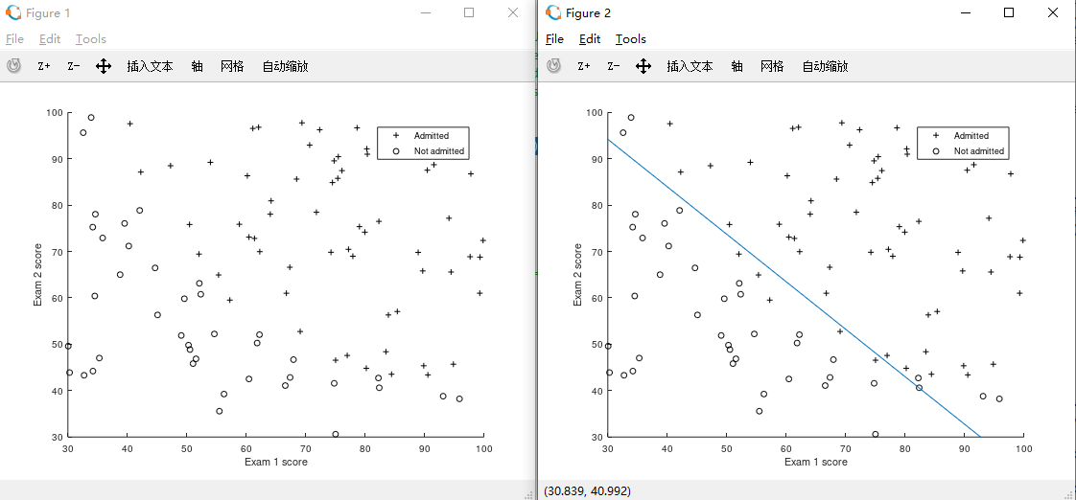

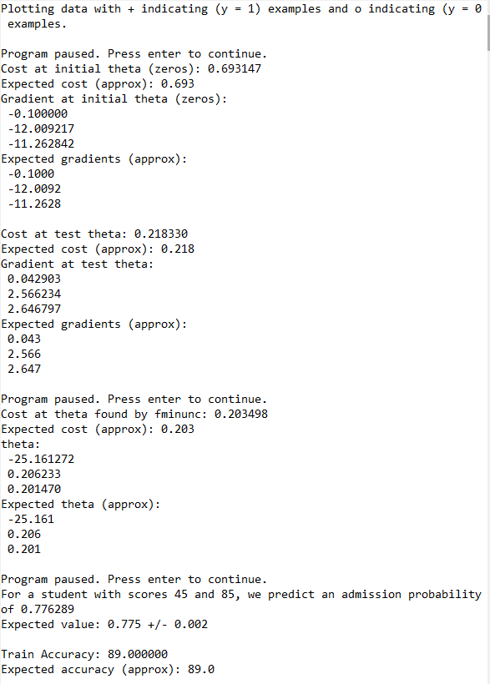

**function [J, grad] = costFunctionReg(theta, X, y, lambda)**

计算正则项系数为lambda的二范数正则的逻辑回归的损失函数和对theta的偏导数

代码：

hypothesis = sigmoid(X * theta);

J = -1 / m * sum( y .* log(hypothesis) + (1 - y) .* log(1 - hypothesis) ) ...

+ lambda / 2 / m * (sum(theta .^ 2) - theta(1)^2);

grad = 1 / m * X' * (hypothesis - y) + lambda / m * theta;

grad(1) = grad(1) - lambda / m * theta(1);

% no need to regularize theta 0

**ex2_reg运行结果**

