实验三

**function [J, grad] = lrCostFunction(theta, X, y, lambda)**

计算正则项系数为lambda的二范数正则的逻辑回归的损失函数和对theta的偏导数

代码：

（同练习2costFunctionReg(theta, X, y, lambda) ）

hypothesis = sigmoid(X * theta);

J = -1 / m * sum( y .* log(hypothesis) + (1 - y) .* log(1 - hypothesis) ) ...

+ lambda / 2 / m * (sum(theta .^ 2) - theta(1)^2);

grad = 1 / m * X' * (hypothesis - y) + lambda / m * theta;

grad(1) = grad(1) - lambda / m * theta(1);

% no need to regularize theta 0

**function [all_theta] = oneVsAll(X, y, num_labels, lambda)**

训练一对多逻辑回归分类器，返回最终权重(shape = num_labels*(n+1),个人认为返回(n+1)*num_labels大小的矩阵更方便，可以省掉此处以及predictOneVsAll里的转置)

代码：

for i = 1:num_labels

initial_theta = zeros(n + 1, 1);

options = optimset('GradObj', 'on', 'MaxIter', 50);

initial_theta = fmincg ( ...

@(t)(lrCostFunction(t, X, (y == i), lambda)), initial_theta, options ...

);

% The i th row of all_theta corresponds to

% the vector of weight of i th lable’s LR_Classifier.

all_theta(i, :) = initial_theta';

endfor

**function p = predictOneVsAll(all_theta, X)**

用一对多分类训练得到的权重进行预测

代码：

predictions = X * all_theta';

[max_val, p] = max(predictions, [], 2);

**ex3运行结果**

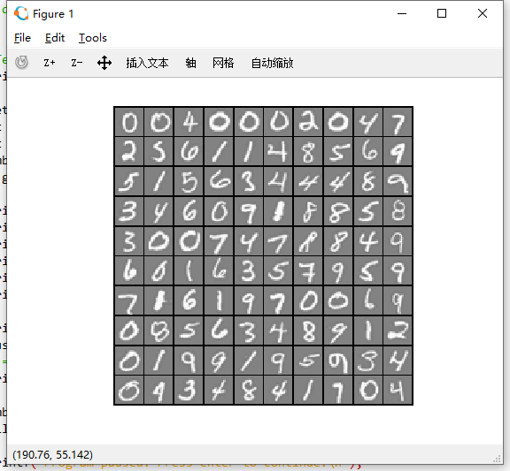 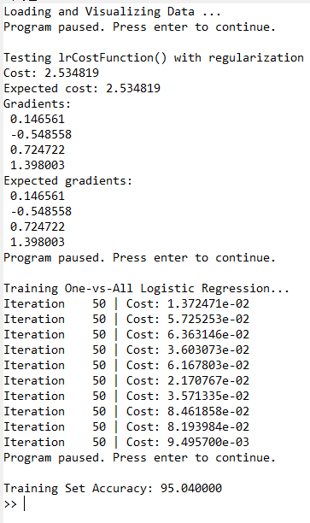

**function p = predict(Theta1, Theta2, X)**

用预训练好的两层神经网络的权重进行预测

代码：

X = [ones(m, 1) X];

hidden = sigmoid(X * Theta1');

hidden = [ones(m, 1) hidden];

predictions = sigmoid(hidden * Theta2');

[max_val, p] = max(predictions, [], 2);

**ex3_nn运行结果**

