实验四

**function g = sigmoidGradient(z)**

计算自变量为z的sigmoid函数的导数

代码：

g = sigmoid(z) .* (1 - sigmoid(z));

**function W = randInitializeWeights(L_in, L_out)**

初始化第L层神经元和第L+1层神经元之间的权重，该权重矩阵的行数等于L+1层的神经元数量（不含常数项），列数等于L层的神经元数量（含常数项），其中L层的神经元数目为L_in（不包含常数项），L+1层的神经元数目为L_out（不包含常数项）

代码：

W = rand(L_out, 1 + L_in) * 2 * 0.1 - 0.1;

% set initial weights between -0.1 and 0.1

**function [J grad] = nnCostFunction(nn_params, ...**

**input_layer_size, ...**

**hidden_layer_size, ...**

**num_labels, ...**

**X, y, lambda)**

计算含二范数正则项的两层神经网络的损失函数值和偏导数

代码：

Y = zeros(m, num_labels);

for i = 1:m

Y(i, y(i)) = 1; % Y: 5000 x 10

endfor

% Theta1: 25 x 401

% Theta2: 10 x 26

X = [ones(m, 1) X]; % X: 5000 x 401

z1 = X * Theta1'; % z1: 5000 x 25

a1 = sigmoid(z1);

a1 = [ones(m, 1) a1]; % a1: 5000 x 26

z2 = a1 * Theta2'; % z2: 5000 x 10

a2 = sigmoid(z2); % a2: 5000 x 10

J = -1 / m * sum(sum( Y .* log(a2) + (1-Y) .* log(1-a2) ));

J = J + lambda / 2 / m * (sum(sum(Theta1(:, 2:end).^2)) + sum(sum(Theta2(:, 2:end).^2)));

d2 = a2 - Y; % d2: 5000 x 10

D2 = d2' * a1; % D2: 10 x 26

d1 = (d2 * Theta2) .* a1 .* (1 - a1); % d1: 5000 x 26

D1 = d1(:, 2:end)' * X; % D1: 25 x 401

Theta2(:,1) = 0;

Theta2_grad = (D2 + lambda * Theta2) / m;

Theta1(:,1) = 0;

Theta1_grad = (D1 + lambda * Theta1) / m;

**反向传播矩阵形式推导笔记**

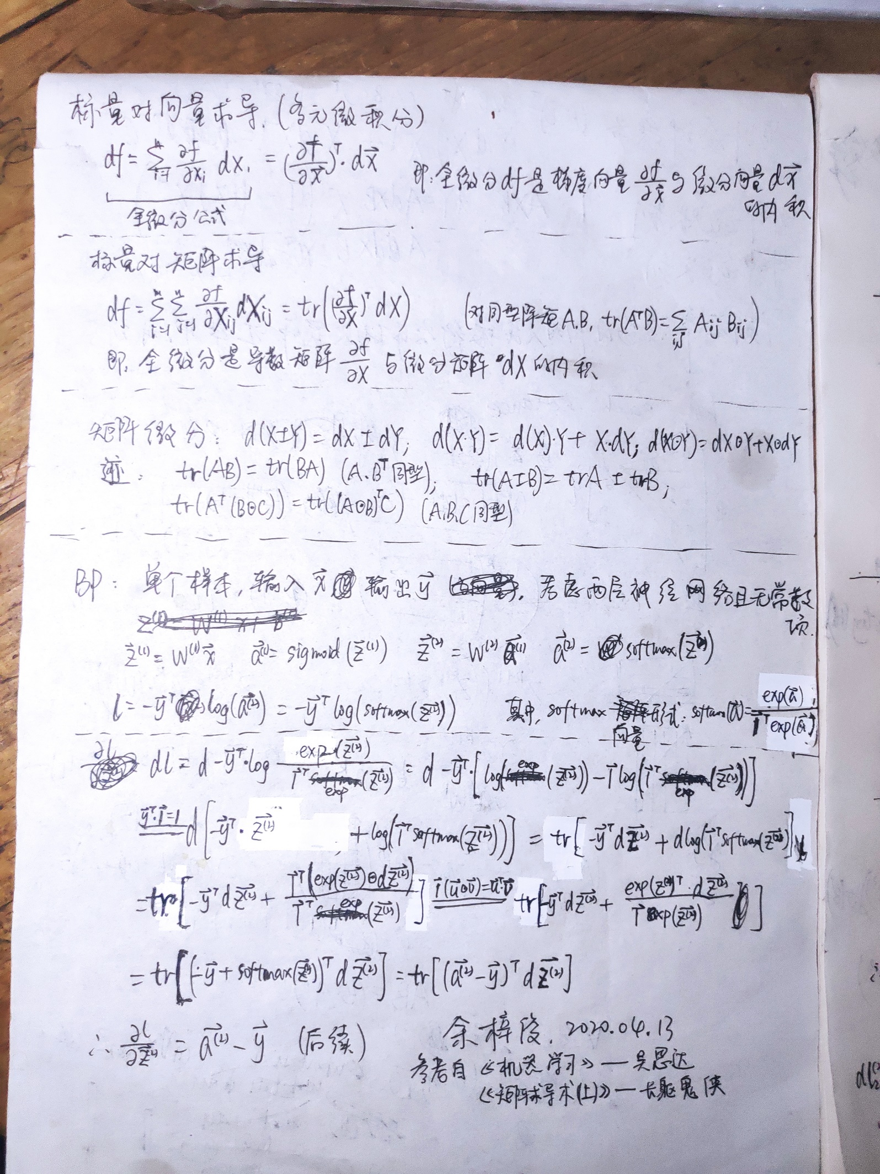

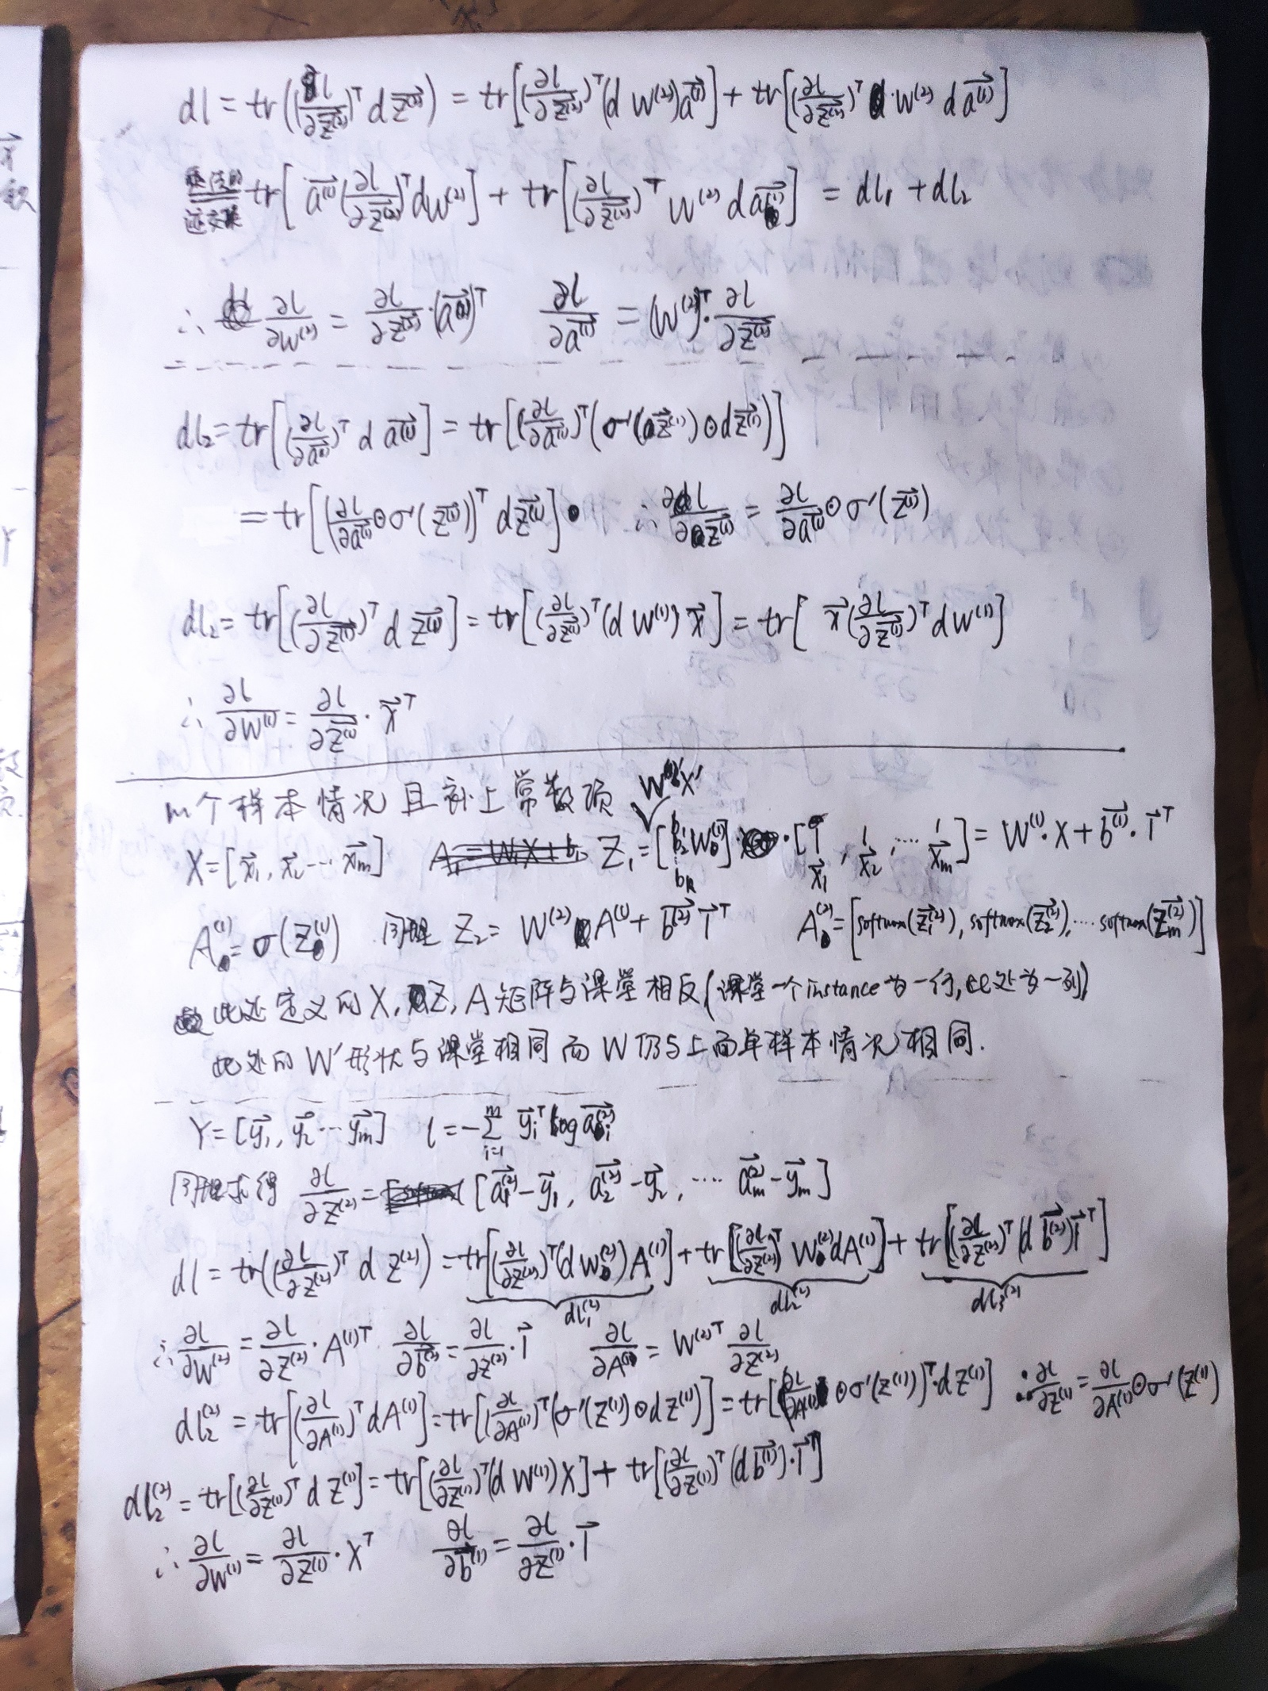

**ex4运行结果**

