Econ0007: Quiz 1(non-assessed)

You have 30 minutes to complete this quiz during your tutorial. The quiz is divided into two parts: Part A: Multiple-Choice Questions and Part B: Short-Answer Questions. You must submit all your answers on one single A4 sheet of paper.
Please write your full name, student number, email address and tutorial day and time at the top of your sheet.
This quiz is formative, and the marks do not count towards your overall grade. This is a closed-book exercise, designed to simulate exam conditions. So you should not use your mobile phones, computers, or textbook.
-------------
Part A: Multiple-Choice Questions
There are 10 questions in this section. You will receive 2 marks for each correct answer. 1 mark will be deducted for each incorrect answer. If you do not attempt a question, you will receive 0 marks for that question.
1.Which of these statements is correct?

A. Ricardian comparative advantage theory is able to explain South-South trade.
B. Ricardian comparative advantage theory is able to explain Vertical intra-industry trade
C. None of the above

2. Which of these statements is correct?
A. South Korea exporting mobile phones to Vietnam and importing cloths in return, is an example of North-South trade.
B. South Korea outsourcing the assembly of Samsung mobiles to Vietnam is an example of trade in similar tasks.
C. None of the above

3. Which of these statements is correct?
A. The age of hyper-globalisation has been marked by convergence of income within countries.
B. The age of hyper-globalisation has been marked by convergence of income across countries.
C. None of the above

4. Which of these statements is correct?

A. The Ricardian theory of comparative advantage assumes free movement of labor across countries.
B. The Ricardian theory of comparative advantage theory predicts growing income inequality within countries.
C. None of the above

5. Which one of these statements is correct?

A. When a country has a comparative advantage in production of x, it means it can produce x at a lower cost compared to other countries
B. When a country has a comparative advantage in production of x, it means it can produce x at a lower price compared to other products
C. None of the above

6. Which of these statements is correct?

A. The age of hyper globalisation has been marked by open capital accounts
B. The age of hyper globalisation has been marked by growing restrictions on movement of multinational firms.
C. None of the above

7. Which of these statements is correct?

A. According to the theory of absolute advantage, free trade leads to lower prices for consumers.
B. According to the theory of absolute advantage, free trade enhances competition among countries and encourage producers to become more efficient.
C. None of the above

8. Which of these statements is correct?

A. It is impossible for a country not to have an absolute advantage in any product (assuming there are no identical countries in the world)
B. It is impossible for a country not to have a comparative advantage in any product (assuming there are no identical countries in the world)
C. None of the above

9. Based on the shown graph, which of these statements is correct?

A. Vietnam and Japan consume the same amount of Rice and Motorcycle
B. Vietnam and Japan have a balanced trade account
C. None of the above

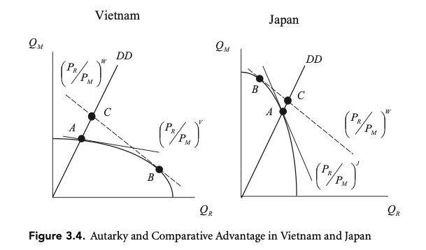

10. Which of these statements is correct?

A. According to the Ricardian theory of comparative advantage, differences in relative prices across countries is caused by differences in labour productivity.
B. According to the theory of absolute advantage, differences in absolute prices across countries is caused by differences in taste.
C. None of the above.

Part B: Short questions.

You must answer one of the following questions. Do not exceed one side of an A4 sheet of paper.

1. Is the below table consistent with Ricardian theory of comparative advantage? Explain.

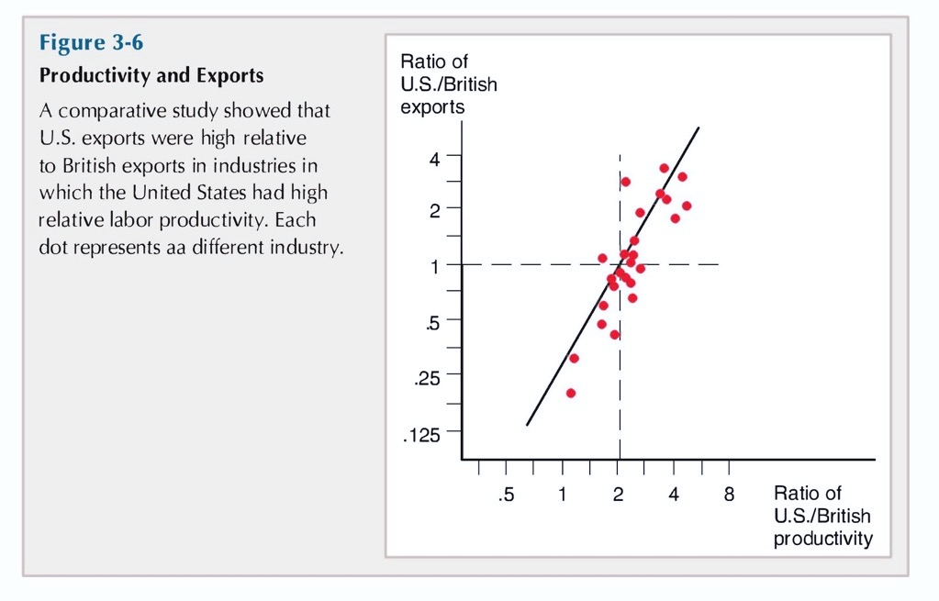

2. As shown in the figure below, since 1980 the value of world exports has increased much faster than world GDP. How does the rise of global value chains help explain why international trade has grown more rapidly than global output?

