Lecture 1: Introduction to Management Accounting
1. Core Purpose of Management Accounting
- Management accounting focuses on providing economic information to internal parties (managers) to support planning, control, and decision-making.
- Its primary goal is to enhance value creation (building network effects, brand strength, efficient operations) and value capture (monetisation, pricing, shareholder returns).
2. Key Differences from Financial Accounting
- Users: External (investors, regulators) vs. internal (managers).
- Time focus: Historical (verifiable) vs. forward-looking (relevant for decisions).
- Quality focus: Verifiability (true and fair) vs. Relevance (planning and control)
- Subject: Whole entity vs. segments (products, departments).
- Rules: Must follow IFRS/GAAP vs. flexible, based on internal needs.
3. Strategic Role of Management Accounting
- Supports expansionist, risky, and entrepreneurial strategies through:
  - Long-term planning and resource allocation.
  - Risk assessment (scenario/sensitivity analysis, capital budgeting).
  - Performance measurement beyond financial metrics (innovation, market share).
- Particularly important for intangible assets (R&D, brand, software) – helps measure, appraise, and manage uncertainty.
4. Planning and Control Cycle
- Planning: Setting goals, predicting outcomes, deciding actions.
- Control: Evaluating performance, providing feedback for improvement.
- Budgets (financial plans) and
- performance reports (actual vs. budget) are key tools.
- Compliance: meet external regulatory and legal reporting obligations
5. Three Functions of Management Accounting
- Scorekeeping: Accumulating and reporting reliable data.
- Attention directing: Helping managers focus on key issues/opportunities.
- Problem solving: Analysing alternatives to choose the best course.
6. Value Chain Analysis
- Management accounting examines all activities from R&D to customer service to identify cost control and value-creation opportunities.
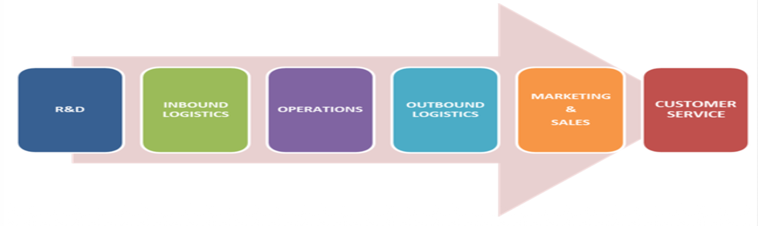
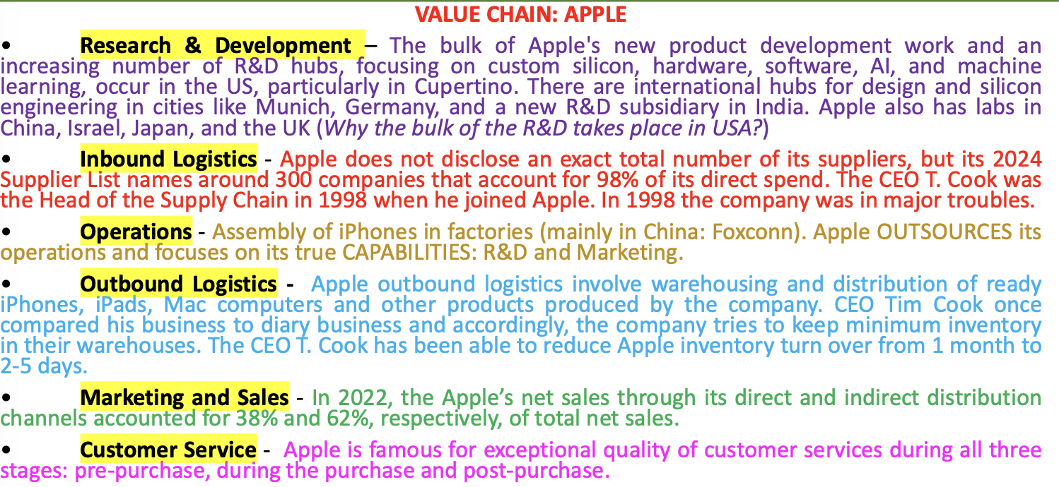
7. Decision-Making Process
A six-step cycle:
Identify objectives → Search alternatives → Select course → Implement → Compare actual vs. planned → Respond to divergences to support decision making
8. Flexibility of Management Accounting
- No external rules; systems are designed based on cost-benefit and human/organisational context.
- Customer satisfaction is a central organisational goal.
Seminar 1:
1. Management vs. Financial Accounting
Feature | Management Accounting | Financial Accounting
Primary users | Internal managers | External parties (investors, regulators)
Time focus | Future-oriented (planning, control) | Past-oriented (historical)
Rules | No prescribed format; flexible | Must follow IFRS/GAAP
Reporting frequency | As needed (real-time, monthly, etc.) | Periodic (quarterly, annually)
Emphasis | Relevance, timeliness, decision-making | Verifiability, accuracy, compliance

2. Value Chain Functions (6 stages)
Memorise the order and examples:
- Research & Development (R&D) – generating ideas, designing products/services.
- Inbound Logistics – receiving, storing, distributing raw materials.
- Operations – transforming inputs into final product (manufacturing, assembly).
- Outbound Logistics – collecting, storing, distributing finished goods to customers.
- Marketing & Sales – advertising, pricing, selling, promotion.
- Customer Service – installation, repair, support, after-sales.
Exam tip: You will be asked to classify costs (e.g., R&D salary, advertising, shipping) into one of these six functions.

3. Cost Management Definition
Cost management = actions managers take to satisfy customers while continuously reducing and controlling costs.
It links strategy, operations, and accounting.

4. Management Accountant as “Customer-Focused”
- Treat internal managers (e.g., production, marketing, logistics) as customers.
- Proactively ask: What information do you need to make better decisions?
- Seek regular feedback to improve relevance and timeliness of reports.

5. Five Purposes of Accounting Systems
Each report or analysis serves one of these:
Purpose | Description | Example
1. Formulating long-range strategies | Overall plans, expansion, M&A | 5-year projection for new TV network
2. Resource allocation & pricing | Product emphasis, pricing decisions | Revenue by type of sporting event
3. Cost planning & control | Monitoring operational efficiency | Monthly office costs by location
4. Performance measurement & evaluation | Evaluating people/teams | Profitability comparison by manager
5. External reporting & legal compliance | Mandatory financial statements | Interim income statement for investors

6. Three Functions of Management Accounting (Scorekeeping, Attention Directing, Problem Solving)
Function | Definition | Example task
Scorekeeping | Accumulating and reporting reliable data | Processing weekly payroll; tallying sales by branch
Attention directing | Helping managers focus on key issues/problems | Interpreting variance report; explaining why sales quota missed
Problem solving | Comparative analysis for decision-making | Analysing lease vs. buy options; evaluating alternative production methods
Exam tip: Be ready to classify a given activity (e.g., “preparing a report on benefits of leasing vs. owning”) into one of these three.

7. Planning vs. Control (with variance analysis)
- Planning = setting goals, predicting outcomes, deciding how to achieve them (e.g., budgeted circulation and price).
- Control = implementing the plan and evaluating performance (e.g., comparing actual vs. budgeted revenue).
Revenue performance report format:
Item | Actual | Budgeted | Variance (A - B)
Units sold (circulation) | 440,000/day × 31 = 13,640,000 | 400,000/day × 31 = 12,400,000 | 1,240,000 F
Price per unit | £0.50 | £0.50 | 0
Total revenue | £6,820,000 | £6,200,000 | £620,000 F
(F = Favorable; A = Adverse if actual < budget)
Possible actions after variance analysis:
- Increase advertising to sustain higher circulation.
- Adjust price further if demand is elastic.
- Investigate whether extra circulation came from new or existing customers.

8. Strategic Management Accounting (SMA) – Key Concepts from Article
- SMA = merging strategic business objectives with management accounting information to support forward-looking decisions.
- Techniques include: target costing, life-cycle costing, strategic cost analysis, brand management accounting.
- Finding: Many practitioners are unfamiliar with the term “SMA” and few implement its techniques fully, but most see value in closer cooperation between accounting and marketing.

9. Role of Professional Accountants
- Accountants help drive sustainable organisational success by integrating ESG factors (environmental, social, governance) into strategy, operations, and reporting.
- Two challenges:
  - Short-term pressure (quarterly results) can distract from long-term vision.
  - Translating long-term vision into daily operations is complex.
- Solution: Combine financial, social, and environmental performance measures.

