Econ0007: Quiz 2(non-assessed)

You have 30 minutes to complete this quiz during your tutorial. The quiz is divided into two parts: Part A: Multiple-Choice Questions and Part B: Short-Answer Questions. You must submit all your answers on one single A4 sheet of paper.
Please write your full name, student number, email address and tutorial day and time at the top of your sheet.
This quiz is formative, and the marks do not count towards your overall grade. This is a closed-book exercise, designed to simulate exam conditions. So you should not use your mobile phones, computers, or textbook.
----------------------------
Part A: Multiple-Choice Questions

There are 10 questions in this section. You will receive 2 marks for each correct answer. 1 mark will be deducted for each incorrect answer. If you do not attempt a question, you will receive 0 marks for that question.

A1. Which of the following options is among the factors that determines trade specialisation according to the Heckscher Ohlin Model?

A. Differences in production experience
B. Differences in real interest rates
C. None of the above

A2. Which of these statements is correct?

A. Under free trade, Heckscher Ohlin model predicts a fall in global income inequality in the long term
B. Under free trade, Heckscher Ohlin model predicts a rise in global income inequality in the long-term
C. None of the above

A3. Which of these statements is correct?

A. Under free trade, Heckscher-Ohlin model predicts a rise in income inequality within rich countries

B. Under free trade, Heckscher-Ohlin model predicts a rise in income inequality within developing countries
C. None of the above

A4. Which of these options are among the losers of trade liberalisation, according to the Heckscher Ohlin model?

A. Computer programmer in Ethiopia
B. Unskilled shoe producers in Ethiopia
C. None of the above

A5. Which of these options are among the winners of trade liberalisation, according to the New Trade Theory?

A. Bondholders in Germany
B. Unskilled workers in Germany
C. None of the above

A6. Which of these statements is correct?

A. New Trade Theory is able to explain the concentration of trade in just few regions
B. New Trade Theory is able to explain inter-industry trade
C. None of the above

A7. Which of these statements is correct?

A. New Trade Theory assumes downward supply curves for firms.
B. New Trade Theory assumes homogenous production technology across countries.
C. None of the above

A8. Which of these options are among the assumptions of Heckscher-Ohlin model?

A. Composition of the consumption basket is the same in the two countries

B. Constant return to capital

C. None of the above

A9. Based on the shown figure, which of these statements is correct?

A. The data for China is consistent with New Trade Theory.
B. The data for Japan is consistent with Heckscher-Ohlin model.
C. None of the above.

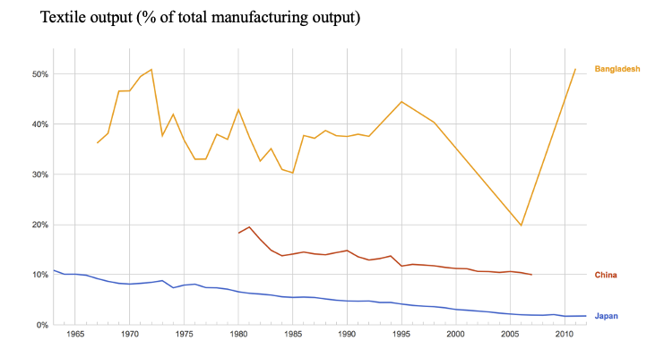
Source: World Bank Development Indicators.

A10. You can find the data on Saudi Arabia’s export basket below. Based on that data, which of these options is correct?

A. Saudi Arabia’s export basket is consistent with Heckscher-Ohlin model.
B. Saudi Arabia’s export basked is highly diversified.
C. None of the above.

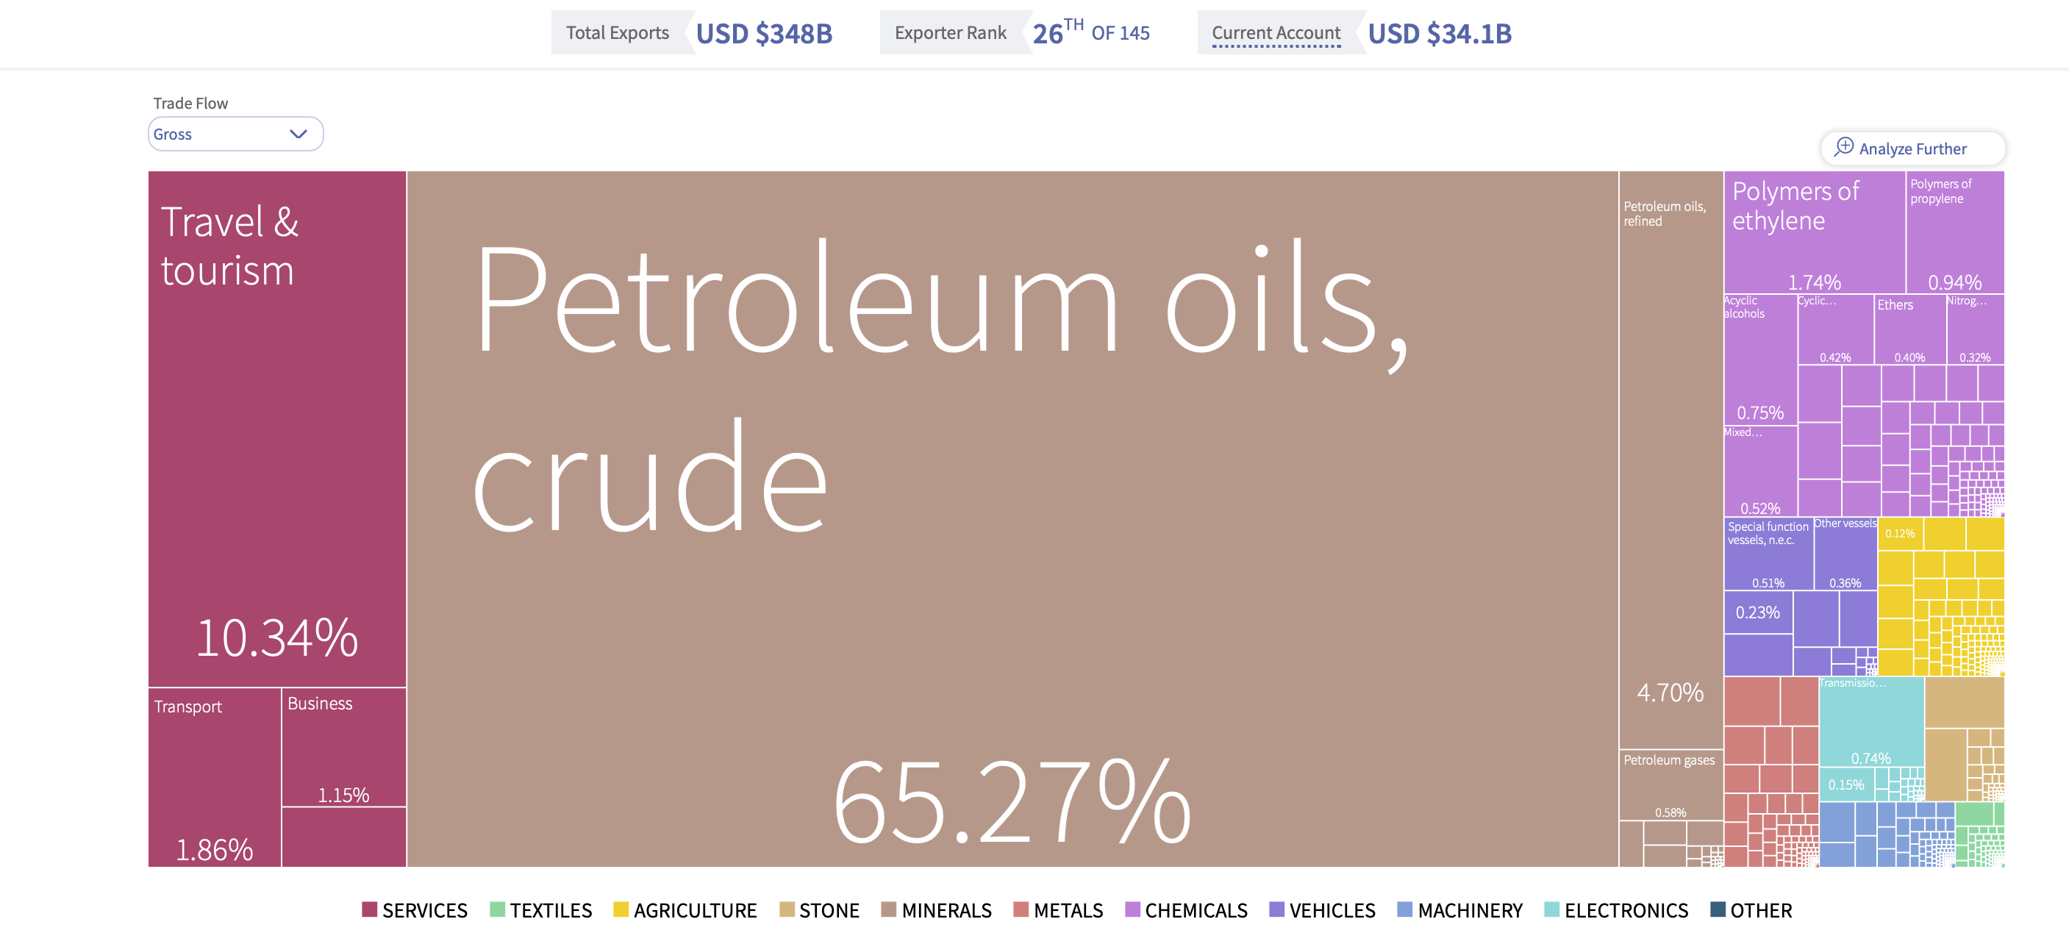

Part B: Short questions.

You must answer one of the following questions. Do not exceed one side of an A4 sheet of paper.

1. Is the below graph consistent with the predictions of Heckscher-Ohlin Model? Explain.

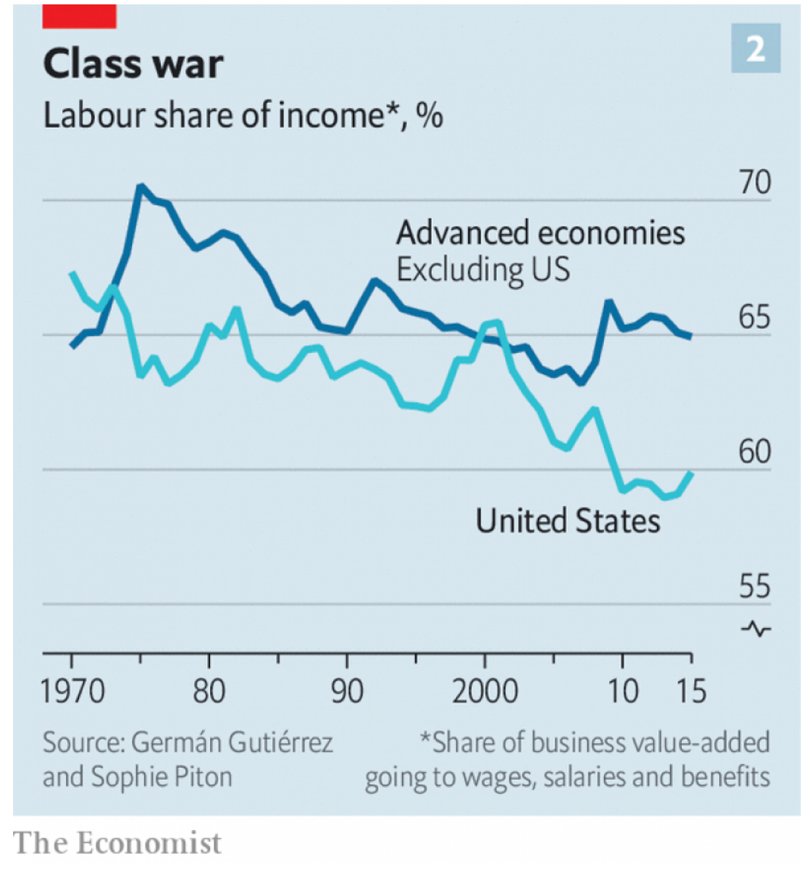

2. Can New Trade Theory help us predict the pattern of horizontal intra-industry trade among countries? Explain.

