Create a solution diagram for the following use case.
A client will request a Cognito User Pool token with machine to machine client app using MTls configuration.
  - The client request a Oauth2 token sends the credentials to AWS API Gateway using MTLS.
  - THe credentials are send as Basic Authentication
  - API Gateway exposes an POST rest API using lambda as the backend.
  - The backend Lambda function verifies the the Basic Authentication and parses it extracting the Client ID and Client secret and sends the request to cognito user pool for the the Oauth Token.
  - The API Gateway web api has a cognito authorizer.
  - The conginto authorizer validates the client certificate DN against a list of Whitelist of Trusted CA certificates
  - There is a AWS WAF in Cognito user pool to allow only requests from the API Gateway and deny anything else.
  - Once Congnito generates the token and the backend lambda function gets the response, it send back to the API Consumer the token with the same format as cognito response.

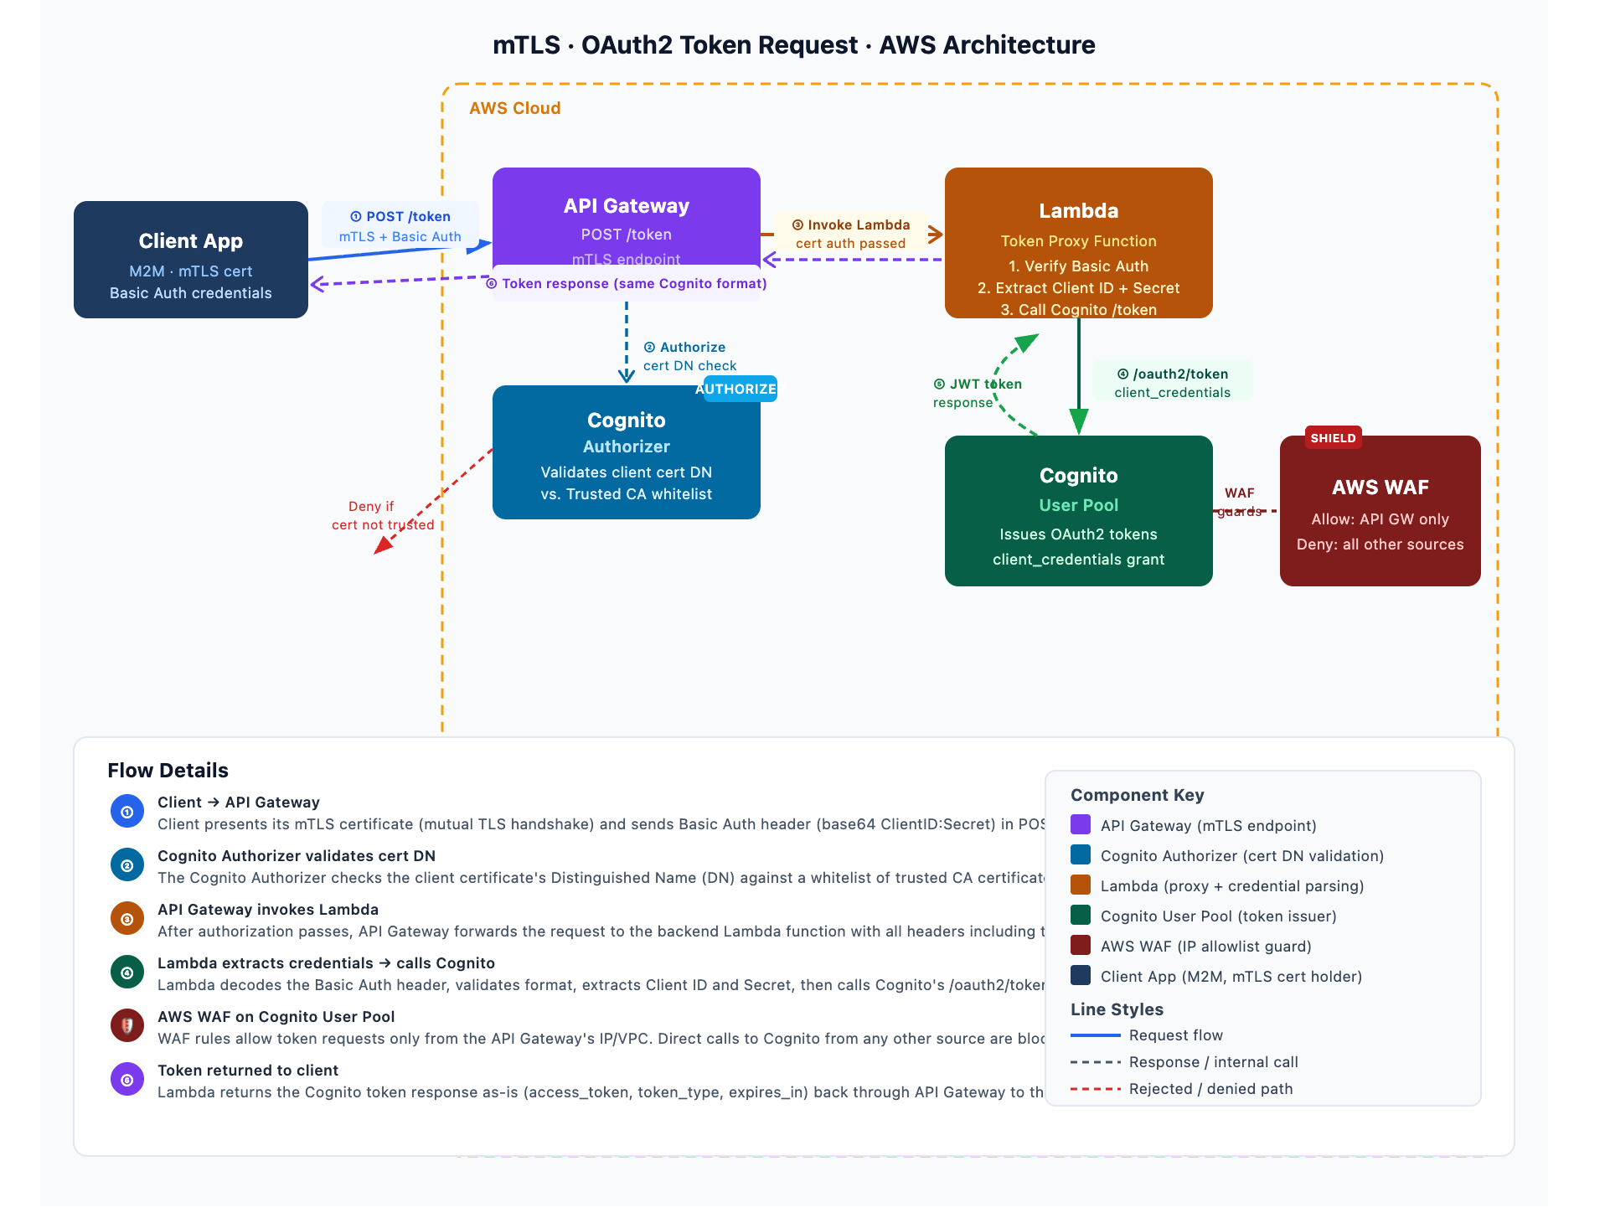

The diagram covers the full end-to-end flow:
Request path (numbered steps):
- Client → API Gateway — mTLS handshake (client cert presented) + Basic Auth header carrying ClientID:Secret
- Cognito Authorizer — validates the client certificate's DN against the trusted CA whitelist; rejects with 403 if not in the whitelist
- API Gateway → Lambda — forwards the authorized request to the backend function
- Lambda → Cognito User Pool — decodes Basic Auth, extracts client_id + client_secret, calls /oauth2/token with client_credentials grant
- WAF on Cognito — blocks any token request not originating from the API Gateway (prevents direct-to-Cognito bypass)
- Response flows back — Lambda passes the Cognito token payload (access_token, token_type, expires_in) unchanged to the client
Key security layers:
- mTLS at the API Gateway edge (transport-level client authentication)
- Certificate DN whitelist check in the Cognito Authorizer (identity validation)
- WAF on the Cognito User Pool (network-level isolation — only the API Gateway can reach Cognito directly)
