|  |
| --- |
|  |
| Public Education Finances in United States |
| Webpage Prototype |
|  |
| **Team #5: Wenxin Zhao, Bowen Huang** |
| **3/20/15** |

# Content

This document is a brief introduction of the prototype of our INF 554 final project. In the beginning, we will show the page tree. Besides, we will show the interface design of each page. Moreover, we will also list the widgets we use.

1. Pages
   1. Page Tree

Home  
 Washington State  
 California

* 1. Home
     1. User Interface

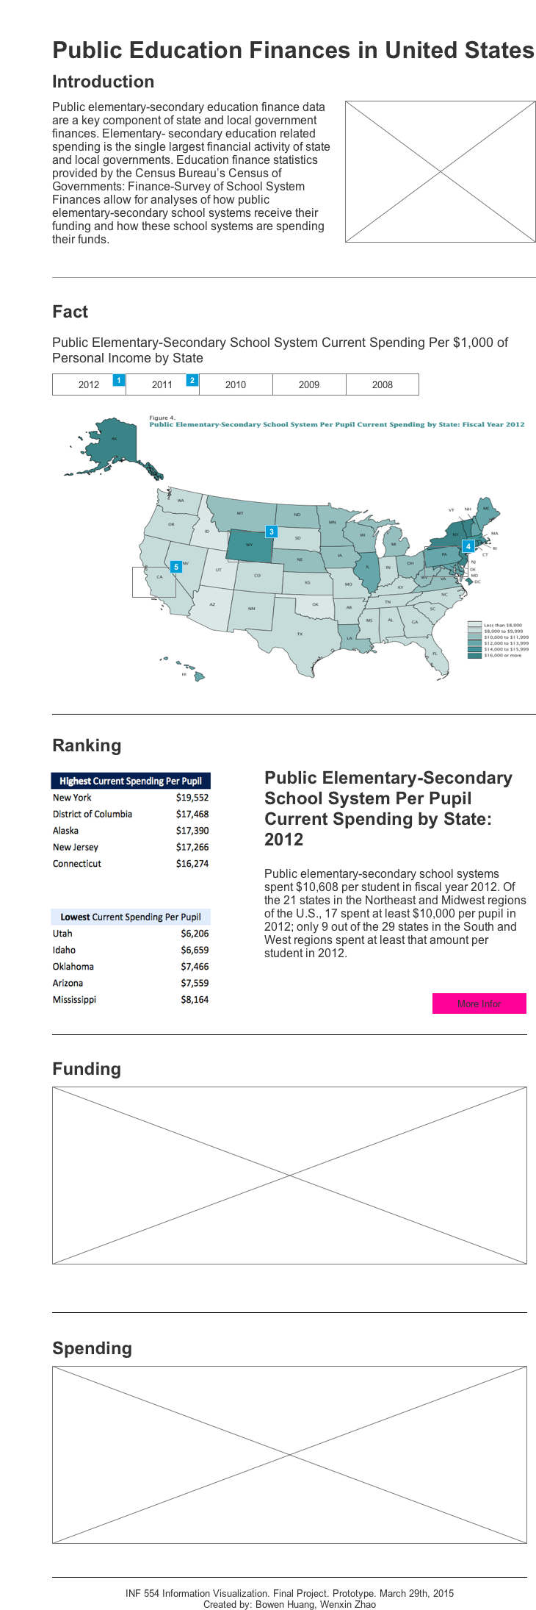

* + 1. Widget Table

|  |  |  |
| --- | --- | --- |
| Footnote | Name | Interactions |
| 1 |  | OnClick:  Case 1:  Set map to State1 |
| 2 |  | OnClick:  Case 1:  Set map to State2 |
| 3 |  | OnClick:  Case 1:  Open Washington State in Current Window OnMouseEnter:  Case 1:  Show tt treat as flyout |
| 4 |  | OnMouseEnter:  Case 1:  Show tt treat as flyout |
| 5 |  | OnClick:  Case 1:  Open California in Current Window OnMouseEnter:  Case 1:  Show tt treat as flyout |

* + 1. map
       1. State1
       2. User Interface

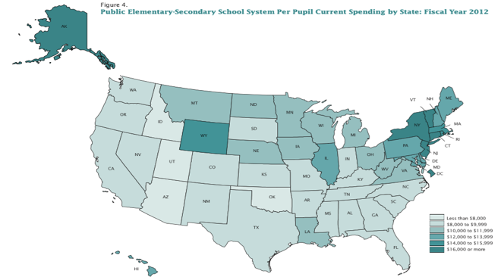

* + - 1. State2
      2. User Interface

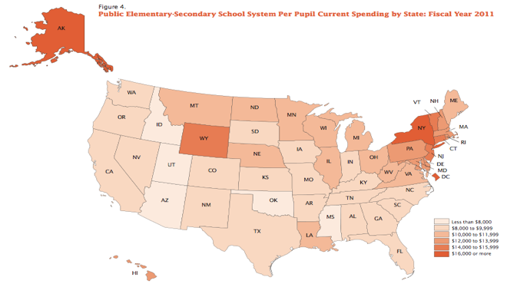

* 1. Washington State
     1. User Interface

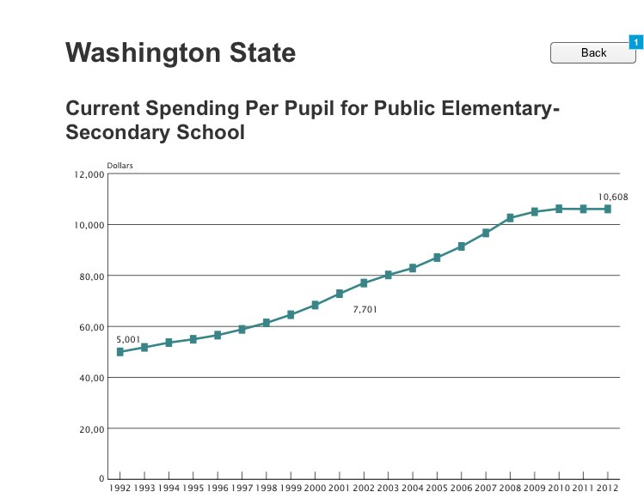

* + 1. Widget Table

|  |  |
| --- | --- |
| Footnote | Interactions |
| 1 | OnClick:  Case 1:  Open Home in Current Window |

* 1. California
     1. User Interface

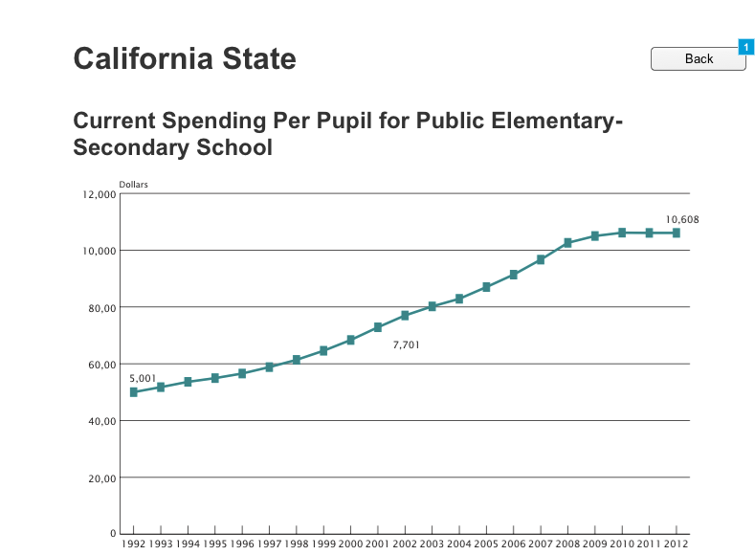

* + 1. Widget Table

|  |  |
| --- | --- |
| Footnote | Interactions |
| 1 | OnClick:  Case 1:  Open Home in Current Window |