NCHU Thesis Format and Example
Instruction for use

- Please refer to Registration Division of Academic Affairs Office for “NCHU Thesis/Dissertation Format “.
- Remember to delete this page, and “Text Box“ and “Comment“ on each page. (Reviews → Show Markup)
- The PDF file does not need to add watermark and security settings, the system will automatically process it after the review is passed.

National Chung Hsing University
Cover
Department/Institute of XXXX
Master thesis/Doctoral dissertation

Thesis/Dissertation Title in Chinese
Thesis/Dissertation Title in English

Advisor: XXX XXX
Student Name: XXX XXX

Date: October, 2021
This page is provided by each department/institute/program with advisor and committee members’ signatures of passing the defense. Scan the certificate in JPG/PDF format with signatures of your advisor and oral defense committee. The watermark is not necessary in the page of certificate of defense approval because it is a JPG file.
Evaluation

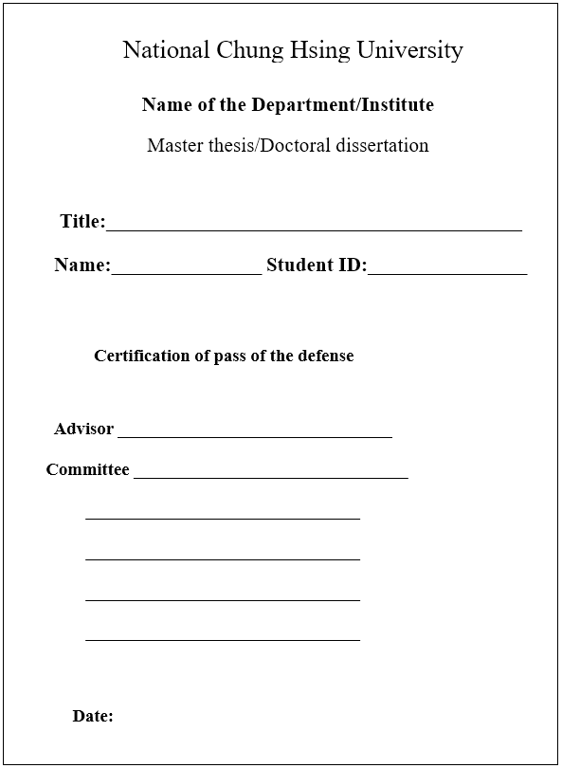

Acknowledgements
To express student’s gratitude to the advisors, colleagues, or their family members in 1 page and not to exceed 2 pages. (Optional)

Abstract in Chinese
Normally in 1 page and not to exceed 2 pages. Briefly describe the research purpose, methods and design, data analysis, results and discussion. (Optional)
Keywords:1-2 keywords

Abstract in English
Instructions are same with the Abstract in Chinese.
Keywords:1-2 keywords

Table of Contents
Abstract in Chinese i
Abstract in English ii
Table of Contents iii
List of Tables iv
List of Figures v
Chapter 1 1
References 3
Appendix 4

Based on the sequence of the “Page contents and orders”, arrange in order specifying its content and page.

List of Tables
Arrange each tables and figures with their number, title, and page. Align to the right of the page. Tables first, follow with Figures. If tables and figures exceed 10, separate into Table and Figure category.

List of Figures
Instructions are same with the List of Tables.

Chapter 1
Text
- Layout of the thesis/dissertation
1. The thesis/dissertation is separated into chapters that start on a new page. Chapter title is centered on the first line of a new page. Section is separated after the chapter, which subtitle in a section is centered in the page but not on a new page.
2. Use Arabic symbol to number the chapters in the thesis/dissertation; leave 1 space between the number and the title.
3. In each chapter or section, please use the following formats.
1.
ΔΔ 1.1. Indent 2 spaces
ΔΔΔΔ1.1.1. Indent 4 spaces
ΔΔΔΔΔΔ1.1.1.1. Indent 6 spaces
4. Line distance: For Chinese, line spacing is 1 with at least 32 lines per page; for English, line spacing is 1.5 with at least 29 lines per page. Please leave 2 line spacing after each chapter title.
5. Letter distance: For Chinese, at least 32 characters per line; there is no limit for English.
- Processing of Tables and Figures
1. Arabic numbers should be assigned to all tables and figures separately. The number of the tables and figures should be numbered in sequence as in the text.
2. Number of the table and its caption should be centered on top of the table.
3. Number of the figure and its legend should be centered under the figure.
4. References and footnotes of the table and figure should be aligned to the left under the table or figure.
5. Referring to any table or figure in the text should be specific, e.g. Table 1, Figure 1.
6. Tables and figures should be placed in an optimal position, commonly after the paragraph that they were first mentioned. If necessary, a new page with the figures and tables can be established in the center of the page.

7. If tables or figures are too big to fit in A4 size page, they can be printed on a larger sheet of paper and folded within the thesis/dissertation.
- Footnotes
1. There is no format of a footnote; it can be based on each institute’s format. It can be a Pagenote at the end of the page, or Chapternote after the end of each chapter, or Endnote after the conclusion and before the references.
2. Footnotes can be placed after the text without the need to star a new page.
3. When citing a reference, footnotes a=should always be used.
4. Within a chapter, the numbering is continuous. Between chapters, the numbering is discrete.

References
1. All citations used in the text should be listed in the reference section after the main text. The reference section should start on a new page. The page number is continous with the main text. Chinese references should be in front of English references. References can be textbooks, journals, website resources, etc.
2. Reference format can be decided by each institute, normally using MLA, Chicago Manual, American Psychological Association, etc. styles.

Appendix
Any large or lengthy data that is not suitable to be placed in the main text, for example raw data, interview reports or questionnaires should be assigned in the appendix after the reference starting with a new page. Page numbering is continuous with the reference.

