Read Me

List of all the files in the system:

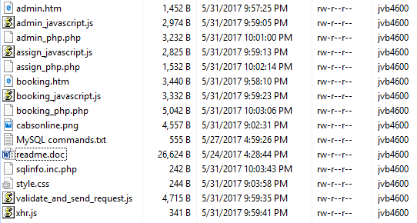

Brief instructions on how to use the system:
- Open the booking.htm page.
- Enter the booking details. Be careful, contact phone only accept numbers, unit number can be left blank, and pick up time should be selected by using the built-in calendar.
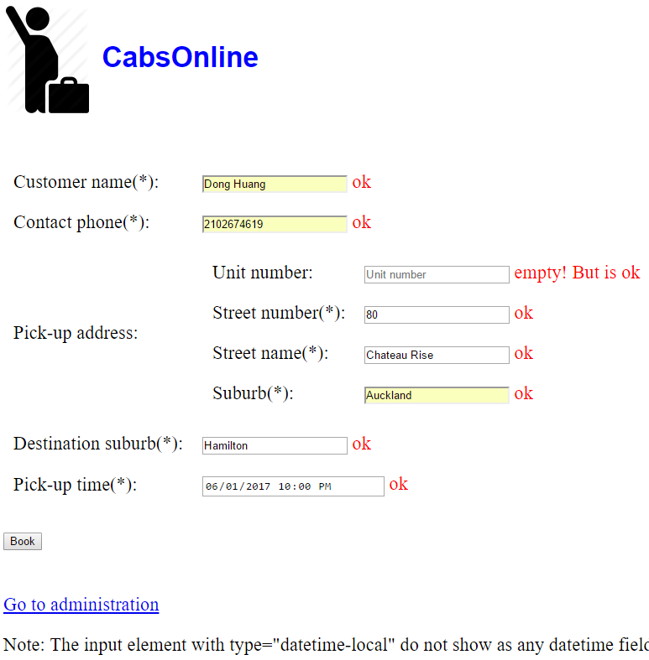
Note: The input element with type="datetime-local" do not show as any datetime field/calendar in Firefox or in IE12 and earlier versions.
- The booking reference number is a seven-digit unique random number, which is generated on the server side.
- All the booking fields are validated before sent to the server side.
- Click the ‘Book’ button to create a new booking request.
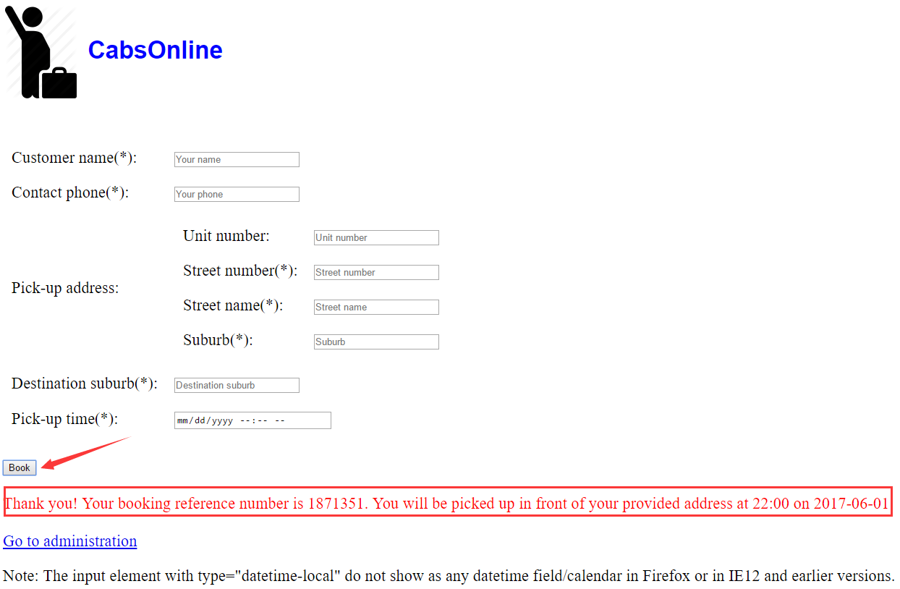
- The booking.htm page will display a booking confirmation upon successful booking.
- Click the ‘Go to administration’ hyper link will go to the admin.htm page.
- In the admin.htm page, click the ‘Show bookings’ button will show all the bookings with a pick-up time within 2 hours from now only. If no records found, only the head row of the table will be displayed, with no booking records appended.
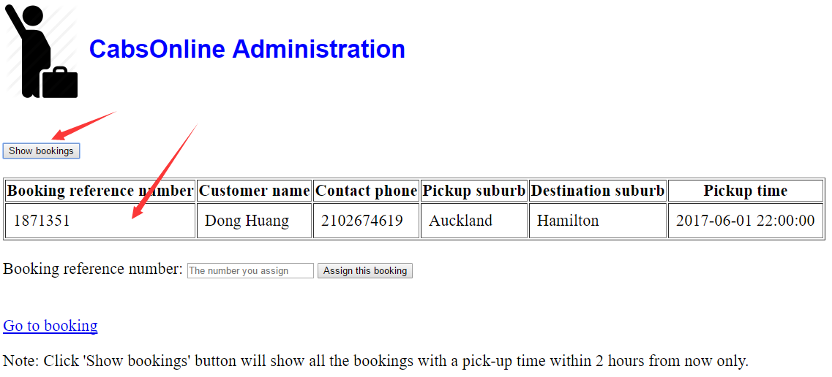
- In the input box for the booking reference number, you can input a booking reference number that you want to assign, regardless of whether that booking is due with 2 hours.
- Upon successfully assigning a booking, a confirmation text will show below the input box.
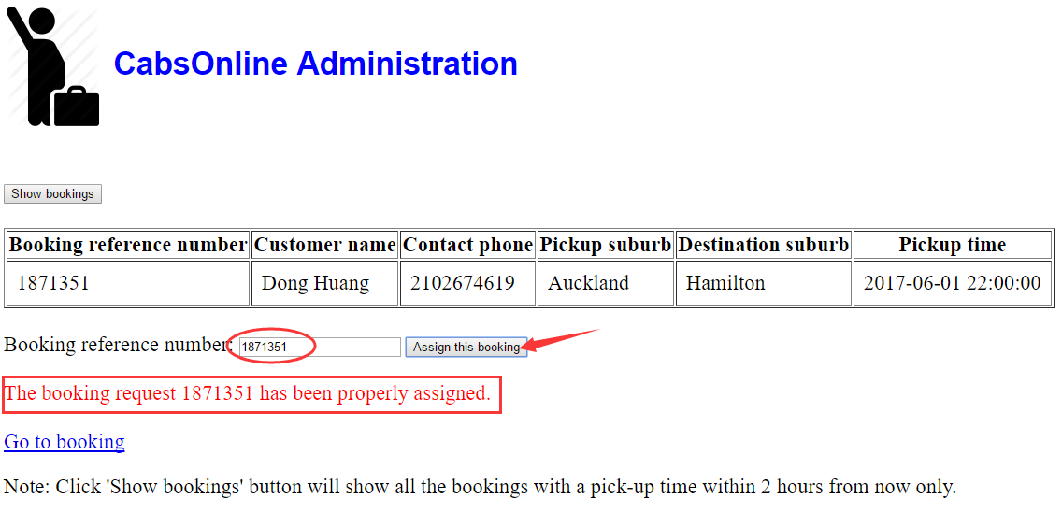
- If a booking has already assigned before and you try to assign that booking again, or if a booking reference number is not exist, you will get an error message: The booing reference number xxx is not found in system or has already been assigned. Please verify before assignment.
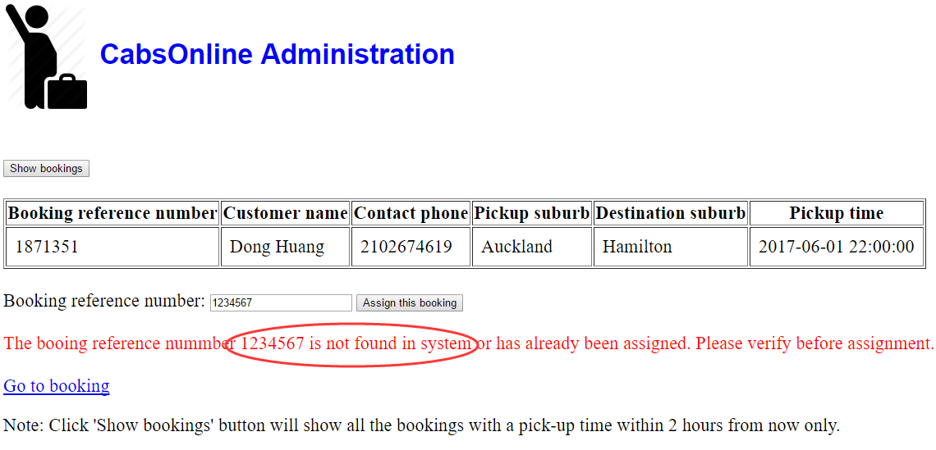
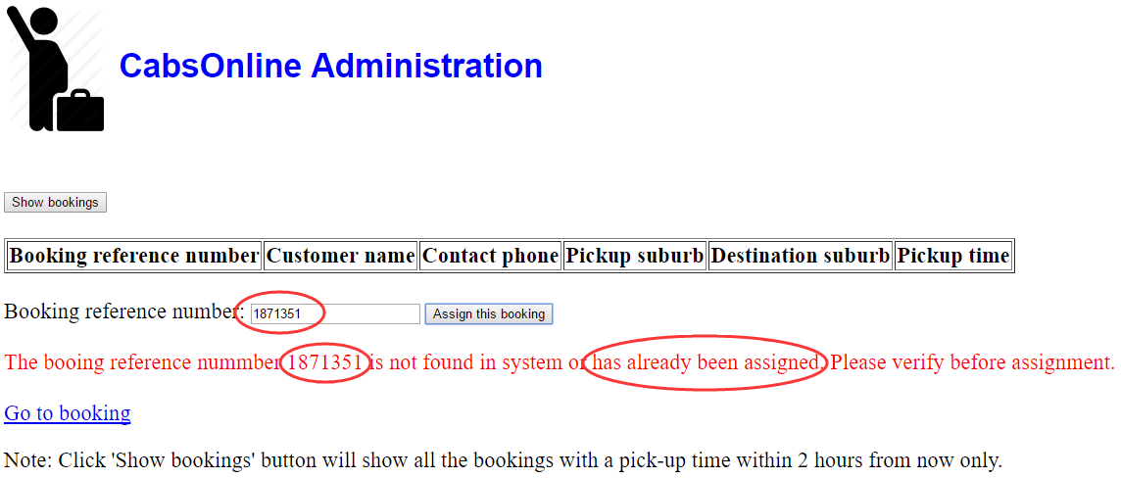
- All the input fields are user-friendly and very responsive.

