BACS-hw1.R

2022-04-08

setwd("C:/Users/eason/Desktop/清大 BACS/資料/")  
customers <- read.table(file = "customers.txt", header = TRUE)  
ages <- customers$age  
  
#1. What is the 5th element in the original list of ages?  
ages[5]

## [1] 45

#2. What is the fifth lowest age?  
sorted_ages <- sort(ages)  
sorted_ages[5]

## [1] 19

#3. Extract the five lowest ages together   
#HINT: to get a sequence of numbers from a list, you can use:  
#my_list[c(1,2,3,4,5)] but can you think of a shorter or clearer way of doing this?  
sorted_ages[c(1,2,3,4,5)]

## [1] 18 19 19 19 19

#4. Get the five highest ages by first sorting them in decreasing order first.  
#HINT: find out how to sort in decreasing order by using: help(sort) or ?sort  
sorted_ages2 <- sort(ages, decreasing = TRUE)  
sorted_ages2[c(1,2,3,4,5)]

## [1] 85 83 82 82 81

#5. What is the average (mean) age?  
mean(ages)

## [1] 46.80702

sum(ages)/length(ages)

## [1] 46.80702

#6. What is the standard deviation of ages? (guess or google the standard deviation function in R)  
sd(ages)

## [1] 16.3698

#7. Make a new variable called age_diff, with the difference between each age and the mean age  
age_diff <- ages - mean(ages)

#8. What is the average ? Difference between each age and the mean age?  
#HINT: think carefully why someone would want to know this, and what it implies about how to do #7  
mean(age_diff)

## [1] -1.623275e-15

#9. Visualize the raw data as we did in class: (a) histogram, (b) density plot, (c) boxplot + stripchart  
hist(ages)

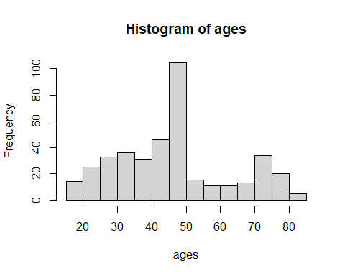

plot(density(ages))

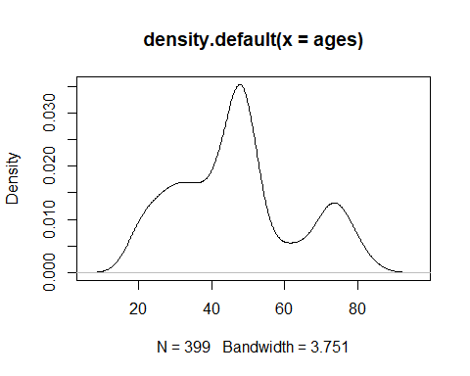

boxplot(ages, horizontal = TRUE)  
stripchart(ages, method = "stack", add = TRUE)

