BACS-hw3.R

2022-04-11

#Question1  
#a  
#1  
set.seed(10)  
rnorm_dist <- rnorm(1000, mean=940, sd=150)  
  
standardize <- function(x){  
 (x - mean(x)) / sd(x)  
}  
  
rnorm_std <- standardize(rnorm_dist)  
mean(rnorm_std)

## [1] 9.963238e-17

sd(rnorm_std)

## [1] 1

#2  
plot(density(rnorm_std))

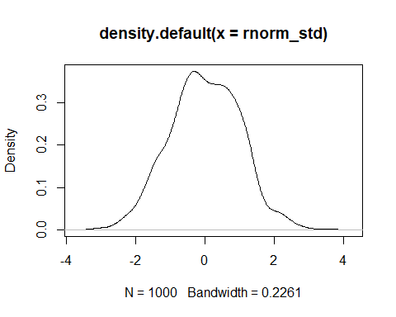

#3  
standard normal distribution (?

#b  
#1  
setwd("C:/Users/eason/Desktop/清大 BACS/資料/")  
bookings <- read.table("first_bookings_datetime_sample.txt", header=TRUE)  
bookings$datetime[1:9]

## [1] "4/16/2014 17:30" "1/11/2014 20:00" "3/24/2013 12:00" "8/8/2013 12:00"   
## [5] "2/16/2013 18:00" "5/25/2014 15:00" "12/18/2013 19:00" "12/23/2012 12:00"  
## [9] "10/18/2013 20:00"

hours <- as.POSIXlt(bookings$datetime, format="%m/%d/%Y %H:%M")$hour  
mins <- as.POSIXlt(bookings$datetime, format="%m/%d/%Y %H:%M")$min  
minday <- hours*60 + mins  
  
standardize <- function(x){  
 (x - mean(x)) / sd(x)  
}  
  
minday_std <- standardize(minday)  
mean(minday_std)

## [1] -4.25589e-17

sd(minday_std)

## [1] 1

#2  
plot(density(minday_std))

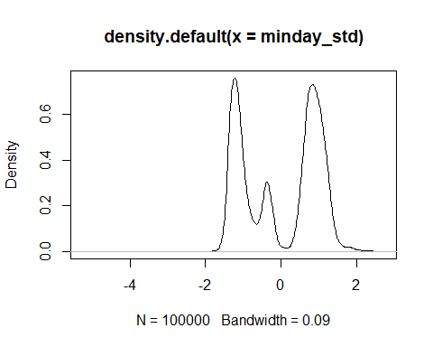

plot(density(minday))

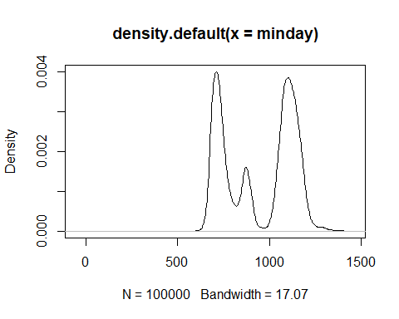

#Question2  
#a  
visualize_sample_ci <- function(num_samples = 100, sample_size = 100,   
 pop_size=10000, distr_func=rnorm, ...) {  
 # Simulate a large population  
 population_data <- distr_func(pop_size, ...)  
 pop_mean <- mean(population_data)  
 pop_sd <- sd(population_data)  
   
 # Simulate samples  
 samples <- replicate(num_samples,   
 sample(population_data, sample_size, replace=FALSE))  
   
 # Calculate descriptives of samples  
 sample_means = apply(samples, 2, FUN=mean)  
 sample_stdevs = apply(samples, 2, FUN=sd)  
 sample_stderrs <- sample_stdevs/sqrt(sample_size)  
 ci95_low <- sample_means - sample_stderrs*1.96  
 ci95_high <- sample_means + sample_stderrs*1.96   
 ci99_low <- sample_means - sample_stderrs*2.58  
 ci99_high <- sample_means + sample_stderrs*2.58  
   
 # Visualize confidence intervals of all samples  
 plot(NULL, xlim=c(pop_mean-(pop_sd/2), pop_mean+(pop_sd/2)),   
 ylim=c(1,num_samples), ylab="Samples", xlab="Confidence Intervals")  
 add_ci_segment(ci95_low, ci95_high, ci99_low, ci99_high,  
 sample_means, 1:num_samples, good=TRUE)  
   
 # Visualize samples with CIs that don't include population mean  
 bad = which(((ci95_low > pop_mean) | (ci95_high < pop_mean)) |  
 ((ci99_low > pop_mean) | (ci99_high < pop_mean)))  
 add_ci_segment(ci95_low[bad], ci95_high[bad], ci99_low[bad], ci99_high[bad],  
 sample_means[bad], bad, good=FALSE)  
   
 # Draw true population mean  
 abline(v=mean(population_data))  
}  
  
add_ci_segment <- function(ci95_low, ci95_high, ci99_low, ci99_high,   
 sample_means, indices, good=TRUE) {  
 segment_colors <- list(c("lightcoral", "coral3", "coral4"),  
 c("lightskyblue", "skyblue3", "skyblue4"))  
 color <- segment_colors[[as.integer(good)+1]]  
   
 segments(ci99_low, indices, ci99_high, indices, lwd=3, col=color[1])  
 segments(ci95_low, indices, ci95_high, indices, lwd=3, col=color[2])  
 points(sample_means, indices, pch=18, cex=0.6, col=color[3])  
}  
  
visualize_sample_ci(num_samples = 100, sample_size = 100, pop_size = 10000, distr_func = rnorm, mean = 20, sd = 3)

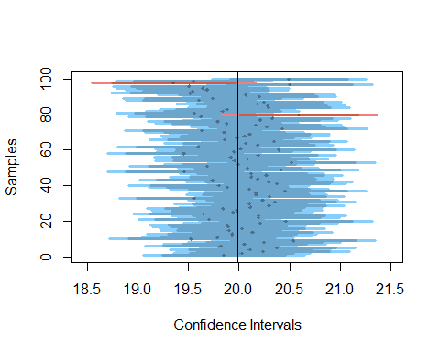

#b  
visualize_sample_ci(num_samples = 100, sample_size = 300, pop_size = 10000, distr_func = rnorm, mean = 20, sd = 3)

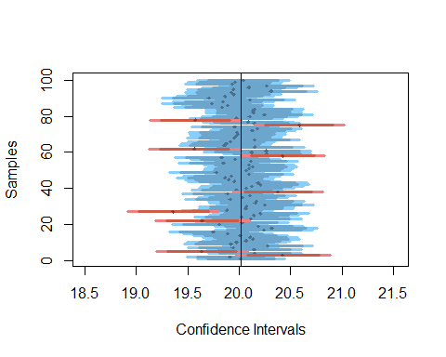

#c  
visualize_sample_ci(num_samples = 100, sample_size = 100, pop_size = 10000, distr_func = runif)

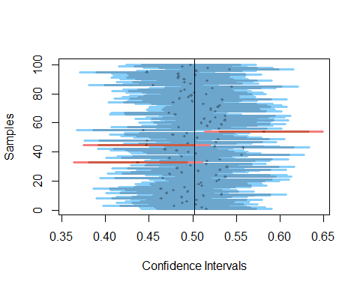

visualize_sample_ci(num_samples = 100, sample_size = 300, pop_size = 10000, distr_func = runif)

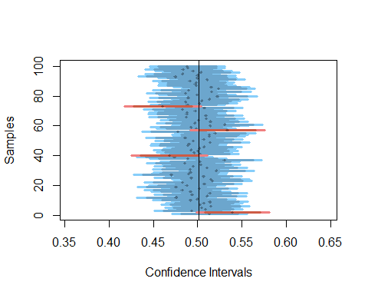

#Question 3  
#a  
setwd("C:/Users/eason/Desktop/清大 BACS/資料/")  
bookings <- read.table("first_bookings_datetime_sample.txt", header=TRUE)  
bookings$datetime[1:9]

## [1] "4/16/2014 17:30" "1/11/2014 20:00" "3/24/2013 12:00" "8/8/2013 12:00"   
## [5] "2/16/2013 18:00" "5/25/2014 15:00" "12/18/2013 19:00" "12/23/2012 12:00"  
## [9] "10/18/2013 20:00"

hours <- as.POSIXlt(bookings$datetime, format="%m/%d/%Y %H:%M")$hour  
mins <- as.POSIXlt(bookings$datetime, format="%m/%d/%Y %H:%M")$min  
minday <- hours*60 + mins  
plot(density(minday), main="Minute (of the day) of first ever booking", col="blue", lwd=2)

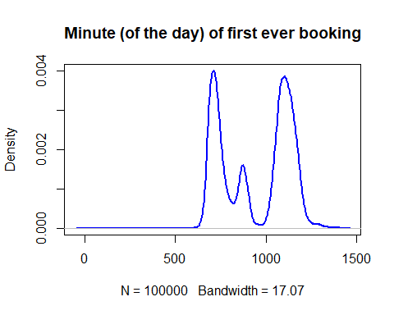

#1  
minday_mean <- mean(minday)  
minday_sd <- sd(minday)  
minday_size <- length(minday)  
minday_se <- (minday_sd / sqrt(minday))  
minday_ci_95 <- quantile(minday, probs=c(0.025, 0.975))  
  
#2,3 b2的方法也可以 俐落一點  
plot_resample <- function(sample0){  
 resample <- sample(sample0, length(sample0), replace = TRUE)  
 lines(density(resample), col = rgb(0.5, 0.5, 1, 0.1))  
 resample_stat <- mean(resample)  
 abline(v = mean(resample), col = rgb(0.5, 1, 1, 0.1))  
 return(resample_stat)  
}  
  
show_resample_width <- function(sample0){  
 num_bootstraps = 2000  
 plot(density(sample0), lwd = 0, ylab = "", frame.plot = FALSE, yaxt = "n")  
 sample_means <- replicate(num_bootstraps, plot_resample(sample0))  
 lines(density(sample0), lwd = 1, col = "black")  
}  
  
show_resample_width(minday)

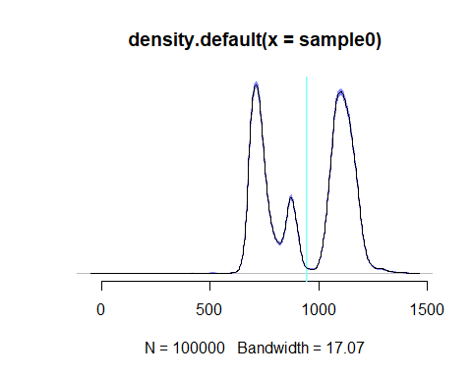

#4  
quantile(show_resample_width(minday), probs = c(0.025, 0.975))

## 2.5% 97.5%   
## NA NA

#b  
#1  
minday_median <- median(minday)  
minday_median

## [1] 1040

#2  
sample0 <- minday  
resample_minday_median <- function(sample0) {  
 resample <- sample(sample0, length(sample0), replace=TRUE)  
 mean(resample)  
 }  
  
boots_minday_median <- replicate(2000, resample_minday_median(sample0))  
  
plot(density(boots_minday_median))

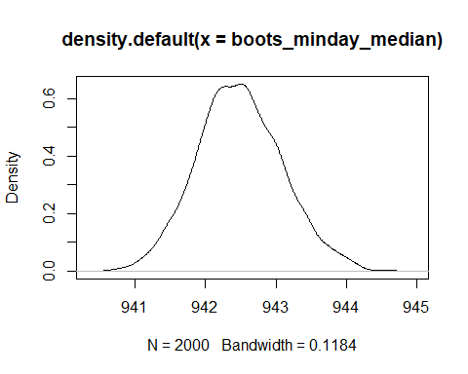

#3  
quantile(boots_minday_median, probs = c(0.025, 0.975))

## 2.5% 97.5%   
## 941.3628 943.7383