BACS-hw4.R

2022-04-12

#Question 1  
#a  
pnorm(-3.7)

## [1] 0.0001077997

#b  
pnorm(-3.7)*2500000

## [1] 269.4993

#Question 2  
#a  
setwd("C:/Users/eason/Desktop/清大 BACS/資料/")  
verizon <- read.csv("verizon.csv")  
time <- verizon$Time  
  
#1  
#Density Plot  
plot(density(time), lwd=2, col="cornflowerblue")  
abline(v=mean(time), lty="dashed")

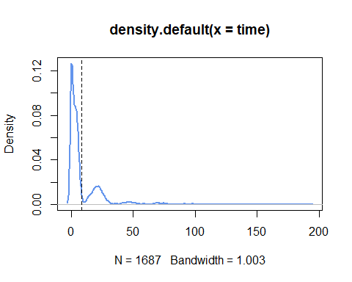

#2  
Hnull: The population mean is 7.6  
Halt: The population mean is significantly greater than or less than 7.6

#The hypothesis  
hyp_mean <- 7.6  
  
#Sample descriptive statistics  
sample_n <- length(time)  
sample_mean <- mean(time)  
sample_sd <- sd(time)  
sample_se <- sd(time)/sqrt(length(time))  
  
#3 就是這裡會有點不懂(不過就假設有一個t分布)  
#Confidence Interval  
quants_99_2sided <- qt(c(0.005, 0.995), sample_n - 1)  
sample_mean + quants_99_2sided * sample_se

## [1] 7.593524 9.450495

#4 想問t分布跟原本hyp_mean的圖形會長一樣嗎  
t_value <- (mean(time)-hyp_mean) / sample_se  
p_value <- pt(t_value, sample_n - 1, lower.tail = FALSE)  
  
#5  
Classical hypothesis testing(t-value, p-value) seems to relate to the Null t-distribution  
  
#6  
The hypothesis cannot be rejected at 99% CI(two-tailed), but we should probably collect more data  
  
#b 下面這個解把三種合起來 學起來  
sample_boot <- function(sample0, hyp_mean) {  
 resample <- sample(sample0, replace = TRUE)  
 resample_se <- sd(resample) / sqrt(length(resample))  
   
 boot_mean <- mean(resample)  
 boot_diff <- mean(resample) - hyp_mean  
 boot_t <- (mean(resample) - hyp_mean) / resample_se  
 c(boot_mean, boot_diff, boot_t)  
}  
set.seed(42)  
boot_stats <- replicate(2000, sample_boot(time, hyp_mean))  
  
#1 Bootstrapped means  
boot_means <- boot_stats[1,]  
q_means <- quantile(boot_means, probs = c(0.005, 0.995))  
plot(density(boot_means))  
abline(v=hyp_mean, lwd=2)  
abline(v=q_means, lty="dashed")

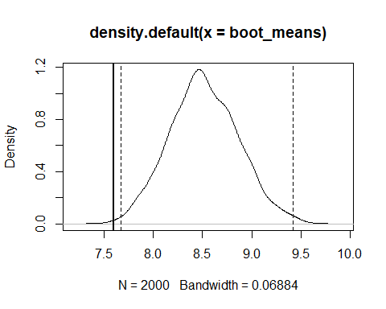

#2 Bootstrapped differences  
boot_diffs <- boot_stats[2,]  
q_diffs <- quantile(boot_diffs, probs = c(0.005, 0.995))  
plot(density(boot_diffs))  
abline(v=0, lwd=2)  
abline(v=q_diffs, lty="dashed")

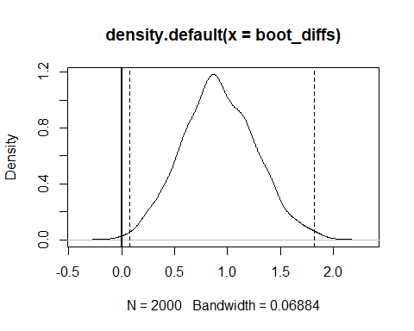

#3 Bootstrapped t-statistics  
boot_t_vals <- boot_stats[3,]  
q_boots <- quantile(boot_t_vals, probs = c(0.005, 0.995))  
plot(density(boot_t_vals))  
abline(v=0, lwd=2)  
abline(v=q_boots, lty="dashed")

