Arduino键盘使用

一．准备材料

Arduino Uno 开发板

4\*4矩阵键盘

8根跳线

二．接线

键盘的8跟引线，从左到右分别为第1-4行，第1-4列。

Keypad Pin R1 –> Arduino Pin 13

Keypad Pin R2 –> Arduino Pin 12

Keypad Pin R3 –> Arduino Pin 11

Keypad Pin R4 –> Arduino Pin 10

Keypad Pin C1 –> Arduino Pin 9

Keypad Pin C2 –> Arduino Pin 8

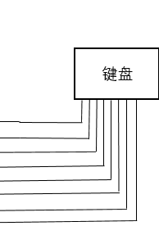Keypad Pin C3 –> Arduino Pin 7

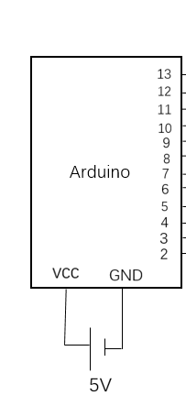Keypad Pin C4 –> Arduino Pin 6

3.代码

准备：网上下载一个arduino的keypad安装包，手动添加到Arduino库中。

运行程序之后，在Arduino环境中点击 工具 串口监视器便可以观察到按下的按键。

#include <Keypad.h>

const byte ROWS = 4; //four rows

const byte COLS = 4; //four columns

//define the cymbols on the buttons of the keypads

char hexaKeys[ROWS][COLS] = {

{'1','2','3','A'},

{'4','5','6','B'},

{'7','8','9','C'},

{'\*','0','#','D'}

};

byte rowPins[ROWS] = {13, 12, 11, 10}; //connect to the row pinouts of the keypad

byte colPins[COLS] = {9, 8, 7, 6}; //connect to the column pinouts of the keypad

//initialize an instance of class NewKeypad

Keypad customKeypad = Keypad( makeKeymap(hexaKeys), rowPins, colPins, ROWS, COLS);

void setup(){

Serial.begin(9600);

}

void loop(){

char customKey = customKeypad.getKey();

if (customKey){

Serial.println(customKey);

}

}