QuickDiagram Developer’s Manual

We are very happy that you are interested in the QuickDiagram project and downloaded this manual for QuickDiagram. We thank you very much for your potential contributions to this project. This document is written in order to aid you running this program via Visual Studio 2008 on your computer. Before you start, you are advised to follow the following important regulation: please do not submit the compiled files such as *.dll, *.manifest, *.pdp, *.xml, or any other files that are created by the compiling procedure of Visual Studio or those you have not personally made the modification. Since you have already installed VS2008, let’s start.

- You need to have an SVN tool on your computer. TortoiseSVN is recommended for its convenience and flexibility. We will take this tool as an example to show the procedures but we will always try to avoid ambiguousness.
- Create a folder on your computer dedicated to our QuickDiagram project. Then check out the code files with HTTPS (if you are member of the developing team) or HTTP (if you are not member of the developing team) given in the “Source” label of our project home page. Enter your Google account and your “generated Google.com password” when asked by a dialogue box if you are a developing team member. As shown in figure 1.
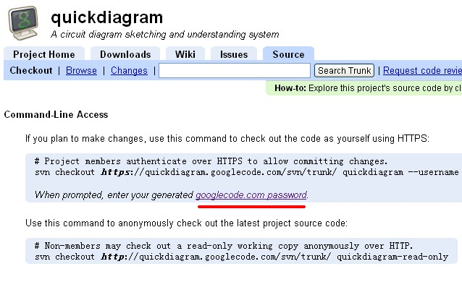
Figure 1. Click on the hyperlink with red underline if you are a member to get your password
*If you are not a member of the team, you are still able, and always welcome, to download all the code files of the latest version. However, you are not able to commit any changes. Interested in our project and want to become a team member? E-mail kxf829@sina.com and cc to csliuwy@cityu.edu.hk now with your developing proposal and we will arrange your membership.

- Once you finish the check out procedure, you can now right-click on your folder and choose “SVN Update.” to download the newest version of our project code. You can update at anytime when you feel there may be some changes in our version.
- Now that all the codes are downloaded, let us begin to compile the whole project via VS2008. Open QuickDiagram.sln first.
- At the first time you open the solution, you would see many link errors. They are normal because all those modules are not yet compiled. That is- .dll files are still not created. Just right-click on the solution ’QuickDiagram’ and choose to build the whole solution. Please wait patiently until your computer finishes the job. Open the reference tree of the whole solution’s main project-‘QuickDiagramUI’ and check whether all the reference libraries are ready, as shown in figure 2. If not, check whether you chose “Debug” as the output folder (shown in figure 3) and rebuild the solution. If you still have problems, please do send the error description to us. We will help you as much as possible.
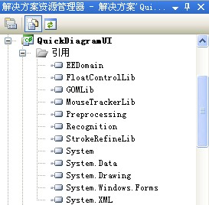
Figure 2. Reference tree of the main project-QuickDiagramUI


Figure 3. Choose “Debug” as the output folder

- Once all the libraries are ready, copy the folder “Templates” (at your root dir) to the following position:
YourSVNRootDir\QuickDiagramUI\bin\Debug\Templates
- Now you can press F5 to lunch debug. When the program is reading the templates, you may see many “.svn file can not be read” errors. Just ignore these annoying errors. Our SVN tool just created a hidden .svn folder under every folder of our project and they have nothing to do with our program. They will also not affect the operation.
- Once you see the main window, you have successfully compiled the project on your computer. But, as mentioned at the very start, please do not submit the compiled files such as *.dll, *.manifest, *.pdp, *.xml, or any other files that are created by compilation or those you have not personally made the modification.

