XML file structure of objects

User can develop their own objects with XML files; here is the template of the xml object files:

<graphicTemplate id=" ">
<points>
<point id="PT_1" x="37" y="0" controllable="False" connectable="False" />
<point id="PT_2" ….>
…..
</points>
<drawings>
<line startPoint="PT_1" endPoint="PT_2" style="def" />
<line startPoint="PT_2"/>
…..
</drawings>
<fillings />
<styles>
<drawingStyle id="def" red="0" green="0" blue="0" width="1" style="solid" />
</styles>
<attribute>
<variable id="info" value1="100" value1="…" value2="…" value3="………../>
<variable id="…." value1="…." value1="…" value2="…" value3="………../>
</attribute>
<restriction>
<rules type="…" value1="…" value2="…"/>
</restriction>
</graphicTemplate>

Descriptions of items in XML files:

Points Includes points that constitutes the objects
Drawings Includes the lines that link the points specify in <Points> together
Styles Includes the he Drawing style of the lines specify in <drawings>
Attribute All the objects variables are stored here; the rules will be mentioned in next part.
Restrictions The drawing rules of the objects
Variables of the objects

For tag <attribute>, user can specify the information of the object, such as the names, the contents, the properties, etc. Also, with use some modifiers, you can specify what functions you want to display and what information you want to be modified in while drawing. You can freely to assign attribute in this parts, but so restrictions should be follow.

- Information should be put into <variable …. /> and the first item should be id = “…” that specify the use of this line.

- Reserved words (modify, show) cannot be used as the attribute name.

- Repeat name assignment of attribute name should not be allowed.
(e.g. <variable id= “test” test= “bio” test = “chem.” />

User should follow the above rules develop the objects in XML files.

Information on the drawing area

In additions, the information that show above on the objects can be assigned into XML, the structure is like this:

<variable id= “example” att1 = “a1” att2 = “a2” att3 = “a3” show =”a1,a2”>

The information could be specified in the tag show = “” and use “,” for separation.
Notes: space in the is not allowed in the <show> tag

Modification of attributes on the drawing area

You can also specify which information can be modified by others when drawing. The <modify> tag is used to achieve this.

<variable id= “example” att1 = “a1” att2 = “a2” att3 = “a3” modify =”a1,a2”>

The information could be specified in the tag modify = “” and use “,” for separation.
Notes: space in the is not allowed in the <modify> tag

Here is the example about specify the information in object “Transistors”

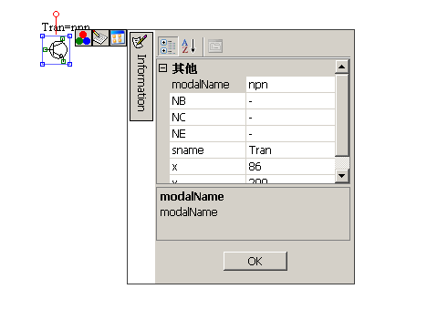
<variable id="info" name="Transistor" sname="Tran" modalName="npn" NB="-" NC="-" NE="-" modify="sname,modalName,NB,NC,NE" show="sname,=,modalName" />

Figure: Example of Transistors properties with use XML defined methods

