Log improvement

I am analyzing the exceptions in server logs, I found some of it are easy to fix as the logs give me sufficient information about the problem, and some of it are difficult even I can do nothing with it, just because I can't get sufficient information from logs or get nothing from logs. So I decided to going over the java logging. Below is my practice plus several references and the logging problems of our system. Welcom to contribute opinions and discuss about logging to better our logging.

– Good logging is helpful for tech support and bug fix.

The references:
- https://docs.oracle.com/javase/7/docs/technotes/guides/logging/overview.html
- https://tomcat.apache.org/tomcat-7.0-doc/logging.html#Java_logging_API_%E2%80%94_java.util.logging
- https://www.javacodegeeks.com/2011/01/10-tips-proper-application-logging.html
- https://wiki.opendaylight.org/view/BestPractices/Logging_Best_Practices
- http://c2.com/cgi/wiki?LoggingBestPractices
- http://bewarethepenguin.blogspot.com/2014/09/java-application-logging-guidelines.html

- Do not use e.printStackTrace(), use java.util.logging.Logger instead.
Let's say a wrongly performance id passed to call PerformanceOnlineSale.restoreToken
Below is a example logs by e.printStackTrace()
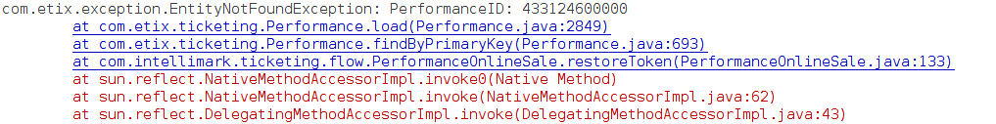
Below is the logs but by
logger.log(Level.SEVERE, "Performance not found by given performance_id " + perfId + " during restore token.", e);
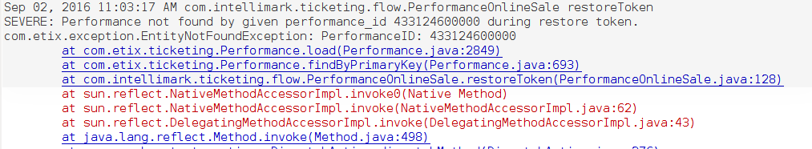
By compare the two screen shot we can find the benefit of java.util.logging.Logger:
  - we can easy find out the place that print this log com.intellimark.ticketing.flow.PerformanceOnlineSale restoreToken
  - we can easy find the date time that the logs printed or the exception was thrown out. Sep 02, 2016 11:03:17 AM
  - The severity of the log. SEVERE
  - we can simply ship another useful message in logging like Performance not found by given performance_id 433124600000 during restore token.
  - Besides the above 5 advantage with java.util.logging there are some important ability shipped by java.util.logging
  - write the log statement to different locations at once, e.g. the console and a file
  - filter the log statements by severity (SEVE, WARNING, INFO, FINE etc.) and origin (normally package or class based)
  - have some influence on the log format without having to change the code
- Do not use System.out.print, use java.util.logging.Logger instead. As java.util.logging.Logger has all the advantages descripted in previous compare to System.out.print
- Use java.util.logging.Logger correctly
  - There are lots of override methods named log in java.util.logging.Logger to do logging. Every these method has it's special usage, but the very popolar used method are the two java.util.logging.Logger.log(Level, String, Throwable) and java.util.logging.Logger.log(Level, String). The former mainly used for logging for exceptions, and the later mainly used to log normal string message, and there are convenience methods for the later in java.util.logging.Logger, like Logger.sever(String), Logger.warning(String), Logger.info(String), etc.
  - Don't use java.util.logging.Logger.log(Level, String) or any of it's convenience variants to log for exceptions like below:
    - logger.log(Level.SEVER, e) or logger.SEVER(e)//it's useless as lose the stack trace and suppose the toString() method properly implemented in the Exception class.
    - logger.log(Level.SEVER, e.toString()) or logger.SEVER(e.toString())//it's useless as lose the stack trace and suppose the toString() method properly implemented in the Exception class.
    - logger.log(Level.SEVER, e.getMessage()) or logger.SEVER(e.getMessage())//lost the stack trace, and may be return null by e.getMessage().
We should log the exceptions like: logger.log(Level.SEVER, “information of the context”, e) // the context information and the stack trace would be in logs and these information are very useful.
- The styles.
The purpose of make the logs in a good style is to help easy read and easy parse.
  - (we should discuss to work out some good styles to logging.)
  - We should run application to see if the log messages formatted correctly.
- Throw Exception more meaningfully.
  - Always throw EntityNotFoundException with entity type and ID.
  - Always thow exceptions with message by call new Throwable(String) to construct a instance of java.lang.Throwable.
- The levels of Logging
There are seven levels defined in java.util.logging.Level, they are SEVERE, WARNING, INFO, CONFIG, FINE, FINER, FINEST. We should do logging with aproper level, to choose the right level, we should think of the severity of the log. (The java.util.logging's standard levels is too complicated, the well know logging facede slf4j only have 5 levels) In most situation we only need the 4 levels SEVERE, WARNING, INFO, FINE, the below is the guideline to choose the proper level when do logging(picked up from API doc)
  - SEVERE is a message level indicating a serious failure. In general SEVERE messages should describe events that are of considerable importance and which will prevent normal program execution. They should be reasonably intelligible to end users and to system administrators.
  - WARNING is a message level indicating a potential problem. In general WARNING messages should describe events that will be of interest to end users or system managers, or which indicate potential problems.
  - INFO is a message level for informational messages. Typically INFO messages will be written to the console or its equivalent. So the INFO level should only be used for reasonably significant messages that will make sense to end users and system administrators.
  - FINE is a message level providing tracing information. All of FINE, FINER, and FINEST are intended for relatively detailed tracing. The exact meaning of the three levels will vary between subsystems, but in general, FINEST should be used for the most voluminous detailed output, FINER for somewhat less detailed output, and FINE for the lowest volume (and most important) messages. In general the FINE level should be used for information that will be broadly interesting to developers who do not have a specialized interest in the specific subsystem. FINE messages might include things like minor (recoverable) failures. Issues indicating potential performance problems are also worth logging as FINE.
These are pick up from website:
  - SEVERE: something terribly wrong had happened, that must be investigated immediately. No system can tolerate items logged on this level. Example: NPE, database unavailable, mission critical use case cannot be continued
  - WARNING: the process might be continued, but take extra caution. Actually I always wanted to have two levels here: one for obvious problems where work-around exists (for example: “Current data unavailable, using cached values”) and second (name it: ATTENTION) for potential problems and suggestions. Example: “Application running in development mode” or “Administration console is not secured with a password”. The application can tolerate warning messages, but they should always be justified and examined.
  - INFO: Important business process has finished. In ideal world, administrator or advanced user should be able to understand INFO messages and quickly find out what the application is doing. For example if an application is all about booking airplane tickets, there should be only one INFO statement per each ticket saying “[Who] booked ticket from [Where] to [Where]”. Other definition of INFO message: each action that changes the state of the application significantly (database update, external system request).
  - FINE: information that is useful only to developers. FINE level should be disabled in any deployment environment other than DEV and possibly TEST, so it is not to be relied upon for routine troubleshooting by non-developers.
- Logging configuration file in Tomcat 7.
There is a global logging configuration file in $TOMCAT_HOME/conf named logging.properties. And for each context we can put logging.properties in WEB-INF/classes/, this configurations only apply the corresponding context. I made a example logging.properties, the content as bellow:
# just out the logs in console, it's catalina.out in tomcat
handlers = java.util.logging.ConsoleHandler
# Default global logging level. If not override by sub-logger, only INFO and abover can be out put to logging.
.level = INFO

# set the handler's level is Lowest level “FINEST”, means every log level can be out put by console handler.
java.util.logging.ConsoleHandler.level = FINEST
#To specify a log formatter, note, to specify the formatter's pattern we should config the pattern in tomcat's global logging.properties.
java.util.logging.ConsoleHandler.formatter = java.util.logging.SimpleFormatter
#the bellow line should be in tomcat's global logging.properties
#java.util.logging.SimpleFormatter.format=%4$s: %5$s [%1$tc]%n

#Mostly in our production environment we only want output INFO or abover level's log
com.etix.level = INFO
com.intellimark.level = INFO

#Set sub-logger's level, for instance if we only want a special package or a special class output FINE or abover level's log we should uncoment the two bellow line
#{special class name}.level = FINE
#{special package name}.level = FINE

- Examples
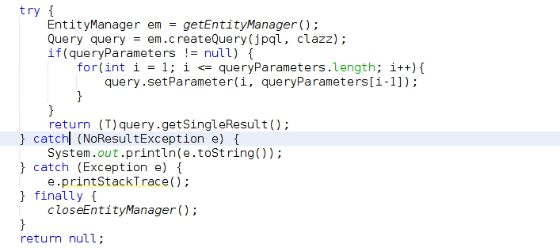
The above code snippet in our JPAUtil, we catched the NoResultException and just System.out.println(e.toString()) we end up get a lot of logs like javax.persistence.NoResultException: No entity found for query. I think the log like that is useless. If we change it as
logger.log(Level.FINE, "No {0} found for query: {1} with parameters {2}", new Object[] {clazz.getSimpleName(), jpql, Arrays.deepToString(queryParameters)}),
we should get the logs like bellow when NoResultException occur.
Sep 02, 2016 2:46:07 PM com.etix.util.JPAUtil selectByJPQLQuery
FINE: No LoyaltyMatch found for query: select lm from LoyaltyMatch lm where lm.membershiplevelId=?1 with parameters [850]
How useful the logs like this !

