**基于硫代谢微生物生理特性分析的ASO脱氮工艺研究**

**Abstract**

**Keywords**

**Background**

**随着城市化进程不断加深，城镇污水水量不断增加，复杂程度提高。许多生活污水呈现低碳氮（C/N）比的趋势。同时国家污水排放标准在COD、氨氮、总氮指标上也在进一步严格，因而传统的城镇污水处理处理工艺越来越无法满足要求。**

**近年来，硫自养反硝化已被广泛研究以提高污水处理性能.**，硫自养反硝化方法有两个主要优点[52]： （1）无需添加外部有机底物（例如甲醇），**从而减少了出水中有机碳过剩的可能性；**（2）涉及的 三种 SRB、SOB、硝化微生物都是低污泥产生的微生物，基本不排泥。

**(3) 降低运行成本，原料价低易.**

**已在污废水领域鉴定和分离出来的反硝化脱硫微生物**

Previous research has suggested that a core microbial community exists within污水装置**，**

Wang等[]开发了一种新型的生 物废水处理工艺——硫酸盐还原自养反硝化和硝化联合工艺（Sulfate reduction Autotrophic denitrification and Nitrification Integrated，SANI）. 硫酸盐还原菌（SRB）是主要种群，将硫酸盐还原为硫化物.

**随后，有很多研究者对 SANI 工艺开展了广泛的研究，对 SANI 工艺建立了稳态模型[53]、分析了各种因素对 SANI 工艺的影响[54]、对其中微生物群落进行测序[55]. 当前已在污废水领域鉴定和分离出来的反硝化脱硫微生物**. Desulfovibrio, Desulfobulbus, Desulfomicrobium and Desulfobacter are the most commonly found SRB genera in these sulfate reduction bioreactors. Desulfovibrio, Desulfobulbus and Desulfomicrobium belong to the group of incomplete organic oxidizers, while Desulfobacter is the only dominant complete organics oxidizer identified [H,T,H ].

Metagenomic is an important tool for understanding microbial ecosystems, given its ability to provide information about the diversity and distribution of the different members of a community and their metabolic potential.16 This methodology has increased the knowledge about diverse microbiomes, such as oceans,17 the human body,18, 19, 20 and soil,

Hiibel, S.R., Pereyra, L.P., Riquelme Breazeal, M.V., Reisman, D.J., Reardon, K.F., Pruden, A., 2011. Effect of organic substrate on the microbial community structure in pilot-scale sulfatereducing biochemical reactors treating mine drainage. Environ. Eng. Sci. 28, 563e572.

**T. P. H. van den Brand,K. Roest,G. H. Chen,D. Brdjanovic,M. C. M. van Loosdrecht. Potential for beneficial application of sulfate reducing bacteria in sulfate containing domestic wastewater treatment[J]. World Journal of Microbiology and Biotechnology,2015,31(11).**

**[1]Hao Tian-wei,Xiang Peng-yu,Mackey Hamish R,Chi Kun,Lu Hui,Chui Ho-kwong,van Loosdrecht Mark C M,Chen Guang-Hao. A review of biological sulfate conversions in wastewater treatment.[J]. Water research,2014,65.**

[1]Wang Jin,Shi Manyuan,Lu Hui,Wu Di,Shao Ming-Fei,Zhang Tong,Ekama George A,van Loosdrecht Mark C M,Chen Guang-Hao. Microbial community of sulfate-reducing up-flow sludge bed in the SANI® process for saline sewage treatment.[J]. Applied microbiology and biotechnology,2011,90(6).

[53] Lu H , Wang J , Li S , et al. Steady-state model-based evaluation of sulfate reduction, autotrophic denitrification and nitrification integrated (SANI) process[J]. Water Research, 2009, 43(14):0-3621. [54] Lu H , Huang H , Yang W , et al. Elucidating the stimulatory and inhibitory effects of dissolved sulfide on sulfur-oxidizing bacteria (SOB) driven autotrophic denitrification[J]. Water Research, 2018, 133:165-172. [55] Hao T , Luo J , Wei L , et al. Physicochemical and biological characterization of long-term operated sulfate reducing granular sludge in the SANI process[J]. Water Research, 2015, 71:74-84.

传统脱氮除磷工艺面临的难题是:如何解决反硝化细菌和聚磷菌竞争碳源和两者泥龄的问题 。相比较而言,污泥工艺中聚磷菌和硝化菌独立存在于不同的反应器中,在反硝化除磷上表现更好**[ ].**

**，开发了一种中试规模的电解厌氧/缺氧/有氧（AAO）工艺，以增强从低碳/氮（C / N）中去除氮（N）的能力。**

**To cross such an organic-dependent barrier, a pilot-scale anoxic/** settlement/**oxic (ASO) process was** was designed in combination with sulfur autotrophic denitrification **for enhanced removal of nitrogen (N) from low carbon/nitrogen (C/N) municipal wastewater**

**[1] Wei Huang,Benzhou Gong,Yingmu Wang,Ziyuan Lin,Lei He,Jian Zhou,Qiang He. Metagenomic analysis reveals enhanced nutrients removal from low C/N municipal wastewater in a pilot-scale modified AAO system coupling electrolysis[J]. Water Research,2020,173.**

**在这里，我们阐明了在实验室规模的厌氧氨氧化生物反应器的启动和运行过程中，厌氧氨氧化细菌Brocadia及其支持社区成员之间更深的代谢关系。我们首先通过以基因组为中心的宏基因组学和16S rRNA基因测序相结合的方式来分析“厌氧菌群落”的形成。在启动过程中，将正向富集细菌的代谢特征与负向富集细菌进行比较。接下来，我们将研究重点放在由微生物相互作用驱动的厌氧氨氧化性能不稳定事件上。最后，我们进行厌氧氨氧化社区的对比分析，研究同样厌氧氨氧化社区[ 18，20]突出显示我们的结果具有更广泛的意义。就我们所知，这是首次基于系列的研究，将厌氧氨氧化宏基因组学见解和群落组成与厌氧氨氧化生物反应器功能联系起来[ 21 ]。**

**Here, we illuminate deeper metabolic relationships between an anammox bacterium, Brocadia, and its supporting community members during the start-up and operation of a laboratory-scale anammox bioreactor. We begin by analyzing the formation of the “anammox community” through a combination of genome-centric metagenomics and 16S rRNA gene sequencing. Metabolic features of positively enriched bacteria are compared to negatively enriched bacteria during the start-up process. Next, we focus our investigation on an anammox performance destabilization event that was driven by microbial interactions. Last, we conduct a comparative analysis of our anammox community to similarly studied anammox communities [180] to highlight the broader relevance of our results. To our knowledge, this is the first time series-based study to link anammox metagenomic insights and community composition to anammox bioreactor functionality [21].**

Speth DR, in ’t M, Guerrero-Cruz S, Dutilh BE, Jetten MSM. Genome-based microbial ecology of anammox granules in a full-scale wastewater treatment system. Nat Commun. 2016;7:11172.

Tang X, Guo Y, Jiang B, Liu S. Metagenomic approaches to understanding bacterial communication during the anammox reactor start-up. Water Res. 2018;136:95–103.

**MATERIALS AND METHODS**

2.1. Bioreactor installation and operation

反应器装置安装在实验室内，缺、好氧单元的有效容积分别为3L、6L。整个运行过程中温度保持 25°C。缺氧段的接种污泥取自上海闵行区江川水质净化厂的厌氧池，好氧 段的接种污泥取自上海闵行区江川水质净化厂的好氧池。进水采用葡萄糖和蛋白 胨作为碳源，NH4Cl 作为氮源，KH2PO4 作为磷源，用自来水进行人工配水。

The bioreactor was operated in a continuous flow mode.反应器运行主要分为四 个阶段：启动阶段驯化反应器微生物使其适应。第二个阶段为高负荷阶段，提高碳氮负荷，研究高氨氮浓度且低碳氮比下 ASO 工艺运行效果和微生物群落变化；第三阶段为调整阶段，保持进水各物质浓度不变，提高硝化液回流比。第四阶段为稳定运行阶段。

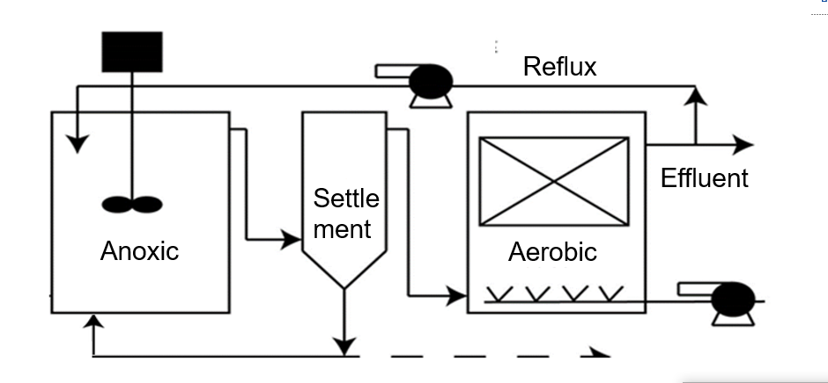

Fig. 2-1 Flow chart of the ASO system

2.2. Chemical analysis**反应器运行期间，每日采集配水和厌氧、缺氧、好氧单元的水样进行水质分析。用于水质检测的水样采样后立即用 0.45 μm 的有机水系膜过滤，并于 4 °C 低温保存。****The concentrations of Cl−, NO3–, NO2–, and SO42− were** **analysed using ion chromatography (IC) (Shenghan CIC-100, China).**

**2.3.**

**为了考察 ASO 工艺系统在不同运行条件下功能微生物的群落结构，在不同**

**反应阶段定期采集各反应器污泥样品。采集的微生物样品 50 %乙醇固定并保存在**

**-20℃冰箱冷藏备用。**

**2.4.** **DNA extraction, Illumina MiSeq Sequencing, and bioinformatic analysis**

**Activated sludge samples named G1, G2, G3, G4… were collected on day 10, day 20, day 30…for 16S rRNA sequencing and metagenome analysis. Each sample was centrifuged at 10000 rpm for 10 min, after which the supernatant was discarded. Genomic DNA was extracted from the sludge pellet using the Fast DNA SPIN Kit for soil (MP Biomedicals, Solon, OH, USA).**

.5. High-throughput metagenomic sequencing and data analysis

To explore the diversity and abundance of the activated sludge samples

To explore the diversity and abundance of the activated sludge samples in the sulphur-based autotrophic denitrification system,将纯化的 DNA 发送到商业测序公司进行高通量测序。High-throughput sequencing was performed on Illumina MiSeq. Using the basic local comparison search tool (BLASTx) we compared the generated quality-filtered reads with the database downloaded from KEGG. Reads annotated in ppm with one million sequencing reads were used to represent the relative abundances of enzymes functional genes and from KEGG in the samples[q].

**Q. Hu, X. Zhang, S. Jia, K. Huang, J. Tang, P. Shi, L. Ye, H. Ren**

**Metagenomic insights into ultraviolet disinfection effects on antibiotic resistome in biologically treated wastewater**

**Water Res., 101 (2016), pp. 309-317**

**3. RESULTS AND DISCUSSION**

**Chemical variation in ASO bioreactor**

**使用一种新污水处理工艺——“缺氧池-二沉池-好氧池”（ 即ASO工艺 ），分别调控不同功能微生物菌群的污泥龄，在各反应器内积累高浓度的专性功能微生物。反应器中碳氮硫物质转化的化学计量关系如下：**

**缺氧池：硫酸盐还原，异养反硝化和硫自养反硝化**

3H2SO4 + C6H12O6 → 3H2S+ 6CO2 + 6H2O 1

**8HNO3 + 5H2S → 4N2 + 5H2SO4 + 4H2O**

**6HNO3 +5CH3OH → 3N2 + 5CO2 + 7H2O + 6H2O**

好氧池：好氧硝化和还原性无机硫物质利用氧气还原

NH4+ + 2O2 → NO3− +H2O + 2H+

H2S + 2O2 → H2SO4

**基于化学计量关系进一步分析ASO反应器碳、氮和硫的转化关系， 按如上式（1）、式（2）、式（3）和式（3）计算 ASO 工艺运行过程中碳、硫和氮的转化率。重点关注采取泥样当日的碳氮硫转化效果，如表 3-1 所示。**

**Table 3-1 Transfer of carbon, nitrogen and sulfur in the ASO process based on stoichiometric analysis**

**得出厌氧池过量还原的硫酸盐产物，在缺氧池未被及时氧化，大量还原性硫物质在好氧段氧化影响了氨氮的氧化，经调整后好氧段氨氮氧化效果提升。ASO 工艺运行过程中未产生剩余污泥，能减少污水处理设施的剩余污泥处理处置的运行成本，从而减少了能源消耗。**

**3.3. Microbial analysis**

**To characterize this new biological system, we carried out microbial analysis to identify and reveal their genomic information.**

**3.2. Microbial community structure**

**To characterize this new biological system, we carried out microbial analysis to identify and reveal their genomic information.**

**[Fig. 4](https://www.sciencedirect.com/science/article/pii/S0960852420301383?via%3Dihub" \l "f0020)b shows that 31 phyla detected in aerobic samples, The Proteobacteria has the maximum abundance among different samples.** **Nitrospira is more abundant than the hypoxic pool. The results of most of the wastewater treatment facility microbiological studies are consistent.**

**X. Guo, Y. Miao, B. Wu, L. Ye, H. Yu, S. Liu, X.X. Zhang Correlation between microbial community structure and biofouling as determined by analysis of microbial community dynamics Bioresour Technol, 197 (2015), pp. 99-105**

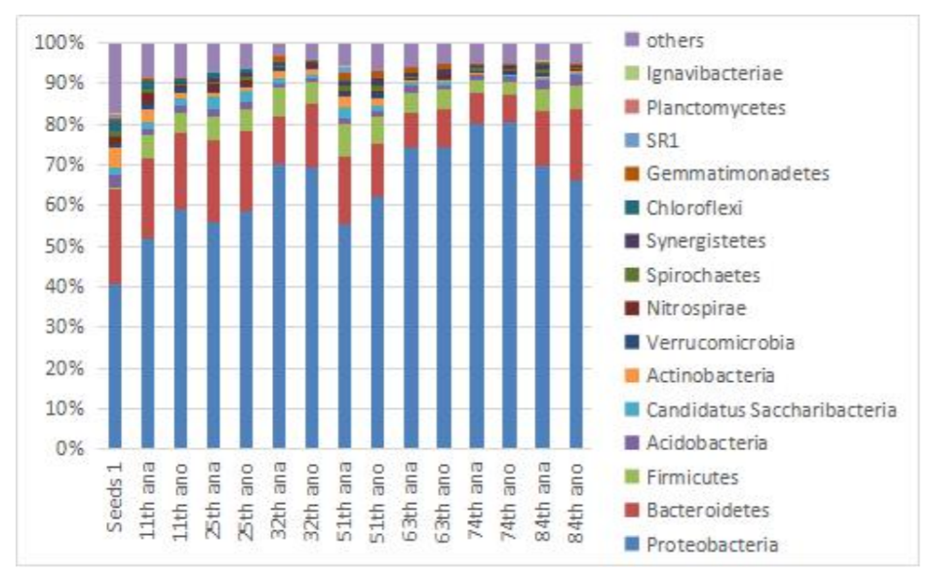

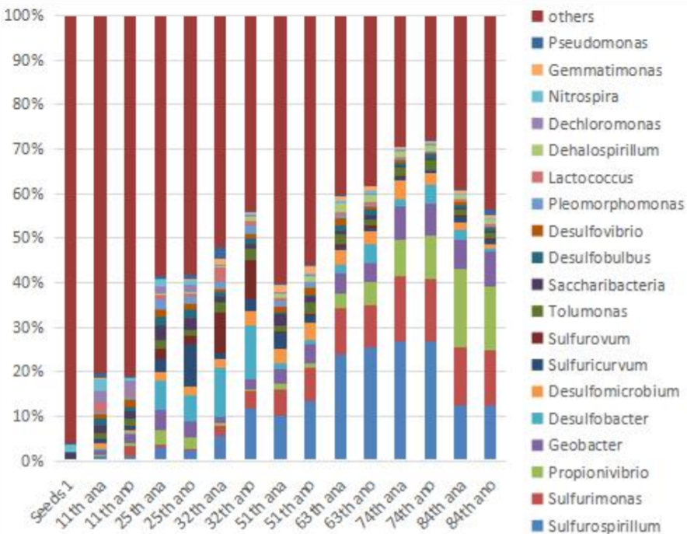

**Fig.3-1** Relative abundance of dominant bacteria in phylum level (a) and genus level (b).

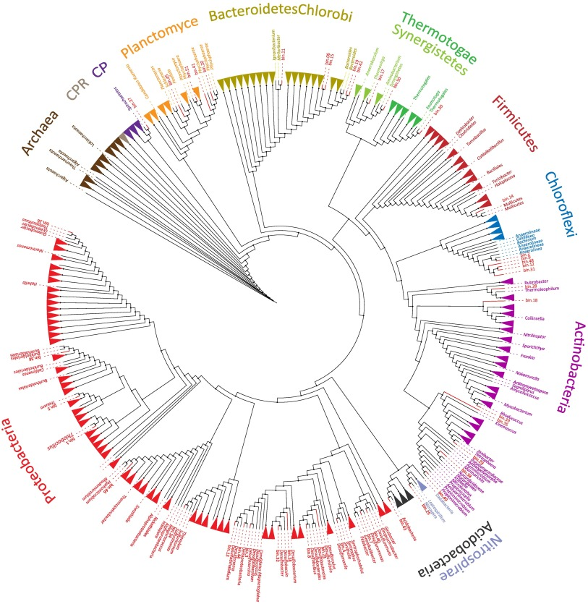

**Fig.4-2** Phylogenetic tree of the 51 MAGs retrieved from microbiome. The tree was constructed based on an alignment of their concatenated ribosomal protein sequences.

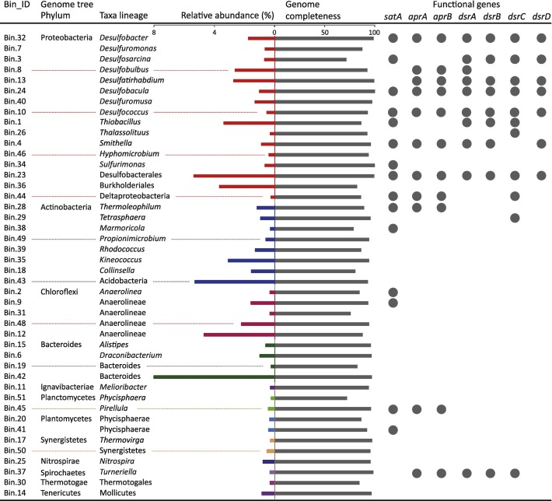

Fig. 4-3. Genome completeness and relative abundance (shown as bar graph) of retrieved MAGs. The right-hand columns showed the presence (closed circle).

Phylogenetic analysis based on the concatenated 16 ribosomal protein (RP) sequences, as well as functional genes, showed the community composition of the sulfur metabolic bacteria. Abundant functional microorganisms are critical for nitrogen removal[D]. **A total of 30 phyla detected in aerobic samples, were detected in the anoxic sludge sample.** [**Fig. 4**](https://www.sciencedirect.com/science/article/pii/S0960852420301383?via%3Dihub#f0020)**a shows that microbial populations in anoxic reactor could be classified into 3 main phyla, *Proteobacteria, Bacteroidetes* and *Firmicutes,*** ***which has been proved by many studies* [P]. The Proteobacteria has the maximum abundance among different samples.** **According to previous studies, Proteobacteria could not only exist in an NH4+-rich environment but also exhibit better denitrification capacity[Y].** Proteobacteria is the most common denitrification phylum in denitrifying bioreactors particularly with coexisted NO3− and HS−[D]. The Bacteroidetes and Ignavibacteria existed, which were mainly used for degradation of high molecular weight compounds for nitrate reduction during the anaerobic denitrification process. **Previous studies had shown that the abundance of Firmicutes increased in tandem with the increasing NH4+-N concentrations[K].** Chloroflexi is an important bacteria responsible for cellular material biodegradation and closely sensitive to SO42− in nitrification and denitrification processes[H]. Other bacteria, e.g. Nitrospirae, SR1, Actinobacteria, were also found to be responsible for nitrogen removal in this biofilter.

**D. Xu, E. Xiao, P. Xu, Y. Zhou, F. He, Q. Zhou, D. Xu, Z. Wu Performance and microbial communities of completely autotrophic denitrification in a bioelectrochemically-assisted constructed wetland system for nitrate removal Bioresour. Technol., 228 (2017), pp. 39-46**

**P. Wang, Z. Yu, J. Zhao, H. Zhang Do microbial communities in an anaerobic bioreactor change with continuous feeding sludge into a full-scale anaerobic digestion system Bioresour. Technol, 249 (2017), pp. 89-98**

**Close**

**Y. Wu, R. Han, X. Yang, X. Fang, X. Chen, D. Yang, R. Zhang Correlating microbial community with physicochemical indices and structures of a full-scale integrated constructed wetland system Appl Microbiol Biotechnol, 100 (15) (2016), pp. 6917-6926**

**D. Chen, H. Wang, K. Yang, F. Ma Performance and microbial communities in a combined bioelectrochemical and sulfur autotrophic denitrification system at low temperature Chemosphere, 193 (2018), pp. 337-342**

**K.A. Fimlaid, A. Shen Diverse mechanisms regulate sporulation sigma factor activity in the Firmicutes Curr Opin Microbiol, 24 (2015), pp. 88-95**

**H. Li, B. Zhou, Z. Tian, Y. Song, H. Yu, L. Xiang, S. Wang, C. Sun Johannesburg-sulfur autotrophic denitrification system treatment of municipal wastewater with a low COD/TN ratio: Performance, material balance and bacterial community**

**Desalin. Water. Treat., 59 (2017), pp. 99-113**

**Genus level analysis provides a detailed understanding of the spatial change and the function of microbial community. Fig. 4(d) shows that the dominant genus in this system were Thiobacillus, Sulfurimonas, Ferritrophicum and Anaerolineae. The spatial change of these bacteria was obvious.** **Thiobacillus and Sulfurimonas were predominant in the anoxic** **system, which were also considered as major autotrophic denitrifies and related to the oxidization of inorganic sulfur and the facilitation of nitrate reduction[Y].** **Previous study showed Thiobacillus was a dominant species in sulfur-based denitrification. Sulfurimonas was isolated from sulfidic habitats and detected in denitrifying reactors[M].** **In this study it was found that the important denitrification contributors, Thiobacillus and Sulfurimonas, worked together and were also detected at a high relative abundance of genus. Fig. 3(a) shows a gradual decrease of NO3−-N removal capacity in different units, which corresponded to the decrease of Sulfurimonas. The sulfur could be utilized as the electron donor for denitrification bacteria, and the NO3− as the electron acceptor for the denitrification[R].** In addition, the system also contained a number of other bacterial genera, such as Denitratisoma, Caldilineaceae and Thermomonas with a low relative abundance, which has the capacity of removing nitrogen and other compounds[Y]. Considering the above data, it was deducted that heterotrophic denitrification might exist in the ASO recter.

**Y. Yang, S. Gerrity, G. Collins, T. Chen, R. Li, S. Xie, X. Zhan Enrichment and characterization of autotrophic Thiobacillus denitrifiers from anaerobic sludge for nitrate removal Process. Biochem., 68 (2018), pp. 165-170**

**M.F. Shao, T. Zhang, H.P. Fang Sulfur-driven autotrophic denitrification: diversity, biochemistry, and engineering applications Appl. Microbiol. Biotechnol., 88 (2010), pp. 1027-1042**

**R. Khanongnuch, F. Di Capua, A.M. Lakaniemi, E.R. Rene, P.N.L. Lens Effect of N/S ratio on anoxic thiosulfate oxidation in a fluidized bed reactor: experimental and artificial neural network model analysis Process. Biochem., 68 (2018), pp. 171-181**

**Y. Wu, R. Han, X. Yang, X. Fang, X. Chen, D. Yang, R. Zhang Correlating microbial community with physicochemical indices and structures of a full-scale integrated constructed wetland system Appl. Microbiol. Biotechnol., 100 (15) (2016), pp. 6917-6926**

3.3. Abundance of denitrifying functional genes in the bioreactor

The sequences annotated as narG, nirS, nirK, norB, and nosZ were assigned to specific bacterial hosts at the genus level by BLASTX against the NCBI-nr database to reveal the microbial interaction mechanisms during the 120 d treatment (Fig. 4). Nitrate reduction genes narG encoded more than 10 genera and had high relative abundance in this system, which may be the reason for the high NO3–-N removal efficiency. It is particularly worth mentioning here that norB and nosZ, two functional genes encoding nitric oxide-reducing bacteria and nitrous oxide-reducing bacteria, respectively, showed adaptability to salinity and NO3–-N load, and the relative abundance increased continuously throughout the domestication process.

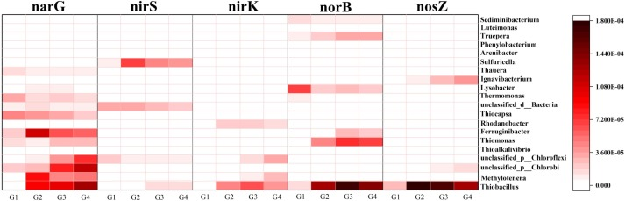 Fig. 4. Heatmap of relative abundance of napG, nirS, nirK, norB and nosZ type genera in four samples. Sequences were aligned against ‘nr’ database and then assigned to NCBI taxonomies with MEGAN. The reads number visualized by MEGAN was taken as 100%.

3.3 Functional classification and metabolic pathways of the metagenomes

For the purpose of analyzing the metabolic potential of the microbial community, we evaluated only genomes with > 70% completeness (n = 88) . we checked for the presence of genes based on their KEGG Orthology (KO) number and calculated KEGG module completeness[B].

Results from the KEGG Pathway Database indicated that enzymes encoded by corresponding functional genes were involved in nitrogen metabolism in the sulphur-based autotrophic denitrification system (Fig. 3). This is consistent with previous research that the genes encoding NO3–-N reductase (EC 1.7.99.4) had the highest relative abundance in the nitrogen metabolism pathway[M].Compared with other pathways of nitrogen metabolism (EC 1.7.2.6, EC 1.7.1.4, EC 1.7.99.1, EC 1.18.6.1), these three enzymes encoded by corresponding functional genes had higher relative abundance under high NO3–-N and salinity stress, demonstrating that the denitrification subsystem played the most important role in the four samples.

Burstein D, Sun CL, Brown CT, Sharon I, Anantharaman K, Probst AJ, et al. Major bacterial lineages are essentially devoid of CRISPR-Cas viral defence systems. Nat Commun. 2016;7:10613.

M. Yu, R. Liao, X. Zhang, Y. Wang, P. Shi, B. Liu, A. Li Metagenomic insights into Cr(VI) effect on microbial communities and functional genes of an expanded granular sludge bed reactor treating high-nitrate wastewater Water Res., 76 (2015), pp. 43-52

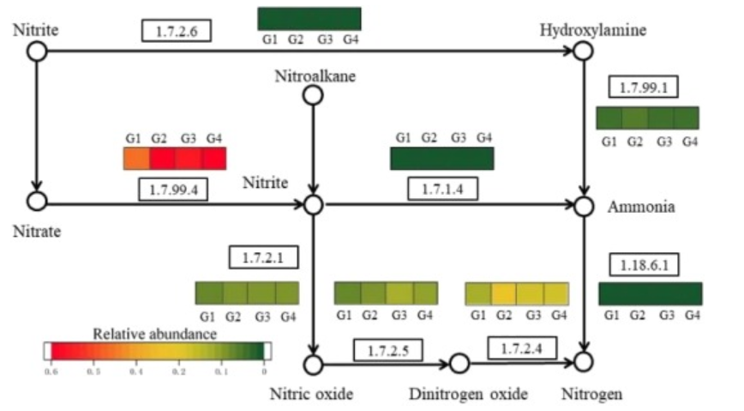

Fig. 3. Nitrogen metabolic pathway of sulphur-based autotrophic denitrification system revealed by annotating Illumina sequencing datasets against KEGG Pathway Database. The scale bar represents the relative abundance.

针对传统 A2O 工艺反硝化碳源不足问题，开发了利用硫自养 反硝化且运行模式为双污泥系统的新型 ASO 工艺。双污泥系统运行模式有利于 ASO 工艺不同功能微生物富集。Metagenomics studies revealed that ASO 工艺逐渐形成相对稳定的功能微生物群落。缺氧和好氧微生物存在明显差异，调整运行条件后 Sulfurospirillum 为 主要的硫还原微生物，Sulfurimonas 为主要的硫氧化微生物。

**Reference**