# Introduction

**What is the Asian Natural Disaster Inquiry database？**

* A collection of natural disasters and insurance information in Asia.
* Include 6 entities: Disasters, DisasterSubtypes, DisasterTypes, Countries, Insurance, InsuranceCompanies.

**Why we made the database?**

* Disasters can have significant impacts on the lives and livelihoods of millions of people
* If we have historical data about disasters, we will have the ability to forecast them and reduce losses from disasters.
* We can know how insurances worked after disasters to reduce residents’ economic losses

# Queries

1 查找发生在南亚的灾害类型，按伤亡人数降序排列->找到对南亚影响最大的灾害类型

**Query1**

SELECT disasterSubtype, SUM(totalDeaths) AS deaths, SUM(totalAffected) AS affected

FROM Countries INNER JOIN

(DisasterSubtypes INNER JOIN Disasters

ON Disasters.subtypeID = DisasterSubtypes.ID)

ON Disasters.country = Countries.country

WHERE Countries.subRegion = 'Southern Asia'

GROUP BY disasterSubtype

ORDER BY SUM(totalDeaths) DESC;

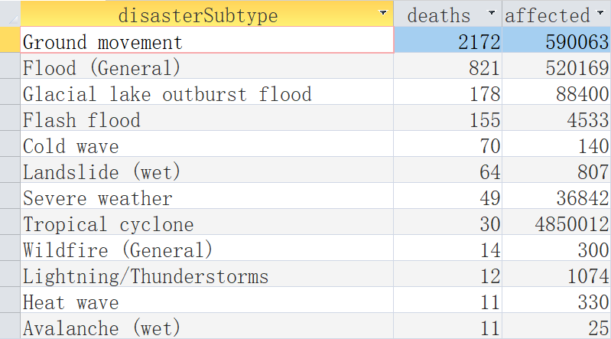

2 依据卫生水平，计算国家平均人口、GDP、GDP增长率、保险公司数量，以判断它们之间是否有相关性

SELECT HealthCareLevel, AVG(population) AS avgPop, AVG(GDP) AS avgGDP, AVG(GDPGrowthRate) AS avgRate, COUNT(companyName) AS companyNum

FROM Countries INNER JOIN InsuranceCompanies ON InsuranceCompanies.countryID = Countries.ID

GROUP BY HealthCareLevel;

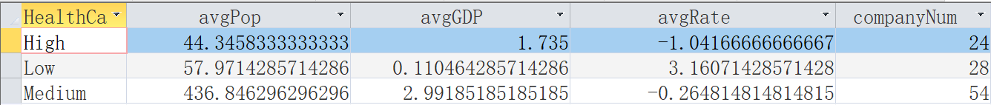

3 查找每个灾害类型造成死亡人数最多的国家 -> 找到每种灾害受灾最严重的国家

SELECT T1.disasterType, T1.country, T1.TotalDeaths AS death

FROM (

SELECT DisasterTypes.disasterType, Disasters.country, SUM(Disasters.totalDeaths) AS TotalDeaths

FROM DisasterTypes INNER JOIN

(DisasterSubtypes INNER JOIN Disasters

ON DisasterSubtypes.ID = Disasters.subtypeID)

ON DisasterTypes.ID = DisasterSubtypes.disasterTypeID

GROUP BY Disasters.country, DisasterTypes.disasterType

) AS T1

WHERE T1.TotalDeaths = (

SELECT MAX(T2.TotalDeaths)

FROM (

SELECT DisasterTypes.disasterType, Disasters.country, SUM(Disasters.totalDeaths) AS TotalDeaths

FROM DisasterTypes INNER JOIN

(DisasterSubtypes INNER JOIN Disasters

ON DisasterSubtypes.ID = Disasters.subtypeID)

ON DisasterTypes.ID = DisasterSubtypes.disasterTypeID

GROUP BY Disasters.country, DisasterTypes.disasterType

) AS T2

WHERE T2.disasterType = T1.disasterType

GROUP BY T2.disasterType

) 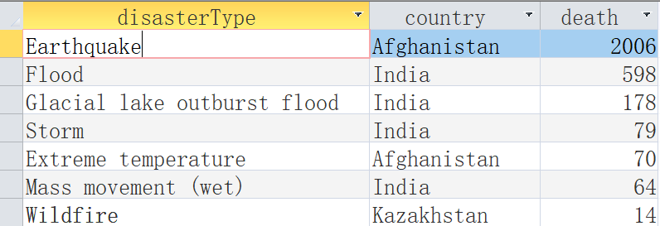

4.查询每个国家发生某种灾害的次数，此灾害造成的总死亡人数以及此国家对应的卫生水平水平->卫生水平对于受灾水平的影响以及哪种灾害对于亚洲国家的冲击最大

SELECT

Disasters.country,

DisasterTypes.disasterType,

COUNT(Disasters.disNo) AS disaster_count,

SUM(Disasters.totalDeaths) AS total_deaths,

Countries.healthcareLevel

FROM

(Disasters

INNER JOIN

Countries ON Disasters.country = Countries.country)

INNER JOIN

DisasterTypes ON Disasters.subtypeID = DisasterTypes.ID

GROUP BY

Disasters.country, DisasterTypes.disasterType, Countries.healthcareLevel

ORDER BY

SUM(Disasters.totalDeaths) DESC;

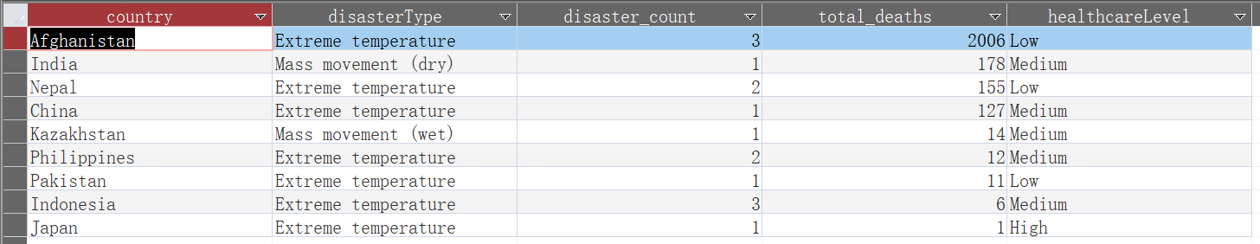

5. 在Access中写SQL语句连接上面多个表以此查询各个国家的保险公司的个数，同时查询此国家各种保险的数量（Category）以及灾害发生次数，以此探究灾害发生次数对于保险公司数量和保险政策的影响

SELECT

Countries.country AS Country,

COUNT(InsuranceCompanies.countryID) AS InsuranceCompaniesCount,

SUM(IIF(Insurance.InsuranceType = 'Health', 1, 0)) AS HealthInsuranceCount,

SUM(IIF(Insurance.InsuranceType = 'Life', 1, 0)) AS LifeInsuranceCount,

SUM(IIF(Insurance.InsuranceType = 'Auto', 1, 0)) AS AutoInsuranceCount,

SUM(IIF(Insurance.InsuranceType = 'Homeowners', 1, 0)) AS HomeownersInsuranceCount,

SUM(IIF(Insurance.InsuranceType = 'Renters', 1, 0)) AS RentersInsuranceCount,

SUM(IIF(Insurance.InsuranceType = 'Disability', 1, 0)) AS DisabilityInsuranceCount,

SUM(IIF(Insurance.InsuranceType = 'Travel', 1, 0)) AS TravelInsuranceCount,

SUM(IIF(Insurance.InsuranceType = 'Pet', 1, 0)) AS PetInsuranceCount,

COUNT(Disasters.ID) AS DisasterCount

FROM

((Countries

LEFT JOIN

InsuranceCompanies ON (Countries.ID = InsuranceCompanies.countryID))

LEFT JOIN

Insurance ON (InsuranceCompanies.primaryInsuranceType1 = Insurance.InsuranceType OR InsuranceCompanies.primaryInsuranceType2 = Insurance.InsuranceType))

LEFT JOIN

Disasters ON (Countries.country = Disasters.country)

GROUP BY

Countries.country;

