# 实验报告

实验要求：比赛模拟

实验目的：学习如何使用python来计算模拟概率

实验题目：通过分析A和B的能力值以及场数来分析他们俩分别获胜的概率

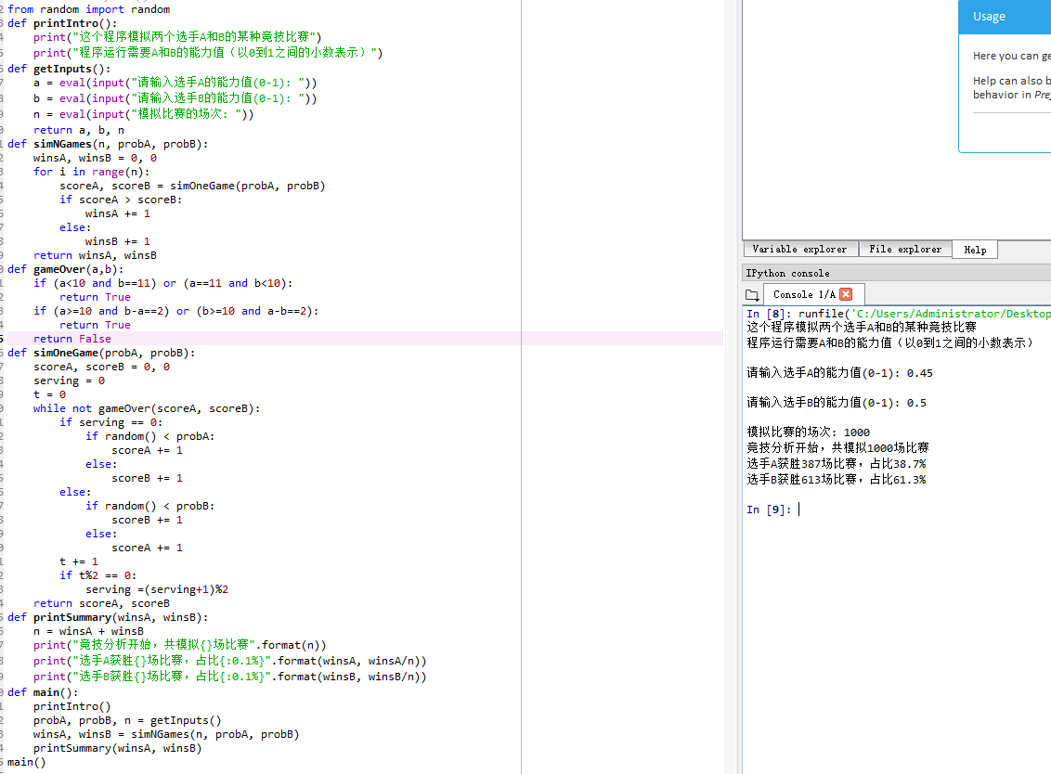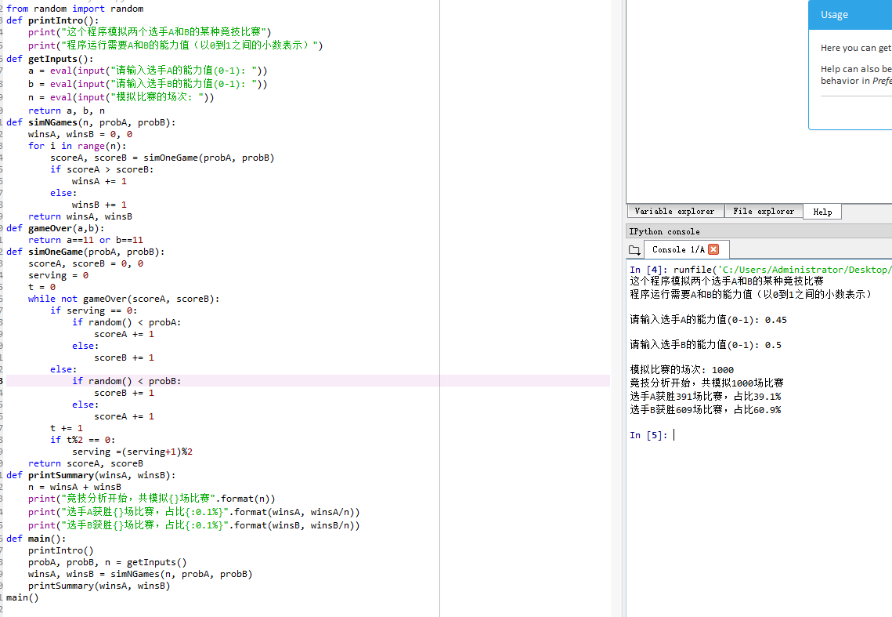

import random

def printIntro():

print("这个程序模拟两个选手A和B的某种竞技比赛")

print("程序运行需要A和B的能力值（以0到1之间的小数表示）")

def getInputs():

g1 = eval(input("请输入球队A的投篮能力值(0-1): "))

b1 = eval(input("请输入球队A的篮板能力值(0-1): "))

g2 = eval(input("请输入球队B的投篮能力值: "))

b2 = eval(input("请输入球队的篮板能力值: "))

n = eval(input("模拟比赛的场次: "))

return g1,b1,g2,b2,n

def simNGames(n, goleA,boardA,goleB,boardB):

winsA, winsB = 0, 0

for i in range(n):

scoreA, scoreB = simOneGame(goleA,boardA,goleB,boardB)

if scoreA > scoreB:

winsA += 1

else:

winsB += 1

return winsA, winsB

def gameOver(t):

return t >= 12*60

def simOneGame(goleA,boardA,goleB,boardB):

scoreA, scoreB = 0, 0

serving = 0

totalTime=0

while not gameOver(totalTime):

t = random.randint(1,24)

totalTime += t

if t ==24:

serving =(serving + 1)%2

else:

if serving == 0:

if random() < goleA:

scoreA +=1

serving=1

else:

if random() < goleA:

serving=0

else:

serving=1

else:

if random() < goleB:

scoreB +=1

serving=0

else:

if random() < goleB:

serving=1

else:

serving=0

return scoreA, scoreB

def printSummary(winsA, winsB):

n = winsA + winsB

print("竞技分析开始，共模拟{}场比赛".format(n))

print("球队A获胜{}场比赛，占比{:0.1%}".format(winsA, winsA/n))

print("球队B获胜{}场比赛，占比{:0.1%}".format(winsB, winsB/n))

def main():

printIntro()

goleA,boardA,goleB,boardB, n = getInputs()

winsA, winsB = simNGames(n, goleA,boardA,goleB,boardB)

printSummary(winsA, winsB)

main()