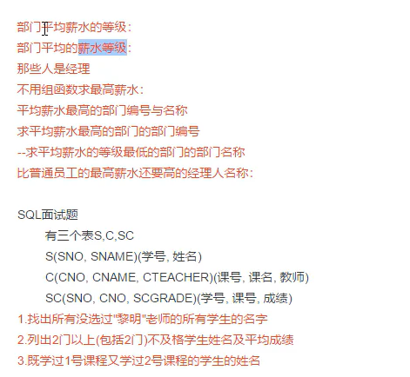

1. 平均薪水的等级【中间表】

select deptno,grade from salgrade

join (select deptno,avg(sal) avg_sal from emp group by deptno)t

on avg_sal between salgrade.losal and salgrade.hisal

1. 平均的薪水等级【中间表】

select deptno,avg(grade) from

(select ename,deptno,grade from emp e

join salgrade s on (e.sal between s.losal and s.hisal)) t

group by deptno

1. 经理名字【中间结果：集合】

select ename from emp where empno in

(select distinct mgr from emp where mgr is not null)

1. 不用组函数求最高薪水【集合】

select * from emp order by sal desc limit 1

或者

select sal from emp where sal not in

(select distinct e1.sal from emp e1

join emp e2 on e1.sal<e2.sal) 【集合肯定不包含最高薪水】

1. 平均薪水最高的部门【集合，=】

select deptno,dname from dept where deptno =

(select deptno from emp group by deptno order by avg(sal) desc limit 1)

1. 平均薪水等级最低

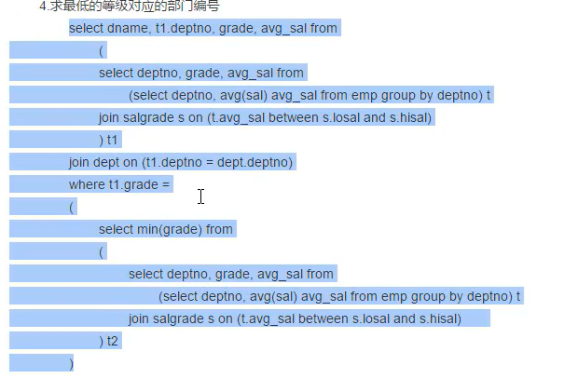

1. 比普通员工最高薪水还高的经理

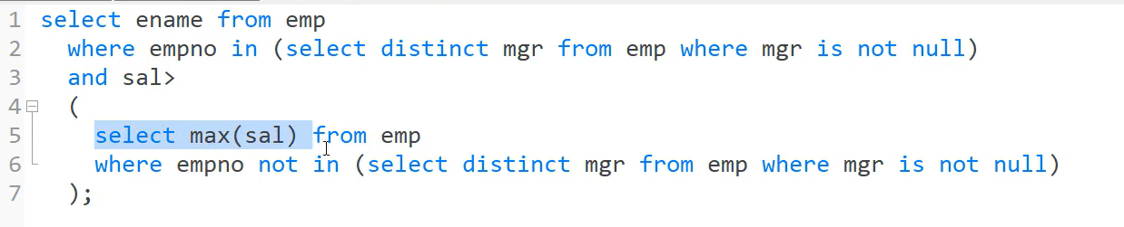

总结：

1. 最：select xxx from xxx where filed = ()
2. 集合：select xxx from xxx where filed =in ()
3. 连接：join
4. 所有：利用集合not in