

**《机器学习》课程实验报告**

**学 院 软件学院**

**专 业 软件工程**

**组 员**  **黄景超**

**学 号 201530611722**

**邮 箱 [1620265690@qq.com](mailto:1620265690@qq.com)**

**指导教师**  **吴庆耀**

**提交日期** **2017年 12 月 9 日**

## 1. 实验题目: 逻辑回归、线性分类与随机梯度下降

## 2. 实验时间：2017年 12 月 2 日

## 3. 报告人:黄景超

## 4. 实验目的:

A.对比理解梯度下降和随机梯度下降的区别与联系。

B.对比理解逻辑回归和线性分类的区别与联系。

C.进一步理解SVM的原理并在较大数据上实践。

## 数据集以及数据分析：

实验使用的是LIBSVM Data的中的a9a数据，包含32561 / 16281(testing)个样本，每个样本有123/123 (testing)个属性。

## 实验步骤:

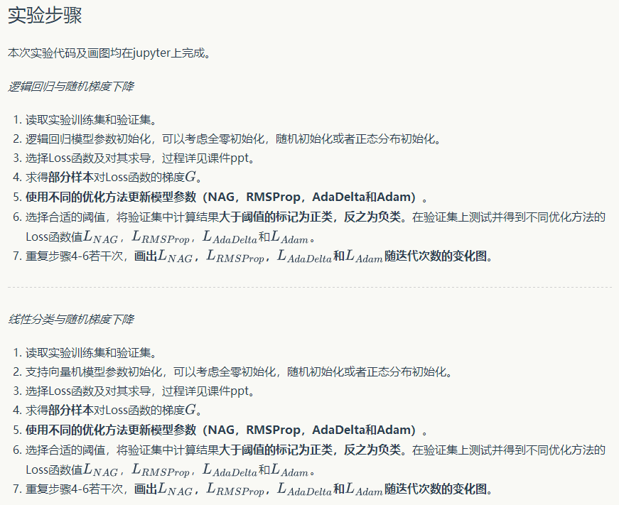

## （逻辑回归）代码内容:

import numpy as np

import random

import matplotlib.pyplot as plt

from sklearn.externals.joblib import Memory

from sklearn.datasets import load_svmlight_file

from sklearn.model_selection import train_test_split

def get_data(path,feature):

data = load_svmlight_file(path,feature)

return data

def predict(W , X, y ,threshold):

z= np.dot(W.T ,X)

temp= 1./(1+np.exp( -z))

y_pred=np.zeros(temp.shape)

y_pred[temp> threshold]=1;

y_pred[temp<=threshold]=0;

cmp=y_pred==y

accuracy=len(cmp[cmp==True])/y.shape[1]

return y_pred,accuracy

# 读取数据

data = get_data(path="a9a",feature=123)

# 数据预处理

x_train=data[0].toarray()

x_train=np.column_stack((x_train,np.ones([x_train.shape[0],1])))

x_train=x_train.T

y_train=data[1]

y_train=y_train.reshape(1,len(y_train))

y_train=y_train.astype(np.int)

y_train[y_train== -1]=0

D_in, N =x_train.shape

D_out = y_train.shape[0]

# 读取数据

data = get_data(path="a9a.t",feature=123)

# 数据预处理

x_test=data[0].toarray()

x_test=np.column_stack((x_test,np.ones([x_test.shape[0],1])))

x_test=x_test.T

y_test=data[1]

y_test=y_test.reshape(1,len(y_test))

y_test=y_test.astype(np.int)

y_test[y_test== -1]=0

# 参数初始化

maxIterations=10000 # 迭代

eta = 0.05 # 学习率

threshold=0.5 # 大于阈值的标记为正类，反之为负类

def logisticRegression(W ,xtrain, ytrain, xtest ,ytest):

N = xtrain.shape[1]

gradNum=10

ind=random.sample(range(0,N),gradNum)

xtrain_batch=xtrain[:,ind]

ytrain_batch=ytrain[:,ind]

train_loss = 0

test_loss =0

dW = np.zeros(W.shape)

z_train= np.dot(W.T ,xtrain)

a_train= 1./(1+np.exp( -z_train))

a_train_batch=a_train[:,ind]

z_test= np.dot(W.T ,xtest)

a_test= 1./(1+np.exp( -z_test))

#逻辑回归Loss

train_loss= -1/N *(np.dot(np.log(a_train),ytrain.T)+np.dot(np.log(1.0-a_train),(1-ytrain).T))

test_loss=-1/N *(np.dot(np.log(a_test),ytest.T)+np.dot(np.log(1.0-a_test),(1-ytest).T))

#loss

dz = a_train_batch-ytrain_batch

dW = 1/N * np.dot(xtrain_batch, dz.T)

return train_loss, test_loss, dW

# NAG

# 参数初始化

W = np.zeros((D_in, D_out)) # weights

pre_d = np.zeros_like(W)

pre_grad = np.zeros_like(W)

gamma =0.9 #动量因子

L_NAG =[]; # 验证loss

for t in range(maxIterations):

# 计算loss

train_loss,test_loss ,grad =logisticRegression(W, x_train, y_train, x_test, y_test)

# 保存

L_NAG.append ( test_loss)

# 更新weight

d = gamma * pre_d + grad + gamma * (grad - pre_grad)

dW = -eta * d

W += dW

pre_d = d

pre_grad = grad

L_NAG=np.array(L_NAG)

L_NAG=L_NAG[:,:,0]

y_pred_NAG_train,training_accuracy_NAG =predict(W , x_train, y_train ,threshold)

y_pred_NAG_test,test_accuracy_NAG=predict(W , x_test, y_test ,threshold)

# NAG

# 参数初始化

W = np.zeros((D_in, D_out)) # weights

pre_d = np.zeros_like(W)

pre_grad = np.zeros_like(W)

gamma =0.9 #动量因子

L_NAG =[]; # 验证loss

for t in range(maxIterations):

# 计算loss

train_loss,test_loss ,grad =logisticRegression(W, x_train, y_train, x_test, y_test)

# 保存

L_NAG.append ( test_loss)

# 更新weight

d = gamma * pre_d + grad + gamma * (grad - pre_grad)

dW = -eta * d

W += dW

pre_d = d

pre_grad = grad

L_NAG=np.array(L_NAG)

L_NAG=L_NAG[:,:,0]

y_pred_NAG_train,training_accuracy_NAG =predict(W , x_train, y_train ,threshold)

y_pred_NAG_test,test_accuracy_NAG=predict(W , x_test, y_test ,threshold)

# AdaDelta

# 参数初始化

W = np.zeros((D_in, D_out)) # weights

E_g2 = np.zeros_like(W)

E_dW2 = np.zeros_like(W)

gamma =0.9 # 衰退因子

epsilon = 1e-3

L_AdaDelta =[] # 验证loss

for t in range(maxIterations):

train_loss,test_loss ,grad =logisticRegression(W, x_train, y_train, x_test, y_test)

L_AdaDelta.append ( test_loss)

E_g2 = gamma * E_g2 + (1-gamma) * np.power(grad,2)

dW = - np.sqrt(E_dW2+epsilon) / np.sqrt(E_g2+epsilon) * grad

W += dW

E_dW2 = gamma * E_dW2 + (1-gamma) * np.power(dW , 2)

L_AdaDelta=np.array(L_AdaDelta)

L_AdaDelta=L_AdaDelta[:,:,0]

y_pred_AdaDelta_train,training_accuracy_AdaDelta =predict(W , x_train, y_train ,threshold)

y_pred_AdaDelta_test,test_accuracy_AdaDelta =predict(W , x_test, y_test ,threshold)

# Adam

# 参数初始化

W = np.zeros((D_in, D_out)) # weights

n = np.zeros_like(W)

m = np.zeros_like(W)

mu = 0.9 # m的衰退因子

v = 0.9 # n的衰退因子

epsilon = 1e-3

L_adam=[] # 验证loss

for t in range(maxIterations):

train_loss,test_loss ,grad =logisticRegression(W, x_train, y_train, x_test, y_test)

L_adam.append ( test_loss)

# 梯度估计

m = mu * m + (1-mu) * grad

n = v * n + (1-v) * np.power(grad,2)

m_hat = m / (1-np.power(mu,t)+epsilon)

n_hat = n / (1-np.power(v,t)+epsilon)

W -= m_hat * eta /(np.sqrt(n_hat) + epsilon)

L_adam=np.array(L_adam)

L_adam=L_adam[:,:,0]

y_pred_Adam_train,training_accuracy_Adam =predict(W , x_train, y_train ,threshold)

y_pred_Adam_test,test_accuracy_Adam =predict(W , x_test, y_test ,threshold)

# 制图

plt.plot(L_NAG,'b',label='L_NAG')

plt.plot(L_RMSProp,'g',label='L_RMSProp')

plt.plot(L_AdaDelta,'r',label='L_AdaDelta')

plt.plot(L_adam,'y',label='L_adam')

plt.title('Loss Curve')

plt.xlabel('Iterations')

plt.ylabel('Loss')

plt.legend()

plt.show()

# 评估和预测结果

print('training accuracy_NAG=',training_accuracy_NAG,

'\ntraining accuracy_RMSProp=',training_accuracy_RMSProp,

'\ntraining accuracy_AdaDelta=',training_accuracy_AdaDelta,

'\ntraining accuracy_Adam=',training_accuracy_Adam)

print('\ntest accuracy_NAG=',test_accuracy_NAG,

'\ntest accuracy_RMSProp=',test_accuracy_RMSProp,

'\ntest accuracy_AdaDelta=',test_accuracy_AdaDelta,

'\ntest accuracy_Adam=',test_accuracy_Adam)

## （逻辑回归）模型参数的初始化方法:

模型参数的初始化方法采用的是全零初始化。

## 9.（逻辑回归）选择的loss函数及其导数:

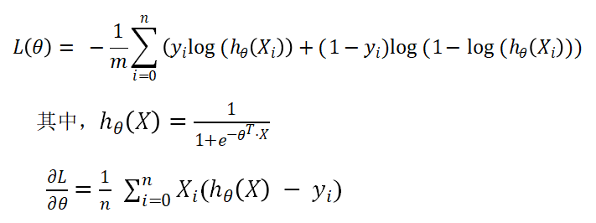

## 10.（逻辑回归）实验结果和曲线图:（各种梯度下降方式分别填写此项）

## 超参数选择：

NAG：

threshold= 0.5

eta=0.05

maxIterations=10000

gamma=0.9

RMSProp：

•threshold=0.5

•eta=0.05

•maxIterations=10000

•gamma=0.9

•epsilon=0.001

AdaDelta：

•threshold=0.5

•maxIterations=10000

•gamma=0.9

•epsilon=0.001

Adam：

•threshold=0.5

•maxIterations=10000

•mu=0.9

•v=0.9

•epsilon=0.001

## 预测结果（最佳结果）：

NAG：0.764

RMSProp：0.784

AdaDelta：0.765

Adam：0.850

## loss曲线图：

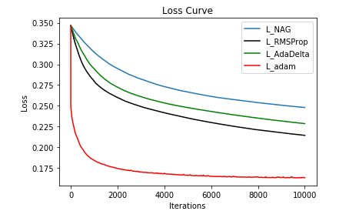

## （逻辑回归）实验结果分析:

从上述预测结果可以看出，所有的预测精度都很高，这说明模型的预测效果是比较好的。

从损失曲线来看，随着迭代次数增加，损失收敛到一个很小的数且接近于零。也就是说，我们所训练的模型是比较好的。

## （线性分类）代码内容:

import numpy as np

import random

import matplotlib.pyplot as plt

from sklearn.externals.joblib import Memory

from sklearn.datasets import load_svmlight_file

from sklearn.model_selection import train_test_split

def get_data(path,feature):

data = load_svmlight_file(path,feature)

return data

# 读取数据

data = get_data(path="a9a",feature=123)

data = get_data(path="a9a.t",feature=123)

# 数据预处理

x_train=data[0].toarray()

x_train=np.column_stack((x_train,np.ones([x_train.shape[0],1])))

y_train=data[1]

C=len(list(set(y_train)))

y_train=y_train.astype(np.int)

y_train[y_train== -1]=0

N,D =x_train.shape

x_test=data[0].toarray()

x_test=np.column_stack((x_test,np.ones([x_test.shape[0],1])))

y_test=data[1]

y_test=y_test.astype(np.int)

y_test[y_test== -1]=0

# 参数初始化

maxIterations=200

eta = 1e-3 # 学习率

def predict(W , X, y ):

# 所有样例的score

score = np.dot(X,W)

# 找到最大score

y_pred= np.argmax(score, axis = 1)

# 计算准确度

cmp=(y_pred == y)

accuracy=len(cmp[cmp==True])/len(cmp)

return y_pred,accuracy

def svm(W, xtrain, ytrain, xtest, ytest, reg):

dW = np.zeros(W.shape)

num_classes = W.shape[1]

#train

train_loss = 0

scores_train = xtrain.dot(W) # num_train by C

num_train = xtrain.shape[0]

scores_train_correct = scores_train[np.arange(num_train), ytrain] # 1 by num_train

scores_train_correct = np.reshape(scores_train_correct, (num_train, 1)) # num_train by 1

margins_train = scores_train - scores_train_correct + 1.0 # num_train by C

margins_train[np.arange(num_train), ytrain] = 0.0

margins_train[margins_train <= 0] = 0.0

train_loss += np.sum(margins_train) / num_train

train_loss += 0.5 * reg * np.sum(W * W)

margins_train[margins_train > 0] = 1.0

row_sum = np.sum(margins_train, axis=1) # 1 by num_train

margins_train[np.arange(num_train), ytrain] = -row_sum

gradNum =20 # 样本数量

ind=random.sample(range(0,num_train),gradNum)

xtrain_batch=xtrain[ind,:]

margins_train_batch=margins_train[ind,:]

dW += np.dot(xtrain_batch.T, margins_train_batch)/gradNum + reg * W # D by C

#test

test_loss = 0

scores_test = xtest.dot(W) # num_test by C

num_test = xtest.shape[0]

scores_test_correct = scores_test[np.arange(num_test), ytest] # 1 by N

scores_test_correct = np.reshape(scores_test_correct, (num_test, 1)) # N by 1

margins_test = scores_test - scores_test_correct + 1.0 # N by C

margins_test[np.arange(num_test), ytest] = 0.0

margins_test[margins_test <= 0] = 0.0

test_loss += np.sum(margins_test) / num_test

test_loss += 0.5 * reg * np.sum(W * W)

return train_loss, test_loss, dW

# NAG

# 参数初始化

W = np.zeros((D, C)) # weights

pre_d = np.zeros_like(W)

pre_grad = np.zeros_like(W)

gamma =0.9 #动量因子

L_NAG =[]; # 验证loss

for t in range(maxIterations):

# 计算loss

train_loss,test_loss ,grad =svm(W, x_train, y_train, x_test, y_test, reg=0.1)

# 保存

L_NAG.append ( test_loss)

# 更新weights

d = gamma * pre_d + grad + gamma * (grad - pre_grad)

dW = -eta * d

W += dW

pre_d = d

pre_grad = grad

L_NAG=np.array(L_NAG)

# 预测结果

y_pred_NAG_train,training_accuracy_NAG = predict(W , x_train, y_train )

y_pred_NAG_test,test_accuracy_NAG = predict(W , x_test, y_test )

# RMSProp

# 参数初始化

W = np.zeros((D, C))

n = np.zeros_like(W)

gamma =0.9 # 衰退因子

epsilon = 0.001

L_RMSProp =[] # 验证loss

for t in range(maxIterations):

train_loss,test_loss ,grad =svm(W, x_train, y_train, x_test, y_test, reg=0.1)

L_RMSProp.append ( test_loss)

n = gamma * n + (1-gamma) * np.power(grad,2)

dW = -eta /np.sqrt(n + epsilon ) * grad

W += dW

L_RMSProp=np.array(L_RMSProp)

y_pred_RMSProp_train,training_accuracy_RMSProp = predict(W , x_train, y_train )

y_pred_RMSProp_test,test_accuracy_RMSProp = predict(W , x_test, y_test )

# AdaDelta

# 参数初始化

W = np.zeros((D, C))

E_g2 = np.zeros_like(W)

E_dW2 = np.zeros_like(W)

gamma =0.8

epsilon = 1e-6

L_AdaDelta =[]

for t in range(maxIterations):

train_loss,test_loss ,grad =svm(W, x_train, y_train, x_test, y_test, reg=0.1)

L_AdaDelta.append ( test_loss)

E_g2 = gamma * E_g2 + (1-gamma) * np.power(grad,2)

dW = - np.sqrt(E_dW2+epsilon) / np.sqrt(E_g2+epsilon) * grad

W += dW

E_dW2 = gamma * E_dW2 + (1-gamma) * np.power(dW , 2)

L_AdaDelta=np.array(L_AdaDelta)

y_pred_AdaDelta_train,training_accuracy_AdaDelta = predict(W , x_train, y_train )

y_pred_AdaDelta_test,test_accuracy_AdaDelta= predict(W , x_test, y_test )

# Adam

# 参数初始化

W = np.zeros((D, C))

n = np.zeros_like(W)

m = np.zeros_like(W)

mu = 0.9

v = 0.9

epsilon = 1e-3

L_adam=[]

for t in range(maxIterations):

train_loss,test_loss ,grad =svm(W, x_train, y_train, x_test, y_test, reg=0.1)

L_adam.append ( test_loss)

m = mu * m + (1-mu) * grad

n = v * n + (1-v) * np.power(grad,2)

m_hat = m / (1-np.power(mu,t)+epsilon)

n_hat = n / (1-np.power(v,t)+epsilon)

W -= m_hat * eta /(np.sqrt(n_hat) + epsilon)

L_adam=np.array(L_adam)

y_pred_Adam_train,training_accuracy_Adam = predict(W , x_train, y_train )

y_pred_Adam_test,test_accuracy_Adam = predict(W , x_test, y_test )

# 制图

plt.plot(L_NAG,'blue',label='L_NAG')

plt.plot(L_RMSProp,'black',label='L_RMSProp')

plt.plot(L_AdaDelta,'green',label='L_AdaDelta')

plt.plot(L_adam,'red',label='L_adam')

plt.title('Error Curve')

plt.xlabel('iterations')

plt.ylabel('error')

plt.legend()

plt.show()

# 评估和预测结果

print('training accuracy_NAG=',training_accuracy_NAG,

'\ntraining accuracy_RMSProp=',training_accuracy_RMSProp,

'\ntraining accuracy_AdaDelta=',training_accuracy_AdaDelta,

'\ntraining accuracy_Adam=',training_accuracy_Adam)

print('\ntest accuracy_NAG=',test_accuracy_NAG,

'\ntest accuracy_RMSProp=',test_accuracy_RMSProp,

'\ntest accuracy_AdaDelta=',test_accuracy_AdaDelta,

'\ntest accuracy_Adam=',test_accuracy_Adam)

## （线性分类）模型参数的初始化方法:

模型参数的初始化方法采用的是全零初始化。

## 14.（线性分类）选择的loss函数及其导数:

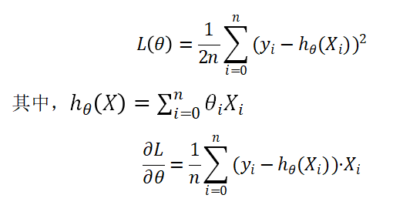

## 15.（线性分类）实验结果和曲线图:（各种梯度下降方式分别填写此项）

## 超参数选择：

NAG：

eta=0.001

maxIterations=200

gamma=0.9

RMSProp：

•eta=0.001

•maxIterations=200

•gamma=0.9

•epsilon=0.001

AdaDelta：

•maxIterations=200

•gamma=0.8

•epsilon=1e-6

Adam：

•maxIterations=200

•mu=0.9

•v=0.9

•epsilon=0.001

## 预测结果（最佳结果）：

NAG：0.765

RMSProp：0.764

AdaDelta：0.798

Adam：0.768

## loss曲线图：

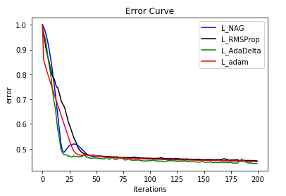

## （线性分类）实验结果分析:

从上述预测结果可以看出，所有的预测精度都很高，这说明模型的预测效果是比较好的。

从损失曲线来看，随着迭代次数增加，损失收敛到一个很小的数且接近于零。也就是说，我们所训练的模型是比较好的。

## 17.对比逻辑回归和线性分类的异同点：

同：

都属于分类问题，都用于预测。

异：

找最优超平面的方法不同，，形象点说，logistic模型找的那个超平面，是尽量让所有点都远离它，而SVM线性分类寻找的那个超平面，是只让最靠近中间分割线的那些点尽量远离，即只用到那些“支持向量”的样本。

逻辑回归只可以处理线性可分情况；SVM则二者皆可。

## 18.实验总结：

本次实验当中，我学习到了很多SGD在实践运用的经验，将课程中学习到的知识运用在实际问题上。但是由于自身对于知识把握懂得程度不高，在实现的过程中遇到了诸如无法正确实现SGD优化算法，调参不够灵活的问题，在总结反思之后解决了问题并顺利完成了实验。

在对模型的训练过程中，我体会到了灵活调参的重要性。在一开始，因为超参数C, learning rate等设置得不合理，导致loss图像与预期相差甚远，模型参数无法收敛或者收敛过慢，跑数据集时间过长等问题，导致无法拟合数据；或者是因为迭代次数过少，参数还未收敛便停止了训练。在进行数次的不同的调参后，模型往预期方向改变，我也从中学得一些经验。