**数码商城综合案例（练习）**

**【学习目标】理解、了解、应用、记忆**

通过今天的学习，参训学员能够：（解释的时候说出二级目标的掌握程度）

1. **【理解】能够阐述数码商城需求**
2. **【应用】能够独立搭建项目环境**
3. **【应用】能够独立完成前台系统之用户管理**
4. **【应用】能够独立完成前台系统--商品列表查询**
5. **【应用】能够独立完成后台系统--商品分类管理**
6. **【应用】能够独立完成后台系统--商品分类查询**
7. **【应用】能够独立完成后台系统--商品信息管理**
8. **【应用】能够独立完成分页查询**

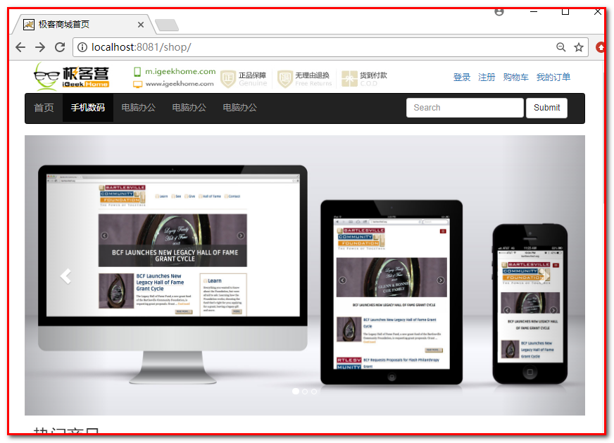

# 数码商城需求介绍

练习一共两天要制作的功能：

1 登陆

2 前台用户商品查看

3 后台商品分类 增、删、改、查

4 后台商品 查、删、改

5 前台商品分页查询

共计10个功能

# 开发准备：

## 创建项目

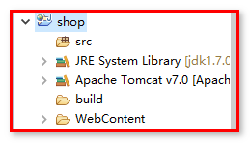

## 搭建环境（jar包、配置文件、工具类、页面（jsp））

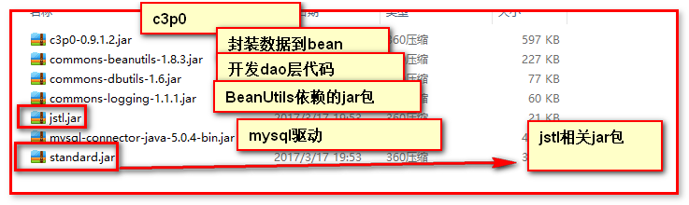



## 数据库准备

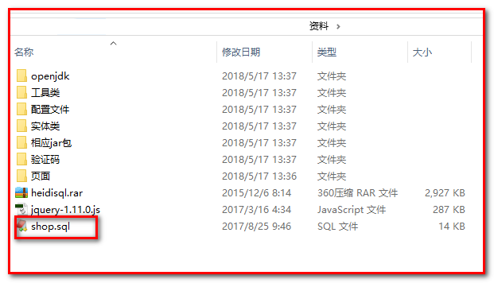

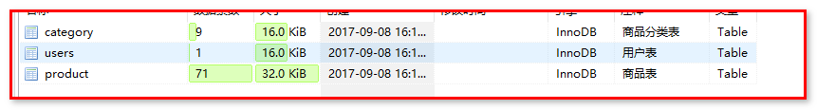

## 分析需求，准备干活

# 前台系统之用户管理(登录)

login.jsp 页面原型的编写（准备验证码）

|  |
| --- |
| <%@ page language=*"java"* contentType=*"text/html; charset=UTF-8"*  pageEncoding=*"UTF-8"*%>  <%@ taglib prefix=*"c"* uri=*"http://java.sun.com/jsp/jstl/core"* %>  <c:set var=*"root"* value=*"*${pageContext.request.contextPath }*"*/>  <!DOCTYPE html>  <html>  <head>  <meta name=*"viewport"* content=*"width=device-width, initial-scale=1"*>  <title>会员登录</title>  <link rel=*"stylesheet"* href=*"css/bootstrap.min.css"* type=*"text/css"* />  <script src=*"js/jquery-1.11.3.min.js"* type=*"text/javascript"*></script>  <script src=*"js/bootstrap.min.js"* type=*"text/javascript"*></script>  <!-- 引入自定义css文件 style.css -->  <link rel=*"stylesheet"* href=*"css/style.css"* type=*"text/css"* />  <style>  **body** {  margin-top: *20px*;  margin: *0 auto*;  }  *.carousel-inner* *.item* **img** {  width: *100%*;  height: *300px*;  }  *.container* *.row* **div** {  /* position:relative;  float:left; */    }  **font** {  color: *#666*;  font-size: *22px*;  font-weight: *normal*;  padding-right: *17px*;  }  </style>  <script type=*"text/javascript"*>    **function** changeimg(){  document.getElementById("checkcode").src = "${root}/img?r="+**new** Date().getTime();  }  </script>  </head>  <body>  <!-- 引入header.jsp -->  <jsp:include page=*"/header.jsp"*></jsp:include>  <div class=*"container"*  style="width: *100%*; height: *460px*; background: *#FF2C4C url('images/loginbg.jpg') no-repeat*;">  <div class=*"row"*>  <div class=*"col-md-7"*>  <!--<img src="./image/login.jpg" width="500" height="330" alt="会员登录" title="会员登录">-->  </div>  <div class=*"col-md-5"*>  <div  style="width: *440px*; border: *1px solid #E7E7E7*; padding: *20px 0 20px 30px*; border-radius: *5px*; margin-top: *60px*; background: *#fff*;">  <font>会员登录</font>USER LOGIN  <div>&nbsp;</div>  <form class=*"form-horizontal"* action=*"*${root }*/LoginServlet"* method=*"post"*>  <div class=*"form-group"*>  <label for=*"username"* class=*"col-sm-2 control-label"*>用户名</label>  <div class=*"col-sm-6"*>  <input type=*"text"* class=*"form-control"* id=*"username"* name=*"email"*  placeholder=*"请输入用户名"*>  </div>  </div>  <div class=*"form-group"*>  <label for=*"inputPassword3"* class=*"col-sm-2 control-label"*>密码</label>  <div class=*"col-sm-6"*>  <input type=*"password"* class=*"form-control"* id=*"inputPassword3"* name=*"password"*  placeholder=*"请输入密码"*>  </div>  </div>  <div class=*"form-group"*>  <label for=*"inputPassword3"* class=*"col-sm-2 control-label"*>验证码</label>  <div class=*"col-sm-3"*>  <input type=*"text"* class=*"form-control"* id=*"inputPassword3"* name=*"checkcode"*  placeholder=*"请输入验证码"*>  </div>  <div class=*"col-sm-3"*>  <img id=*"checkcode"* src=*"*${root}*/img"* onclick="changeimg();"/>  </div>  </div>  <div class=*"form-group"*>  <div class=*"col-sm-offset-2 col-sm-10"*>  <div class=*"checkbox"*>  <label>  </label>&nbsp;&nbsp;&nbsp;&nbsp;&nbsp; <label> <input  type=*"checkbox"*> 记住用户名  </label>  </div>  </div>  </div>  <div class=*"form-group"*>  <div class=*"col-sm-offset-2 col-sm-10"*>  <input type=*"submit"* width=*"100"* value=*"登录"* name=*"submit"*  style="background: *url('./images/login.gif') no-repeat scroll 0 0 rgba(0, 0, 0, 0)*; height: *35px*; width: *100px*; color: *white*;">  </div>  </div>  </form>  </div>  </div>  </div>  </div>  <!-- 引入footer.jsp -->  <jsp:include page=*"/footer.jsp"*></jsp:include>  </body>  </html> |

准备验证码servlet：

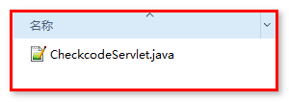

|  |
| --- |
| <servlet>  <servlet-name>CheckcodeServlet</servlet-name>  <servlet-class>cn.igeek.web.CheckcodeServlet</servlet-class>  </servlet>  <servlet-mapping>  <servlet-name>CheckcodeServlet</servlet-name>  <url-pattern>/checkCode</url-pattern>  </servlet-mapping> |

页面js：

|  |
| --- |
| <script type=*"text/javascript"*>  **function** change(){  document.getElementById("code").src = "${root}/checkCode?r="+**new** Date().getTime();  }  </script> |

需求分析：

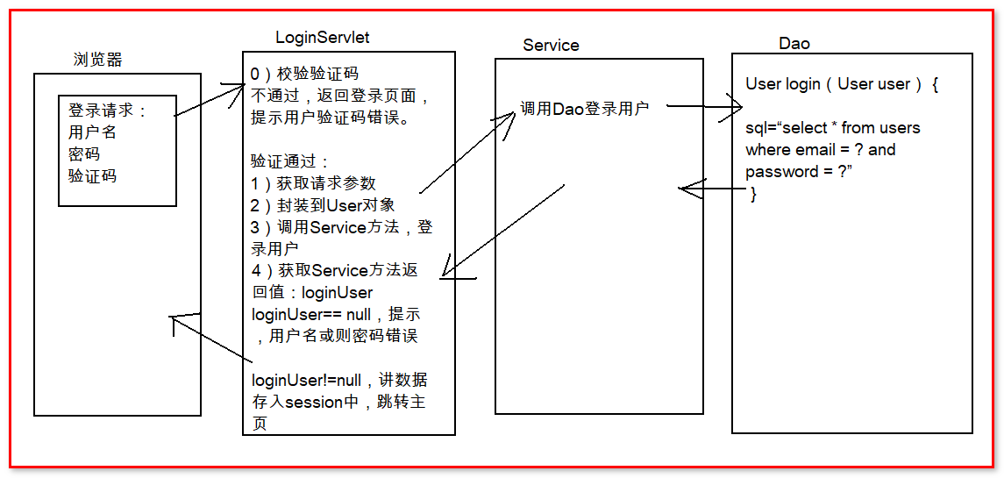

LoginServlet

|  |
| --- |
| **package** cn.igeek.web;  **import** java.io.IOException;  **import** java.lang.reflect.InvocationTargetException;  **import** java.util.Map;  **import** javax.servlet.ServletException;  **import** javax.servlet.http.Cookie;  **import** javax.servlet.http.HttpServlet;  **import** javax.servlet.http.HttpServletRequest;  **import** javax.servlet.http.HttpServletResponse;  **import** org.apache.commons.beanutils.BeanUtils;  **import** cn.igeek.domain.User;  **import** cn.igeek.service.UserService;  **import** cn.igeek.service.impl.UserServiceImpl;  **public** **class** LoginServlet **extends** HttpServlet {  **public** **void** doGet(HttpServletRequest request, HttpServletResponse response) **throws** ServletException, IOException {  //校验验证码  String checkcode = (String) request.getSession().getAttribute("checkcode");  String checkcode2 = request.getParameter("checkcode");  **if**(!checkcode.equalsIgnoreCase(checkcode2)){  //不一致，验证码错误  request.setAttribute("msg", "验证码错误");  request.getRequestDispatcher("/login.jsp").forward(request, response);  **return**;  }  //获取请求参数  Map<String, String[]> map = request.getParameterMap();  //封装数据到对象User  User user = **new** User();  **try** {  BeanUtils.*populate*(user, map);  } **catch** (Exception e) {  e.printStackTrace();  }  //调用Service方法，登陆用户  // UserService 接口 UserServiceImpl 实现类  UserService userService = **new** UserServiceImpl();  User loginUser = userService.login(user);  //根据Service方法返回值，不同处理  **if**(loginUser == **null**){  //用户名或者密码错误  request.setAttribute("msg", "用户名或者密码错误");  request.getRequestDispatcher("/login.jsp").forward(request, response);  **return**;  }**else**{  //=========================添加记住用户名的修改===========================================  String on = request.getParameter("on");  **if**("on".equals(on)){  //需要记住用户名  Cookie cookie = **new** Cookie("email", loginUser.getEmail()) ;  cookie.setMaxAge(60*60*24*7);  response.addCookie(cookie);    }**else**{  //不需要记住用户名——清空原来的Cookie  Cookie cookie = **new** Cookie("email", "");  cookie.setMaxAge(0);  response.addCookie(cookie);  }  //=========================添加记住用户名的修改===========================================  //登录成功，将loginUser存入session中，跳转主页  request.getSession().setAttribute("loginUser", loginUser);  response.sendRedirect(request.getContextPath());  **return**;  }  }  **public** **void** doPost(HttpServletRequest request, HttpServletResponse response) **throws** ServletException, IOException {  doGet(request, response);  }  } |

Service

接口：

|  |
| --- |
| **package** cn.igeek.service;  **import** cn.igeek.domain.User;  **public** **interface** UserService {  /**  * 用户登录的方法  * **@param** user  * **@return**  */  User login(User user);  } |

实现类：

|  |
| --- |
| **package** cn.igeek.service.impl;  **import** cn.igeek.dao.UserDao;  **import** cn.igeek.dao.impl.UserDaoImpl;  **import** cn.igeek.domain.User;  **import** cn.igeek.service.UserService;  **public** **class** UserServiceImpl **implements** UserService {  **private** UserDao userDao = **new** UserDaoImpl();    @Override  **public** User login(User user) {    **return** userDao.login(user);  }  } |

Dao：

接口：

|  |
| --- |
| **package** cn.igeek.dao;  **import** cn.igeek.domain.User;  **public** **interface** UserDao {  /**  * 用户登陆的方法  * **@param** user  * **@return**  */  User login(User user);  } |

实现类：

|  |
| --- |
| **package** cn.igeek.dao.impl;  **import** java.sql.SQLException;  **import** org.apache.commons.dbutils.QueryRunner;  **import** org.apache.commons.dbutils.handlers.BeanHandler;  **import** cn.igeek.dao.UserDao;  **import** cn.igeek.domain.User;  **import** cn.igeek.utils.JDBCUtils;  **public** **class** UserDaoImpl **implements** UserDao {  **private** QueryRunner qr = **new** QueryRunner(JDBCUtils.*getDataSource*());  @Override  **public** User login(User user) {  String sql = "select * from users where email = ? and password = ?";  **try** {  **return** qr.query(sql, **new** BeanHandler<User>(User.**class**), user.getEmail(),user.getPassword());  } **catch** (SQLException e) {  e.printStackTrace();  **throw** **new** RuntimeException("用户登录异常");  }  }  } |

Header.jsp显示用户登录信息

|  |
| --- |
| <div class=*"col-md-3"* style="padding-top:*20px*">  <ol class=*"list-inline"*>  <c:if test=*"*${**empty** loginUser }*"*>  <li><a href=*"login.jsp"*>登录</a></li>  <li><a href=*"register.jsp"*>注册</a></li>  </c:if>  <c:if test=*"*${**not empty** loginUser }*"*>  <li><a href=*"javascript:;"*>${loginUser.nickname }</a></li>  <li><a href=*"loginOut.jsp"*>注销</a></li>  </c:if>  <li><a href=*"cart.jsp"*>购物车</a></li>  <li><a href=*"order_list.jsp"*>我的订单</a></li>  </ol>  </div> |

7: 用户退出 loginOut.jsp

|  |
| --- |
| <%@ page language=*"java"* import=*"java.util.*"* pageEncoding=*"UTF-8"*%>  <%  session.invalidate();  response.sendRedirect(request.getContextPath()+"/login.jsp");  %> |

8: 登录 记住账号功能 基于cookie

|  |
| --- |
| //==================记住用户名修改===============================  //获取remember请求参数  String remember = request.getParameter("remember");  **if**("on".equals(remember)){  //需要记住用户名  Cookie cookie = **new** Cookie("username", loginUser.getEmail());  cookie.setMaxAge(60*60*24*7);  cookie.setPath("/");  response.addCookie(cookie);  }**else**{  //不需要记住用户名  Cookie cookie = **new** Cookie("username", "");  cookie.setMaxAge(0);  cookie.setPath("/");  response.addCookie(cookie);  }  //==================记住用户名修改=============================== |

# 前台系统实现商品列表查询

商品管理: 开发包含: 前台系统和后台系统

后台系统负责商品的管理(商品下架 修改 删除等等操作),前台系统负责商品的展示.

## 需求分析

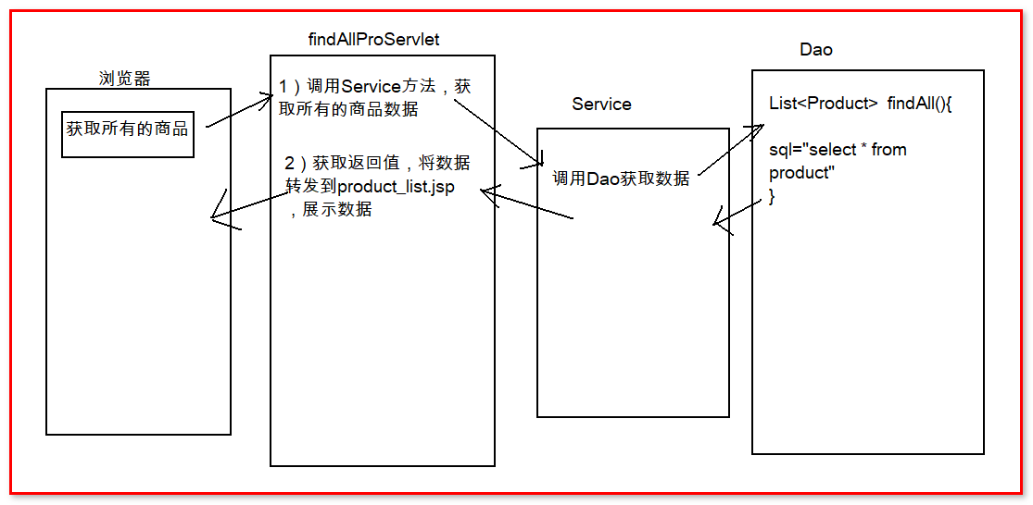

## 案例实现

### 修改JSP

Header.jsp 页面

<li class="active"><a href="${root }/findAllGoods">手机数码<span class="sr-only">(current)</span></a></li>

* + 1. **编写servlet**

Servlet:

|  |
| --- |
| **package** cn.igeek.web;  **import** java.io.IOException;  **import** java.util.List;  **import** javax.servlet.ServletException;  **import** javax.servlet.http.HttpServlet;  **import** javax.servlet.http.HttpServletRequest;  **import** javax.servlet.http.HttpServletResponse;  **import** cn.igeek.domain.Product;  **import** cn.igeek.service.ProductService;  **import** cn.igeek.service.impl.ProductServiceImpl;  **public** **class** FindAllProServlet **extends** HttpServlet {  **public** **void** doGet(HttpServletRequest request, HttpServletResponse response) **throws** ServletException, IOException {    // 调用Service方法获取数据  ProductService productService = **new** ProductServiceImpl();  List<Product> pList = productService.findAll();  // 将数据转发到product_list.jsp页面，展示  request.setAttribute("pList", pList);  request.getRequestDispatcher("/product_list.jsp").forward(request, response);      }  **public** **void** doPost(HttpServletRequest request, HttpServletResponse response) **throws** ServletException, IOException {  doGet(request, response);  }  } |

Service:

接口

|  |
| --- |
| **package** cn.igeek.service;  **import** java.util.List;  **import** cn.igeek.domain.Product;  **public** **interface** ProductService {  /**  * 获取所有商品的方法  * **@return**  */  List<Product> findAll();  } |

实现类：

|  |
| --- |
| **package** cn.igeek.service.impl;  **import** java.util.List;  **import** cn.igeek.dao.ProductDao;  **import** cn.igeek.dao.impl.ProductDaoImpl;  **import** cn.igeek.domain.Product;  **import** cn.igeek.service.ProductService;  **public** **class** ProductServiceImpl **implements** ProductService {  **private** ProductDao productDao = **new** ProductDaoImpl();  @Override  **public** List<Product> findAll() {    **return** productDao.findAll();  }  } |

Dao:

接口

|  |
| --- |
| **package** cn.igeek.dao;  **import** java.util.List;  **import** cn.igeek.domain.Product;  **public** **interface** ProductDao {  List<Product> findAll();  } |

实现类：

|  |
| --- |
| package cn.igeek.dao.impl;  import java.sql.SQLException;  import java.util.List;  import org.apache.commons.dbutils.QueryRunner;  import org.apache.commons.dbutils.handlers.BeanListHandler;  import cn.igeek.dao.ProductDao;  import cn.igeek.domain.Product;  import cn.igeek.utils.JDBCUtils;  public class ProductDaoImpl implements ProductDao {  private QueryRunner qr = new QueryRunner(JDBCUtils.getDataSource());    @Override  public List<Product> findAll() {  String sql = "select * from product";  try {  return qr.query(sql, new BeanListHandler<Product>(Product.class));  } catch (SQLException e) {  e.printStackTrace();  throw new RuntimeException("查询所有的商品失败");  }  }  } |

product_list.jsp显示数据

|  |
| --- |
| <c:forEach items=*"*${products }*"* var=*"pro"*>  <div class=*"col-md-2" style="text-align:center;height:200px;margin:20px;"*>  <a href=*"product_info.htm"*> <img src=*"*${pro.pimage }*"*  width=*"170"* height=*"170"* style="display: *inline-block*;">  </a>  <p>  <a href=*"product_info.html"* style='color: *green*'>${pro.pname}</a>  </p>  <p>  <font color=*"#FF0000"*>商城价：&yen;${pro.shop_price }</font>  </p>  </div>  </c:forEach> |

测试:

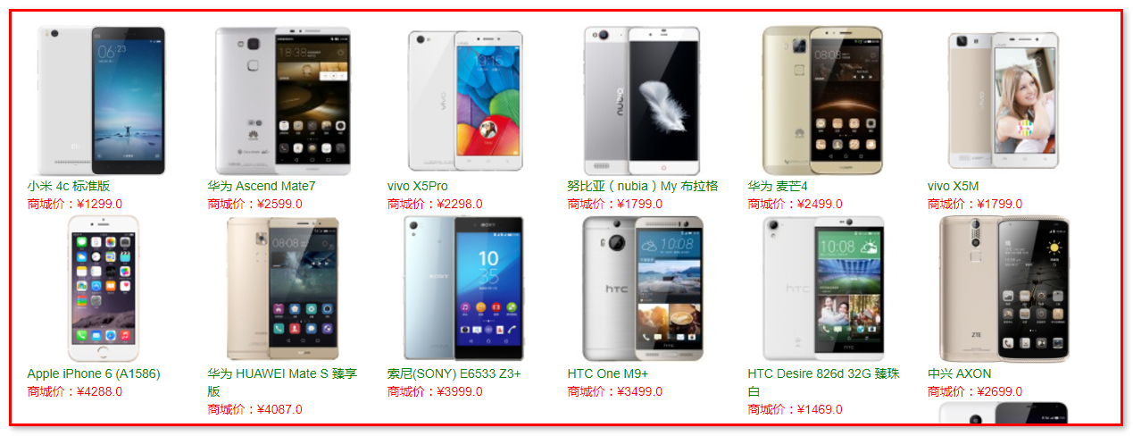

# 后台系统

后台用户管理页面原型如下,index.jsp页面为登录入口.

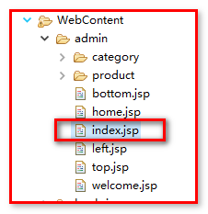

本次开发 :主要围绕product和category目录

商品管理：

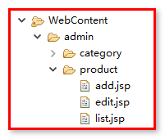

add.jsp页面 商品添加页面.后续完成

edit.jsp页面 商品修改页面

list.jsp页面 商品列表显示页面

分类管理页面原型

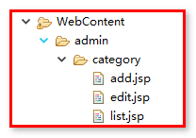

add.jsp页面分类添加

edit.jsp页面分类编辑

list.jsp 分类列表显示.

管理页面：

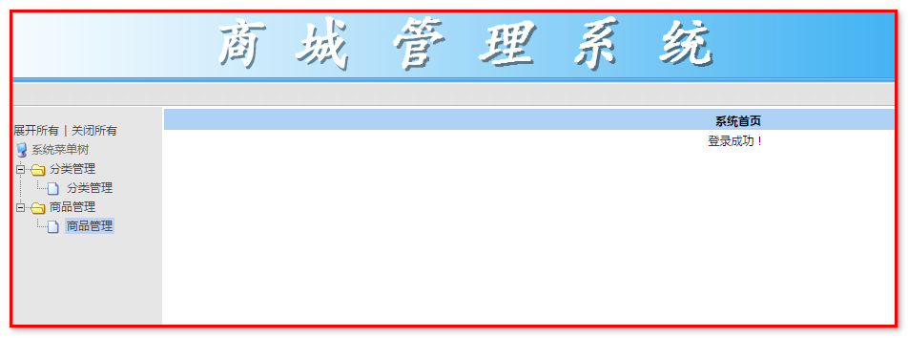

左侧的菜单树由dtree.js创建：

官网：http://www.destroydrop.com/javascripts/tree/

官方案例：

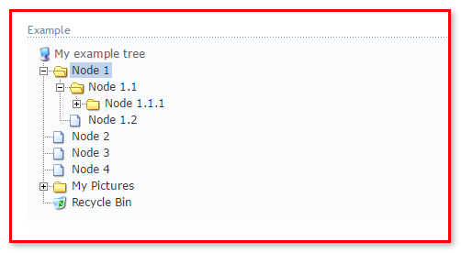

源码：

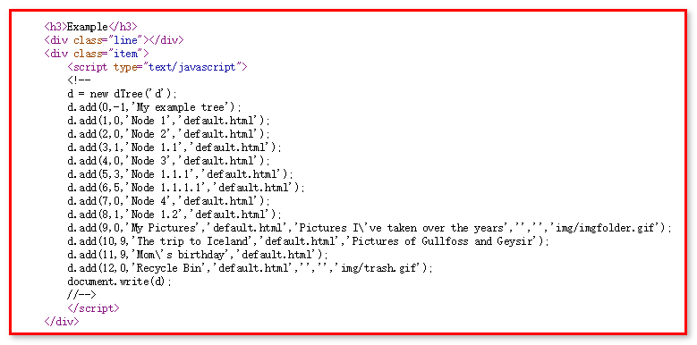

Add方法参数介绍：

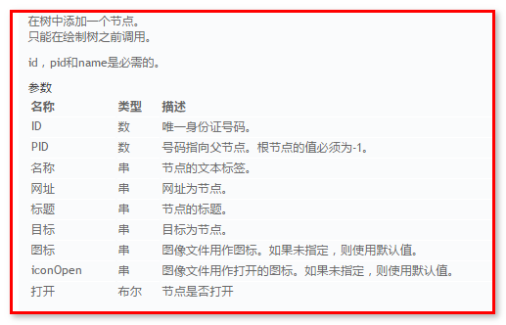

## 商品分类管理

表关系：一对多关系

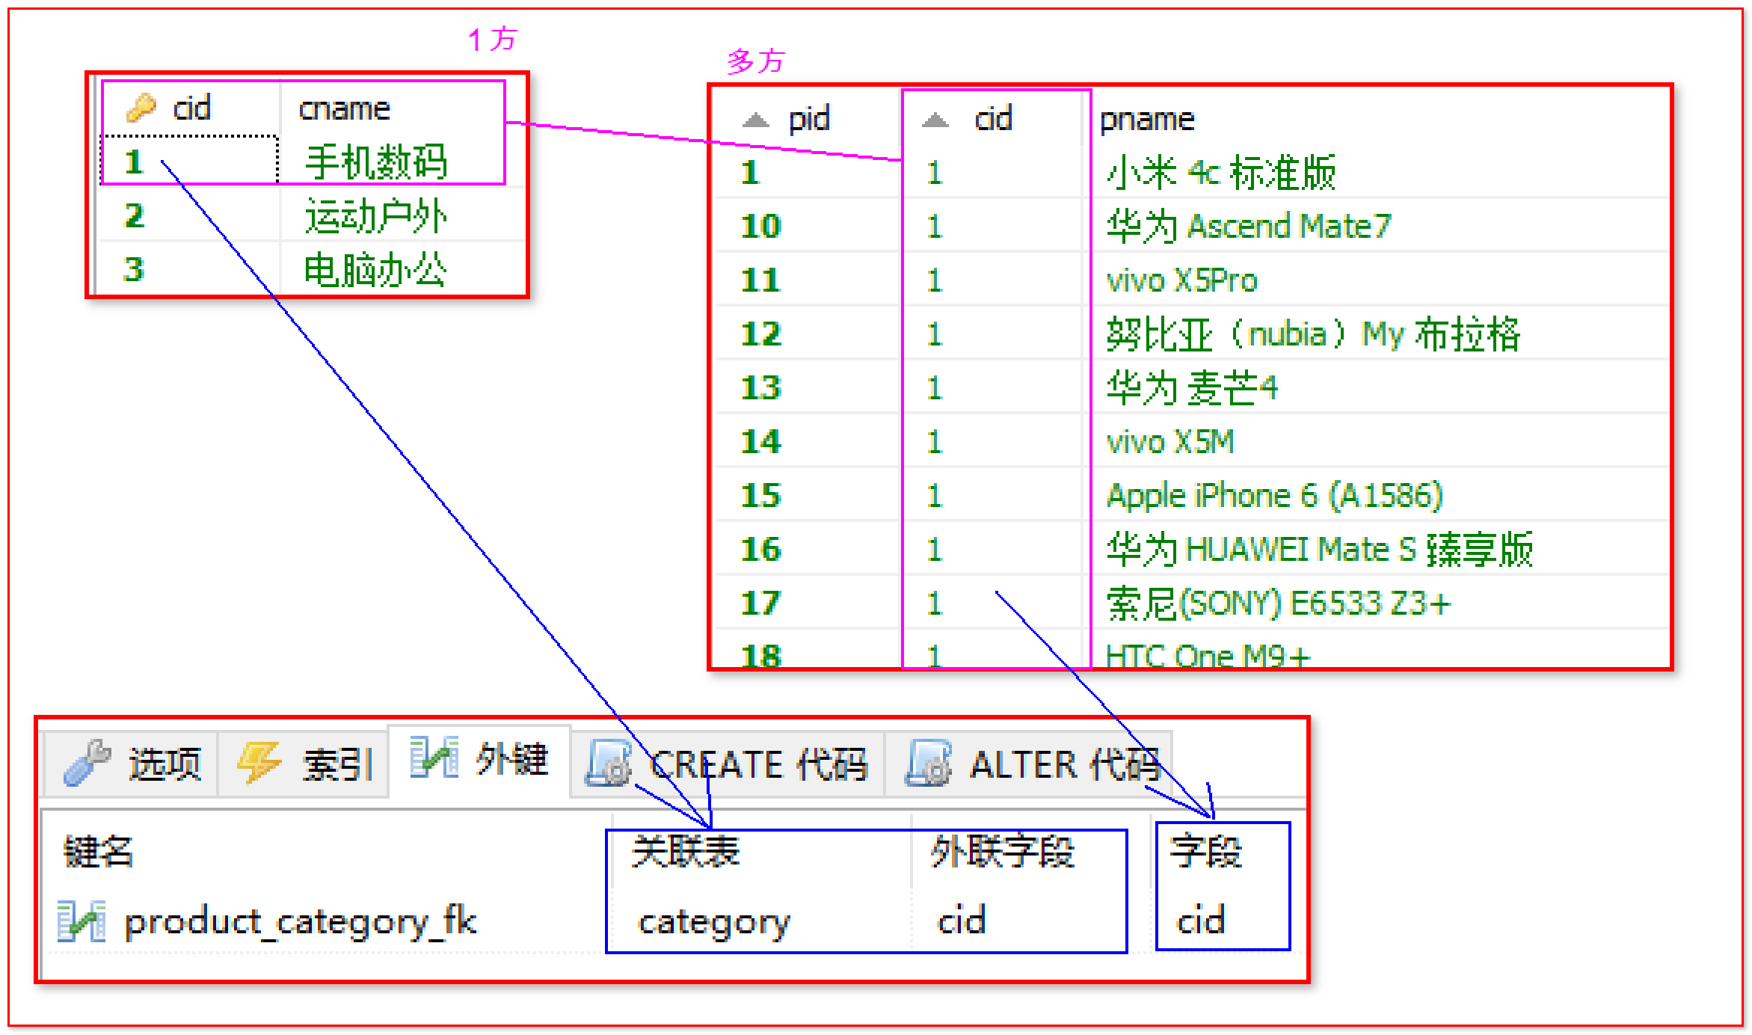

### 商品分类添加

分类信息添加

流程分析:

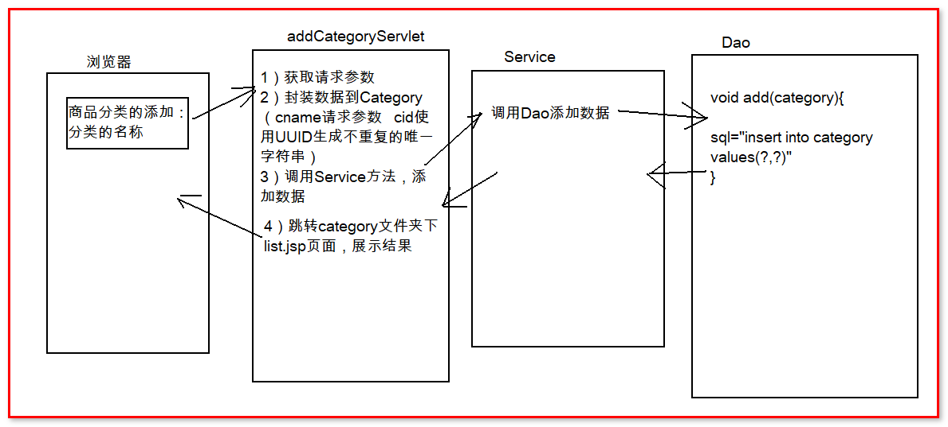

1: 修改add.jsp 页面

Servlet：

|  |
| --- |
| **package** cn.igeek.web;  **import** java.io.IOException;  **import** java.util.UUID;  **import** javax.servlet.ServletException;  **import** javax.servlet.http.HttpServlet;  **import** javax.servlet.http.HttpServletRequest;  **import** javax.servlet.http.HttpServletResponse;  **import** cn.igeek.domain.Category;  **import** cn.igeek.service.CategoryService;  **import** cn.igeek.service.impl.CategoryServiceImpl;  **public** **class** AddCategoryServlet **extends** HttpServlet {  **public** **void** doGet(HttpServletRequest request, HttpServletResponse response) **throws** ServletException, IOException {  request.setCharacterEncoding("utf-8");  //获取参数  String cname = request.getParameter("cname");    //封装数据到category对象  Category cate = **new** Category();  cate.setCname(cname);  cate.setCid(UUID.*randomUUID*().toString().replace("-", ""));  //调用service  CategoryService categoryService = **new** CategoryServiceImpl();  categoryService.add(cate);  //给用户响应jsp  response.sendRedirect(request.getContextPath()+"/admin/category/list.jsp");    }  **public** **void** doPost(HttpServletRequest request, HttpServletResponse response) **throws** ServletException, IOException {  doGet(request, response);  }  } |

Service

|  |
| --- |
| **package** cn.igeek.service;  **import** cn.igeek.domain.Category;  **public** **interface** CategoryService {  /**  * 添加商品分类的方法  * **@param** cate  */  **void** add(Category cate);  } |

|  |
| --- |
| **package** cn.igeek.service.impl;  **import** cn.igeek.dao.CategoryDao;  **import** cn.igeek.dao.impl.CategoryDaoImpl;  **import** cn.igeek.domain.Category;  **import** cn.igeek.service.CategoryService;  **public** **class** CategoryServiceImpl **implements** CategoryService {  **private** CategoryDao categoryDao = **new** CategoryDaoImpl();    @Override  **public** **void** add(Category cate) {  categoryDao.add(cate);  }  } |

Dao：

|  |
| --- |
| **package** cn.igeek.dao;  **import** cn.igeek.domain.Category;  **public** **interface** CategoryDao {  /**  * 添加分类的方法  * **@param** cate  */  **void** add(Category cate);  } |

|  |
| --- |
| **package** cn.igeek.dao.impl;  **import** java.sql.SQLException;  **import** org.apache.commons.dbutils.QueryRunner;  **import** cn.igeek.dao.CategoryDao;  **import** cn.igeek.domain.Category;  **import** cn.igeek.utils.JDBCUtils;  **public** **class** CategoryDaoImpl **implements** CategoryDao {  **private** QueryRunner qr = **new** QueryRunner(JDBCUtils.*getDataSource*());    @Override  **public** **void** add(Category cate) {    String sql = "insert into category values(?,?)";  **try** {  qr.update(sql, cate.getCid(),cate.getCname());  } **catch** (SQLException e) {  e.printStackTrace();  **throw** **new** RuntimeException("添加分类失败");  }    }  } |

## 分类查询

1: left.jsp 修改地址

d.add('010201','0102','分类管理','${pageContext.request.contextPath}/findAllCategory','','mainFrame');

Servlet:

|  |
| --- |
| **package** cn.igeek.web;  **import** java.io.IOException;  **import** java.util.List;  **import** javax.servlet.ServletException;  **import** javax.servlet.http.HttpServlet;  **import** javax.servlet.http.HttpServletRequest;  **import** javax.servlet.http.HttpServletResponse;  **import** cn.igeek.domain.Category;  **import** cn.igeek.service.CategoryService;  **import** cn.igeek.service.impl.CategoryServiceImpl;  **public** **class** FindAllCategoryServlet **extends** HttpServlet {  **public** **void** doGet(HttpServletRequest request, HttpServletResponse response) **throws** ServletException, IOException {  CategoryService categoryService = **new** CategoryServiceImpl();  List<Category> list = categoryService.findAll();  request.setAttribute("list", list);  request.getRequestDispatcher("/admin/category/list.jsp").forward(request, response);  }  **public** **void** doPost(HttpServletRequest request, HttpServletResponse response) **throws** ServletException, IOException {  doGet(request, response);  }  } |

Service:

|  |
| --- |
| @Override  **public** List<Category> findAll() {  **return** categoryDao.findAll();  } |

Dao:

|  |
| --- |
| @Override  **public** List<Category> findAll() {  String sql = "select * from category";  **try** {  **return** qr.query(sql, **new** BeanListHandler<Category>(Category.**class**));  } **catch** (SQLException e) {  e.printStackTrace();  **return** **null**;  }  } |

页面展示：

|  |
| --- |
| <%@ page language=*"java"* pageEncoding=*"UTF-8"*%>  <%@ taglib prefix=*"c"* uri=*"http://java.sun.com/jsp/jstl/core"* %>  <c:set var=*"root"* value=*"*${pageContext.request.contextPath }*"*/>  <HTML>  <HEAD>  <meta http-equiv=*"Content-Language"* content=*"zh-cn"*>  <meta http-equiv=*"Content-Type"* content=*"text/html; charset=UTF-8"*>  <link href=*"*${pageContext.request.contextPath}*/css/Style1.css"*  rel=*"stylesheet"* type=*"text/css"* />  <script language=*"javascript"*  src=*"*${pageContext.request.contextPath}*/js/public.js"*></script>  <script type=*"text/javascript"*>  **function** addCategory(){  window.location.href = "${pageContext.request.contextPath}/admin/category/add.jsp";  }  </script>  </HEAD>  <body>  <br>  <table cellSpacing=*"1"* cellPadding=*"0"* width=*"100%"* align=*"center"*  bgColor=*"#f5fafe"* border=*"0"*>  <TBODY>  <tr>  <td class=*"ta_01"* align=*"center"* bgColor=*"#afd1f3"*><strong>分类列表</strong>  </TD>  </tr>  <tr>  <td class=*"ta_01"* align=*"right"*>  <button type=*"button"* id=*"add"* name=*"add"* value=*"添加"*  class=*"button_add"* onclick="addCategory()">  &#28155;&#21152;</button>  </td>  </tr>  <tr>  <td class=*"ta_01"* align=*"center"* bgColor=*"#f5fafe"*>  <table cellspacing=*"0"* cellpadding=*"1"* rules=*"all"*  bordercolor=*"gray"* border=*"1"* id=*"DataGrid1"*  style="BORDER-RIGHT: *gray 1px solid*; BORDER-TOP: *gray 1px solid*; BORDER-LEFT: *gray 1px solid*; WIDTH: *100%*; WORD-BREAK: *break-all*; BORDER-BOTTOM: *gray 1px solid*; BORDER-COLLAPSE: *collapse*; BACKGROUND-COLOR: *#f5fafe*; WORD-WRAP: *break-word*">  <tr  style="FONT-WEIGHT: *bold*; FONT-SIZE: *12pt*; HEIGHT: *25px*; BACKGROUND-COLOR: *#afd1f3*">  <td align=*"center"* width=*"18%"*>序号</td>  <td align=*"center"* width=*"17%"*>分类名称</td>  <td width=*"7%"* align=*"center"*>编辑</td>  <td width=*"7%"* align=*"center"*>删除</td>  </tr>  <c:forEach items=*"*${list }*"* var=*"category"*>  <tr onmouseover="this.style.backgroundColor = 'white'"  onmouseout="this.style.backgroundColor = '#F5FAFE';">  <td style="CURSOR: *hand*; HEIGHT: *22px*" align=*"center"*  width=*"18%"*>${category.cid }</td>  <td style="CURSOR: *hand*; HEIGHT: *22px*" align=*"center"*  width=*"17%"*>${category.cname }</td>  <td align=*"center"* style="HEIGHT: *22px*"><a  href=*"*${ pageContext.request.contextPath }*/admin/category/edit.jsp"*>  <img  src=*"*${pageContext.request.contextPath}*/images/i_edit.gif"*  border=*"0"* style="CURSOR: *hand*">  </a></td>  <td align=*"center"* style="HEIGHT: *22px*"><a  href=*""*>  <img src=*"*${pageContext.request.contextPath}*/images/i_del.gif"*  width=*"16"* height=*"16"* border=*"0"* style="CURSOR: *hand*">  </a></td>  </tr>  </c:forEach>  </table>  </td>  </tr>  </TBODY>  </table>  </body>  </HTML> |

### 分类修改

流程分析:

分两次处理：

数据回显：

页面：<a href="${ pageContext.request.contextPath }/findCategoryById?cid=${category.cid }">

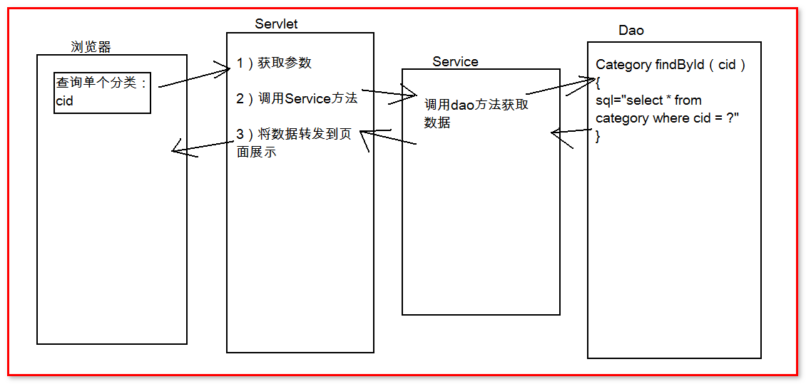

代码：

Sevlet：

|  |
| --- |
| **package** cn.igeek.web;  **import** java.io.IOException;  **import** javax.servlet.ServletException;  **import** javax.servlet.http.HttpServlet;  **import** javax.servlet.http.HttpServletRequest;  **import** javax.servlet.http.HttpServletResponse;  **import** cn.igeek.domain.Category;  **import** cn.igeek.service.CategoryService;  **import** cn.igeek.service.impl.CategoryServiceImpl;  **public** **class** FindCategoryById **extends** HttpServlet {  **public** **void** doGet(HttpServletRequest request, HttpServletResponse response) **throws** ServletException, IOException {  **int** cid = Integer.*parseInt*(request.getParameter("cid"));    CategoryService categoryService = **new** CategoryServiceImpl();  Category category = categoryService.findById(cid);    request.setAttribute("category", category);  request.getRequestDispatcher("/admin/category/edit.jsp").forward(request, response);  }  **public** **void** doPost(HttpServletRequest request, HttpServletResponse response) **throws** ServletException, IOException {  doGet(request, response);  }  } |

Service：

|  |
| --- |
| **public** Category findById(**int** cid) {  **return** categoryDao.findById(cid);  } |

Dao：

|  |
| --- |
| public Category findById(int cid) {  String sql = "select * from category where cid = ?";  try {  return qr.query(sql, new BeanHandler<Category>(Category.class),cid);  } catch (SQLException e) {  e.printStackTrace();  return null;  }  } |

分类修改：

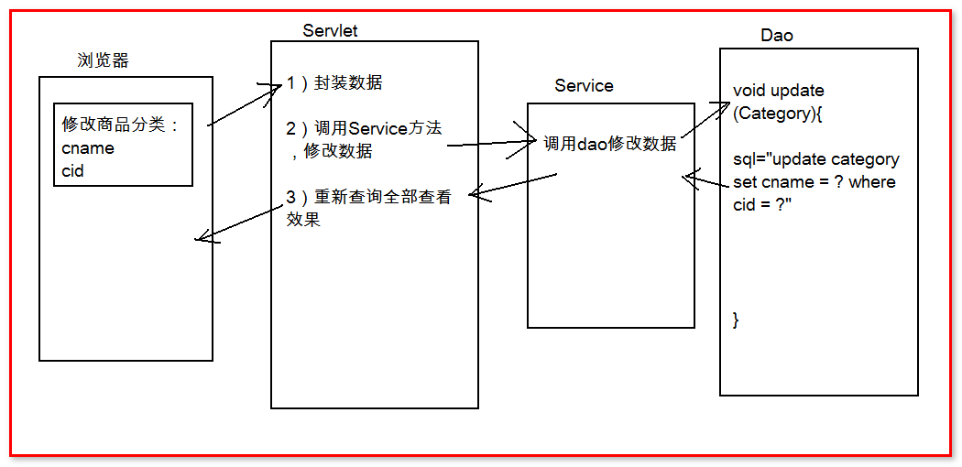

页面：

|  |
| --- |
| <%@ page language=*"java"* pageEncoding=*"UTF-8"*%>  <HTML>  <HEAD>  <meta http-equiv=*"Content-Language"* content=*"zh-cn"*>  <meta http-equiv=*"Content-Type"* content=*"text/html; charset=UTF-8"*>  <LINK href=*"*${pageContext.request.contextPath}*/css/Style1.css"* type=*"text/css"* rel=*"stylesheet"*>  </HEAD>    <body>  <form id=*"userAction_save_do"* name=*"Form1"* action=*"*${pageContext.request.contextPath}*/updateCategory"* method=*"post"*>  &nbsp;  <table cellSpacing=*"1"* cellPadding=*"5"* width=*"100%"* align=*"center"* bgColor=*"#eeeeee"* style="border: *1px solid #8ba7e3*" border=*"0"*>  <tr>  <td class=*"ta_01"* align=*"center"* bgColor=*"#afd1f3"* colSpan=*"4"*  height=*"26"*>  <strong><STRONG>编辑分类</STRONG>  </strong>  </td>  </tr>  <tr>  <td width=*"18%"* align=*"center"* bgColor=*"#f5fafe"* class=*"ta_01"*>  分类名称：  </td>  <td class=*"ta_01"* bgColor=*"#ffffff"* colspan=*"3"*>  <input type=*"text"* name=*"cname"* value=*"*${category.cname }*"* id=*"userAction_save_do_logonName"* class=*"bg"*/>  <input type=*"hidden"* name=*"cid"* value=*"*${category.cid }*"*>  </td>  </tr>    <tr>  <td class=*"ta_01"* style="WIDTH: *100%*" align=*"center"*  bgColor=*"#f5fafe"* colSpan=*"4"*>  <button type=*"submit"* id=*"userAction_save_do_submit"* value=*"确定"* class=*"button_ok"*>  &#30830;&#23450;  </button>  <FONT face=*"宋体"*>&nbsp;&nbsp;&nbsp;&nbsp;&nbsp;&nbsp;&nbsp;</FONT>  <button type=*"reset"* value=*"重置"* class=*"button_cancel"*>&#37325;&#32622;</button>  <FONT face=*"宋体"*>&nbsp;&nbsp;&nbsp;&nbsp;&nbsp;&nbsp;&nbsp;</FONT>  <INPUT class=*"button_ok"* type=*"button"* onclick="history.go(-1)" value=*"返回"*/>  <span id=*"Label1"*></span>  </td>  </tr>  </table>  </form>  </body>  </HTML> |

Servlet：

|  |
| --- |
| **package** cn.igeek.web;  **import** java.io.IOException;  **import** java.lang.reflect.InvocationTargetException;  **import** javax.servlet.ServletException;  **import** javax.servlet.http.HttpServlet;  **import** javax.servlet.http.HttpServletRequest;  **import** javax.servlet.http.HttpServletResponse;  **import** org.apache.commons.beanutils.BeanUtils;  **import** cn.igeek.domain.Category;  **import** cn.igeek.service.CategoryService;  **import** cn.igeek.service.impl.CategoryServiceImpl;  **public** **class** UpdateCategoryServlet **extends** HttpServlet {  **public** **void** doGet(HttpServletRequest request, HttpServletResponse response) **throws** ServletException, IOException {    request.setCharacterEncoding("utf-8");  Category category = **new** Category();  **try** {  BeanUtils.*populate*(category, request.getParameterMap());  } **catch** (Exception e) {  e.printStackTrace();  }  CategoryService categoryService = **new** CategoryServiceImpl();  categoryService.update(category);  response.sendRedirect(request.getContextPath() + "/findAllCategory");  }  **public** **void** doPost(HttpServletRequest request, HttpServletResponse response) **throws** ServletException, IOException {  doGet(request, response);  }  } |

Service：

|  |
| --- |
| **public** **void** update(Category category) {  categoryDao.update(category);  } |

Dao：

|  |
| --- |
| **public** **void** update(Category category) {  String sql = "update category set cname = ? where cid = ?";  **try** {  qr.update(sql,category.getCname(), category.getCid());  } **catch** (SQLException e) {  e.printStackTrace();  }  } |

### 分类删除

Threadlocal

业务流程分析

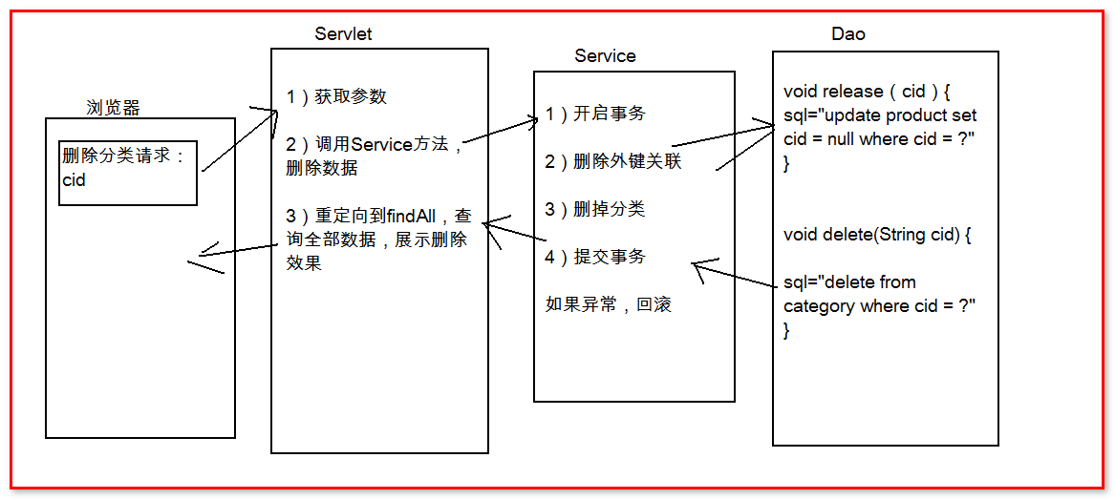

页面修改：

<a href="${ pageContext.request.contextPath }/deleteCategoryById?cid=${category.cid }">

Servlet:

|  |
| --- |
| **package** cn.igeek.web;  **import** java.io.IOException;  **import** javax.servlet.ServletException;  **import** javax.servlet.http.HttpServlet;  **import** javax.servlet.http.HttpServletRequest;  **import** javax.servlet.http.HttpServletResponse;  **import** cn.igeek.service.CategoryService;  **import** cn.igeek.service.impl.CategoryServiceImpl;  **public** **class** DeleteCategoryServlet **extends** HttpServlet {  **public** **void** doGet(HttpServletRequest request, HttpServletResponse response) **throws** ServletException, IOException {  String cid = request.getParameter("cid");  CategoryService categoryService = **new** CategoryServiceImpl();  categoryService.delete(cid);  response.sendRedirect(request.getContextPath() + "/findAllCategory");  }  **public** **void** doPost(HttpServletRequest request, HttpServletResponse response) **throws** ServletException, IOException {  doGet(request, response);  }  } |

Service：

|  |
| --- |
| **private** ProductDao productDao = **new** ProductDaoImpl();  @Override  **public** **void** del(**int** cid) {  //事务控制  **try** {  JDBCUtils.*startTransaction*();  //释放外键  productDao.release(cid);  categoryDao.del(cid);  JDBCUtils.*commit*();    } **catch** (SQLException e) {  e.printStackTrace();  **try** {  JDBCUtils.*rollback*();  } **catch** (SQLException e1) {  e1.printStackTrace();  }  } **finally**{  **try** {  JDBCUtils.*close*();  } **catch** (SQLException e) {  e.printStackTrace();  }  }    } |

Dao:

|  |
| --- |
| **productDao======================**  **private** QueryRunner run =**new** QueryRunner();  @Override  **public** **void** release(String cid) {  String sql = "update product set cid = null where cid = ?";  **try** {  run.update(JDBCUtils.*getCurrentConnection*(),sql, cid);  } **catch** (SQLException e) {  e.printStackTrace();  }  }  **Categorydao=======================**  **private** QueryRunner run = **new** QueryRunner();  @Override  **public** **void** delete(String cid) {  String sql = "delete from category where cid = ?";  **try** {  run.update(JDBCUtils.*getCurrentConnection*(), sql, cid);  } **catch** (SQLException e) {  e.printStackTrace();  }    } |

## 商品信息管理

前台系统显示的商品信息,由后台系统进行维护管理. 包括商品的上架,下架,修改,删除等等操作.

### 商品查询

代码实现:

页面：

d.add('010401','0104','商品管理','${pageContext.request.contextPath}/AdminFindAllGoods','','mainFrame');

Servlet：

|  |
| --- |
| **package** cn.igeek.web;  **import** java.io.IOException;  **import** java.util.List;  **import** javax.servlet.ServletException;  **import** javax.servlet.http.HttpServlet;  **import** javax.servlet.http.HttpServletRequest;  **import** javax.servlet.http.HttpServletResponse;  **import** cn.igeek.domain.Product;  **import** cn.igeek.service.ProductService;  **import** cn.igeek.service.impl.ProductServiceImpl;  **public** **class** AdminFindAllGoods **extends** HttpServlet {  **public** **void** doGet(HttpServletRequest request, HttpServletResponse response) **throws** ServletException, IOException {    ProductService productService = **new** ProductServiceImpl();  List<Product> list = productService.findAll();    request.setAttribute("list", list);  request.getRequestDispatcher("/admin/product/list.jsp").forward(request, response);      }  **public** **void** doPost(HttpServletRequest request, HttpServletResponse response) **throws** ServletException, IOException {  doGet(request, response);  }  } |

3:list.jsp显示后台商品数据

|  |
| --- |
| <%@ page language=*"java"* pageEncoding=*"UTF-8"*%>  <%@taglib prefix=*"c"* uri=*"http://java.sun.com/jsp/jstl/core"*%>  <HTML>  <HEAD>  <meta http-equiv=*"Content-Language"* content=*"zh-cn"*>  <meta http-equiv=*"Content-Type"* content=*"text/html; charset=UTF-8"*>  <link href=*"*${pageContext.request.contextPath}*/css/Style1.css"*  rel=*"stylesheet"* type=*"text/css"* />  <script language=*"javascript"*  src=*"*${pageContext.request.contextPath}*/js/public.js"*></script>  <script type=*"text/javascript"*>  **function** addProduct(){  window.location.href = "${pageContext.request.contextPath}/admin/product/add.jsp";  }  </script>  </HEAD>  <body>  <br>  <form id=*"Form1"* name=*"Form1"*  action=*"*${pageContext.request.contextPath}*/user/list.jsp"*  method=*"post"*>  <table cellSpacing=*"1"* cellPadding=*"0"* width=*"100%"* align=*"center"*  bgColor=*"#f5fafe"* border=*"0"*>  <TBODY>  <tr>  <td class=*"ta_01"* align=*"center"* bgColor=*"#afd1f3"*><strong>商品列表</strong>  </TD>  </tr>  <tr>  <td class=*"ta_01"* align=*"right"*>  <button type=*"button"* id=*"add"* name=*"add"* value=*"添加"*  class=*"button_add"* onclick="addProduct()">  &#28155;&#21152;</button>  </td>  </tr>  <tr>  <td class=*"ta_01"* align=*"center"* bgColor=*"#f5fafe"*>  <table cellspacing=*"0"* cellpadding=*"1"* rules=*"all"*  bordercolor=*"gray"* border=*"1"* id=*"DataGrid1"*  style="BORDER-RIGHT: *gray 1px solid*; BORDER-TOP: *gray 1px solid*; BORDER-LEFT: *gray 1px solid*; WIDTH: *100%*; WORD-BREAK: *break-all*; BORDER-BOTTOM: *gray 1px solid*; BORDER-COLLAPSE: *collapse*; BACKGROUND-COLOR: *#f5fafe*; WORD-WRAP: *break-word*">  <tr  style="FONT-WEIGHT: *bold*; FONT-SIZE: *12pt*; HEIGHT: *25px*; BACKGROUND-COLOR: *#afd1f3*">  <td align=*"center"* width=*"18%"*>序号</td>  <td align=*"center"* width=*"17%"*>商品图片</td>  <td align=*"center"* width=*"17%"*>商品名称</td>  <td align=*"center"* width=*"17%"*>商品价格</td>  <td align=*"center"* width=*"17%"*>是否热门</td>  <td width=*"7%"* align=*"center"*>编辑</td>  <td width=*"7%"* align=*"center"*>删除</td>  </tr>  <c:forEach items=*"*${list }*"* var=*"good"*>  <tr onmouseover="this.style.backgroundColor = 'white'"  onmouseout="this.style.backgroundColor = '#F5FAFE';">  <td style="CURSOR: *hand*; HEIGHT: *22px*" align=*"center"*  width=*"18%"*>${good.pid }</td>  <td style="CURSOR: *hand*; HEIGHT: *22px*" align=*"center"*  width=*"17%"*><img width=*"40"* height=*"45"* src=*"*${good.pimage }*"*></td>  <td style="CURSOR: *hand*; HEIGHT: *22px*" align=*"center"*  width=*"17%"*>${good.pname }</td>  <td style="CURSOR: *hand*; HEIGHT: *22px*" align=*"center"*  width=*"17%"*>${good.shop_price }</td>  <td style="CURSOR: *hand*; HEIGHT: *22px*" align=*"center"*  width=*"17%"*>${good.is_hot }</td>  <td align=*"center"* style="HEIGHT: *22px*"><a  href=*"*${ pageContext.request.contextPath }*/admin/product/edit.jsp"*>  <img  src=*"*${pageContext.request.contextPath}*/images/i_edit.gif"*  border=*"0"* style="CURSOR: *hand*">  </a></td>  <td align=*"center"* style="HEIGHT: *22px*"><a href=*"#"*> <img  src=*"*${pageContext.request.contextPath}*/images/i_del.gif"*  width=*"16"* height=*"16"* border=*"0"* style="CURSOR: *hand*">  </a></td>  </tr>  </c:forEach>  </table>  </td>  </tr>  </TBODY>  </table>  </form>  </body>  </HTML> |

效果：

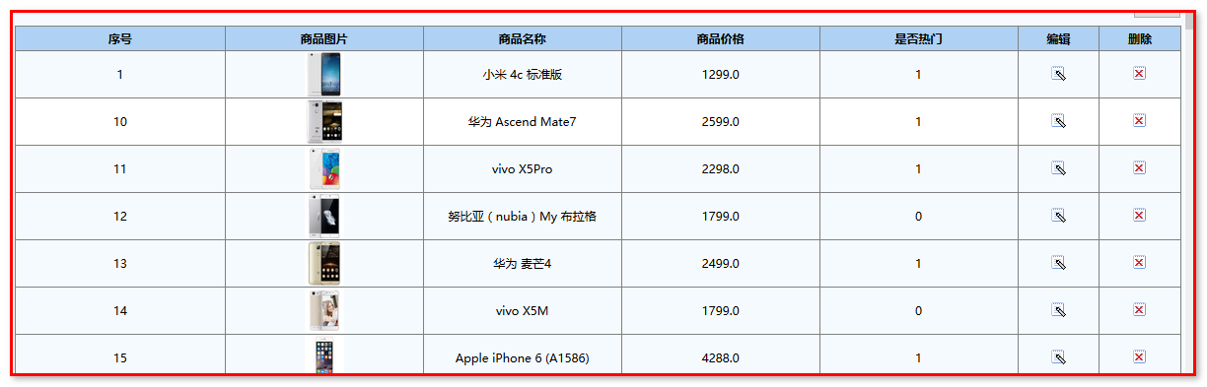

### 商品修改

案例分析

第一次请求：

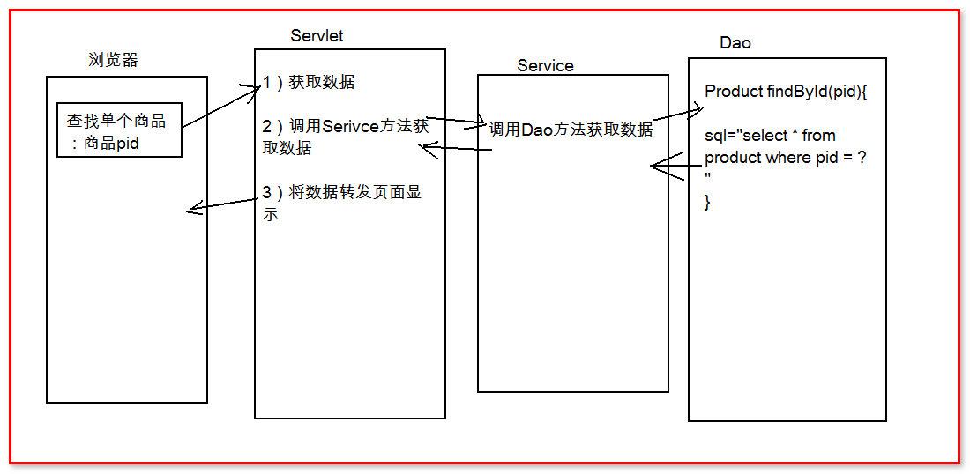

第二次请求：

案例实现

页面：

<a href="${ pageContext.request.contextPath }/FindProById?pid=${good.pid}">

Servlet:

|  |
| --- |
| **package** cn.igeek.web;  **import** java.io.IOException;  **import** java.util.List;  **import** javax.servlet.ServletException;  **import** javax.servlet.http.HttpServlet;  **import** javax.servlet.http.HttpServletRequest;  **import** javax.servlet.http.HttpServletResponse;  **import** cn.igeek.domain.Category;  **import** cn.igeek.domain.Product;  **import** cn.igeek.service.CategoryService;  **import** cn.igeek.service.ProductService;  **import** cn.igeek.service.impl.CategoryServiceImpl;  **import** cn.igeek.service.impl.ProductServiceImpl;  **public** **class** FindProById **extends** HttpServlet {  **public** **void** doGet(HttpServletRequest request, HttpServletResponse response) **throws** ServletException, IOException {  String pid = request.getParameter("pid");  ProductService productService = **new** ProductServiceImpl();  CategoryService categoryService = **new** CategoryServiceImpl();  List<Category> cateList = categoryService.findAll();  Product pro = productService.findById(pid);  request.setAttribute("pro", pro);  request.setAttribute("cateList", cateList);  request.getRequestDispatcher("/admin/product/edit.jsp").forward(request, response);    }  **public** **void** doPost(HttpServletRequest request, HttpServletResponse response) **throws** ServletException, IOException {  doGet(request, response);  }  } |

Service:

|  |
| --- |
| **public** Product findById(String pid) {  **return** productDao.findById(pid);  } |

Dao:

|  |
| --- |
| **public** Product findById(String pid) {  String sql = "select * from product where pid = ?";  **try** {  **return** qr.query(sql, **new** BeanHandler<Product>(Product.**class**),pid);  } **catch** (SQLException e) {  e.printStackTrace();  **return** **null**;  }  } |

页面回显：

|  |
| --- |
| <%@ page language=*"java"* pageEncoding=*"UTF-8"*%>  <%@ taglib prefix=*"c"* uri=*"http://java.sun.com/jsp/jstl/core"* %>  <HTML>  <HEAD>  <meta http-equiv=*"Content-Language"* content=*"zh-cn"*>  <meta http-equiv=*"Content-Type"* content=*"text/html; charset=UTF-8"*>  <LINK href=*"*${pageContext.request.contextPath}*/css/Style1.css"* type=*"text/css"* rel=*"stylesheet"*>  </HEAD>    <body>  <!-- -->  <form id="userAction_save_do" name="Form1" action="${pageContext.request.contextPath}/EditProductServlet" method="post">    <table cellSpacing=*"1"* cellPadding=*"5"* width=*"100%"* align=*"center"* bgColor=*"#eeeeee"* style="border: *1px solid #8ba7e3*" border=*"0"*>  <tr>  <td class=*"ta_01"* align=*"center"* bgColor=*"#afd1f3"* colSpan=*"4"*  height=*"26"*>  <strong><STRONG>编辑商品</STRONG>  </strong>  </td>  </tr>  <tr>  <td width=*"18%"* align=*"center"* bgColor=*"#f5fafe"* class=*"ta_01"*>  商品名称：  </td>  <td class=*"ta_01"* bgColor=*"#ffffff"*>  <input type=*"text"* name=*"pname"* value=*"*${pro.pname }*"* id=*"userAction_save_do_logonName"* class=*"bg"*/>  </td>  <td width=*"18%"* align=*"center"* bgColor=*"#f5fafe"* class=*"ta_01"*>  是否热门：  </td>  <td class=*"ta_01"* bgColor=*"#ffffff"*>    <select name=*"is_hot"*>  <option value=*"1"* <c:if test="${pro.is_hot==1 }">selected="selected"</c:if>>是</option>  <option value=*"0"* <c:if test="${pro.is_hot==0 }">selected="selected"</c:if>>否</option>  </select>  </td>  </tr>  <tr>  <td width=*"18%"* align=*"center"* bgColor=*"#f5fafe"* class=*"ta_01"*>  市场价格：  </td>  <td class=*"ta_01"* bgColor=*"#ffffff"*>  <input type=*"text"* name=*"market_price"* value=*"*${pro.market_price }*"* id=*"userAction_save_do_logonName"* class=*"bg"*/>  </td>  <td width=*"18%"* align=*"center"* bgColor=*"#f5fafe"* class=*"ta_01"*>  商城价格：  </td>  <td class=*"ta_01"* bgColor=*"#ffffff"*>  <input type=*"text"* name=*"shop_price"* value=*"*${pro.shop_price }*"* id=*"userAction_save_do_logonName"* class=*"bg"*/>  </td>  </tr>  <tr>  <td width=*"18%"* align=*"center"* bgColor=*"#f5fafe"* class=*"ta_01"*>  商品图片：  </td>  <td class=*"ta_01"* bgColor=*"#ffffff"* colspan=*"3"*>  <input type=*"file"* name=*"upload"* value=*"*${pro.pimage }*"*/>  </td>  </tr>  <tr>  <td width=*"18%"* align=*"center"* bgColor=*"#f5fafe"* class=*"ta_01"*>  所属分类：  </td>  <td class=*"ta_01"* bgColor=*"#ffffff"* colspan=*"3"*>  <select name=*"categorySecond.csid"*>  <c:forEach items=*"*${cateList }*"* var=*"cate"*>  <option <c:if test="${pro.cid==cate.cid }">selected="selected"</c:if> >${cate.cname }</option>  </c:forEach>  </select>  </td>  </tr>  <tr>  <td width=*"18%"* align=*"center"* bgColor=*"#f5fafe"* class=*"ta_01"*>  商品描述：  </td>  <td class=*"ta_01"* bgColor=*"#ffffff"* colspan=*"3"*>  <textarea name=*"pdesc"* rows=*"5"* cols=*"30"*>${pro.pdesc }</textarea>  </td>  </tr>  <tr>  <td class=*"ta_01"* style="WIDTH: *100%*" align=*"center"*  bgColor=*"#f5fafe"* colSpan=*"4"*>  <button type=*"submit"* id=*"userAction_save_do_submit"* value=*"确定"* class=*"button_ok"*>  &#30830;&#23450;  </button>  <FONT face=*"宋体"*>&nbsp;&nbsp;&nbsp;&nbsp;&nbsp;&nbsp;&nbsp;</FONT>  <button type=*"reset"* value=*"重置"* class=*"button_cancel"*>&#37325;&#32622;</button>  <FONT face=*"宋体"*>&nbsp;&nbsp;&nbsp;&nbsp;&nbsp;&nbsp;&nbsp;</FONT>  <INPUT class=*"button_ok"* type=*"button"* onclick="history.go(-1)" value=*"返回"*/>  <span id=*"Label1"*></span>  </td>  </tr>  </table>  </form>  </body>  </HTML> |

修改流程分析：

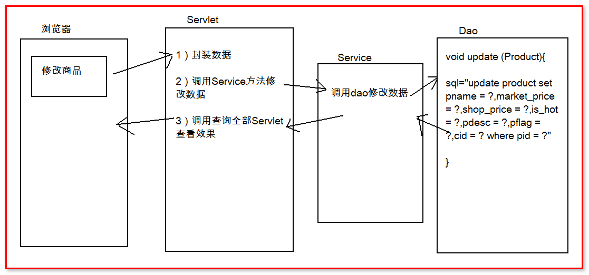

Servlet:

|  |
| --- |
| **package** cn.igeek.web;  **import** java.io.IOException;  **import** java.lang.reflect.InvocationTargetException;  **import** javax.servlet.ServletException;  **import** javax.servlet.http.HttpServlet;  **import** javax.servlet.http.HttpServletRequest;  **import** javax.servlet.http.HttpServletResponse;  **import** org.apache.commons.beanutils.BeanUtils;  **import** cn.igeek.domain.Product;  **import** cn.igeek.service.ProductService;  **import** cn.igeek.service.impl.ProductServiceImpl;  **public** **class** EditProductServlet **extends** HttpServlet {  **public** **void** doGet(HttpServletRequest request, HttpServletResponse response) **throws** ServletException, IOException {  Product p = **new** Product();  **try** {  BeanUtils.*populate*(p, request.getParameterMap());  } **catch** (Exception e) {  e.printStackTrace();  }    ProductService productService = **new** ProductServiceImpl();    productService.update(p);  response.sendRedirect(request.getContextPath() + "/AdminFindAllGoods");  }  **public** **void** doPost(HttpServletRequest request, HttpServletResponse response) **throws** ServletException, IOException {  doGet(request, response);  }  } |

Service:

|  |
| --- |
| **public** **void** update(Product p) {  productDao.update(p);  } |

Dao:

|  |
| --- |
| **public** **void** update(Product p) {  **try** {  String sql = "update product set pname = ?,market_price = ?,shop_price = ?,is_hot = ?,pdesc = ?,pflag = ?,cid = ? where pid = ?";  qr.update(sql, p.getPname(), p.getMarket_price(), p.getShop_price(), p.getIs_hot(), p.getPdesc(),  p.getPflag(), p.getCid(), p.getPid());  } **catch** (SQLException e) {  e.printStackTrace();  **throw** **new** RuntimeException(e);  }  } |

### 商品删除

<a href="${ pageContext.request.contextPath }/DeletProduct?pid=${good.pid}">

案例分析

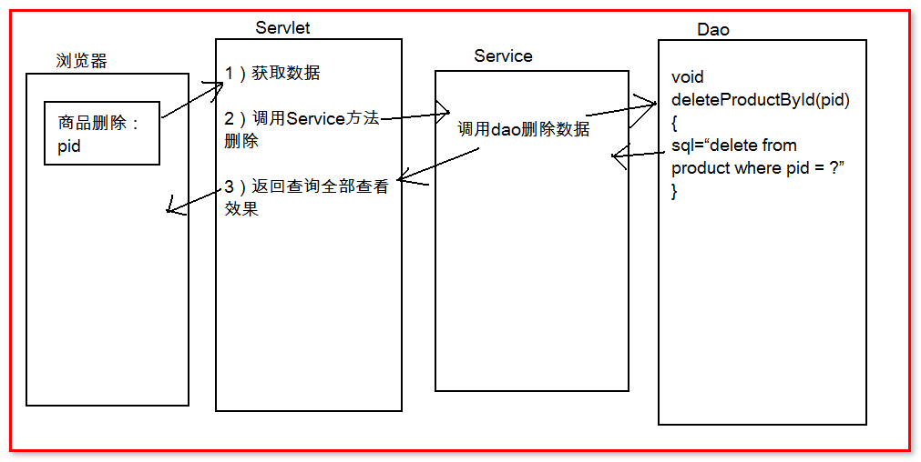

案例实现

Servlet:

|  |
| --- |
| **package** cn.igeek.web;  **import** java.io.IOException;  **import** javax.servlet.ServletException;  **import** javax.servlet.http.HttpServlet;  **import** javax.servlet.http.HttpServletRequest;  **import** javax.servlet.http.HttpServletResponse;  **import** cn.igeek.service.ProductService;  **import** cn.igeek.service.impl.ProductServiceImpl;  **public** **class** DeletProduct **extends** HttpServlet {  **public** **void** doGet(HttpServletRequest request, HttpServletResponse response) **throws** ServletException, IOException {  String pid = request.getParameter("pid");  ProductService productService = **new** ProductServiceImpl();  productService.deleteProductById(pid);  response.sendRedirect(request.getContextPath() + "/AdminFindAllGoods");  }  **public** **void** doPost(HttpServletRequest request, HttpServletResponse response) **throws** ServletException, IOException {  doGet(request, response);  }  } |

Service:

|  |
| --- |
| **public** **void** deleteProductById(String pid) {  productDao.deleteProductById(pid);  } |

Dao:

|  |
| --- |
| **public** **void** deleteProductById(String pid) {  **try** {  String sql = "delete from product where pid = ?";  qr.update(sql, pid);  } **catch** (SQLException e) {  e.printStackTrace();  **throw** **new** RuntimeException(e);  }  } |

# 前台系统之商品列表查询——分页查询(大结果集分页)

## 后台系统之商品分页实现

相关知识点:

大结果集： 一次性，从，数据库中，获取，大量的，数据。

分页： 将数据分批次展示给用户

大结果集分页的技术需求(它因为什么原因诞生的)：

1）物理计算机的瓶颈（内存瓶颈），如果给一个只有1千万数据内存的机器，给了2千万数据。数据溢出。

一个水桶，只能装1L水，现在我给他灌2L的水，肯定有1L的水溢出，浪费了。

2）封装数据到对象，过程十分慢长（这个漫长是数据量太大），这样的用户体验非常差

假设：有一个超级机器，内存无限的，1个数据要1秒钟，1千万数据，一千万秒。

用户体验（响应速度）：

1 类似商品这样的数据，有大量的替代品，速度越快越好（控制在毫秒级）

2 在线支付，用户可以等待10~15秒，类似，可能会发送误操作的功能，用户可等待久一些

3 12306 火车票，不可替代品，用户愿意久等。

分页技术，数据库实现：通过关键字，限制一次性从数据库中获取数据的起始位置和长度。

起始位置：数据从哪一行开始获取。

长度：一次性获取数据的量。

MySql关键字：limit 限制的意思

Select * from contact where key =XX limit ?,?

第一个问号：起始位置

第二个问号：长度

2: 分页查询结果集封装问题

1 当前数据中的总记录数total

2 当前一页多少数据size

3 用户想要访问的页码 pageNum

4 一共多少页（尾页） end

5 要分页显示的商品数据 data List<Product>

查询的结果集封装到分页实体类中 Pagination<T>,设计该实体类可以显示jsp页码需要的分页数据和分页栏

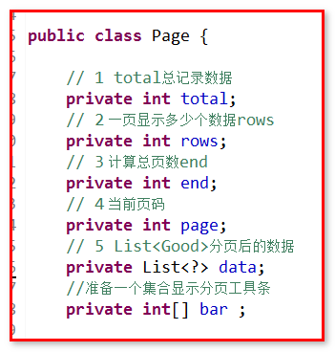

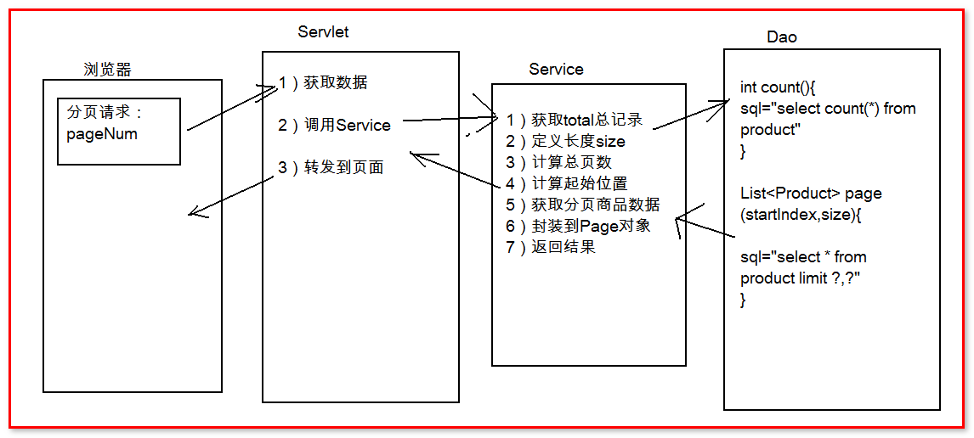

分页代码实现:

Servlet:

|  |
| --- |
| **package** cn.igeek.web;  **import** java.io.IOException;  **import** javax.servlet.ServletException;  **import** javax.servlet.http.HttpServlet;  **import** javax.servlet.http.HttpServletRequest;  **import** javax.servlet.http.HttpServletResponse;  **import** cn.igeek.domain.Page;  **import** cn.igeek.service.ProductService;  **import** cn.igeek.service.impl.ProductServiceImpl;  **public** **class** FindAllGoodsServlet **extends** HttpServlet {  **public** **void** doGet(HttpServletRequest request, HttpServletResponse response) **throws** ServletException, IOException {  **int** page = Integer.*parseInt*(request.getParameter("page"));    ProductService productService = **new** ProductServiceImpl();  //List<Product> ps = productService.findAll();  Page pageBean = productService.page(page);  //request.setAttribute("products", ps);  request.setAttribute("pageBean",pageBean);  request.getRequestDispatcher("/product_list.jsp").forward(request, response);  }  **public** **void** doPost(HttpServletRequest request, HttpServletResponse response) **throws** ServletException, IOException {  doGet(request, response);  }  } |

Service:

|  |
| --- |
| **public** Page page(**int** page) {  // 1 total总记录数据  **int** total = productDao.count();  // 2 一页显示多少个数据rows  **int** rows = 20;  // 3 计算总页数end  **int** end = total % rows == 0 ? (total / rows) : (total / rows)+1;  // 5 List<Good>分页后的数据  List<Product> data = productDao.page((page - 1)*rows,rows);  Page p = **new** Page();    p.setData(data);  p.setEnd(end);  p.setPage(page);    p.setRows(rows);  p.setTotal(total);  **return** p;  } |

Dao:

|  |
| --- |
| @Override  **public** List<Product> page(**int** i, **int** rows) {  String sql = "select * from product limit ?,?";  **try** {  **return** qr.query(sql, **new** BeanListHandler<Product>(Product.**class**),i,rows);  } **catch** (SQLException e) {  e.printStackTrace();  **return** **null**;  }  } |

页面分页条：

|  |
| --- |
| <%@ page language=*"java"* contentType=*"text/html; charset=UTF-8"*  pageEncoding=*"UTF-8"*%>  <%@ taglib prefix=*"c"* uri=*"http://java.sun.com/jsp/jstl/core"* %>  <c:set var=*"root"* value=*"*${pageContext.request.contextPath }*"*/>  <!DOCTYPE html>  <html>  <head>  <meta name=*"viewport"* content=*"width=device-width, initial-scale=1"*>  <title>会员登录</title>  <link rel=*"stylesheet"* href=*"css/bootstrap.min.css"* type=*"text/css"* />  <script src=*"js/jquery-1.11.3.min.js"* type=*"text/javascript"*></script>  <script src=*"js/bootstrap.min.js"* type=*"text/javascript"*></script>  <!-- 引入自定义css文件 style.css -->  <link rel=*"stylesheet"* href=*"css/style.css"* type=*"text/css"* />  <style>  **body** {  margin-top: *20px*;  margin: *0 auto*;  width: *100%*;  }  *.carousel-inner* *.item* **img** {  width: *100%*;  height: *300px*;  }  </style>  </head>  <body>  <!-- 引入header.jsp -->  <jsp:include page=*"/header.jsp"*></jsp:include>  <div class=*"row"* style="width: *1210px*; margin: *0 auto*;">  <div class=*"col-md-12"*>  <ol class=*"breadcrumb"*>  <li><a href=*"#"*>首页</a></li>  </ol>  </div>    <c:forEach items=*"*${pageBean.data }*"* var=*"p"*>  <div class=*"col-md-2"* style="text-align:*center*;height:*200px*;margin:*20px*;">  <a href=*"product_info.htm"*> <img src=*"*${p.pimage }*"*  width=*"170"* height=*"170"* style="display: *inline-block*;">  </a>  <p>  <a href=*"product_info.html"* style='color: *green*'>${p.pname }</a>  </p>  <p>  <font color=*"#FF0000"*>商城价：&yen;${p.shop_price }</font>  </p>  </div>  </c:forEach>  </div>  <!--分页 -->  <div style="width: *450px*; margin: *0 auto*; margin-top: *50px*;">  <ul class=*"pagination"* style="text-align: *center*; margin-top: *10px*;">  <li>  <a href=*"*${root }*/findAllGoods?page=1"* aria-label=*"Previous"*>  <span aria-hidden=*"true"*>&laquo;</span>  </a>  </li>  <c:forEach items=*"*${pageBean.bar }*"* var=*"pageNum"*>  <li <c:if test="${pageNum == pageBean.page }">class="active"</c:if>><a href=*"*${root }*/findAllGoods?page=*${pageNum }*"*>${pageNum }</a></li>  </c:forEach>  <li><a href=*"*${root }*/findAllGoods?page=*${pageBean.end }*"* aria-label=*"Next"*> <span aria-hidden=*"true"*>&raquo;</span>  </a></li>  </ul>  </div>  <!-- 分页结束 -->  <!--商品浏览记录-->  <div  style="width: *1210px*; margin: *0 auto*; padding: *0 9px*; border: *1px solid #ddd*; border-top: *2px solid #999*; height: *246px*;">  <h4 style="width: *50%*; float: *left*; font: *14px/30px 微软雅黑*">浏览记录</h4>  <div style="width: *50%*; float: *right*; text-align: *right*;">  <a href=*""*>more</a>  </div>  <div style="clear: *both*;"></div>  <div style="overflow: *hidden*;">  <ul style="list-style: *none*;">  <li  style="width: *150px*; height: *216*; float: *left*; margin: *0 8px 0 0*; padding: *0 18px 15px*; text-align: *center*;"><img  src=*"products/1/cs10001.jpg"* width=*"130px"* height=*"130px"* /></li>  </ul>  </div>  </div>  <!-- 引入footer.jsp -->  <jsp:include page=*"/footer.jsp"*></jsp:include>  </body>  </html> |

分页Bean：

|  |
| --- |
| package cn.igeek.domain;  import java.util.Arrays;  import java.util.List;  public class Page {    private int total ;  private int size ;  private int end ;  private int pageNum ;  private List<Product> data ;  private int[] bar;  public int getTotal() {  return total;  }  public void setTotal(int total) {  this.total = total;  }  public int getSize() {  return size;  }  public void setSize(int size) {  this.size = size;  }  public int getEnd() {  return end;  }  public void setEnd(int end) {  this.end = end;  }  public int getPageNum() {  return pageNum;  }  public void setPageNum(int pageNum) {  this.pageNum = pageNum;  }  public List<Product> getData() {  return data;  }  public void setData(List<Product> data) {  this.data = data;  }  //计算获取分页条  public int[] getBar() {  //确定好开头和结尾  int start ;  int stop ;  //少于10页  if(end < 10){  start = 1;  stop = end;    }else{    start = pageNum -5;  stop = pageNum +4;  if(pageNum +4 >= end){  start = end - 9;  stop = end ;  }  if(pageNum -5 <=0){  start = 1;  stop = 10;  }    }  bar = new int[stop - start + 1];  int index = 0;  for (int i = start; i <= stop; i++) {  bar[index++] = i;  }  return bar;  }  public void setBar(int[] bar) {  this.bar = bar;  }  @Override  public String toString() {  return "Page [total=" + total + ", size=" + size + ", end=" + end + ", pageNum=" + pageNum + ", data=" + data  + ", bar=" + Arrays.toString(bar) + "]";  }  } |