Component Definition 2.0
Component List
Inclusions Database
- List of inclusions
- User driven
- Permissions based
- Organized by projects / components

Workflow Engine
- Assignees
- Inclusion owner
- Event driven

Notification System
- Updates to web interface
- Email

Statistics Gathering
- Actual start / completion dates
- Data auditing

Customizable Web Interface
- Sorting
- Filtering
- Search capabilities
- Permissions based
- Batch & detailed edit abilities

Static Mobile Interface
- Default view of inclusions list
- Add inclusions ability

Detailed Definition
Data Elements
The following tables will exist in a MS SQL Database:
- Inclusions – Viewable and editable from the Inclusions List view, which is the result of a default query when logging in from the web, or a limited display when logging in from a mobile device. Input points are the list view itself (quick edit mode) or the detailed edit view that results from clicking on the title of an inclusion from the Inclusions List view.
  - Fields:
    - id - number
    - title - varchar
    - description - varchar
    - type – inclusiontype id
    - stage – stage id
    - owner – user id
    - assignee – user id
    - product – product id
    - component – component id

- InclusionTypes – Viewable and editable from the Inclusion Types List view, which is the result of a specific “Inclusions Types” query. Also editable in the list or the detailed Inclusion Types page.
  - Fields:
    - id – number
    - title – varchar
    - description - varchar
  - Available Types:
    - Feature Request
    - Technical Requirement
    - Technical Improvement
    - Defect
- Stages - Viewable and editable from the Stages List view, which is the result of a specific “Stages” query. Also editable in the list or the detailed Stages page.
  - Fields:
    - id – number
    - title – varchar
    - description - varchar
  - Available Stages:
    - Demand
    - Require
    - Request

- Users - Viewable and editable from the Users List view, which is the result of a specific “Users” query. Also editable in the list or the detailed Users page.
  - Fields:
    - id – number
    - firstname – varchar
    - lastname – varchar
    - email – varchar

- Products - Viewable and editable from the Products List view, which is the result of a specific “Products” query. Also editable in the list or the detailed Products page.
  - Fields:
    - id – number
    - title – varchar
    - description – varchar
  - Available Products:
    - Watson Consumer
    - Watson Enterprise
    - “This System” – to be named later.

- Components - Viewable and editable from the Components List view, which is the result of a specific “Components” query. Also editable in the list or the detailed Components page.
  - Fields:
    - id – number
    - title – varchar
    - description – varchar
  - Available Components:
    - Engine
    - User Interface
    - Controller
    - Word App. Adapter
    - IE App. Adapter
    - Power Point App. Adapter
    - Logging
    - Installer
    - Web Site

- Permissions - Viewable and editable from the Permissions List view, which is the result of a specific “Permissions” query. Also editable in the list or the detailed Permissions page.
  - Fields:
    - id – number
    - title – varchar
    - type – permissiontype id
    - user – user id
    - inclusion – inclusion id

- PermissionTypes - Viewable and editable from the Permission Types List view, which is the result of a specific “Permission Types” query. Also editable in the list or the detailed Permission Types page.
  - Fields:
    - id – number
    - title – varchar
    - description – varchar
  - Available Permission Types:
    - Read
    - Write

Presentation
The Inclusions List and detailed Edit Inclusion pages will follow the design of the prototypes shown below. Each of the other pages will use a similar template for presentation. As mentioned, each will have both quick edit and detailed edit options.

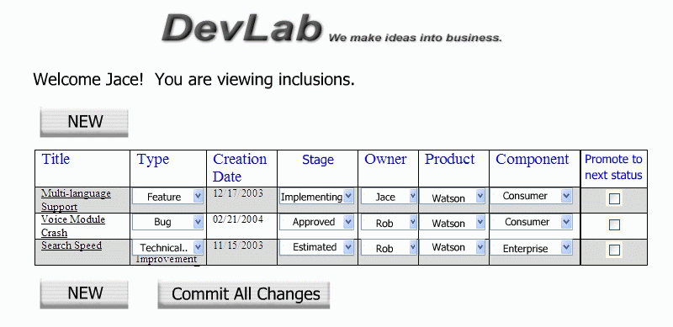
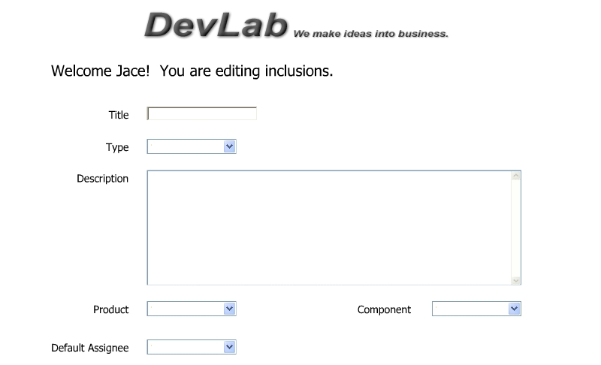

Logic
Inclusions filtered by default, or fields not visible by the default, should all be viewable via customizable query. Each page should be populated by a search of a table (or tables) in the db, so any view should be possible.

On delete of an inclusion should cascade, however on delete of any supporting element, such as a user, permission, type etc. should require that no references exist.

When editing either in quick edit mode (the result of a query displayed as a page) or in a detailed edit mode (a pre-defined page for the component corresponding to a particular table), all changes made should be reflected in and committed to the database on submit.

